DUT — Faculty of Accounting & Informatics
GROUP 15
TOMBSTONE SERVICES

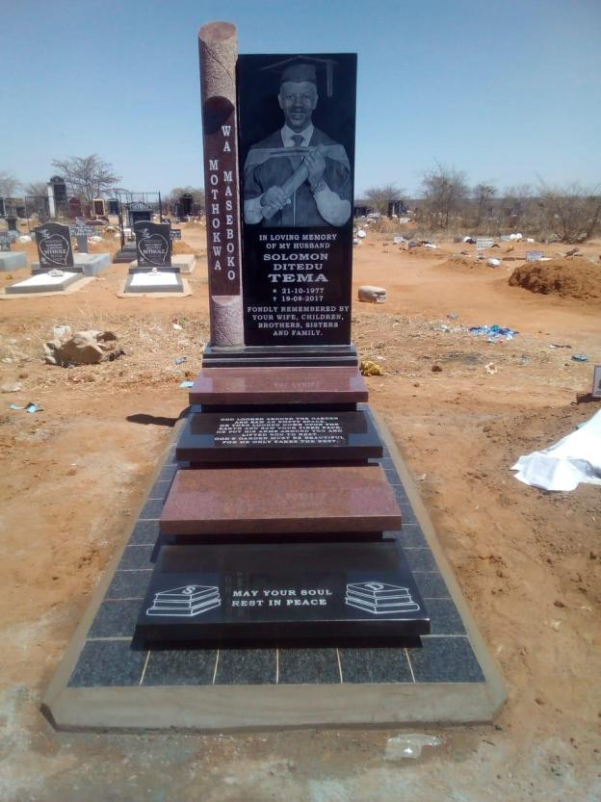

TABLE OF CONTENTS

APPENDIX A: GROUP PROJECT COVER SHEET
Group No.: 15
Group Name: TOMBSTONE SERVICES
Project Name: BISB301
Please complete this form and submit it as a cover sheet with your project submission. One submission is required per group. The details completed below must be correct.
Student No. | Surname & Initials | Task Completed | Signature
22416369 | AMAHLE SIBISI | ERD | AS
22124072 | BANELE DUBE | NORMALIZATION | BD
22239183 | MHLAMBI ZO | SAMPLE DATA & SQL | ZOM
22268369 | CELE NOZUZO | DATA WAREHOUSE | NC
22310593 | NDLELA S | DATA MART | SN
22206931 | NZAMA Z | REPORT AND DOCUMENT | ZN
22453696 | NHLANGOTHI PP | REPORT AND DOCUMENT | PPN
22064268 | SOKHULU KM | REPORT AND DOCUMENT | KMS
22410105 | ZONDI S | DATA MART | ZS

APPENDIX B: GROUP PLAGIARISM STATEMENT
FACULTY OF ACCOUNTING AND INFORMATICS – DEPARTMENT OF INFORMATION TECHNOLOGY

Group Plagiarism Statement
You are guilty of plagiarism if you copy something from a book, article, or website without acknowledging the source and passing it off as your own. In effect, you are stealing something that belongs to someone else. This is not only the case when you copy work word-by-word (verbatim), but also when you submit someone else's work in a slightly altered form (paraphrase) or use a line of argument without acknowledging it. You are not allowed to use another student's past written work. You are also not allowed to let anybody copy your work to pass it off as his/her work.
Students who commit plagiarism will get 0 (zero) for the plagiarised work, without the opportunity to resubmit, AND the matter may also be referred to the Dean for disciplinary action. Plagiarism is regarded as a serious contravention of the rules and can lead to expulsion from this and other universities.
This declaration must be completed and submitted to your respective group lecturer for all phases of the project.
No. | Student No. | Student Initials & Surname | Signature
1 | 22239183 | ZO Mhlambi | ZM
2 | 22268369 | Nozuzo Cele | NC
3 | 22416369 | Amahle Sibisi | AS
4 | 22124072 | Banele Dube | BD
5 | 22206931 | Zazi Nzama | ZN
6 | 22310593 | Sandiso Ndlela | SN
7 | 22064268 | Kwanele Sokhulu | KS
8 | 22453696 | Nhlangothi Phindi | NP
9 | 22410105 | Zondi S | ZS

- We understand what plagiarism is and we are aware of the DUT's policy in this regard.
- We declare that this tutorial/project is our own work.
- Where other people's work has been used (either from a printed source, the internet, or any other source) this has been carefully acknowledged and referenced following departmental requirements.
- We have not used other students' past work to hand in as our own.
- We have not allowed and will not allow anyone to copy our work to pass it off as their work.

INTRODUCTION
Our project is based on a small tombstone and monument business that designs, manufactures and installs granite memorials for families who have lost a loved one. A job usually starts when a customer comes in to order a headstone or memorial, choosing the design, size and wording for the inscription. From there the business sources granite slabs and other materials from its suppliers, manufactures and engraves the stone, and once it has passed quality checks, invoices the customer and arranges delivery and installation at the correct cemetery.
Because the business is juggling customers, orders, suppliers, materials and production at the same time, it needs a proper system to keep track of all of this and simple reports that let management see how sales and production are going. That is what this project sets out to build: a relational database (Part 1), a data warehouse (Part 2), and two data marts (Part 3).

PART 1: RELATIONAL DATABASE DESIGN
Part 1 covers the day-to-day operational database for the company, a business that manufactures and installs granite tombstones, headstones and memorial monuments for customers arranging a memorial for a deceased family member. It includes the Entity-Relationship Diagram, the normalisation process from an unnormalised design through First, Second and Third Normal Form, sample data (3-5 rows per table) and the SQL scripts used to create and populate the tables.

1.1 Entity-Relationship Diagram (ERD)
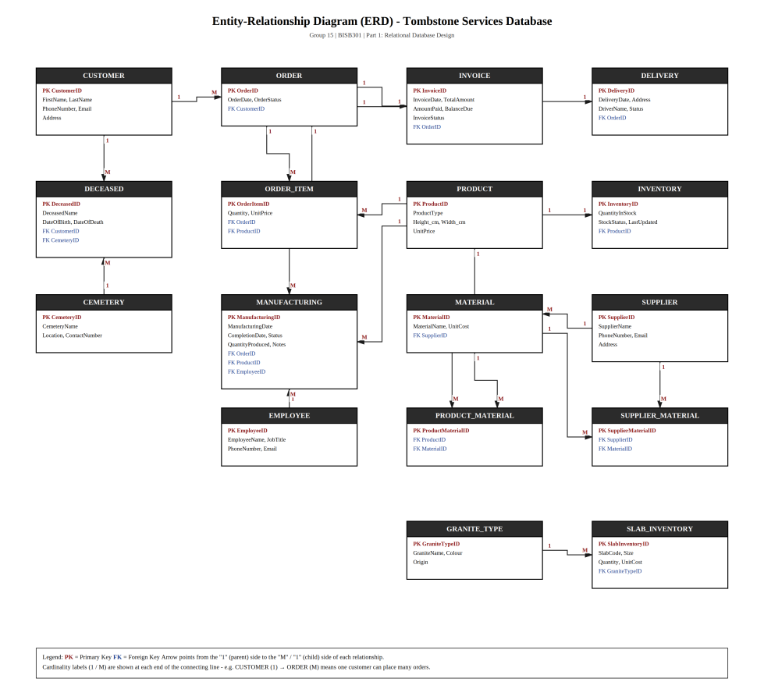
Figure 1: Entity-Relationship Diagram for the Tombstone Services operational database. Arrows point from the "1" (parent) side to the "M"/"1" (child) side of each relationship; PK = Primary Key, FK = Foreign Key.

1.2 Relational Schema (Normalised to First Normal Form (1NF))
- ORDER_FORM (OrderID PK, OrderDate, OrderStatus, CustomerName, CustomerPhone, CustomerEmail, CustomerAddress)
- ORDER_ITEM (OrderID PK/FK, ProductID PK/FK, ProductName, ProductType, Height_cm, Width_cm, Quantity, UnitPrice)

1.3 Relational Schema (Normalised to Second Normal Form (2NF))
- PRODUCT (ProductID PK, ProductName, ProductType, Height_cm, Width_cm, UnitPrice)
- ORDER_ITEM (OrderItemID PK, Quantity, UnitPrice, OrderID FK, ProductID FK)
- ORDER (OrderID PK, OrderDate, OrderStatus, CustomerName, CustomerPhone, CustomerEmail, CustomerAddress)

1.4 Relational Schema (Normalised to Third Normal Form (3NF))
- CUSTOMER (CustomerID PK, FirstName, LastName, PhoneNumber, Email, Address)
- ORDER (OrderID PK, OrderDate, OrderStatus, CustomerID FK)
- INVOICE (InvoiceID PK, InvoiceDate, TotalAmount, AmountPaid, BalanceDue, InvoiceStatus, OrderID FK)
- DELIVERY (DeliveryID PK, DeliveryDate, DeliveryAddress, DriverName, DeliveryStatus, OrderID FK)
- SUPPLIER (SupplierID PK, SupplierName, PhoneNumber, Email, Address)
- PRODUCT (ProductID PK, ProductName, ProductType, Height_cm, Width_cm, UnitPrice)
- ORDER_ITEM (OrderItemID PK, Quantity, UnitPrice, OrderID FK, ProductID FK)
- DECEASED (DeceasedID PK, DeceasedName, DateOfBirth, DateOfDeath, CustomerID FK, CemeteryID FK)
- CEMETERY (CemeteryID PK, CemeteryName, Location, ContactNumber)
- MANUFACTURING (ManufacturingID PK, ManufacturingDate, CompletionDate, ManufacturingStatus, QuantityProduced, ManufacturingNotes, OrderID FK, ProductID FK, EmployeeID FK)
- EMPLOYEE (EmployeeID PK, EmployeeName, JobTitle, PhoneNumber, Email)
- INVENTORY (InventoryID PK, QuantityInStock, StockStatus, LastUpdated, ProductID FK)
- MATERIAL (MaterialID PK, MaterialName, UnitCost, SupplierID FK)
- GRANITE_TYPE (GraniteTypeID PK, GraniteName, Colour, Origin)
- SLAB_INVENTORY (SlabInventoryID PK, SlabCode, Size, Quantity, UnitCost, GraniteTypeID FK)
- SUPPLIER_MATERIAL (SupplierMaterialID PK, SupplierID FK, MaterialID FK)
- PRODUCT_MATERIAL (ProductMaterialID PK, ProductID FK, MaterialID FK)
Every non-key attribute in every table above now depends on the whole primary key and nothing but the primary key, which is the definition of 3NF. This is the schema implemented by the SQL scripts in section 1.6.

1.5 Sample Data

CUSTOMER
ID | First Name | Last Name | Phone | Email | Address
C001 | Zanele | Zungu | 0627885467 | zunguz@gmail.com | Durban
C002 | Jomo | Zwane | 0784456790 | jzwane@gmail.com | Pinetown
C003 | Emily | Armish | 0834521345 | smith2@gmail.com | Ballito

CEMETERY
ID | Name | Location | Contact
CEM1 | Stellawood Cemetery | Umbilo, Durban | 0312758908
CEM2 | Pinetown Cemetery | Fields Hill, Pinetown | 0312789046
CEM3 | Umhlali Cemetery | Salt Rock Road, Ballito | 0324783094

SUPPLIER
ID | Name | Number | Email | Address
SUP1001 | David Blom | 0678453210 | blomd@gmail.com | Cape Town
SUP1002 | Zakes Nkosi | 0897634569 | zakesnkosi@gmail.com | Durban
SUP1003 | Albert Yaman | 0725789656 | yaman@gmail.com | Johannesburg

GRANITE_TYPE
ID | Name | Colour | Origin
GR01 | Nero Rustenburg | Dark Grey | South Africa
GR02 | Zimbabwe Black | Deep Intense Black | South Africa
GR03 | African Red | Deep Red | South Africa

EMPLOYEE
ID | Name | Job | Phone | Email
E101 | Zinhle Buthelezi | Sales Consultant | 0867845637 | zbuthelezi@gmail.com
E102 | Kevin Moodley | Master Stone Carver | 0723678907 | moodleyk@gmail.com
E103 | Lungani Cele | Installation Specialist | 0824789084 | cele24@gmail.com

PRODUCT
ID | Product Name | Product Type | Height cm | Width cm | Unit Price
P01 | Rustenburg Grey Flat Marker | Lawn Plaque | 10 | 60 | 4500.00
P02 | Zimbabwe Black Classic | Headstone | 80 | 65 | 12000.00
P03 | African Red Double Memorial | Full Monument | 110 | 150 | 3500.00

ORDER
ID | Order Date | Order Status | CustomerID
1001 | 2026-07-06 | Quality Check | C001
1002 | 2026-07-08 | In Production | C002
1003 | 2026-07-13 | Ready | C003

INVOICE
ID | Invoice Date | Total Amount | Amount Paid | Balance Due | Status | OrderID
N1 | 2026-07-06 | 4500 | 2000 | 2500 | Unpaid | 1001
N2 | 2026-07-08 | 12000 | 6000 | 6000 | Partially Paid | 1002
N3 | 2026-07-13 | 3500 | 3500 | 0 | Paid | 1003

DELIVERY
ID | Delivery Date | Address | Driver | Status | OrderID
DEL01 | 2026-07-16 | Umbilo, Durban | Lungisani Cele | Delivered | 1001
DEL02 | 2026-08-03 | Fields Hill, Pinetown | Lungisani Cele | Delivered | 1002
DEL03 | NULL | Salt Rock, Ballito | Lungisani Cele | Scheduled | 1003

ORDER_ITEM
ID | Quantity | Unit Price | OrderID | ProductID
1 | 1 | 4500 | 1001 | P01
2 | 1 | 12000 | 1002 | P02
3 | 1 | 3500 | 1003 | P03

DECEASED
ID | Name | DOB | DOD | CustomerID | CemeteryID
D01 | Siphila Zungu | 1995-02-28 | 2026-06-25 | C001 | CEM1
D02 | Zwelihle Zwane | 1942-08-08 | 2026-07-01 | C002 | CEM2
D03 | World Armish | 2002-04-17 | 2026-07-10 | C003 | CEM3

MANUFACTURING
ID | Man. Date | Completion | Status | Qty | Notes | OrderID | ProductID
MFG001 | 2026-07-09 | 2026-07-14 | Completed | 1 | Moved to dispatch bay | 1001 | P01
MFG002 | 2026-06-12 | 2026-07-28 | Completed | 1 | Etching completed | 1002 | P02
MFG003 | 2026-07-15 | NULL | In Progress | 1 | Raw stone slab loaded | 1003 | P02

INVENTORY
ID | Qty In Stock | Stock Status | Last Updated | ProductID
1 | 4 | In Stock | 2026-07-14 | P01
2 | 2 | Low Stock | 2026-07-28 | P02
3 | 6 | In Stock | 2026-07-13 | P03

MATERIAL
ID | Name | Unit Cost | SupplierID
M1 | Industrial Sandblast Diamond 25kg | 1450 | SUP1001
M2 | Monumental Gold Leaf Foil 23 Karat | 2800 | SUP1002
M3 | Weatherproof EpoxyStone Sealant 5L | 850 | SUP1003

SLAB_INVENTORY
ID | Code | Size | Quantity | Unit Cost | GraniteTypeID
Slab01 | Rst1 | 250x140x3cm | 15 | 4200 | GR01
Slab02 | Zim2 | 240x120x5cm | 8 | 7800 | GR02
Slab03 | Afr3 | 260x150x5cm | 5 | 6100 | GR03

SUPPLIER_MATERIAL
ID | SupplierID | MaterialID
SM01 | SUP1001 | M1
SM02 | SUP1002 | M2
SM03 | SUP1003 | M3

PRODUCT_MATERIAL
ID | ProductID | MaterialID
PM001 | P01 | M1
PM002 | P02 | M2
PM003 | P03 | M3

1.6 SQL Scripts
The full script is provided as a separate, executable file named SQLqueries-tables.sql, submitted alongside this report. It contains every CREATE TABLE and INSERT INTO statement, organised in dependency order (parent tables are created before the child tables that reference them with a FOREIGN KEY) and grouped table-by-table below for readability. The script was tested end-to-end and executes without errors.

(a) Table creation (DDL) — in dependency order
-- 1.1 CUSTOMER (no dependencies)
CREATE TABLE Customer (
CustomerID VARCHAR(10) PRIMARY KEY NOT NULL,
FirstName VARCHAR(50),
LastName VARCHAR(50),
PhoneNumber VARCHAR(20),
Email VARCHAR(100),
Address VARCHAR(150)
);

-- 1.2 CEMETERY (no dependencies)
CREATE TABLE Cemetery (
CemeteryID VARCHAR(10) PRIMARY KEY NOT NULL,
CemeteryName VARCHAR(100),
Location VARCHAR(150),
ContactNumber VARCHAR(20)
);

-- 1.3 SUPPLIER (no dependencies)
CREATE TABLE Supplier (
SupplierID VARCHAR(10) PRIMARY KEY NOT NULL,
SupplierName VARCHAR(100),
PhoneNumber VARCHAR(20),
Email VARCHAR(100),
Address VARCHAR(150)
);

-- 1.4 GRANITE_TYPE (no dependencies)
CREATE TABLE Granite_Type (
GraniteTypeID VARCHAR(10) PRIMARY KEY NOT NULL,
GraniteName VARCHAR(100),
Colour VARCHAR(50),
Origin VARCHAR(100)
);

-- 1.5 EMPLOYEE (no dependencies)
CREATE TABLE Employee (
EmployeeID VARCHAR(10) PRIMARY KEY NOT NULL,
EmployeeName VARCHAR(50),
JobTitle VARCHAR(50),
PhoneNumber VARCHAR(20),
Email VARCHAR(100)
);

-- 1.6 PRODUCT (no dependencies)
CREATE TABLE Product (
ProductID VARCHAR(10) PRIMARY KEY NOT NULL,
ProductName VARCHAR(100),
ProductType VARCHAR(100),
Height_cm INT,
Width_cm INT,
UnitPrice DECIMAL(10,2)
);

-- 1.7 ORDER (depends on Customer)
CREATE TABLE `Order` (
OrderID INT PRIMARY KEY NOT NULL,
OrderDate DATE,
OrderStatus VARCHAR(30),
CustomerID VARCHAR(10),
FOREIGN KEY (CustomerID) REFERENCES Customer (CustomerID)
);

-- 1.8 INVOICE (depends on Order)
CREATE TABLE Invoice (
InvoiceID VARCHAR(10) PRIMARY KEY NOT NULL,
InvoiceDate DATE,
TotalAmount DECIMAL(10,2),
AmountPaid DECIMAL(10,2),
BalanceDue DECIMAL(10,2),
InvoiceStatus VARCHAR(30),
OrderID INT,
FOREIGN KEY (OrderID) REFERENCES `Order` (OrderID)
);

-- 1.9 DELIVERY (depends on Order)
CREATE TABLE Delivery (
DeliveryID VARCHAR(10) PRIMARY KEY NOT NULL,
DeliveryDate DATE,
DeliveryAddress VARCHAR(150),
DriverName VARCHAR(100),
DeliveryStatus VARCHAR(30),
OrderID INT,
FOREIGN KEY (OrderID) REFERENCES `Order` (OrderID)
);

-- 1.10 ORDER_ITEM (depends on Order, Product)
CREATE TABLE Order_Item (
OrderItemID INT PRIMARY KEY NOT NULL,
Quantity INT,
UnitPrice DECIMAL(10,2),
OrderID INT,
ProductID VARCHAR(10),
FOREIGN KEY (OrderID) REFERENCES `Order` (OrderID),
FOREIGN KEY (ProductID) REFERENCES Product (ProductID)
);

-- 1.11 DECEASED (depends on Customer, Cemetery)
CREATE TABLE Deceased (
DeceasedID VARCHAR(10) PRIMARY KEY NOT NULL,
DeceasedName VARCHAR(50),
DateOfBirth DATE,
DateOfDeath DATE,
CustomerID VARCHAR(10),
CemeteryID VARCHAR(10),
FOREIGN KEY (CustomerID) REFERENCES Customer (CustomerID),
FOREIGN KEY (CemeteryID) REFERENCES Cemetery (CemeteryID)
);

-- 1.12 MANUFACTURING (depends on Order, Product, Employee)
CREATE TABLE Manufacturing (
ManufacturingID VARCHAR(10) PRIMARY KEY NOT NULL,
ManufacturingDate DATE,
CompletionDate DATE,
ManufacturingStatus VARCHAR(30),
QuantityProduced INT,
ManufacturingNotes VARCHAR(255),
OrderID INT,
ProductID VARCHAR(10),
EmployeeID VARCHAR(10),
FOREIGN KEY (OrderID) REFERENCES `Order` (OrderID),
FOREIGN KEY (ProductID) REFERENCES Product (ProductID),
FOREIGN KEY (EmployeeID) REFERENCES Employee (EmployeeID)
);

-- 1.13 INVENTORY (depends on Product)
CREATE TABLE Inventory (
InventoryID INT PRIMARY KEY NOT NULL,
QuantityInStock INT,
StockStatus VARCHAR(30),
LastUpdated DATE,
ProductID VARCHAR(10),
FOREIGN KEY (ProductID) REFERENCES Product (ProductID)
);

-- 1.14 MATERIAL (depends on Supplier)
CREATE TABLE Material (
MaterialID VARCHAR(10) PRIMARY KEY NOT NULL,
MaterialName VARCHAR(100),
UnitCost DECIMAL(10,2),
SupplierID VARCHAR(10),
FOREIGN KEY (SupplierID) REFERENCES Supplier (SupplierID)
);

-- 1.15 SLAB_INVENTORY (depends on Granite_Type)
CREATE TABLE Slab_Inventory (
SlabInventoryID VARCHAR(10) PRIMARY KEY NOT NULL,
SlabCode VARCHAR(50),
Size VARCHAR(50),
Quantity INT NOT NULL,
UnitCost DECIMAL(10,2),
GraniteTypeID VARCHAR(10),
FOREIGN KEY (GraniteTypeID) REFERENCES Granite_Type (GraniteTypeID)
);

-- 1.16 SUPPLIER_MATERIAL (junction table: depends on Supplier, Material)
CREATE TABLE Supplier_Material (
SupplierMaterialID VARCHAR(10) PRIMARY KEY NOT NULL,
SupplierID VARCHAR(10),
MaterialID VARCHAR(10),
FOREIGN KEY (SupplierID) REFERENCES Supplier (SupplierID),
FOREIGN KEY (MaterialID) REFERENCES Material (MaterialID)
);

-- 1.17 PRODUCT_MATERIAL (junction table: depends on Product, Material)
CREATE TABLE Product_Material (
ProductMaterialID VARCHAR(10) PRIMARY KEY NOT NULL,
ProductID VARCHAR(10),
MaterialID VARCHAR(10),
FOREIGN KEY (ProductID) REFERENCES Product (ProductID),
FOREIGN KEY (MaterialID) REFERENCES Material (MaterialID)
);

(b) Sample data population (DML)
The corresponding INSERT INTO statements for every table (Customer, Cemetery, Supplier, Granite_Type, Employee, Product, Order, Invoice, Delivery, Order_Item, Deceased, Manufacturing, Inventory, Material, Slab_Inventory, Supplier_Material and Product_Material) are provided in full in SQLqueries-tables.sql, populated with the sample rows shown in section 1.5 above.

PART 2: DATA WAREHOUSE DESIGN
Part 2 builds directly on the Part 1 operational database. It designs a data warehouse that reorganises the operational sales data using dimensional modelling, so that management can run fast, flexible analytical queries.
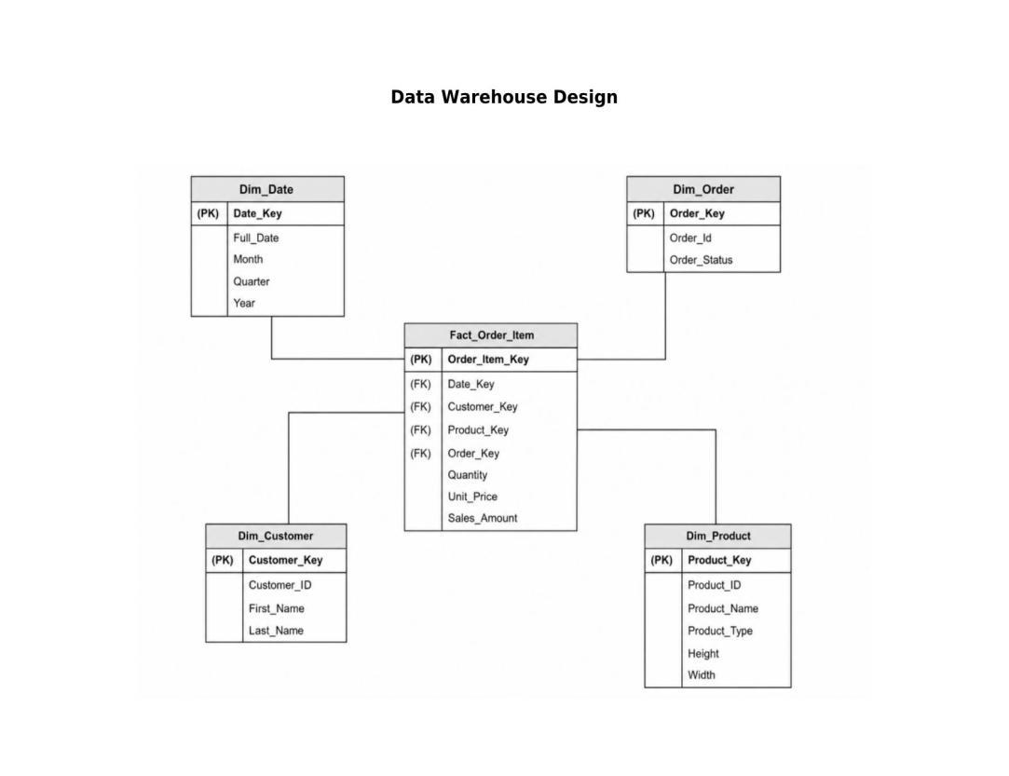
Figure 2: Star schema for the Tombstone Services data warehouse (Fact_Order_Item with four conformed dimensions).

2.1 Facts and Dimension Tables

Fact Table
Fact_Order_Item stores individual products purchased within customer orders. It contains:
- Order_Item_Key as the primary key.
- Foreign keys for Date, Customer, Product, and Order.
- Measures: Quantity, Unit_Price, and Sales_Amount.

Dim_Date
- Full_Date
- Month
- Quarter
- Year
Allows the analysis of sales over time.

Dim_Product
- Product_Key, Product_ID
- Product_Type, Product_Name
- Height and Width
Highlights the details of the product and the type of product sold.

Dim_Order
- Order_Key, Order_Id
- Order_Status
Allows the analysis of sales according to order status.

Dim_Customer
- Customer_Key, Customer_ID
- First_Name, Last_Name
Describes the customer making the purchase.

2.2 Design Choice Explained
The Star Schema was chosen because it provides a clear and practical structure for sales analysis. One central Fact_Order_Item table is connected directly to four denormalised dimension tables (Dim_Date, Dim_Customer, Dim_Product and Dim_Order), which keeps joins simple and query performance fast. The design supports business intelligence, reporting, and management decision-making across the company's sales and order-fulfilment process.

PART 3: DATA MARTS
Two business-process data marts were derived from the Part 2 data warehouse, in line with the project brief: one for the core business process (sales) and one for a secondary/management business process (order fulfilment monitoring), both built from the single Fact_Order_Item fact table and its conformed dimensions.

3.1 Data Mart 1: Sales Performance Mart (Core Process)
Purpose: gives sales and management staff a pre-aggregated view of revenue and quantity sold by product and by month. Grain: one row per product per month.

Key indicators / metrics
- Total Revenue – sum of Sales_Amount per product per month
- Total Quantity Sold – sum of Quantity per product per month
- Line Items – count of order items, indicating how many separate purchases contributed
- Average Sale Value – Total Revenue divided by Line Items

Derivation SQL (from the Part 2 warehouse)
CREATE VIEW Mart_Sales_Performance AS
SELECT
d.Year, d.Month,
p.Product_Type, p.Product_Name,
SUM(f.Sales_Amount) AS Total_Revenue,
SUM(f.Quantity) AS Total_Quantity_Sold,
COUNT(f.Order_Item_Key) AS Line_Items,
SUM(f.Sales_Amount) / COUNT(f.Order_Item_Key) AS Avg_Sale_Value
FROM Fact_Order_Item f
JOIN Dim_Date d ON f.Date_Key = d.Date_Key
JOIN Dim_Product p ON f.Product_Key = p.Product_Key
GROUP BY d.Year, d.Month, p.Product_Type, p.Product_Name;

Sample output (July 2026)
Product | Product Type | Total Revenue (R) | Qty Sold | Line Items | Avg Sale Value (R)
Rustenburg Grey Flat Marker | Lawn Plaque | 4 500.00 | 1 | 1 | 4 500.00
Zimbabwe Black Classic | Headstone | 12 000.00 | 1 | 1 | 12 000.00
African Red Double Memorial | Full Monument | 3 500.00 | 1 | 1 | 3 500.00
Business value: management can see immediately that Headstones generate the highest revenue per sale, which supports decisions on stock priorities, marketing focus and pricing for the different monument types.

3.2 Data Mart 2: Order Fulfilment Mart (Secondary/Management Process)
Purpose: gives management visibility into how much order value sits at each stage of the fulfilment pipeline, supporting production and workflow planning. Grain: one row per order status per month.

Key indicators / metrics
- Orders Count – number of distinct orders in each status
- Value in Pipeline – total Sales_Amount tied up in each status
- Share of Pipeline (%) – each status's value as a percentage of total order value

Derivation SQL (from the Part 2 warehouse)
CREATE VIEW Mart_Order_Fulfilment AS
SELECT
d.Year, d.Month,
o.Order_Status,
COUNT(DISTINCT o.Order_Key) AS Orders_Count,
SUM(f.Sales_Amount) AS Value_In_Pipeline,
SUM(f.Sales_Amount) * 100.0 /
SUM(SUM(f.Sales_Amount)) OVER (PARTITION BY d.Year, d.Month) AS Share_Of_Pipeline_Pct
FROM Fact_Order_Item f
JOIN Dim_Date d ON f.Date_Key = d.Date_Key
JOIN Dim_Order o ON f.Order_Key = o.Order_Key
GROUP BY d.Year, d.Month, o.Order_Status;

Sample output (July 2026)
Order Status | Orders | Value in Pipeline (R) | Share of Pipeline
Quality Check | 1 | 4 500.00 | 22.5%
In Production | 1 | 12 000.00 | 60.0%
Ready | 1 | 3 500.00 | 17.5%
Business value: the mart flags that 60% of order value is currently tied up 'In Production', pointing management towards checking capacity and lead times for that stage before it becomes a bottleneck, rather than waiting for a customer complaint about a late delivery.

Summary of Business Value
Together, the two data marts turn the raw operational sales records captured in Part 1 into decision-ready information. The Sales Performance Mart directly serves the company's core revenue-generating process, helping management track income by product line. The Order Fulfilment Mart serves the secondary/management process of monitoring production workflow, helping identify where order value and effort are concentrated at any point in time. Because both marts are built from the same conformed Date, Product and Order dimensions in the shared warehouse, results from the two marts can be compared side by side, for example checking whether the highest-revenue product line is also the one most often stuck in production.

REFERENCES
Durban University of Technology (n.d.) Project database schema. Faculty of Accounting & Informatics. Unpublished project material.
Elmasri, R. and Navathe, S.B. (2016) Fundamentals of Database Systems. 7th edn. Boston: Pearson.
Kimball, R. and Ross, M. (2013) The Data Warehouse Toolkit: The Definitive Guide to Dimensional Modeling. 3rd edn. Indianapolis: Wiley.

