Assignment 4

64 pts

Learning Outcomes

- Understand how to use basic code constructs such as accepting input, conditionals, loops, and producing output to creatively combine them achieving some task.

Preliminaries

- Create an assignment folder named YourName_assignment4
- Download all the files given in Brightspace into this folder
- Create a folder named images within the assignment folder
- Move the image files, door1.png, door2.png, door3.png, goat.png, hawaii.png, dyer.jpg, wooden.png and jerome.png into the images folder.

Requirements

- (18 pts) Exercise1.html contains a partially completed web page (Figure 1).

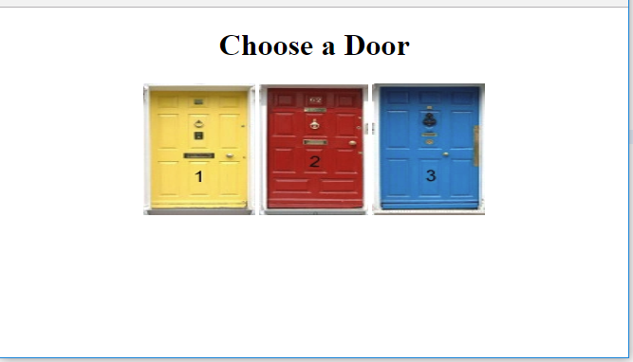
Figure 1. Web browser rendering of exercise1.html.

- Add event handlers so that whenever the mouse moves over the Door 1 or the Door 2 image the image is replaced by the image of the goat (goat.png). See Figure 2.
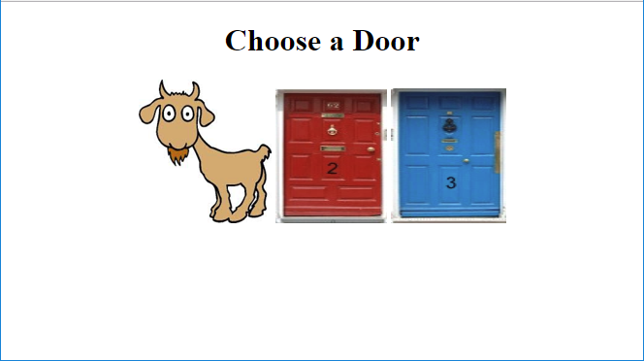
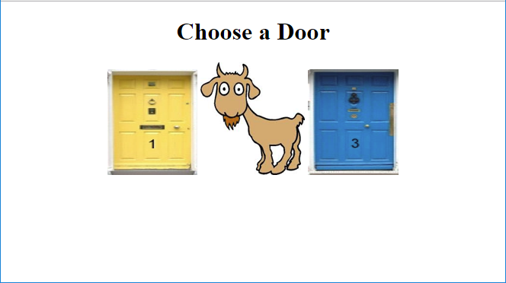

Figure 2. Effect of moving mouse pointer over either Door 1 or Door 2 image.

- Add an event handler so that whenever the mouse moves over the Door 3 image the image is replaced by the image of the Hawaii travel poster (hawaii.png). See Figure 3.
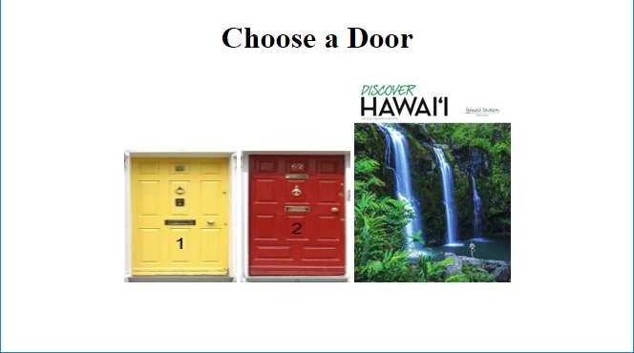
Figure 3. Effect of moving mouse pointer over Door 3 image.

- Add event handlers so that whenever the mouse is moved beyond the goat images or the Hawaii travel poster image, the image is changed back to its original value.

- (09 pts) Exercise2.html contains a partially completed web page (Figure 4).

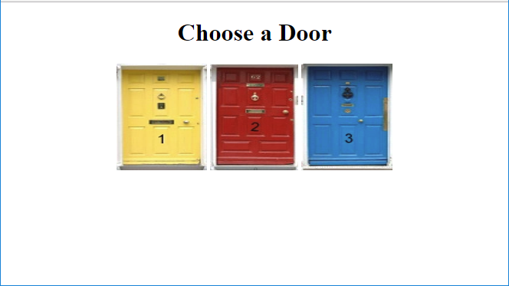
Figure 4. Web browser rendering of exercise2.html.

- Add an event handler so that whenever the user clicks the Door 1 image the image is changed to the goat (goat.png).
- Add an event handler so that whenever the user clicks the Door 2 image the image is changed to the goat (goat.png).
- Add an event handler so that whenever the user clicks the Door 3 image the image is changed to the Hawaii travel poster (hawaii.png).
Figure 5 shows the results of clicking Door 1 and then clicking Door 3.

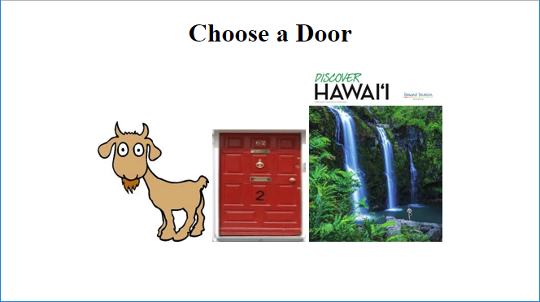

Figure 5. Web page display after clicking Door 1 and Door 3 images.

- (12 points) Exercise3.html contains a partially completed web page (Figure 6). NOTE: To make the required event handlers work you will need to make some other minor changes to the web page!

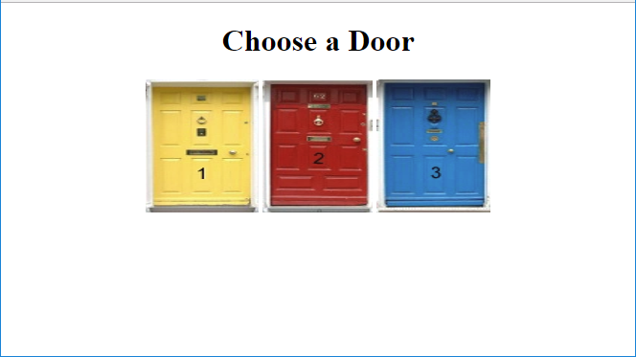
Figure 6. Web browser rendering of exercise3.html.

- Add a buttons labeled ‘Door 1’, ‘Door 2’, ‘Door 3’ and ‘Reset’ within the <p> beneath the images of the doors. See Figure 7.

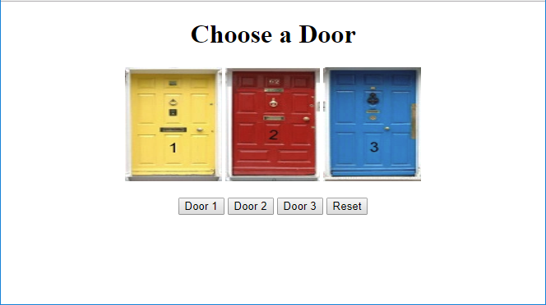

Figure 7. Adding buttons to exercise3.html.

- Add event handlers to the “Door” buttons so that when a user clicks them they change the images as in Exercises 1 and 2. Figure 8 shows the display after the Door 1 and Door 3 buttons are clicked.

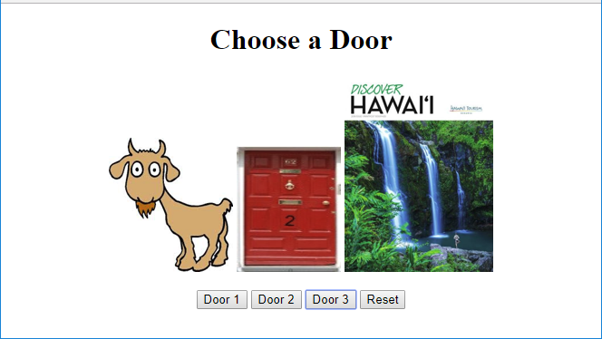

Figure 8. Web display after Door 1 and Door 3 buttons are clicked.

- Add an event handler to the ‘Reset’ button so that all images are changed back to their originals when the button is clicked.

- (12 points) Exercise4.html contains a partially completed web page (Figure 9). This web page contains a <div> element just below the horizontal rule. Add event handlers so that when a user clicks an image the content of the <div> element is replaced by an inspirational quote associated with it as shown in Figures 10, 11 and 12. The text of the quote must be embedded in an <h2> element and the author’s name must be displayed in italics.

NOTE: To make the event handlers work you will need to make one other minor change to the web page!

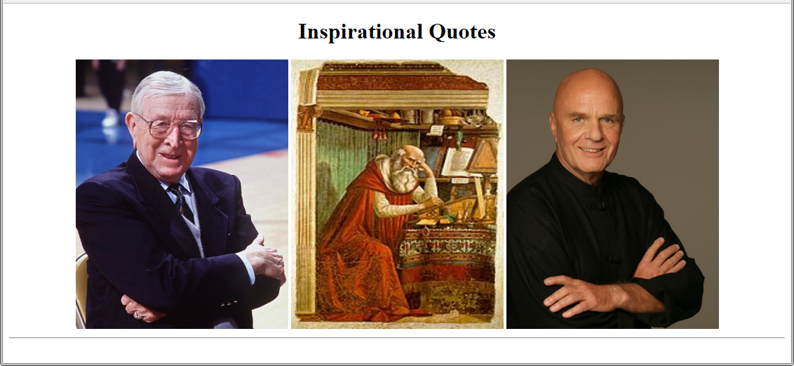

Figure 9. Web browser rendering of exercise4.html.

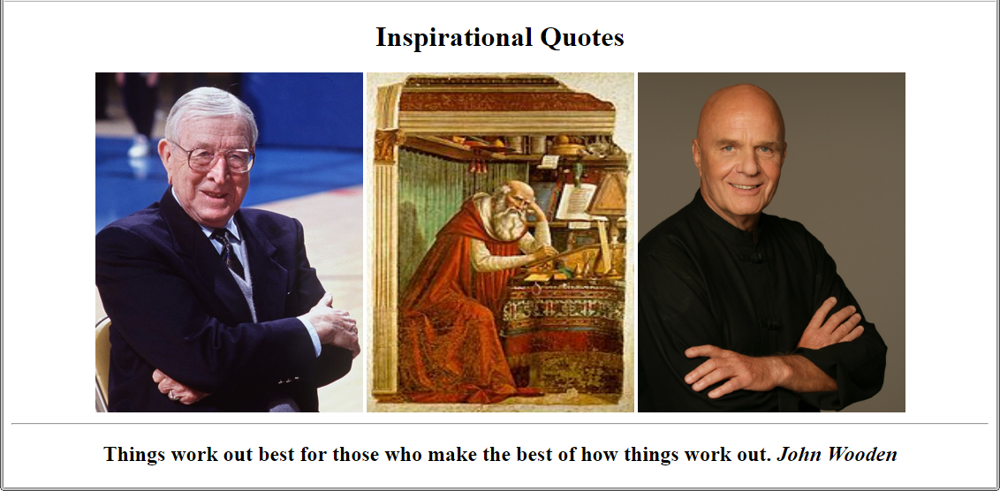

Figure 10. Web browser display when leftmost image (John Wooden) is clicked.

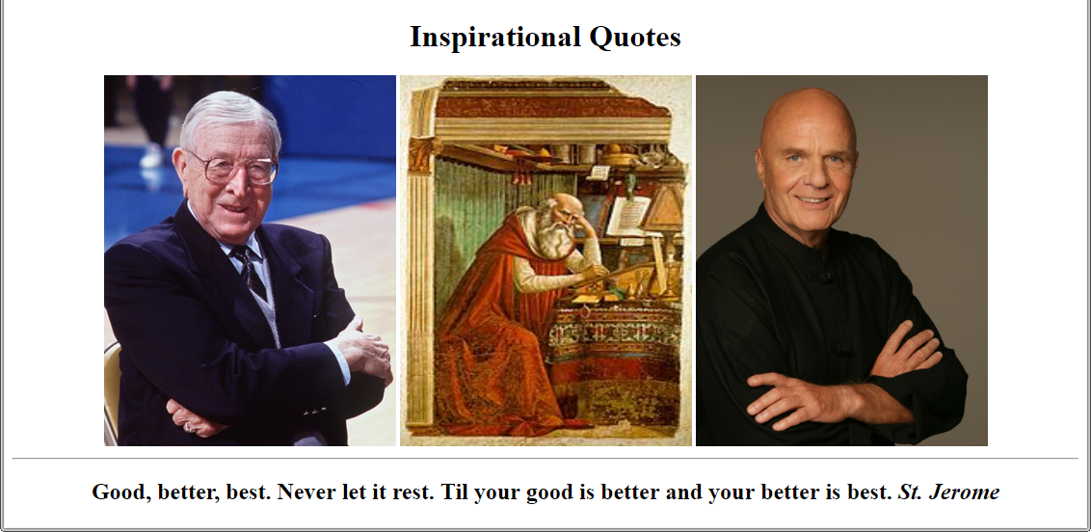

Figure 11. Web browser display when middle image (St. Jerome) is clicked.

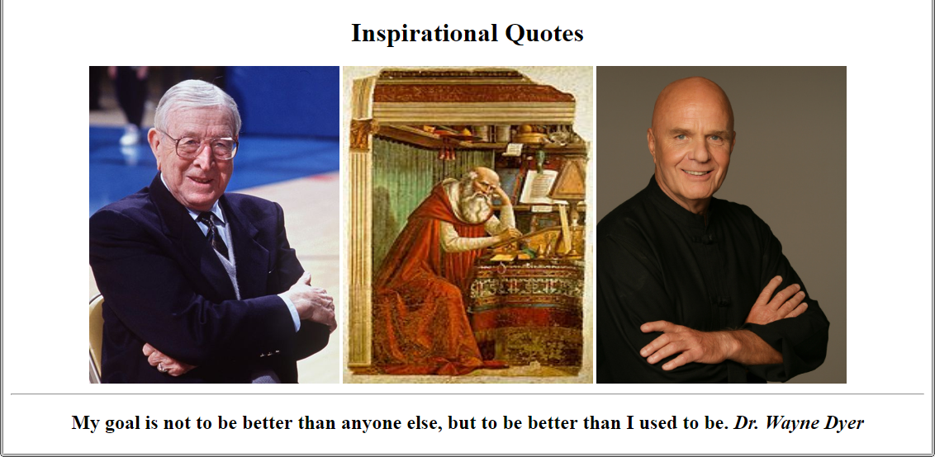

Figure 12. Web browser display when rightmost image (Dr. Wayne Dyer) is clicked.

- (13 points) Exercise5.html contains a partially completed web page (Figure 13). NOTE: To complete this exercise you may need to do some research.

(a) Add three buttons below the horizontal rule. Label the buttons “Normal”, “Medium” and “Large”.
(b) Add an event handler to the “Normal” button so that when the button is clicked all of the text in the “message” div is changed to a font size of 1em.

(c) Add an event handler to the “Medium” button so that when the button is clicked all of the text in the “message” div is changed to a font size of 1.5em. Figure 14 shows a portion of the resulting web page.

(d) Add an event handler to the “Large” button so that when the button is clicked all of the text in the “message” div is changed to a font size of 2.0em.

(e) Add an event handler to each <p> element so that the text color is changed to yellow and the text background is changed to black when the mouse moves into the paragraph. See Figure 15.

(f) Add an event handler to each <p> element so that the text color is changed to black and the text background is changed to white whenever the mouse moves out of the paragraph.

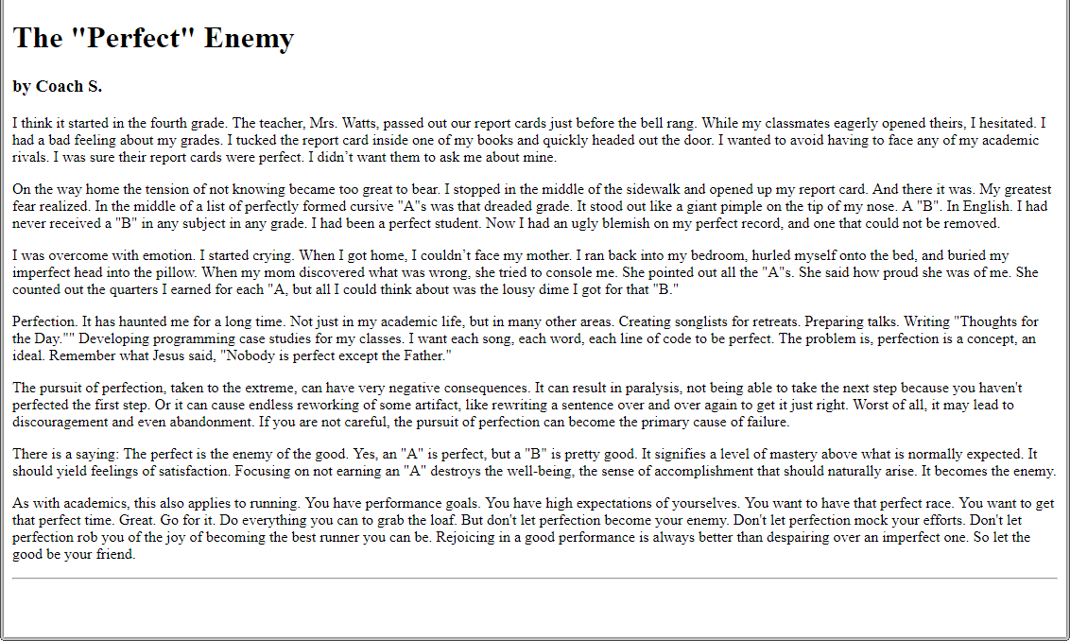

Figure 13. Web browser display of exercise5.html.

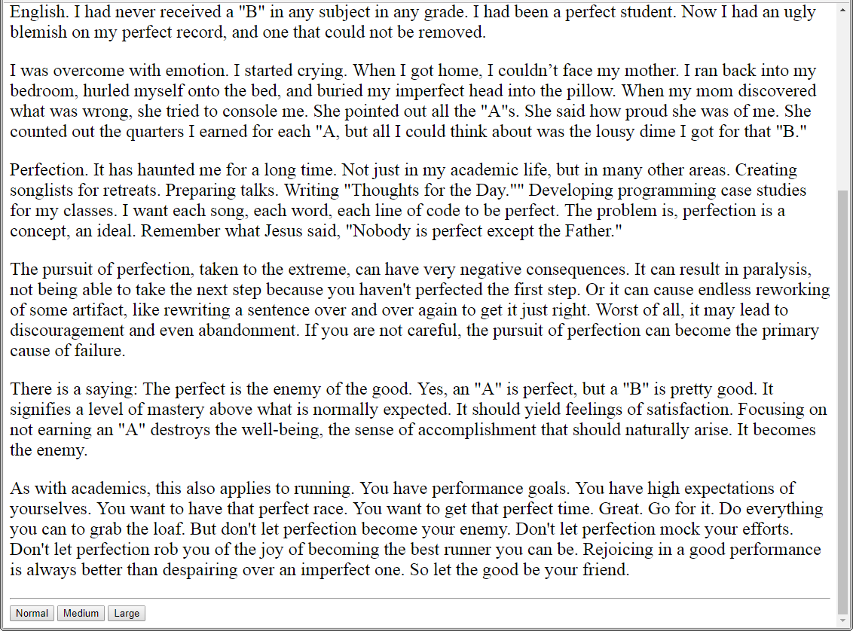

Figure 14. Web browser display after the “Medium” button is clicked. Only a portion of the page is shown because its content does not entirely fit within the browser window. Notice that the text is larger than in Figure 13.

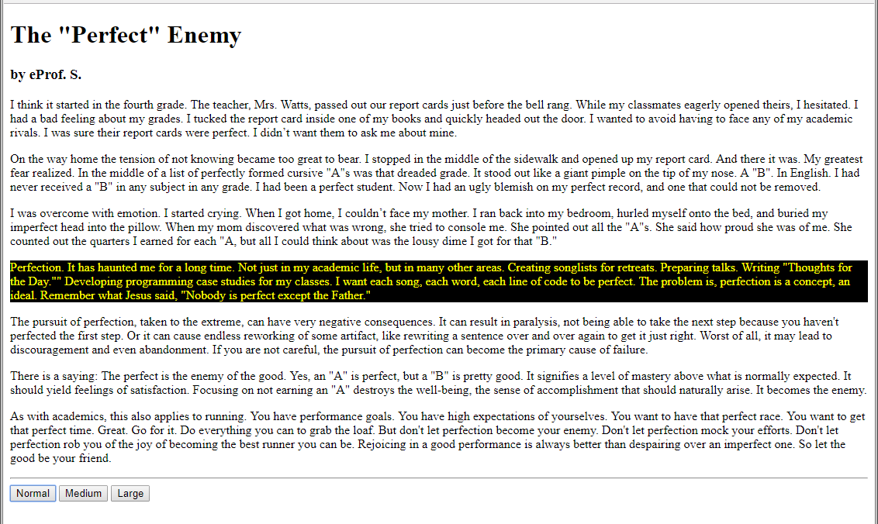

Figure 15. Web browser display of when mouse pointer enters the fourth paragraph.

What to Submit

- Test your work in the Chrome browser
- Zip the assignment folder
- Submit the zip file to Brightspace

