实验2 带控制端的8位运算器设计
一、实验目的
- 掌握加法器的设计方法。
- 掌握测试文件的设计方法。
- 掌握FPGA技术的层次化设计方法。
- 掌握FPGA下载测试方法。
二、实验主要仪器设备
- FPGA实验板
- FPGA实验板配套软件，ModelSim仿真软件
三、设计任务与要求
1. 基本任务及要求
（1）用Verilog设计一个带低有效控制端的一位全加器，再利用级联方法构成带低有效控制端的8位加法器。
（2）用Verilog测试文件，实现ModelSim时序仿真。
（3）根据FPGA开发板，配置输入和输出管脚，生成下载文那你件，实现下载测试。
2. 扩展任务及要求
（1）用Verilog设计带低有效控制端的4位并行进位加法器，再利用层次设计方法构成带低有效控制端的8位并行加法器。
（2）用Verilog设计加减运算器，通过控制端完成8位加法和8位减法的转换。
（3）用Verilog测试文件，实现ModelSim时序仿真。
（4）根据FPGA开发板，配置输入和输出管脚，生成下载文件，实现下载测试。
四、实验内容与步骤
1. 基本任务
(1) 带低有效控制端的1位全加器
(a) 工作原理
用门电路实现两个二进制数相加并求出和的组合线路，可以处理低位进位，并输出本位加法进位。

(b) Verilog源程序
module full_add(
input wire Ai,
input wire Bi,
input wire Ci,
input wire E,
output reg Si,
output reg Ciout
);
wire S = Ci ^ Ai ^ Bi;
wire C = Ai & Bi | (Ai ^ Bi) & Ci;

always @ (*) begin
if (E == 1'b0) begin
Si = S;
Ciout = C;
end else begin
Si = 1'bz;
Ciout = 1'bz;
end
end
endmodule

(c) RTL视图
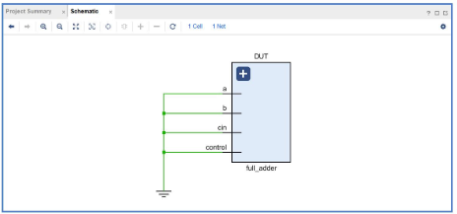

(d) ModelSim源程序
module add_tb();
reg Ain,Bin;
reg clk;
wire sum1,cout1;
initial
begin
#10
Ain=0;
Bin=0;
clk=0;
end
always #5 clk = ~clk;
always @(posedge clk)
begin
Ain={$random}%2;
Bin={$random}%2;
end
add u1(.a(Ain),
.b(Bin),
.sum(sum1),
.cout(cout1));
endmodule

(d) ModelSim仿真结果
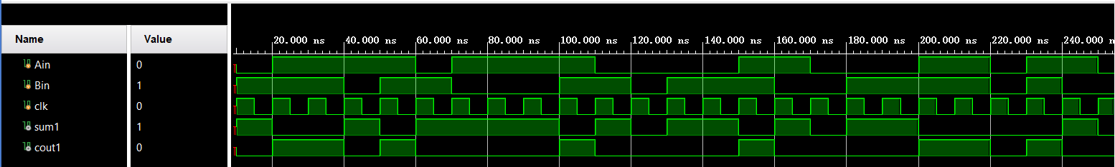

(e) 下载测试结果
管脚配置
set_property -dict {PACKAGE_PIN B24 IOSTANDARD LVCMOS33} [get_ports {Si}]
set_property -dict {PACKAGE_PIN E21 IOSTANDARD LVCMOS33} [get_ports {Ciout}]
set_property -dict {PACKAGE_PIN T3 IOSTANDARD LVCMOS33} [get_ports {Ai}]
set_property -dict {PACKAGE_PIN J3 IOSTANDARD LVCMOS33} [get_ports {Bi}]
set_property -dict {PACKAGE_PIN M2 IOSTANDARD LVCMOS33} [get_ports {Ci}]
set_property -dict {PACKAGE_PIN P1 IOSTANDARD LVCMOS33} [get_ports {E}]

(2) 由1位全加器级联8位加法器
(a) 工作原理
八个一位全加器组级联

(b) Verilog源程序
module full_add(
input wire Ai,
input wire Bi,
input wire Ci,
input wire E,
output reg Si,
output reg Ciout
);
wire S = Ci ^ Ai ^ Bi;
wire C = Ai & Bi | (Ai ^ Bi) & Ci;

always @ (*) begin
if (E == 1'b0) begin
Si = S;
Ciout = C;
end else begin
Si = 1'bz;
Ciout = 1'bz;
end
end
endmodule

module add(
input wire [7:0] A,
input wire [7:0] B,
input wire E,
input wire C0,
output wire [7:0] S,
output wire C8
);
wire C1, C2, C3, C4, C5, C6, C7;

full_add f0(
.Ai(A[0]),
.Bi(B[0]),
.Ci(C0),
.E(E),
.Si(S[0]),
.Ciout(C1)
);

full_add f1(
.Ai(A[1]),
.Bi(B[1]),
.Ci(C1),
.E(E),
.Si(S[1]),
.Ciout(C2)
);

full_add f2(
.Ai(A[2]),
.Bi(B[2]),
.Ci(C2),
.E(E),
.Si(S[2]),
.Ciout(C3)
);

full_add f3(
.Ai(A[3]),
.Bi(B[3]),
.Ci(C3),
.E(E),
.Si(S[3]),
.Ciout(C4)
);

full_add f4(
.Ai(A[4]),
.Bi(B[4]),
.Ci(C4),
.E(E),
.Si(S[4]),
.Ciout(C5)
);

full_add f5(
.Ai(A[5]),
.Bi(B[5]),
.Ci(C5),
.E(E),
.Si(S[5]),
.Ciout(C6)
);

full_add f6(
.Ai(A[6]),
.Bi(B[6]),
.Ci(C6),
.E(E),
.Si(S[6]),
.Ciout(C7)
);

full_add f7(
.Ai(A[7]),
.Bi(B[7]),
.Ci(C7),
.E(E),
.Si(S[7]),
.Ciout(C8)
);
endmodule

(c) RTL视图
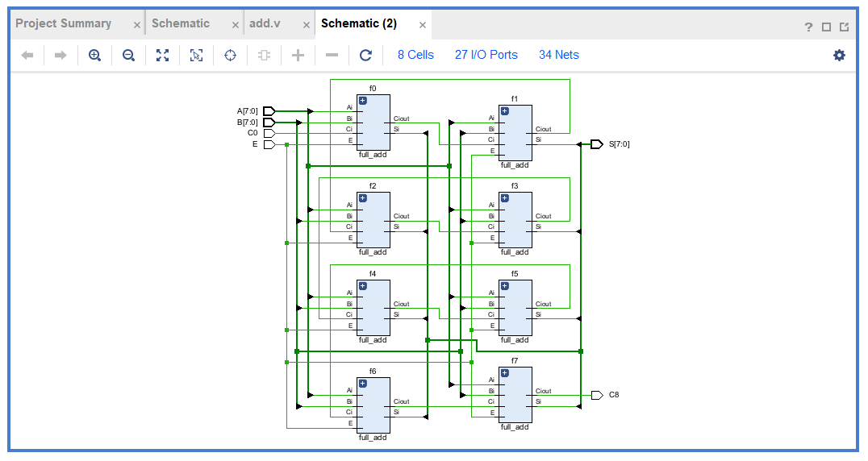

(d) ModelSim源程序
module add_tb;
reg [7:0] A, B;
reg C0;
reg E;
wire [7:0] S;
wire C8;

add uut (
.A(A),
.B(B),
.C0(C0),
.E(E),
.S(S),
.C8(C8)
);

initial begin
E = 1;
A = 0;
B = 0;
C0 = 0;

#10 A = 8'd50; B = 8'd70;
#10 A = 8'd255; B = 8'd1;
#10 E = 1'b0;
#10 A = 8'd150; B = 8'd100;
#10 A = 8'd200; B = 8'd55; C0 = 1'b1;
#10 A = 8'd0; B = 8'd0;
#10 A = 8'd128; B = 8'd128;
#10 A = 8'd127; B = 8'd1;
#10 A = 8'd255; B = 8'd255;

#30 A = 1'd0; B = 1'd0;
end
endmodule

(d) ModelSim仿真结果
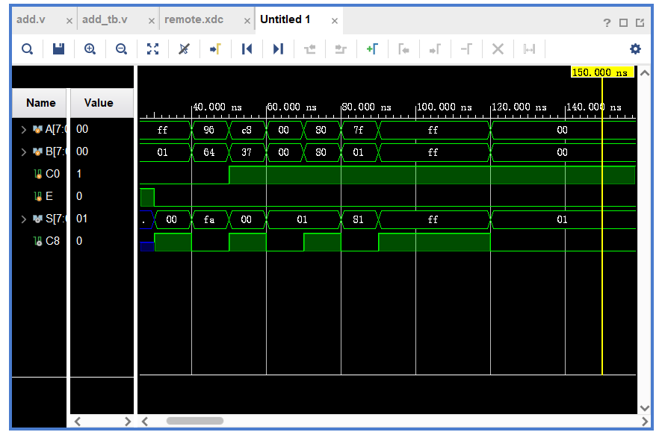

(e) 下载测试结
管脚配置
set_property -dict {PACKAGE_PIN B24 IOSTANDARD LVCMOS33} [get_ports {S[0]}]
set_property -dict {PACKAGE_PIN E21 IOSTANDARD LVCMOS33} [get_ports {S[1]}]
set_property -dict {PACKAGE_PIN A24 IOSTANDARD LVCMOS33} [get_ports {S[2]}]
set_property -dict {PACKAGE_PIN D23 IOSTANDARD LVCMOS33} [get_ports {S[3]}]
set_property -dict {PACKAGE_PIN C22 IOSTANDARD LVCMOS33} [get_ports {S[4]}]
set_property -dict {PACKAGE_PIN C21 IOSTANDARD LVCMOS33} [get_ports {S[5]}]
set_property -dict {PACKAGE_PIN E20 IOSTANDARD LVCMOS33} [get_ports {S[6]}]
set_property -dict {PACKAGE_PIN B22 IOSTANDARD LVCMOS33} [get_ports {S[7]}]
set_property -dict {PACKAGE_PIN C23 IOSTANDARD LVCMOS33} [get_ports {C8}]
set_property -dict {PACKAGE_PIN T3 IOSTANDARD LVCMOS33} [get_ports {A[0]}]
set_property -dict {PACKAGE_PIN J3 IOSTANDARD LVCMOS33} [get_ports {A[1]}]
set_property -dict {PACKAGE_PIN M2 IOSTANDARD LVCMOS33} [get_ports {A[2]}]
set_property -dict {PACKAGE_PIN P1 IOSTANDARD LVCMOS33} [get_ports {A[3]}]
set_property -dict {PACKAGE_PIN P4 IOSTANDARD LVCMOS33} [get_ports {A[4]}]
set_property -dict {PACKAGE_PIN L5 IOSTANDARD LVCMOS33} [get_ports {A[5]}]
set_property -dict {PACKAGE_PIN L3 IOSTANDARD LVCMOS33} [get_ports {A[6]}]
set_property -dict {PACKAGE_PIN N6 IOSTANDARD LVCMOS33} [get_ports {A[7]}]
set_property -dict {PACKAGE_PIN M6 IOSTANDARD LVCMOS33} [get_ports {B[0]}]
set_property -dict {PACKAGE_PIN N7 IOSTANDARD LVCMOS33} [get_ports {B[1]}]
set_property -dict {PACKAGE_PIN M7 IOSTANDARD LVCMOS33} [get_ports {B[2]}]
set_property -dict {PACKAGE_PIN L7 IOSTANDARD LVCMOS33} [get_ports {B[3]}]
set_property -dict {PACKAGE_PIN M5 IOSTANDARD LVCMOS33} [get_ports {B[4]}]
set_property -dict {PACKAGE_PIN K3 IOSTANDARD LVCMOS33} [get_ports {B[5]}]
set_property -dict {PACKAGE_PIN J1 IOSTANDARD LVCMOS33} [get_ports {B[6]}]
set_property -dict {PACKAGE_PIN L2 IOSTANDARD LVCMOS33} [get_ports {B[7]}]
set_property -dict {PACKAGE_PIN K2 IOSTANDARD LVCMOS33} [get_ports {E}]
set_property -dict {PACKAGE_PIN K1 IOSTANDARD LVCMOS33} [get_ports {C0}]

测试图
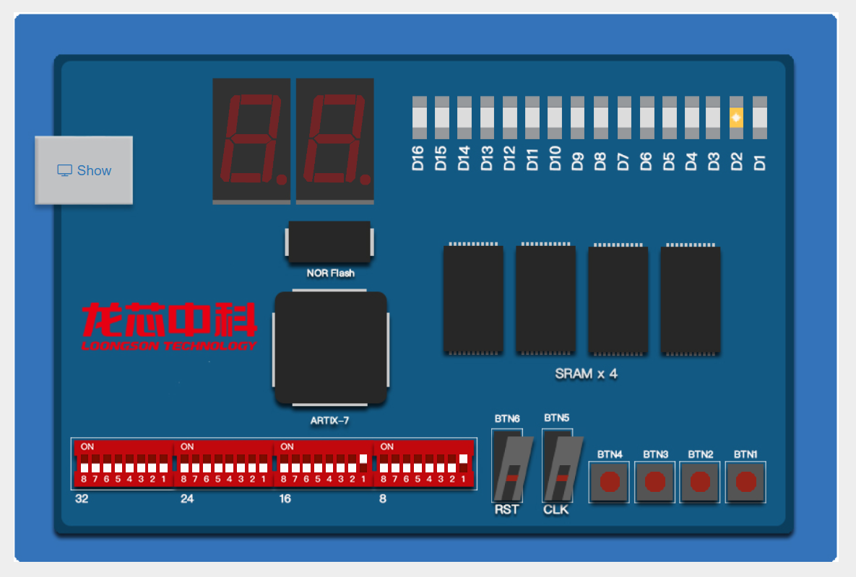
2. 扩展任务
（1）
源程序
module adder4(
input wire C0,
input wire [3:0] A,
input wire [3:0] B,
output wire C4,
output wire [3:0] S);
wire C1,C2,C3;
wire G0,G1,G2,G3;
wire P0,P1,P2,P3;
assign P0=A[0]|B[0];
assign P1=A[1]|B[1];
assign P2=A[2]|B[2];
assign P3=A[3]|B[3];
assign G0=A[0]&B[0];
assign G1=A[1]&B[1];
assign G2=A[2]&B[2];
assign G3=A[3]&B[3];
assign C1=G0|(C0&P0);
assign C2=G1|(C1&P1);
assign C3=G2|(C2&P2);
assign C4=G3|(C3&P3);
assign S[0]=A[0]^B[0]^C0;
assign S[1]=A[1]^B[1]^C1;
assign S[2]=A[2]^B[2]^C2;
assign S[3]=A[3]^B[3]^C3;
endmodule

module adder8(
input wire C0,
input wire [7:0] A,
input wire [7:0] B,
output wire [7:0] S,
output wire C8);
wire C4,C8;
adder4 u0(
.C0(C0),
.A(A[3:0]),
.B(B[3:0]),
.S(S[3:0]),
.C4(C4));
adder4 u1(
.C0(C4),
.A(A[7:4]),
.B(B[7:4]),
.S(S[7:4]),
.C4(C8));
Endmodule

RTL视图
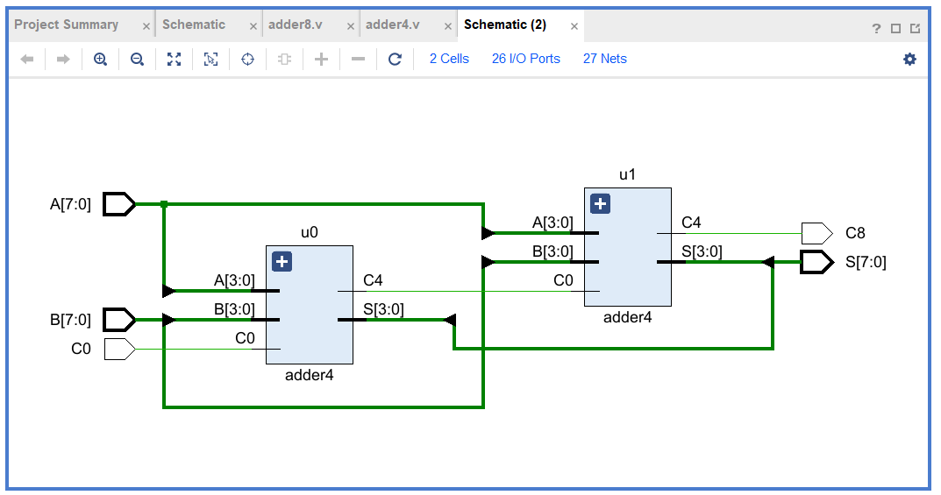

仿真源程序
module add_tb;
reg [7:0] A, B;
reg C0;
reg E;
wire [7:0] S;
wire C8;

add uut (
.A(A),
.B(B),
.C0(C0),
.E(E),
.S(S),
.C8(C8)
);

initial begin
E = 1;
A = 0;
B = 0;
C0 = 0;
#10 A = 8'd50; B = 8'd70;
#10 A = 8'd255; B = 8'd1;
#10 E = 1'b0;
#10 A = 8'd150; B = 8'd100;
#10 A = 8'd200; B = 8'd55;
#10 A = 8'd0; B = 8'd0; C0 = 1;
#10 A = 8'd128; B = 8'd128;
#10 A = 8'd127; B = 8'd1;
#10 A = 8'd255; B = 8'd255;
#10 A = 1'd0; B = 1'd0;
#10 $stop;
end
endmodule

仿真截图
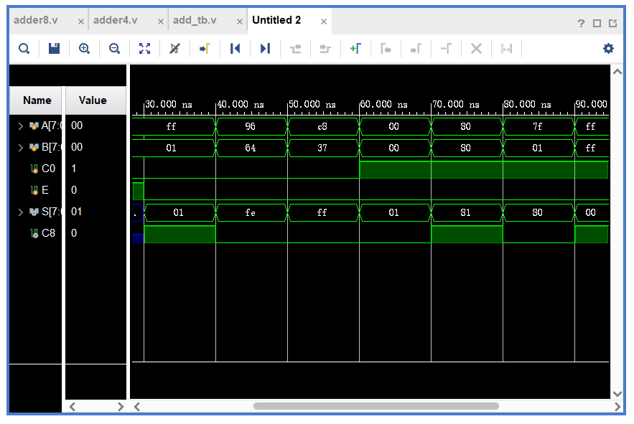

管脚配置
#LEDS
set_property -dict {PACKAGE_PIN B24 IOSTANDARD LVCMOS33} [get_ports {S[0]}]
set_property -dict {PACKAGE_PIN E21 IOSTANDARD LVCMOS33} [get_ports {S[1]}]
set_property -dict {PACKAGE_PIN A24 IOSTANDARD LVCMOS33} [get_ports {S[2]}]
set_property -dict {PACKAGE_PIN D23 IOSTANDARD LVCMOS33} [get_ports {S[3]}]
set_property -dict {PACKAGE_PIN C22 IOSTANDARD LVCMOS33} [get_ports {S[4]}]
set_property -dict {PACKAGE_PIN C21 IOSTANDARD LVCMOS33} [get_ports {S[5]}]
set_property -dict {PACKAGE_PIN E20 IOSTANDARD LVCMOS33} [get_ports {S[6]}]
set_property -dict {PACKAGE_PIN B22 IOSTANDARD LVCMOS33} [get_ports {S[7]}]
set_property -dict {PACKAGE_PIN C23 IOSTANDARD LVCMOS33} [get_ports {C8}]

#DIP_SW
set_property -dict {PACKAGE_PIN T3 IOSTANDARD LVCMOS33} [get_ports {A[0]}]
set_property -dict {PACKAGE_PIN J3 IOSTANDARD LVCMOS33} [get_ports {A[1]}]
set_property -dict {PACKAGE_PIN M2 IOSTANDARD LVCMOS33} [get_ports {A[2]}]
set_property -dict {PACKAGE_PIN P1 IOSTANDARD LVCMOS33} [get_ports {A[3]}]
set_property -dict {PACKAGE_PIN P4 IOSTANDARD LVCMOS33} [get_ports {A[4]}]
set_property -dict {PACKAGE_PIN L5 IOSTANDARD LVCMOS33} [get_ports {A[5]}]
set_property -dict {PACKAGE_PIN L3 IOSTANDARD LVCMOS33} [get_ports {A[6]}]
set_property -dict {PACKAGE_PIN N6 IOSTANDARD LVCMOS33} [get_ports {A[7]}]
set_property -dict {PACKAGE_PIN M6 IOSTANDARD LVCMOS33} [get_ports {C0}]
set_property -dict {PACKAGE_PIN N7 IOSTANDARD LVCMOS33} [get_ports {B[0]}]
set_property -dict {PACKAGE_PIN M7 IOSTANDARD LVCMOS33} [get_ports {B[1]}]
set_property -dict {PACKAGE_PIN L7 IOSTANDARD LVCMOS33} [get_ports {B[2]}]
set_property -dict {PACKAGE_PIN M5 IOSTANDARD LVCMOS33} [get_ports {B[3]}]
set_property -dict {PACKAGE_PIN K3 IOSTANDARD LVCMOS33} [get_ports {B[4]}]
set_property -dict {PACKAGE_PIN J1 IOSTANDARD LVCMOS33} [get_ports {B[5]}]
set_property -dict {PACKAGE_PIN L2 IOSTANDARD LVCMOS33} [get_ports {B[6]}]
set_property -dict {PACKAGE_PIN K2 IOSTANDARD LVCMOS33} [get_ports {B[7]}]
#set_property -dict {PACKAGE_PIN K1 IOSTANDARD LVCMOS33} [get_ports {C0}]

测试
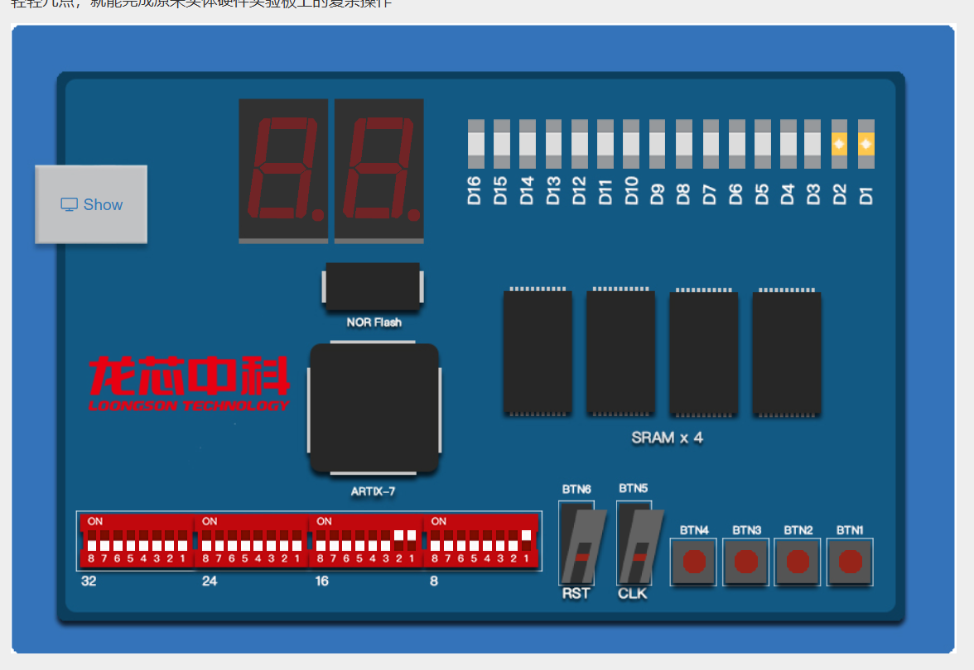
（2）
源程序
module full_add(
input wire Ai,
input wire Bi,
input wire Ci,
output reg Si,
output reg Ciout
);
wire S = Ci ^ Ai ^ Bi;
wire C = Ai & Bi | (Ai ^ Bi) & Ci;
always @ (*) begin
Si = S;
Ciout = C;
end
endmodule
module add(
input wire [7:0] A,
input wire [7:0] B,
input wire C0,
output wire [7:0] S,
output wire C8
);
wire C1, C2, C3, C4, C5, C6, C7;
full_add f0(
.Ai(A[0]),
.Bi(B[0]),
.Ci(C0),
.Si(S[0]),
.Ciout(C1)
);
full_add f1(
.Ai(A[1]),
.Bi(B[1]),
.Ci(C1),
.Si(S[1]),
.Ciout(C2)
);
full_add f2(
.Ai(A[2]),
.Bi(B[2]),
.Ci(C2),
.Si(S[2]),
.Ciout(C3)
);
full_add f3(
.Ai(A[3]),
.Bi(B[3]),
.Ci(C3),
.Si(S[3]),
.Ciout(C4)
);
full_add f4(
.Ai(A[4]),
.Bi(B[4]),
.Ci(C4),
.Si(S[4]),
.Ciout(C5)
)
full_add f5(
.Ai(A[5]),
.Bi(B[5]),
.Ci(C5),
.Si(S[5]),
.Ciout(C6)
);
full_add f6(
.Ai(A[6]),
.Bi(B[6]),
.Ci(C6),
.Si(S[6]),
.Ciout(C7)
);
full_add f7(
.Ai(A[7]),
.Bi(B[7]),
.Ci(C7),
.Si(S[7]),
.Ciout(C8)
);
endmodule
module full_sub(
input wire A,
input wire B,
input wire Cin,
output reg D,
output reg Co
);
always @ (*) begin
D = A ^ (B ^ Cin);
Co = ~A & (B ^ Cin) | Cin & B;
end
endmodule

module sub(
input wire [7:0] A,
input wire [7:0] B,
input wire C0,
output wire [7:0] D,
output wire B8
);
wire B1, B2, B3, B4, B5, B6, B7;
full_sub s0(
.A(A[0]),
.B(B[0]),
.Cin(C0),
.D(D[0]),
.Co(B1)
);
full_sub s1(
.A(A[1]),
.B(B[1]),
.Cin(B1),
.D(D[1]),
.Co(B2)
);
full_sub s2(
.A(A[2]),
.B(B[2]),
.Cin(B2),
.D(D[2]),
.Co(B3)
);
full_sub s3(
.A(A[3]),
.B(B[3]),
.Cin(B3),
.D(D[3]),
.Co(B4)
);
full_sub s4(
.A(A[4]),
.B(B[4]),
.Cin(B4),
.D(D[4]),
.Co(B5)
);
full_sub s5(
.A(A[5]),
.B(B[5]),
.Cin(B5),
.D(D[5]),
.Co(B6)
);
full_sub s6(
.A(A[6]),
.B(B[6]),
.Cin(B6),
.D(D[6]),
.Co(B7)
);
full_sub s7(
.A(A[7]),
.B(B[7]),
.Cin(B7),
.D(D[7]),
.Co(B8)
);
endmodule
module addAndSub(
input wire [7:0] A,
input wire [7:0] B,
input wire E, // 控制信号，1表示加法，0表示减法
input wire C0,
output wire [7:0] Result,
output wire C
);
wire [7:0] sum;
wire [7:0] diff;
wire sum_carry;
wire borrow;
add adder(
.A(A),
.B(B),
.C0(C0),
.S(sum),
.C8(sum_carry)
);
sub subtractor(
.A(A),
.B(B),
.C0(C0),
.D(diff),
.B8(borrow)
);
assign Result = (E) ? sum : diff;
assign C = (E) ? sum_carry : borrow;
endmodule

RTL视图
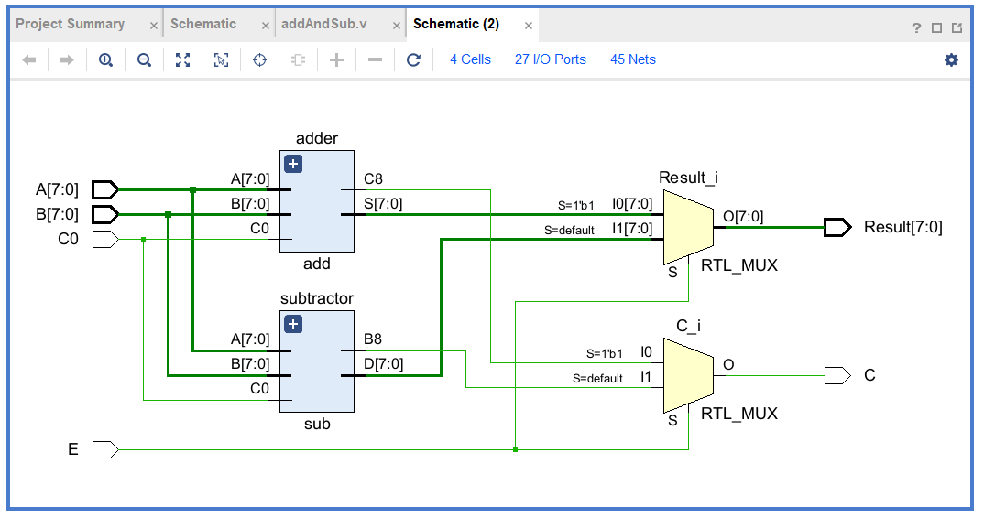

仿真程序
module addAndSub_tb;
reg [7:0] A, B;
reg C0;
reg E;
wire [7:0] Result;
wire C;
addAndSub uut (
.A(A),
.B(B),
.C0(C0),
.E(E),
.Result(Result),
.C(C)
);
initial begin
E = 1;
A = 0;
B = 0;
C0 = 1;
#10 A = 8'd50; B = 8'd70;
#10 A = 8'd255; B = 8'd1;
#10 E = 1'b0;
#10 A = 8'd150; B = 8'd100;
#10 A = 8'd200; B = 8'd55;
#10 A = 8'd0; B = 8'd0; C0 = 0;
#10 A = 8'd128; B = 8'd128; C0 = 1;
#10 A = 8'd127; B = 8'd1;
#10 A = 8'd255; B = 8'd255;
#10 A = 1'd0; B = 1'd0;
end
endmodule

仿真截图
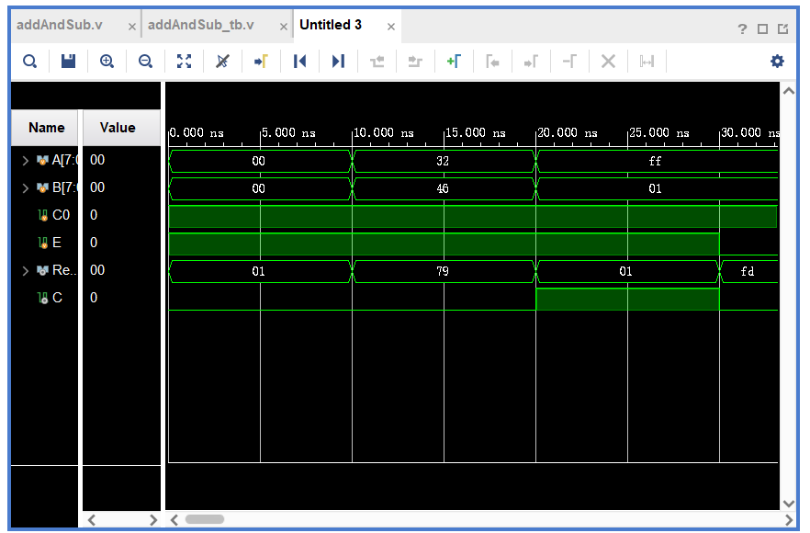

管脚配置
#LEDS
set_property -dict {PACKAGE_PIN B24 IOSTANDARD LVCMOS33} [get_ports {Result[0]}]
set_property -dict {PACKAGE_PIN E21 IOSTANDARD LVCMOS33} [get_ports {Result[1]}]
set_property -dict {PACKAGE_PIN A24 IOSTANDARD LVCMOS33} [get_ports {Result[2]}]
set_property -dict {PACKAGE_PIN D23 IOSTANDARD LVCMOS33} [get_ports {Result[3]}]
set_property -dict {PACKAGE_PIN C22 IOSTANDARD LVCMOS33} [get_ports {Result[4]}]
set_property -dict {PACKAGE_PIN C21 IOSTANDARD LVCMOS33} [get_ports {Result[5]}]
set_property -dict {PACKAGE_PIN E20 IOSTANDARD LVCMOS33} [get_ports {Result[6]}]
set_property -dict {PACKAGE_PIN B22 IOSTANDARD LVCMOS33} [get_ports {Result[7]}]
set_property -dict {PACKAGE_PIN C23 IOSTANDARD LVCMOS33} [get_ports {C}]
#DIP_SW
set_property -dict {PACKAGE_PIN T3 IOSTANDARD LVCMOS33} [get_ports {A[0]}]
set_property -dict {PACKAGE_PIN J3 IOSTANDARD LVCMOS33} [get_ports {A[1]}]
set_property -dict {PACKAGE_PIN M2 IOSTANDARD LVCMOS33} [get_ports {A[2]}]
set_property -dict {PACKAGE_PIN P1 IOSTANDARD LVCMOS33} [get_ports {A[3]}]
set_property -dict {PACKAGE_PIN P4 IOSTANDARD LVCMOS33} [get_ports {A[4]}]
set_property -dict {PACKAGE_PIN L5 IOSTANDARD LVCMOS33} [get_ports {A[5]}]
set_property -dict {PACKAGE_PIN L3 IOSTANDARD LVCMOS33} [get_ports {A[6]}]
set_property -dict {PACKAGE_PIN N6 IOSTANDARD LVCMOS33} [get_ports {A[7]}]
set_property -dict {PACKAGE_PIN M6 IOSTANDARD LVCMOS33} [get_ports {E}]
set_property -dict {PACKAGE_PIN N7 IOSTANDARD LVCMOS33} [get_ports {B[0]}]
set_property -dict {PACKAGE_PIN M7 IOSTANDARD LVCMOS33} [get_ports {B[1]}]
set_property -dict {PACKAGE_PIN L7 IOSTANDARD LVCMOS33} [get_ports {B[2]}]
set_property -dict {PACKAGE_PIN M5 IOSTANDARD LVCMOS33} [get_ports {B[3]}]
set_property -dict {PACKAGE_PIN K3 IOSTANDARD LVCMOS33} [get_ports {B[4]}]
set_property -dict {PACKAGE_PIN J1 IOSTANDARD LVCMOS33} [get_ports {B[5]}]
set_property -dict {PACKAGE_PIN L2 IOSTANDARD LVCMOS33} [get_ports {B[6]}]
set_property -dict {PACKAGE_PIN K2 IOSTANDARD LVCMOS33} [get_ports {B[7]}]
set_property -dict {PACKAGE_PIN K1 IOSTANDARD LVCMOS33} [get_ports {C0}]

测试
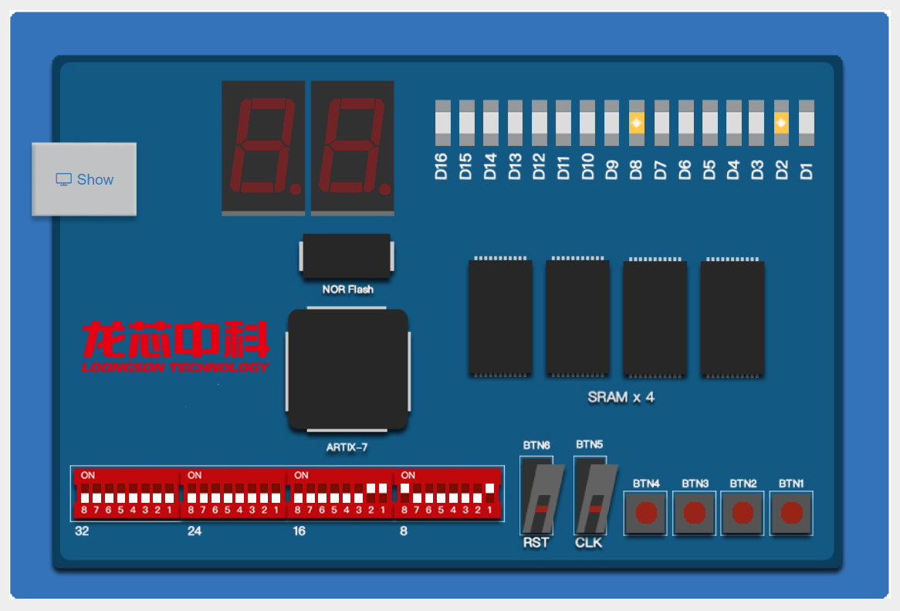
五、实验过程中出现的故障现象、原因分析及解决的办法
加法器最高位进位设置有误，导致溢出出现错误结果，设置最高位进位标志，处理溢出情况。

