

Guide to LXI Documentation

Revision 1.4  
  
Nov 7, 2016

Table of Contents

Guide to LXI Documentation 1

Revision history 3

1 Introduction 4

1.1 Historical 4

1.2 Summary of LXI Specification Documentation 5

2 Documents pertaining to all members of the LXI Consortium and all users of the LXI Trademark and Logo. 6

3 Documents pertaining to all products conformant to any LXI standard. 6

4 Documents pertaining to all products conformant to the LXI Standard for LXI Devices. 7

5 Documents pertaining to LXI Wired Trigger Bus Cables and Terminators 8

6 Documents pertaining to LXI Extended Functions 8

7 LXI general documentations referenced in LXI standards. 8

8 LXI general interest documents. 8

9 Location of referenced documents. 9

**Notice of Rights** All rights reserved. This document is the property of the LXI Consortium.  It may be reproduced, unaltered, in whole or in part, provided the LXI copyright notice is retained on every document page.

**Notice of Liability** The information contained in this document is subject to change without notice. “Preliminary” releases are for specification development and proof-of-concept testing and may not reflect the final “Released” specification.

The LXI Consortium, Inc. makes no warranty of any kind with regard to this material, including but not limited to, the implied warranties of merchantability and fitness for a particular purpose. The LXI Consortium, Inc. shall not be liable for errors or omissions contained herein or for incidental or consequential damages in connection with the furnishing, performance, or use of this material.

In publishing and making this document available, the LXI Consortium is not suggesting or rendering professional or other services for, or on behalf of, any person or entity. Nor is the LXI Consortium undertaking to perform any duty owed by any other person or entity to another. Any person utilizing this or any other LXI Consortium document, should rely on the advice of a competent professional in determining the exercise of reasonable care in any given circumstances.

**Trademark** LXI is a registered trademark of the LXI Consortium.

**Revision history**

|  |  |
| --- | --- |
| ***Revision*** | ***Description*** |
| Revision 1.4  Nov 7, 2016 | Describes the new LXI 1.5 Specification release that has separated many of the Class A and B features into Extended Functions. |
| Revision 1.3  April 11, 2011 | Reformatted TOC and converted to Word 2007 docx file. |
| Revision 1.3  Mar 30, 2011 | Updated to include Extended Functions documentation and to specify LXI Device Specification 2011 instead of 2010. |
| Jan 24, 2011 | Updated documentation overview for Feb 2011 LXI General Meeting and Plugfest |

# Introduction

This document is an overview of the technical documents and specifications maintained by the LXI Consortium. Manufacturers of products subject to LXI Consortium standards should review the documents pertaining to their device.

LXI Documentation consists of Specifications, LXI Consortium Policies, Operating Procedures, Bylaws, and Resources. This document helps to identity locations and content. Of particular importance is the location of the various Specifications that make up the LXI Standard

This is a living document and will be updated as needed to maintain clarity of LXI Documentation.

## Historical

The LXI Standard consists of the LXI Device Specification and Extended Functions documents. It also consists of Editorial and Information documents. Prior to LXI 1.5 Device Specification of 2016, the LXI Device Specification included many features now implemented as optional Extended Functions. This allows the LXI Device Specification to focus on common or core requirements that all LXI Devices must provide to be conformant. LXI Devices that wish to provide advanced features may add Extended Functions with additional requirements to become LXI conformant.

The figure below illustrates the change in documentation with the release of the LXI 1.5 Standard. Note too that all Example and Reference Material also moved from the LXI Device Specification to a separate document for continuous updating without the need for voting approval by LXI Members.

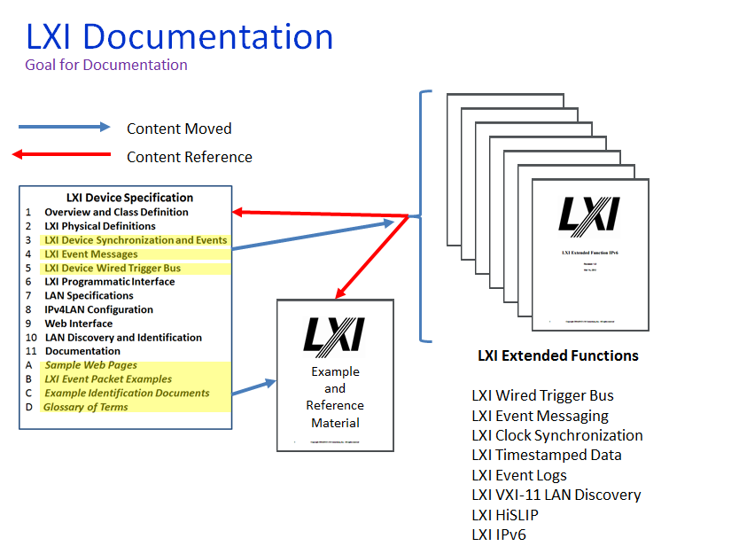

## Summary of LXI Specification Documentation

The resulting collection of specification documents is as follows. All documentation resides on the LXI Consortium website under [Specifications](http://www.lxistandard.org/Specifications/Specifications.aspx):

* LXI Device Specification 2016
* LXI Wired Trigger Bus Extended Function
* LXI Wired Trigger Bus Cable and Terminator Specification
* LXI Event Messaging Extended Function
* LXI Clock Synchronization Extended Function
* LXI Timestamped Data Extended Function
* LXI Event Logs Extended Function
* LXI VXI-11 LAN Discovery and Identification Extended Function
* LXI HiSLIP Extended Function
* LXI IPv6 Extended Function
* LXI Example and Reference Material
* LXI IEEE 1588 Profile
* IVI-3.15 IviLxiSync Specification

**Editorial and Information Documents**

* Guide to LXI Documentation (this document)
* [LXI Interpretations and Clarifications](http://www.lxistandard.org/Documents/Specifications/LXI%20Interpretations%20and%20Clarifications%20June%202014%20final.pdf)
* [LXI Consortium Policy for Certifying Conformance to LXI Consortium Standards](http://www.lxistandard.org/Documents/Specifications/LXI%20Consortium%20Policy%20for%20Certifying%20Conformance%20to%20LXI%20Consortium%20Standards%20rev%201.4.pdf)
* [LXI Consortium Operating Procedures](http://www.lxistandard.org/Documents/Specifications/LXI_Operating_Procedures_May_18_2011.pdf)
* [Application for Certification to LXI Device Specification](http://www.lxistandard.org/Documents/Specifications/Application%20for%20Certification%20to%20LXI%20Device%20Specification%202011%20V1.1.doc)
* [LXI HiSLIP Extended Function Test Procedures](http://www.lxistandard.org/Documents/Specifications/LXI_HiSLIP_Extended_Function_Test_Procedures_v1_01.pdf)
* [LXI IPv6 Extended Function Test Procedures](http://www.lxistandard.org/Documents/Specifications/LXI_IPv6_Extended_Function_Test_Procedures_2012_2_20.pdf)
* [LXIIdentification.xsd](http://www.lxistandard.org/Documents/Specifications/LXIIdentification.xsd)
* [System Tests for LXI Devices implementing IEEE1588-2008](http://www.lxistandard.org/Documents/About/System%20Tests%20for%20LXI%20Devices%20implementing%20IEEE1588-2008.pdf)

# Documents pertaining to all members of the LXI Consortium and all users of the LXI Trademark and Logo.

The following documents contain information and specifications that must be adhered by all members of the LXI Consortium and any organization or person using the LXI Trademark of Logo or making products conformant to any LXI standard <http://www.lxistandard.org/Consortium/Default.aspx>

* [**Bylaws**](http://www.lxistandard.org/Documents/Specifications/LXI_HiSLIP_Extended_Function_Test_Procedures_v1_01.pdf) – cover the LXI Consortium’s governance for operating rules and meeting conventions.
* [**LXI**](http://www.lxistandard.org/Documents/Specifications/LXI_IPv6_Extended_Function_Test_Procedures_2012_2_20.pdf) **Consortium Operating Procedures** – provides the rules and practices for conducting LXI Consortium business
* **IP Declaration** – provides the patent statements and licensing declarations. These declarations come from vendors of LXI Devices.
* **Antitrust Compliance Guidelines** – shows how to conduct LXI Consortium meetings and provides members guidance on anti-trust issues for LXI Consortium meetings.
* **How to Join** – provides information on membership dues, levels of voting, and specifics on how to apply for membership.

# Documents pertaining to all products conformant to any LXI standard.

The following documents contain information and specifications that must be adhered by all manufacturers of products conformant to any LXI standard.

* **LXI Consortium Policy for Certifying Conformance to LXI Consortium Standards** – specifies the conformance process required for any product claiming conformance to the LXI Standard. Also includes the dates for which different versions of the standard are valid.
* **LXI Interpretations and Clarifications** – an important document that answers questions and provides guidance to areas of the LXI Standard that need clarification. Refer often to this particular document for any updates or clarifications that can affect LXI conformance testing.
* **LXI Consortium Trademark, Patent and Licensing Policies -** covers licensing and the specification and use of the LXI trademark and LXI Patent Policy.

# Documents pertaining to all products conformant to the LXI Standard for LXI Devices.

The following documents contain information and specifications that must be adhered to by products designed in conformance to the LXI Standard

<http://www.lxistandard.org/Specifications/Default.aspx>

* ***LXI Device Specification***  – the common or core specification that all LXI Devices must adhere to become LXI conformant
* ***LXI Example and Reference Material*** – provides a living document location for adding examples and reference material the requires no LXI Consortium voting
* ***LXI IEEE 1588 Profile*** is the IEEE-1588 2008 profile for LXI Devices that implement the Extended Function LXI Clock Synchronization.
* ***System Tests For LXI Devices Implementing IEEE 1588-2008*** describes tests that can be used to verify the performance of IEEE 1588-2008 in an LXI Device that implements Extended Function LXI Clock Synchronization.
* ***LXI Conformance Test Suite*** is an executable test suite for products conforming to the ***LXI Device Specification*** and associated LXI Extended Functions. <http://www.lxistandard.org/Products/Conformance.aspx>
* [***IVI-3.15:  IviLxiSync Specification***](http://www.ivifoundation.org/Downloads/Specifications.htm) details the requirements for developing the IVI Device Driver ( Released November 13, 2006) <http://www.ivifoundation.org/specifications/default.aspx>

The following documents pertain to LXI Devices manufactured under earlier releases of the LXI Standard (for LXI Devices) <http://www.lxistandard.org/Specifications/Default.aspx> (Older Specifications link)

* ***LXI Standard Revision 1.4*** (Release May 18, 2011)
* ***LXI Standard Revision 1.3*** (Released October 30, 2008)
* ***LXI Standard Revision 1.2.01*** (Released Nov. 26, 2007)
* [***LXI Standard Revision 1.2***](http://www.lxistandard.org/about/lxi_standards_and_clarifications/LXI_1_2_2007-10-03.pdf)  (Released October 3, 2007)

# Documents pertaining to LXI Wired Trigger Bus Cables and Terminators

The following documents contain information and specifications that must be adhered to by LXI Trigger Bus cables and terminators products

* ***LXI Trigger Bus Cable and Terminator Specification Revision 2.0****(Dec 10, 2010)* <http://www.lxistandard.org/Specifications/Default.aspx>

# Documents pertaining to LXI Extended Functions

These documents are used in the creation of a new LXI Extended Function and can be found at <http://www.lxistandard.org/Specifications/Default.aspx>

* ***LXI Wired Trigger Bus Extended Function***
* ***LXI Event Messaging Extended Function***
* ***LXI Clock Synchronization Extended Function***
* ***LXI Timestamped Data Extended Function***
* ***LXI Event Logs Extended Function***
* ***LXI VXI-11 LAN Discovery and Identification Extended Function***
* ***LXI HiSLIP Extended Function***
* ***LXI IPv6 Extended Function***

# LXI general documentations referenced in LXI standards.

The following documents are referenced in one or more LXI standards documents. They contain material of interest to users and manufacturers of LXI products and systems but are not themselves standards documents.

* ***Recommendations for LXI systems containing devices supporting different versions of IEEE 1588*** <http://www.lxistandard.org/Resources/Papers.aspx>
* [***IVI-3.15:  IviLxiSync Specification***](http://www.ivifoundation.org/Downloads/Specifications.htm) (Released November 13, 2006) <http://www.ivifoundation.org/specifications/default.aspx>

# LXI general interest documents.

In addition to referenced documents the LXI Consortium maintains a collection of white papers and similar informative documents of general interest. These can be obtained from the LXI Consortium web site <http://www.lxistandard.org/Resources/Papers.aspx> A site map gives quick access to location of all such documents – see Section 9 below.

# Location of referenced documents.

Copies of referenced documents can be obtained from the LXI Consortium web site -[www.lxistandard.org](http://www.lxistandard.org). Note that some documents are available only to members of the LXI Consortium and are password protected. A site map is provided at <http://www.lxistandard.org/SiteMap.aspx>.

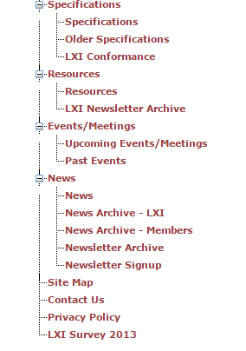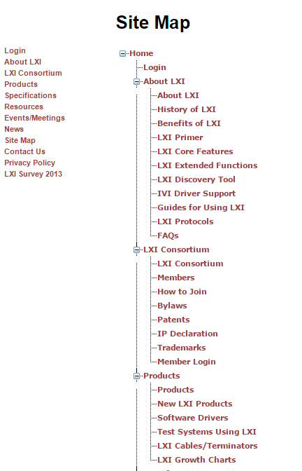The following screen shot is an example of the wide range of content provided on the LXI Consortium site. Please follow the link above for the most current site map.