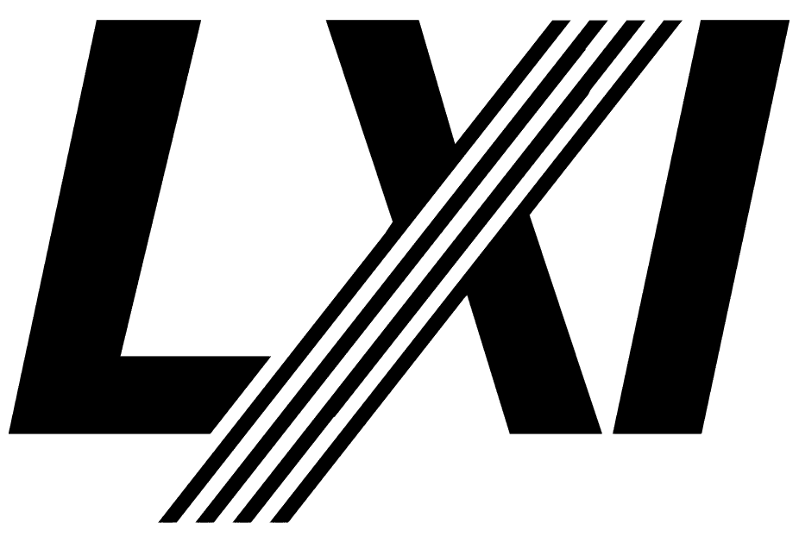

Interpretations and Clarifications

For LXI Specification 2023, Revision 1.6.1

June 12, 2023

Interpretations and Clarifications 1

For LXI Specification 2023, Revision 1.6.1 1

1 Interpretations and Clarifications 5

1.1 Overview 5

1.2 LXI Logo on non-conformant products 5

***Notices***

**Notice of Rights All** rights reserved. This document is the property of the LXI Consortium. It may be reproduced, unaltered, in whole or in part, provided the LXI copyright notice is retained on every document page.

**Notice of Liability The** information contained in this document is subject to change without notice. “Preliminary” releases are for specification development and proof-of-concept testing and may not reflect the final “Released” specification.

The LXI Consortium, Inc. makes no warranty of any kind with regard to this material, including but not limited to, the implied warranties of merchantability and fitness for a particular purpose. The LXI Consortium, Inc. shall not be liable for errors or omissions contained herein or for incidental or consequential damages in connection with the furnishing, performance, or use of this material.

**LXI Standards Documents** are developed within the LXI Consortium and LXI Technical Working Groups sponsored by the LXI Consortium Board of Directors. The LXI Consortium develops its standards through a consensus development process modeled after the American National Standards Institute, which brings together volunteers representing varied viewpoints and interests to achieve the final product. Volunteers are not necessarily members of the Consortium and serve without compensation. While the LXI Consortium administers the process and establishes rules to promote fairness in the consensus development process, the LXI Consortium does not exhaustively evaluate, test, or verify the accuracy of any of the information contained in its standards.

Use of an LXI Consortium Standard is wholly voluntary. The LXI Consortium and its members disclaim liability for any personal injury, property or other damage, of any nature whatsoever, whether special, indirect, consequential, or compensatory, directly or indirectly resulting from the publication, use of, or reliance upon this, or any other LXI Consortium Standard document.

The LXI Consortium does not warrant that the use of the material contained herein is free from patent infringement. LXI Consortium Standards documents are supplied “as is”. The existence of an LXI Consortium Standard does not imply that there are no other ways to produce, test, measure, purchase, market, or provide other goods and services related to the scope of the LXI Consortium Standard. Furthermore, the viewpoint expressed at the time a standard is approved and issued is subject to change brought about through developments in the state of the art and comments received from users of the standard. Users are cautioned to check to determine that they have the latest edition of any LXI Consortium Standard.

In publishing and making this document available, the LXI Consortium is not suggesting or rendering professional or other services for, or on behalf of, any person or entity. Nor is the LXI Consortium undertaking to perform any duty owed by any other person or entity to another. Any person utilizing this, and any other LXI Consortium Standards document, should rely upon the advice of a competent professional in determining the exercise of reasonable care in any given circumstances.

This specification is the property of the LXI Consortium, a Delaware 501c3 corporation, for the use of its members.

**Interpretations** Occasionally questions may arise regarding the meaning of portions of standards as they relate to specific applications. When the need for interpretations is brought to the attention of LXI Consortium, the Consortium will initiate action to prepare appropriate responses. Since LXI Consortium Standards represent a consensus of concerned interests, it is important to ensure that any interpretation has also received the concurrence of a balance of interests. For this reason, LXI Consortium and the members of its working groups are not able to provide an instant response to interpretation requests except in those cases where the matter has previously received formal consideration. Requests for interpretations of this standard may be sent to interpretations@lxistandard.org using the form “*Request for Interpretation of an* Copyright 2004 – 2022 LXI Consortium, Inc. All rights reserved. 7

*LXI Standard Document*”. This document plus a list of interpretations to this standard are found on the LXI Consortium’s Web site: http://www.lxistandard.org

**Legal Issues, Trademarks, Patents, and Licensing Policies.** These items are addressed specifically in the document “LXI *Consortium Trademark, Patent, and Licensing Policies*” found on the LXI Consortium’s Web site: http://www.lxistandard.org .

**Conformance** The LXI Consortium draws attention to the document “*LXI Consortium Policy for Certifying Conformance to LXI Consortium Standards*” found on the LXI Consortium’s Web site: http://www.lxistandard.org . That document specifies the procedures that must be followed to claim conformance with this standard.

**Comments for Revision Comments** for revision of LXI Consortium Standards are welcome from any interested party, regardless of membership affiliation with LXI Consortium. Suggestions for changes in documents should be in the form of a proposed change of text, together with appropriate supporting comments. Comments on standards should be addressed to:

Executive Director LXI Consortium www.lxistandard.org

ExecDir@lxistandard.org

**LXI is a registered trademark of the LXI Consortium**

**Revision history**

|  |  |
| --- | --- |
| ***Revision*** | ***Description*** |
| June 12, 2023 | * Initial Release for LXI 1.6.1 |

# Interpretations and Clarifications

## Overview

After writing and approving a specification by members of the LXI Consortium, there are cases where it is necessary to clarify wording that may be misunderstood or that misrepresented the intent of a rule, recommendation, or other guidance. Rather than making such changes to a specification and reintroducing it for approval, the Interpretations and Clarifications document will contain all such changes until a future revision of the affected specification makes it reasonable to introduce those changes for broad approval.

This document can contain interpretations and clarifications for any of the LXI Version 1.6 documents, including the LXI Device Specification, LXI Extended Functions, Operating Procedures, and so on.

## LXI Logo on non-conformant products

Question:

If a company or person wants to create a product that helps create, test, or in any other way promote LXI devices, but the product is not LXI conformant, can they display the LXI Logo?

Reply:

Yes, with permission from the LXI Consortium Board of Directors.

Additional information:

In section 2.2 of the “LXI Consortium Trademark, Patent and Licensing Polices” document, it says that an “Agent” is a company or person who has been authorized by the LXI Board of Directors to use the LXI logo on behalf of the Consortium for any purpose designated by the Board of Directors.

To contact the LXI Board of Directors, send an email to the LXI Consortium Executive Director at: [ExecDir@lxistandard.org](mailto:ExecDir@lxistandard.org).