**Test of the program:**

**1)Open a new account：**

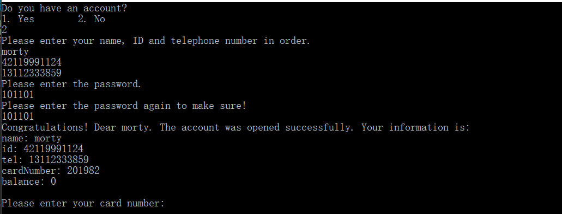

**The password input to the “password.txt”**

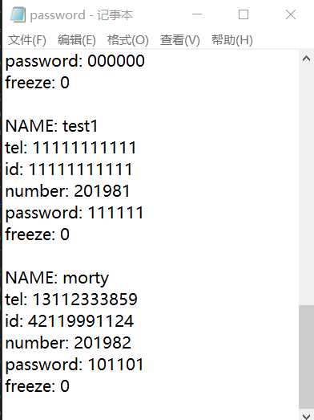

**And the balance input to the “balance.txt”**

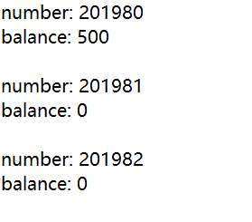

**2)The user input the wrong password 5 times and the staff help him change the password:**

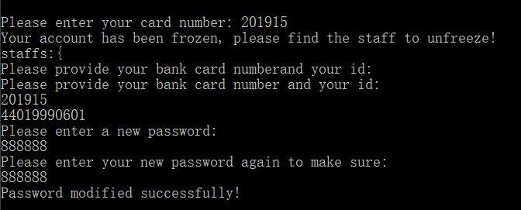

**The change in the txt:**

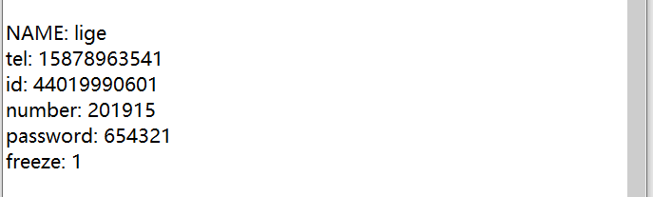

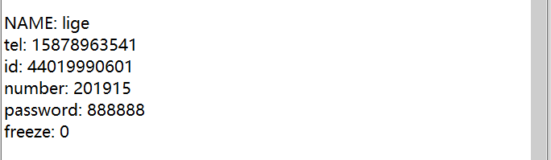

**3)The normal flow**

**--Login in the account**

**--Check the balance**

**--Deposit 500**

**--Withdraw 700**

**--Quit the account**

**--A random staff maintain the ATM**

