# （一）

1. The primary business of an Internet Service Provider is to
   1. design Web pages
   2. sell products from the Web
   3. sell access to the Internet
   4. train users on Internet procedures
2. Which of the following is a network protocol（协议）used to transfer information on the Web?
   1. WWW
   2. URL
   3. HTML
   4. HTTP
3. Which of the following is not a valid URL?
   1. http:/www.cmu.edu
   2. http://www.bell-labs.com
   3. http://cmu.edu
   4. ftp://fraser.corus.com

4.A fragment of text that is a hyperlink shows up as text that is

1. italic
2. blue and underlined
3. blinking
4. larger in size
5. Absolute URLs begin with
   1. "www"
   2. "html"
   3. a communication protocol identifier（通信协议标识符）
   4. a server identifier
6. Which of the following is(are)true about regulation of information on the Web?I.The Advanced Research Project Agency(ARPA)ensures that the contents of Web pages are accurate.
7. The Web administrator regulates all of the content on the Web to ensure it is accurate.
   1. I only
   2. I and II only
   3. None
   4. II only
8. Which of the following is true about the accuracy of information on the Web?
   1. Information on the Web might not be accurate.
   2. Web server programs ensure that information on the Web is accurate.
   3. Web organizations ensure that information on the Web is accurate.
   4. Web administrators ensure that information on the Web is accurate.
9. Which of the following pairs(A,B)use HTTP as a means for A to communicate with B and B to communicate with A?

I.(Web servers,Web clients)

II.(FTP servers,FTP users)//FTP协议

* 1. II only
  2. I only
  3. I and II
  4. None

1. Of the following,which is the most accurate characterization of the World Wide Web?
   1. A collection of commercial sites that sell products and services
   2. The portion of computers on the Internet that communicate via FTP
   3. The portion of computers on the Internet that communicate via HTTP
   4. A collection of commercial sites that offer free disk space but sell advertising space
   5. generally agreed upon rule as to how two computers will communicate with one another over the Internet is called a
      1. filing rule
      2. Web law
      3. server
      4. protocol //协议

# （二）

1. A program that finds Web pages based on user input is typically referred to as a
   1. search client
   2. search engine
   3. Uniform Resource Locator
   4. help server
2. Which of the following are likely to be true for Web commerce?
3. Products tend to cost more when ordered over the Web than when ordered from a printed catalog.
4. The list of products in a Web-based catalog can be quickly changed and updated.
5. The Web can be used to locate products easily.
   1. I only
   2. II and III only
   3. I,II,and III
   4. I and II only
6. Consider the Web as a client-server system.In that context,the role of the Web browser would be that of
   1. an end system
   2. a client
   3. a host
   4. a server

Which of the following tasks can an Internet user accomplish through the Web?

1. Making commercial transactions
2. Forming special interest groups //成立特殊利益集团
   1. I only
   2. II only
   3. I and II
   4. None
3. Which of the following statements is(are)true about servers(服务器)and clients（客户端）?
4. Typically,servers respond to requests from clients.II.Typically,servers initiate requests from clients.
   1. I and II
   2. I only
   3. None
   4. II only
5. Which of the following statements is(are)true about URLs?
6. All URLs begin with the string"www".
7. All URLs begin with a protocol identifier.
8. All URLs end with the string"html".
   1. I,II,and III
   2. I and III only
   3. II only
   4. I only
9. A Web server and a Web client communicate using the?protocol.
   1. FTP
   2. URL
   3. HTTP
   4. HTML
10. Which of the following is(are)true about client-server architecture?
11. Web clients can only be executed on a powerful computer.
12. Web servers can support only one client at a time.
    1. I only
    2. None
    3. I and II
    4. II only
13. Which of the following is ethical to do without the permission of the owner of a Web site?
    1. Use a picture from that site in your Web page
    2. Use large amounts of text from that site in your Web page
    3. Place a link to that site in your Web page
    4. Use small amounts of text from that site in your Web page,without attributing the text to its source
14. Which of the following is a network protocol used to transfer information on the Web?
    1. WWW
    2. URL
    3. HTML
    4. HTTP

（三）dcccc cdbab

Quiz 1.2

1.Which of the following in an HTML file cause(s)a line break to occur in a

Web page?

I.A carriage return

II.<br>

Ⅲ<line>

(a)I and II only

(b)I and III only

(c)I only

(d)II only。

2.A browser uses these in deciding how to display text

(a)java comments

(b)HTML comments

(c)HTML tags

(d)java tags

3.In an HTML page,which of the following tags directs Web browsers to display the page with a blue background?

(a)<body bgcolor="#fff00">

(b)<head bgcolor="#ff0000">

(c)<body bgcolor="#000ff">

(d)<head bgcolor="#0000ff'>

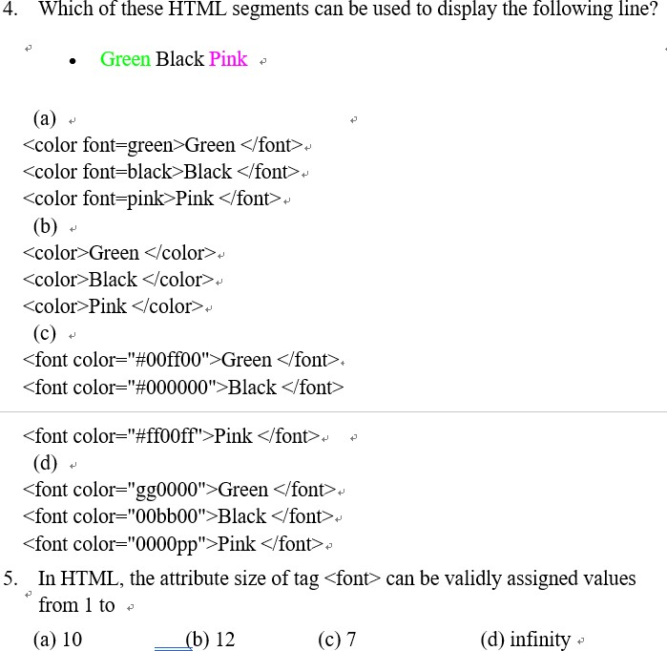

DCCCC

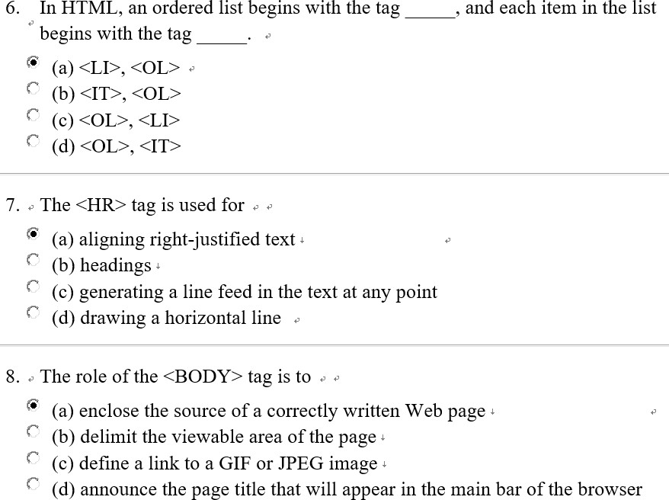

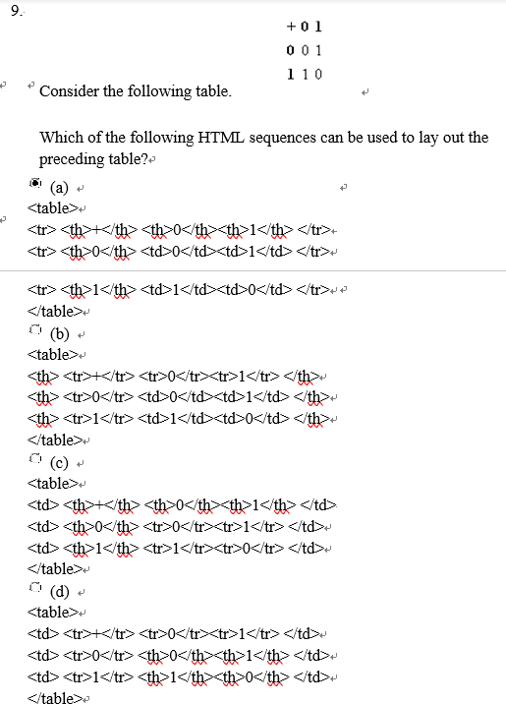

CDBA

1. Which of the following HTML tags is(are)typically found within tags<table>and</table>?
2. <tr>
3. <body>
4. <td>
   1. I,II,and III
   2. I and III only
   3. I and II only
   4. II and III only

# （四）

1. Which of the following statements is(are)true about Web browsers?
2. The primary purpose of a Web browser is to execute Java programs.
3. A Web browser can communicate using HTTP.
   1. I only
   2. II only
   3. I and II
   4. None
4. Which of the following file formats is(are)used for images if the image data need to be preserved exactly?
5. GIF
6. JPEG
   1. I and II
   2. I only
   3. None
   4. II only
7. HTML is an acronym for
8. Hypertext Markup Language
9. High Tech Manager and Linker
10. High Tech Manuscript Locator
11. Hidden Tele-text Modeling Language
12. Hypertext refers to
13. Extremely long sections of text.
14. A set of text fragments interconnected by links.
15. Text that blinks or uses other modern,eye-catching features.
16. Extremely interesting text.
17. In the context of HTML,the term tag refers to a
18. certain kind of Web page
19. block of text that a user can click
20. piece of symbolism used to specify structure or format
21. server on which a Web page resides
22. Which of the following is least likely to be an effect of including too many graphics in a Web page?
23. making the Web page hard to read
24. causing the browser to crash
25. making the page visually unattractive
26. causing the Web page to be slow to download
27. A link in a Web page is
28. always a reference to a different Web page
29. any underlined word or group of words
30. a picture or text that takes your browser to another location when you click on it
31. the only part of the Web page which reacts once you click on it
32. Which of the following is(are)true about the use of the tag pair<a></a>in an HTML document?
33. To create a link to another file
34. To create an internal link
35. To give a name to a location in the document
    1. II only
    2. III only
    3. I,II,and III
    4. I only
36. An HTML tag that causes,by default,text to appear underlined in one browser and bold in another must be
37. a logical style tag
38. a physical style tag
39. an absolute tag
40. a relative tag
41. What is the conceptual difference between logical and physical styles?
42. Logical styles are intended to specify the look of content,whereas physical styles are used to specify the meaning of content.
43. Logical styles are intended to be used for graphics,whereas physical styles are intended to be used for text.
44. Logical styles are intended to be used for text,whereas physical styles are intended to be used for graphics.
45. Logical styles are intended to specify the meaning of content,whereas physical styles are used to specify the look of content.

# （五）

quiz 1.3

1. Which of the following is(are)necessary for a radio button or checkbox control in an HTML form to be considered successful?
2. It must be checked or selected.
3. The HTML FORM element in which it appears must contain at least one INPUT element with a type of hidden.
4. The HTML element that defines it must set a value for the attribute named value.
   1. I and III only
   2. II and III only
   3. I only
   4. II only
5. The action attribute of an HTML FORM element determines
6. a list of form controls to submit
7. the encoding standard used to encode the data of the form
8. the network protocol used to submit the data of the form
9. the processing agent to which the data of the form is submitted
10. In the name-value pairs that represent a submitted HTML form,names are separated from values by the character,and pairs are separated from one another by the character.

(a)=,?

(b)=,&

(c)&,=

(d)&,?

1. For a given Java servlet,which of the following events typically result(s)in the termination of the servlet?
2. The servlet completes a request and forwards its response to the server.
3. The server sends a servlet's response to a client.
   1. II only
   2. I only
   3. None
   4. I and II

5.In an HTML FORM element,the values get and post are the only valid options for which of the following attributes?

* enctype
* action
* method
* accept

6.A Java servlet is a program that typically runs inside which of the following?

1. A Web server
2. A Web browser
   1. None
   2. II only
   3. I only
   4. I and II only
3. Consider the following HTML FORM element.

<FORM action='/servlet/Welcome'method='post'>

The action attribute in the above element specifies which of the following regarding the servlet used to process this form?

1. The name of the servlet
2. The location of the servlet
3. I only
4. I and II
5. None
6. II only
7. Typically,a request from a client browser is forwarded to a servlet by a
   1. Web server
   2. request header
   3. response header
   4. cookie
8. The control of a client-server transaction maintained by the Web server is known as
   1. client pull
   2. server pull
   3. server push
   4. client push
9. Java servlets enable dynamic content at the server side of the implementation of an application.
10. static,server side
11. dynamic,client side
12. dynamic,server side
13. static,client side

（六）12-14

1. In HTML,which of the following is an attribute of the INPUT element that can be used to specify the initial value of a single-line text-input control?
   1. value (b)initial (c)default (d)name

2、Consider the following URL,which corresponds to the submission of an HTML form.

http://www.carnegietech.org/search?keyword=MCQ&course=SSD1

According to the URL,the names of the two successful controls in the submitted form are

(a)keyword and course (b)search and GET

(c)search and HTTP (d)MCQ and SSD1

3、Which of the following path formats can be used to specify the value of the href attribute of the<a>tag?

1. An absolute path
2. A relative path

(a)II only (b)I and II (c)I only (d)None

4、Valid Java comments include which of the following?

1. /*this is an/*embedded*/comment*/
2. /*this is an//embedded//comment*/
3. //this is a comment*/

(a)I and II only (b)II and III only

1. I and III only (d)I only

5、Which word below is not the keyword in Java? 。

A.private B.class

C.subclass D.public

6、Valid Java identifiers include which of the following?

1. _$4dollar
2. $_4dollar
3. 4_dollar

(a)III only (b)I,II,and III (c)None (d)I and II only

7、When programming a Java applet,a programmer creates a(n) file,which a Java compiler translates into a(n) file.

(a)source code,HTML (b)source code,bytecode

(c)bytecode,source code (d)HTML,bytecode

8、Consider the following Java program segment.int i=3;

int j=2;

if((j<0)&&(i>1))i=i*2;

else

j=j-1;

At the end of execution of the program segment,the values of variables i and j will be,respectively

(a)3 and 2 (b)3 and 1 (c)6 and 1 (d)6 and 2

9、How many".class"files will be generated after a successful compilation of any".java"file?

(a)At most one (b)None

(c)At least one (d)Exactly one

10、Which of the following statements is(are)true about the submission of

HTML forms to a Web server?

1.Name-value pairs are sent for a form control only if the control is successful. 2.A form may have more than one submit button.

(a)I and II (b)II only

(c)None (d)I only

（七）12-15

1. What is the name of the class whose definition is begun by the following line?public class Hello extends Greeting
   1. Hello
   2. Greeting
   3. Hello.Greeting
   4. Greeting.Hello

-------------------------------------------------------------------------------

1. When compiling a Java program that contains syntax errors,the compiler will always
   1. ignore the syntax errors and create a compiled program without the lines containing errors
   2. fail to complete the compilation and report a guess of what and where the errors are
   3. fix the syntax errors and complete the compilation
   4. fail to complete the compilation and report the exact location of each error

-------------------------------------------------------------------------------

1. In Java,it is possible to define a within a .
2. method,method
3. class,method
4. method,variabl(d)method,class e

-------------------------------------------------------------------------------

1. Upon compilation,the source code of a Java class MyClass will be stored in the file ,and the corresponding byte code will be stored in the file .
2. MyClass.class,MyClass.exe
3. MyClass.java,MyClass.class
4. MyClass.class,MyClass.java
5. MyClass.java,MyClass.exe

-------------------------------------------------------------------------------

1. The following is a Java program segment:public void paint(Graphics g)

{

intx=10 ;

int y=20;

paintPicture(g,x,y);

}

public void paintPicture(Graphics g,int a,int b)

{

g.setColor(Color.red);

//more code follows

}

What will be the value of the parameter"a",in the method paintPicture when this code is executed?

1. 20
2. 10
3. This will not compile.This is an error because the parameter"a"was never declared and never given a value.
4. 0

-------------------------------------------------------------------------------

1. When a Java class is designed,which of the following is a part(are parts)of the planning stage?
2. Deciding how to display the results
3. Writing a problem definition
4. Identifying the data needed to solve the problem
   1. II and III
   2. I and III
   3. II only
   4. I and II

-------------------------------------------------------------------------------

1. Of the following phases of programming,which is generally the phase on which most time is spent?
2. Defining the problem
3. Testing and evaluation
4. Coding
5. Planning a solution to the problem

-------------------------------------------------------------------------------

1. Which of the following statements is true of the process of programming?
2. Programming is synonymous with coding.
3. Most of the time spent in programming is usually spent planning the solution to a problem.
4. The best way to program is to begin coding immediately,and then to follow up by testing.
5. Programming can be made easier by dividing a larger problem into smaller pieces.

-------------------------------------------------------------------------------

1. Which of the following must be the first phase of the programming process?
2. Planning a solution to the problem
3. Defining the problem
4. Coding
5. Planning the method for obtaining the input

-------------------------------------------------------------------------------

1. Which of the following is a Java statement that imports classes in the package java.sql?
2. import java.sql.*;
3. import java.sql.all;
4. import all java.sql;
5. import java.sql;

（八）12-16

1. Which of the following statements is(are)true about debugging and testing servlets?
2. After a change is made to a servlet,the servlet must be recompiled for the change to take effect.
3. Modifying the parameters of calls to the method out.println can change the HTML in the response of a servlet.
   1. II only
   2. I and II
   3. I only
   4. None

------------------------------------------------------------------------

1. A Java servlet can be declared with the type of content it will produce,such as image/gif or text/html,by using a call to which of the following methods of Http Servlet Response?
   1. resetBuffer
   2. addCookie
   3. setContentType
   4. encodeURL

------------------------------------------------------------------------3. Which of the following is(are)

true regarding computer programs and code?

1. The content of a program is called code.
2. Executing code means erasing the code.
3. Programs consist of text that can cause a computer to perform a task.
   1. I and III only
   2. I and II only
   3. II and III only
   4. I,II,and III

------------------------------------------------------------------------4.Which of the following is(are)

consistent with Java naming conventions regarding capitalization?

1. int numPeople;
2. int Counter;
3. class serviceElevator{}
   1. None
   2. I and III only
   3. I,II,and III
   4. I only

-------------------------------------------------------------------------------

1. Consider the following Java code fragment.

public class TrafficLight{int status;

public void changeStatus(int newStatus){status=newStatus;

}

public void turnOn(int newStatus){

//...

}

}

In the method turnOn,which of the following statements should be used to call method changeStatus?

1. TrafficLight.changeStatus(newStatus);
2. changeStatus(TrafficLight,newStatus);
3. changeStatus.newStatus;
4. changeStatus(newStatus);

-------------------------------------------------------------------------------

1. The following line can be the start of public void paint(Graphics g)
2. a class definition
3. a method call
4. a method definition
5. a variable declaration

-------------------------------------------------------------------------------

1. What is the return value of the following method?void return_value(String s,int i){

//code here

}

1. Its return value is String.
2. Its return values are String and int.
3. Its return value is int.
4. It does not have a return value.

-------------------------------------------------------------------------------

1. Which of the following method names adheres to the Java naming convention standards?
2. isEmpty
3. is-empty
4. IsEmpty
5. is_empty

-------------------------------------------------------------------------------

1. Consider the following Java code segment.public class IQ

{

public int getIQ(String s)

{

return 50;

}

}

If object p is an instance of class IQ,which of the following is a Java statements that will not generate a compilation error?

1. getIQ.p("bob");
2. IQ x=getIQ("chuck");
3. int c=p.getIQ("alex");
4. String s=IQ.getIQ(p);

-------------------------------------------------------------------------------

1. Valid method definitions in Java include which of the following?public method myMethod(){}

public void myMethod(int i){}public void myMethod{}

1. I only
2. II only
3. II and III only
4. None

（九）12-17 （bddaa cdcda）

1. If p1 is an object of a class Point and p1.drawCircle can be called from any Java class,which of the following statements about the method drawCircle in class Point must be true?
   1. The method returns three values.
   2. The keyword public was used in the method's definition.
   3. The method has no arguments.
   4. The method has three arguments.

(b)No Feedback

-------------------------------------------------------------------------------

1. Which of the following is true if a Java class is declared public?
2. The source code of the class is freely available for viewing.
3. The class can be used only by other classes in the same package.
4. The class can be used only by Java applets,not by Java applications.
5. The class can be accessed by any other class.

-------------------------------------------------------------------------------

1. Which of the following variable names conforms to Java naming conventions?
2. FuelRemaining
3. fuel_remaining
4. AmountOfFuelRemainingInTheTank
5. fuelRemaining

-------------------------------------------------------------------------------

1. In Java,methods that change or return the values of instance variables are known as methods.
2. accessor
3. instance
4. class
5. parameter

-------------------------------------------------------------------------------

1. In Java,a variable that can be accessed by all methods of any given class is a(n) variable.
   1. instance
   2. constructor
   3. argument
   4. local

------------------------------------------------------------------------

1. In a Java class Hello,a method declared to be public can be called by
   1. only the classes in the same package as Hello
   2. only the class Hello and the subclasses of Hello
   3. any class
   4. only the class Hello

------------------------------------------------------------------------

1. In Java,which of the following is true about constructors?
2. Constructors can only return 0 or a negative integer.
3. Constructors can only accept primitive Java types as parameters.
4. Constructors must be declared for every class.
5. Constructors cannot return a value.

-------------------------------------------------------------------------------8.Which of the following

statements is true about methods in Java?

1. Every method must be declared public.
2. Every method must accept at least one parameter.
3. Every method must return a value.
   1. I,II,and III
   2. II and III only
   3. none of them
   4. III only

------------------------------------------------------------------------

1. Suppose you are given a class called List which has print as one of its methods and a correctly instantiated object called myList.Which of the following could be a valid call to the print method?
2. myList.print;
3. print.myList();
4. print(List);
5. myList.print();

------------------------------------------------------------------------

1. Which of the following is(are)true regarding objects in Java?
2. Programmers use classes to create objects.
3. An object can belong to more than one class.
   1. I only
   2. II only
   3. I and II
   4. None

（十）12-18（aadcc abcad）

1. What operator is used to allocate storage for objects?
   1. new

(b)==

(c)=

(d)init

-------------------------------------------------------------------------------2.Which of the statements

below correctly constructs an object using the following constructor?Plane(int a,int b,int c)

{

//code

}

(a)p=new Plane(1,2,3);

(b)p=Plane(1,2,3);

1. p=new Plane;
2. p=Plane;

-------------------------------------------------------------------------------3.Valid method definitions in

Java include which of the following?

1. public method myMethod(){}
2. public void myMethod(int i){}
3. public void myMethod{}
   1. II and III only
   2. None
   3. I only
   4. II only

-------------------------------------------------------------------------------

1. If variable br references an instance of the class java.io.BufferedReader,which of the following statements is a legal call to the method readLine of the class?
   1. br.readLine;
   2. br(readLine);
   3. br.readLine();
   4. readLine(br);

-------------------------------------------------------------------------------5.Which of the following is a

Java keyword that is used to create object instances?

1. create
2. construct
3. new
4. public

-------------------------------------------------------------------------------6.Which of the following is(are)

true of constructors in Java?

1. Constructors can have arguments.
2. A class can have multiple constructors.
   1. I and II
   2. None
   3. I only
   4. II only

-------------------------------------------------------------------------------7.How many times will the

body of the following loop be executed?int sum=0;

int n;

for(n=9;n>0;n=n/2)sum=sum+n;

1. three times
2. four times
3. twice
4. once

-------------------------------------------------------------------------------8. int i,j;

for(i=0;i<3;i=i+1)

for(j=0;j<i;j=j+1){System.out.println(""+j);

}

How many lines of output will be produced?

1. 9
2. 6
3. 3
4. 0

-------------------------------------------------------------------------------9.How many times will the

following be executed?int i=0;

while(i>5||i<5) {System.out.println(i+"1");

}

1. infinitely many
2. 4
3. 6
4. 5

-------------------------------------------------------------------------------

1. Which of the following Java constructs loop infinitely?
2. while(true)i=0;
3. while(false)i=1;
4. while(!false)i=0;
   1. III only
   2. I only
   3. I,II and III
   4. I and III only

（十一）12-19（adbdc bbdba）

1. In Java,for primitives,the assignment operator is the symbol and the equality operator is the symbol .

(a)=,==

(b)=,equals()(c):=,=

(d)==,=

-------------------------------------------------------------------------------

1. In Java,the operator"+"can be used for which of the following purposes?
2. Addition of two integers
3. Concatenation of two strings
4. Addition of two floating point variables
   1. II and III only
   2. I and III only
   3. I only
   4. I,II,and III

-------------------------------------------------------------------------------

1. Consider the following code fragment.int m=3;

int n=m/2;

What is the value of n?

(a)1.5

1. 1
2. 2

(d)1.0

-------------------------------------------------------------------------------

1. If T represents the value true and F represents the value false,what does the following expression evaluate to?

!((T||F)&&!F)

* 1. true
  2. The expression cannot be evaluated based on the information presented.
  3. There is an error in the expression so the program containing this expression cannot be compiled.
  4. false

-------------------------------------------------------------------------------

1. The region of a program where a variable can be referenced is known as the

of the variable.

1. type
2. storage space
3. scope
4. conventional space

-------------------------------------------------------------------------------

1. In which of the following Java statements are the variables a,b,c,and d declared?
2. int a,int b,int c,int d;
3. int a,b,c,d;
4. int a-d;
5. int a..d;

-------------------------------------------------------------------------------

1. The term Java Virtual Machine refers to
2. a household appliance operated by Java(usually a smart toaster)
3. an interpreter of Java bytecode
4. a compiler of Java source code
5. a hardware extension needed to run Java

-------------------------------------------------------------------------------

1. In Java,the return type of the method elementAt of the class java.util.Vector is
2. String
3. identical to the class of the object that was inserted into the Vector
4. int
5. Object

-------------------------------------------------------------------------------

1. Java provides eight types for storing and using simple data:byte,short,int,long,float,double,char,and boolean.Which of these types are used to store the logical values true and false?
   1. char
   2. boolean
   3. byte
   4. short

------------------------------------------------------------------------------

1. If a program that is written for one type of machine can run,without major modifications,on another type of machine as well,then the program is said to be
   1. portable
   2. importable
   3. exportable
   4. extendable

（十二）12-20（cddcc abbdc）

1. Which of the following Java statements assigns the bigger of x and y to the variable max.
2. if(x>y)max=x;else max=y;
3. if(y-x<=0)max=x;else max=y;
4. max=x;if(x<y)max=y;
5. III only
6. I only
7. I,II and III
8. I and II only

------------------------------------------------------------------------------

1. A programmer claims that,in the following code fragment,task A will never be performed.Which of the following supports the programmer's claim?

(j<0)&&(i>1)if(x>=20.0&&x<=0.0)perform task A

else

perform task B

* 1. Only one branch of an if-else-statement can be executed.
  2. The value of x is close enough to 20.0 that they could be considered equal.
  3. Any value of x would make the condition true.
  4. The condition could never be true for any value of x.

1. In the following Java code fragment,what must be the type of the variable x in order to make the assignment valid?

int y=2;

x=(double)y;

* 1. int
  2. Undefined
  3. Integer
  4. double

------------------------------------------------------------------------------

1. Which of the following are valid Java statements?i=i;

//y=5;x=10

* 1. II and III only
  2. I and II only
  3. I only
  4. III only

-------------------------------------------------------------------------------

1. When the following code segment is executed,how many times will the string"Hello!"be printed?

for(int i=0;i<6;i++)

for(int j=i;j<6-i;j++)System.out.print("Hello!");

* 1. 36
  2. 21
  3. 12
  4. 11

1. Which of the following kinds of scope do local variables have in Java?
   1. Block
   2. Local
   3. Class
   4. Method

-------------------------------------------------------------------------------

1. What will be output upon execution of the following Java statement?System.out.println((int)(3.6%1.5*10));
   1. 0
   2. 6
   3. 9
   4. 10

-------------------------------------------------------------------------------

1. Consider the Java code below.class MyClass{

int age;

void myMethod(){

int counter=19;age=counter;

}

}

Which of the following is true concerning the code?

1. age and counter have the same scope.
2. age is an instance variable and counter is a local variable.
3. age and counter will always contain the same value.
4. myMethod will generate a compile-time error because age cannot be referenced.

-------------------------------------------------------------------------------

1. How many times will the following loop execute?boolean flag=false;

int count=0;

while(flag=true) {if(count<=10)

count=count+1;

else

}

1. 0
2. 9
3. 10

flag=false;

1. infinitely many

-------------------------------------------------------------------------------

1. What is the value of the variable i at the end of execution of the following Java program segment?

int i=1;while(i<3){

i=i*2;

}

1. 1
2. 3
3. 4
4. 2

（十三）12-23（bbabc caaab）

1. In Java,if x is a Boolean variable with the value true,which of the following expressions will evaluate to true?

!x||x

!(x&&!x)x==!x

* 1. I only
  2. I and II only
  3. III only
  4. I,II,and III

------------------------------------------------------------------------------

1. Which of the following is the term used for the action of informing the system of the true nature of an object reference in Java?
   1. Declaring
   2. Casting
   3. Instantiating
   4. Initializing

-------------------------------------------------------------------------------

1. Consider the following Boolean expression.

!(!(a&&b))

For which of the following values of a and b,respectively,will the expression evaluate to true?

* 1. true,true
  2. false,false
  3. true,false
  4. false,true

------------------------------------------------------------------------------

1. The type of the number 2.0 in Java can be
2. int
3. double
4. boolean
5. Panel

-------------------------------------------------------------------------------

1. Identifiers that are illegal in Java include which of following?
2. void
3. void-void
4. void/void
   1. II and III only
   2. I only
   3. I,II,and III
   4. I and III only

-------------------------------------------------------------------------------

1. Which of the following statements best describes objects in Java?
2. An object is everything included into the program with the import command.
3. An object is a set of classes that share a common structure and a common behavior.
4. An object is a data-structure equipped with methods for manipulating that

data.

1. An object is a collection of methods that produce graphical elements in the applet or application window,or compute and return values.

-------------------------------------------------------------------------------

1. What is the value of x at the end of execution of the following line of Java code?

int x=2+3*(8%3);

1. 8
2. 1
3. 10
4. 2

-------------------------------------------------------------------------------

1. Consider the following code segment.for(int j=0;j<10;j++)

for(int k=10;k>0;k--)System.out.print("Hello");

The code segment shows an example of loops.

1. nested
2. infinite
3. opposite
4. sequential

-------------------------------------------------------------------------------

1. What does the following loop compute,assuming n is a positive even integer?

int i=1;

int sum=0;while(i<=n) {

if(i%2==0)

sum=sum+i;i=i+1;

}

1. Computes the sum of the even integers from 1 through n.
2. Computes the sum of the even integers from 1 through n-1.
3. Computes the sum of the odd integers from 1 through n.
4. Computes the sum of the odd integers from 1 through n-1.

------------------------------------------------------------------------------

1. Consider the following Python program fragment.I=1

If(i):print(True)else:print(False)What is the output?

(a)1 (b)True

(c)False (d)syntaxerror

（十四）12-24（bddcc ddbda）

1. Consider the following Java program fragment.import java.applet.Applet;

public class Hello extends Applet{

...

}

The fragment indicates that

* 1. Applet is a subclass of Hello
  2. Hello is a subclass of Applet
  3. Hello is an instance of Applet
  4. Applet is an instance of Hello

-------------------------------------------------------------------------------

1. Which of the following kinds of relationships between classes does inheritance describe?
2. has-a
3. uses-a
4. produces-a
5. is-a-kind-of

-------------------------------------------------------------------------------

1. In the following program segment,the call super(len,wid)invokes the constructor for which class?

public class CustomWindow extends MyWindow implements ActionListener

{

public CustomWindow(int len,int wid,Font ft)

{

super(len,wid);

}

}

1. CustomWindow
2. ActionListener
3. Font
4. MyWindow

-------------------------------------------------------------------------------

1. Which of the following is true concerning the following example class definition?

public class Hello extends Applet {...

}

1. Hello is a superclass of Applet
2. Hello inherits from Applet III．Hello is a subclass of Applet
   1. I and II only
   2. II only
   3. II and III only
   4. III only

-------------------------------------------------------------------------------

1. If the following line of code is the beginning of a class definition,then class

is being defined,and it is a of class .public class Game extends Applet

1. Applet,superclass,Game
2. Game,superclass,Applet
3. Game,subclass,Applet
4. Applet,subclass,Game

-------------------------------------------------------------------------------

1. Which of the following Java keywords can be used to invoke a superclass constructor for the class in which it appears?
2. this
3. extends
4. protected
5. super

-------------------------------------------------------------------------------

1. Which of the following indicates that class Dog is a subclass of class Animal?
2. public class Animal extends Dog
3. public class Animal imports Dog
4. public class Dog imports Animal
5. public class Dog extends Animal

-------------------------------------------------------------------------------

1. Consider the following Java code fragment where B is a Java class.Public class A extends B{}

Which of the following is indicated by the code fragment?

1. Class A must also extend class Applet.
2. Class A is a subclass of class B.
3. Class B must also extend at least one other class.
4. Class B is a subclass of class A.

-------------------------------------------------------------------------------

1. Consider the following definition of a Java class.

class A{}

Based on this definition,the superclass of the class A is

1. String
2. A
3. Null
4. Object
5. Consider a Java program that contains two classes,Programmer and Person.The class Programmer is a subclass of the class Person,and both classes define a method sleep.Which of the following statements will be true about the program?
   1. The method sleep of Programmer will override that of Person when the program is executed.
   2. The method sleep of Person will override that of Programmer when the program is executed.
   3. The program will not compile.
   4. When the method sleep of Programmer is called,the method sleep of Person will be called first.