- 软件信息
开发者： 软件171 李学悦 1706300030
软件名称：PCM量化系统
软件功能：实现自定义PCM量化

- 软件操作与输出结果
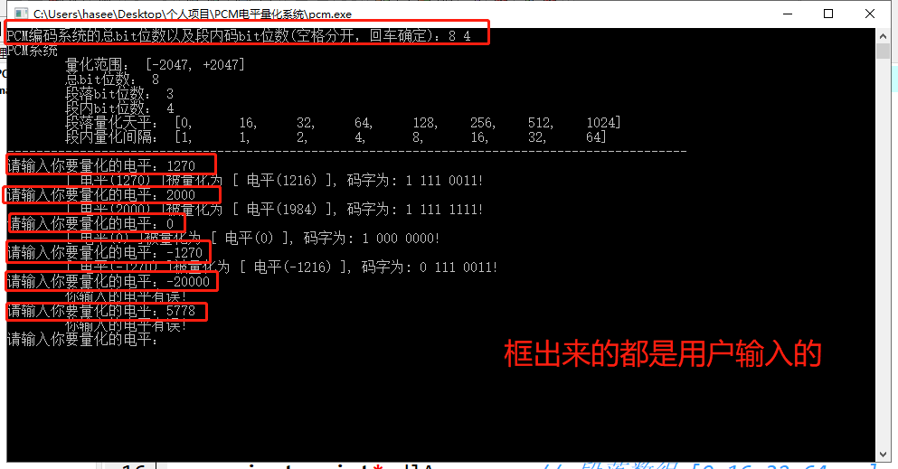

- 源代码
# include<stdio.h>
# include<string>
# include<iostream>
using namespace std;

class PCM{

private: int allBits; // 总共的bits
private: int maxValue;// 最大量化值
private: int dlmBits; // 段落码bits
private: int dnmBits; // 段内码bits
private: int* dlArr; // 段落数组 [0,16,32,64...] 存放段落其实电平
private: int* dnArr; // 段内数组 [1,1,2,4...] 存放段内量化间隔
private: int size; // 长度 (固定为8)
private: bool runningFlag; // false不正常 true正常

// 判断是否正常运行
public: bool runningJudge(){
return runningFlag;
}

public: PCM(){
runningFlag = false;
}
public: PCM(int allBits,int dnmBits){

if (dnmBits>=allBits || allBits<=1 || dnmBits<=0 || allBits>=32){
runningFlag = false;
return ;
}

runningFlag = true;
// 注意异常处理
this->allBits = allBits;
this->dnmBits = dnmBits;// 注意1位符号位
this->dlmBits = allBits - this->dnmBits - 1;

this->size = 8;

this->dlArr = new int[size];
this->dnArr = new int[size];

this->maxValue = (1<<(allBits+dnmBits-1))-1; // allBits有bug!
initArr();

showSystemInfo();

}

public: void showSystemInfo(){

printf("PCM系统\n");
printf(" 量化范围： [%d, +%d]\n",-maxValue,maxValue);
printf(" 总bit位数： %d\n",allBits);
printf(" 段落bit位数： %d\n",dlmBits);
printf(" 段内bit位数： %d\n",dnmBits);

printDlArr();
printDnArr();
printf("----------------------------------------------------------------------------------------------\n");
}

// 量化
public: int quanification(int n,string &mazi){
if (abs(n)>this->maxValue){
return -1; // 出错
}
int flag=1; // 符号位
if (n<0){
flag = 0;
n = -n;
}

int dlNumber = binarySearch(n); // 对应的起始电平位置
int dnNumber = (n-this->dlArr[dlNumber])/this->dnArr[dlNumber]; // 对应的段内号
int ans = this->dlArr[dlNumber] + dnNumber*dnArr[dlNumber]; //
ans = (flag==0?-ans:ans);

mazi=toBinary(flag,1) + " " + toBinary(dlNumber,dlmBits) + " " + toBinary(dnNumber,dnmBits);
return ans;
}

// 初始化量化天平数组和量化间隔数组
private: void initArr(){
dlArr[0] = 0;
dlArr[1] = 1<<(allBits+dnmBits-8);
for (int i=2;i<size;i++){
dlArr[i] = dlArr[i-1]*2;
}

dnArr[0] = 1;
dnArr[1] = dlArr[1]/(1<<dnmBits);
for (int i=2;i<size;i++){
dnArr[i] = dnArr[i-1]*2;
}

}
// 输出量化天平数组
private: void printDlArr(){
printf(" 段落量化天平： [");
for (int i=0;i<size;i++){
if (i!=size-1){
printf("%d,\t",dlArr[i]);
}else{
printf("%d]\n",dlArr[i]);
}
}
}

// 输出量化间隔数组
private: void printDnArr(){
printf(" 段内量化间隔： [");
for (int i=0;i<size;i++){
if (i!=size-1){
printf("%d,\t",dnArr[i]);
}else{
printf("%d]\n",dnArr[i]);
}
}
}

// 10进制转二进制字符串 ,bits是位数
private: string toBinary(int target,int bits){
string ans = "";
for(int i=0;i<bits;i++){

ans = char(target%2+'0') + ans;
target /=2;
}
return ans;
}

// 返回：在dlArr中找到最后一个小于等于target的数的下标
// 规定target要大于等于0，否则会返回-1
private: int binarySearch(int target){
int l=0;
int r=size-1;
while(l<=r){
int mid = (l+r)/2;
if (dlArr[mid]==target){
l = mid + 1;
}else{
if(dlArr[mid]>target){
r = mid - 1;
}else{
l = mid + 1;
}
}
}
return r;
}
// 取绝对值
private: int abs(int a){
if (a>0){
return a;
}
return -a;
}
};
// main函数
int main(){
PCM system;

do{
int allBits,dnmBits;
printf("PCM编码系统的总bit位数以及段内码bit位数(空格分开，回车确定)：");
scanf("%d %d",&allBits,&dnmBits);
system = PCM(allBits,dnmBits);

if (system.runningJudge()==false){
printf("系统创建失败，请重新输入系统设置!\n");
}

}while (system.runningJudge()==false);

while(true){

int n;
printf("请输入你要量化的电平：");
scanf("%d",&n);
string mazi;
int ans = system.quanification(n,mazi);
if (ans == -1){
printf(" 你输入的电平有误！\n");
}else{
printf(" [ 电平(%d) ]被量化为 [ 电平(%d) ], ",n,ans);
cout<<"码字为: "<<mazi<<"!"<<endl;
}
}
}

