Name: Lý Đạt
Id: 2331200190

Problem 1: Bella’s Pet Grooming Shop specializes in grooming dogs and cats. When a customer brings a pet to the shop, the groomer gets the customer's name, address, and phone number. The groomer then records the pet's breed, age, and weight, and provides the customer with a service estimate. The service estimate includes the cost of grooming services, additional care charges, and the total cost including sales tax.

- Identifying All of the Nouns:
Bella’s Pet Grooming Shop pet address weight
service estimate shop phone number dogs
grooming services groomer breed cost
Customer name age cats
additional care charges total cost sales tax

- Some of the nouns really mean the same thing.
Bella’s Pet Grooming Shop pet address weight
service estimate shop phone number dogs
grooming services groomer breed cost
Customer name age cats
additional care charges total cost sales tax
- Shop: Bella’s Pet Grooming Shop
- Pet: dogs, cats

- Some nouns that might represent items that we do not need to solve the problem.
Bella’s Pet Grooming Shop pet address weight
service estimate shop phone number dogs
grooming services groomer breed cost
Customer name age cats
additional care charges total cost sales tax
- Bella’s Pet Grooming Shop, Groomer, shop
- Some nouns that might represent objects, not class
Bella’s Pet Grooming Shop pet address weight
service estimate shop phone number dogs
grooming services groomer breed cost
Customer name age cats
additional care charges total cost sales tax
- grooming services

- Some nouns that might represent simple values that can be stored in primitive variables and not need class
Bella’s Pet Grooming Shop pet address weight
service estimate shop phone number dogs
grooming services groomer breed cost
Customer name age cats
additional care charges total cost sales tax
- Values: address, weight, phone number, breed, cost, name, age, additional care charges, total cost, sales tax
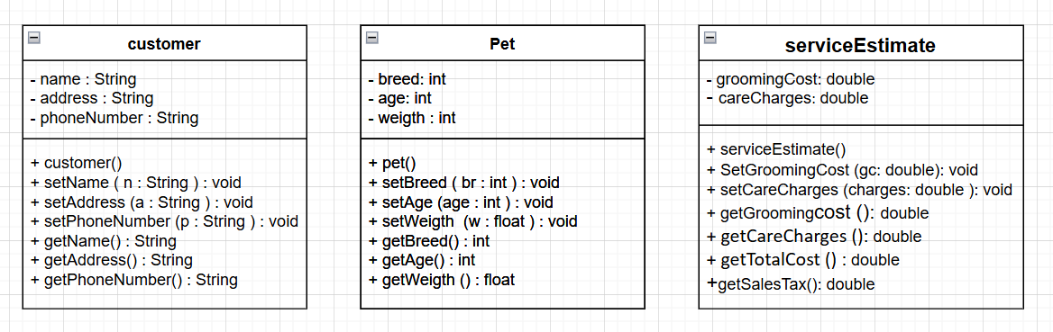

Problem 2: Sweet Delights Bakery takes custom cake orders for events such as weddings and birthdays. When a customer places an order, the baker collects the customer’s name, address, and phone number. The baker then records the type of cake, the number of tiers, and the event date, and provides the customer with a price quote. The price quote includes the cost of ingredients, labor charges, and delivery fee, plus the total amount including sales tax.

- Identifying All of the Nouns:
Sweet Delights Bakery cake events weddings birthdays
Customer type baker name address phone number
number of tiers order event date price quote cost
ingredients labor charges delivery fee total amount sales tax

- Some of the nouns really mean the same thing.
Sweet Delights Bakery cake events weddings birthdays
Customer type baker name address phone number
number of tiers order event date price quote cost
ingredients labor charges delivery fee total amount sales tax
- no same thing

- Some nouns that might represent items that we do not need to solve the problem.
Sweet Delights Bakery cake events weddings birthdays
Customer type baker name address phone number
number of tiers order event date price quote cost
ingredients labor charges delivery fee total amount sales tax
- Sweet Delights Bakery, baker
- Some nouns that might represent objects, not class
Sweet Delights Bakery cake events weddings birthdays
Customer type baker name address phone number
number of tiers order event date price quote cost
ingredients labor charges delivery fee total amount sales tax
- Ingredients, cake, order, events, weddings, birthdays

- Some nouns that might represent simple values that can be stored in primitive variables and not need class
Sweet Delights Bakery cake events weddings birthdays
Customer type baker name address phone number
number of tiers order event date price quote cost
ingredients labor charges delivery fee total amount sales tax
- Values: name, address, phone number, type, number of tiers, event date, cost, labor charges, delivery fee, total amount, sales tax
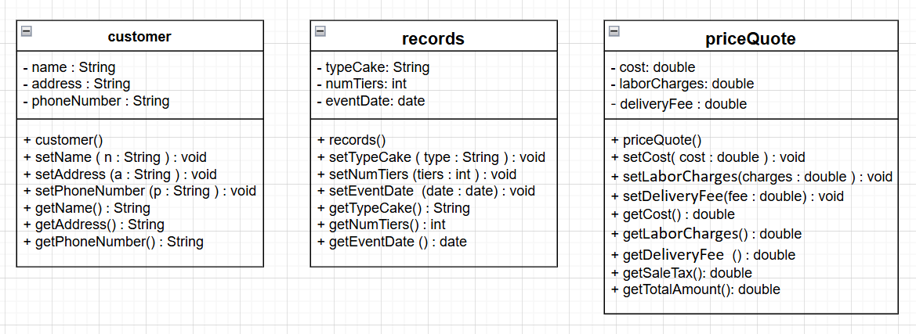

Problem 3: Speedy Car Rentals rents out cars to customers for personal and business use. When a customer rents a car, the rental agent records the customer’s name, address, and driver’s license number. The agent then notes the make and model of the car being rented, the rental period, and the mileage limit, and provides the customer with a rental agreement. The rental agreement includes the base rental fee, any applicable mileage fees, and the total rental cost including taxes.

- Identifying All of the Nouns:
Speedy Car Rentals cars customers personal use business use car
rental agent records name address driver’s license number agent
make of the car model of the car rental period mileage limit
rental agreement base rental fee applicable mileage fees taxes
total rental cost

- Some of the nouns really mean the same thing.
Speedy Car Rentals cars customers personal and business use car
rental agent records name address driver’s license number agent
make of the car model of the car rental period mileage limit
rental agreement base rental fee applicable mileage fees taxes
total rental cost
- Car: cars

- Some nouns that might represent items that we do not need to solve the problem
Speedy Car Rentals cars customers personal and business use car
rental agent records name address driver’s license number agent
make of the car model of the car rental period mileage limit
rental agreement base rental fee applicable mileage fees taxes
total rental cost
- Speedy Car Rentals

- Some nouns that might represent objects, not class
Speedy Car Rentals cars customers personal and business use car
rental agent records name address driver’s license number agent
make of the car model of the car rental period mileage limit
rental agreement base rental fee applicable mileage fees taxes
total rental cost
- personal and business use, agent

- Some nouns that might represent simple values that can be stored in primitive variables and not need class
Speedy Car Rentals cars customers personal and business use car
rental agent records name address driver’s license number agent
make of the car model of the car rental period mileage limit
rental agreement base rental fee applicable mileage fees taxes
total rental cost
- Variables: name, address, driver’s license number, make of the car, model of the car, rental period, mileage limit, base rental fee, applicable mileage fees, taxes, total rental cost
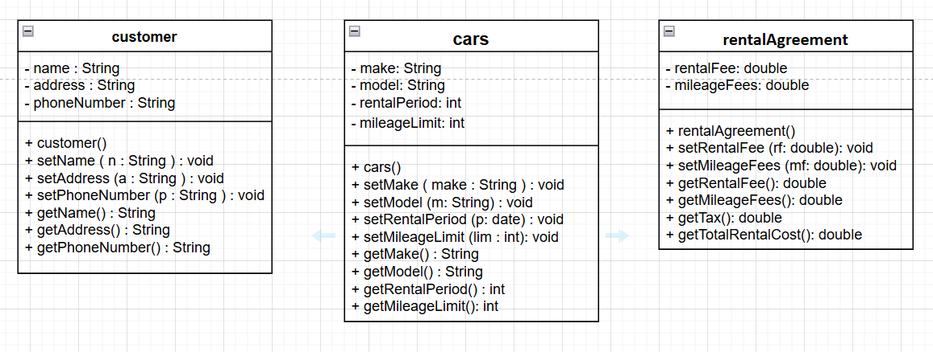

Problem 4: Shutterbug Photography Studio offers photoshoots for families and events. When a customer books a session, the photographer collects the customer’s name, address, and phone number. The photographer also records the type of session (e.g., family, wedding, portrait), the session duration, and the date. A booking confirmation is provided, which includes the base session fee, any additional charges for editing, and the total price including sales tax.

- Identifying All of the Nouns:
Shutterbug Photography Studio photoshoots families events customer
Session photographer name address phone number
type of session Family wedding portrait session duration date
booking confirmation base session fee additional charges total price sales tax

- Some of the nouns really mean the same thing.
Shutterbug Photography Studio photoshoots families events customer
Session photographer name address phone number
type of session Family wedding portrait session duration date
booking confirmation base session fee additional charges total price sales tax
- Family: families

- Some nouns that might represent items that we do not need to solve the problem
Shutterbug Photography Studio photoshoots families events customer
Session photographer name address phone number
type of session Family wedding portrait session duration date
booking confirmation base session fee additional charges total price sales tax
- Shutterbug Photography Studio, photographer

- Some nouns that might represent objects, not class
Shutterbug Photography Studio photoshoots families events customer
Session photographer name address phone number
type of session Family wedding portrait session duration date
booking confirmation base session fee additional charges total price sales tax
- Family, wedding, portrait, photoshoots, events

- Some nouns that might represent simple values that can be stored in primitive variables and not need class
Shutterbug Photography Studio photoshoots families events customer
Session photographer name address phone number
type of session Family wedding portrait session duration date
booking confirmation base session fee additional charges total price sales tax
- Variable: name, address , phone number, type of session, session duration, date, base session fee, additional charges, total price, sales tax.
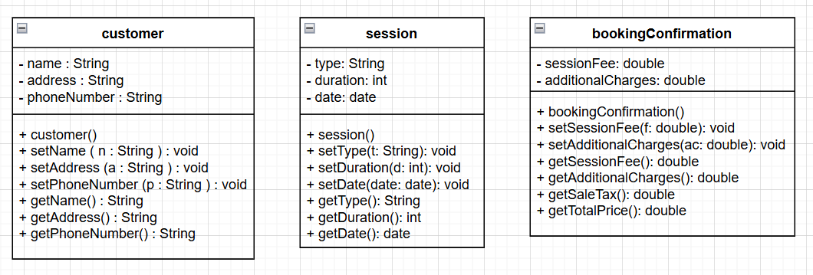
Problem 5: EIU Library offers printed books for borrowing. When a user wants to borrow a book, they first check if it is available. If available, the user provides the ISBN, title, and the number of days they want to borrow the book to the librarian. The librarian then verifies the user’s ID, name, and email address, and checks the list of books the user is currently holding. If the user has more than one overdue book, they cannot borrow any more books.

- Identifying All of the Nouns:
EIU Library printed books user book ISBN title
number of days user’s ID name email address list of books
overdue book books librarian

- Some of the nouns really mean the same thing.
EIU Library printed books user book ISBN title
number of days user’s ID name email address list of books
overdue book books librarian
- Book: books

- Some nouns that might represent items that we do not need to solve the problem
EIU Library printed books user book ISBN title
number of days user’s ID name email address list of books
overdue book books librarian
- EIU Library, librarian

- Some nouns that might represent objects, not class
EIU Library printed books user book ISBN title
number of days user’s ID name email address list of books
overdue book books librarian
- printed books, book

- Some nouns that might represent simple values that can be stored in primitive variables and not need class
EIU Library printed books user book ISBN title
number of days user’s ID name email address list of books
overdue book books librarian

- variables: ISBN, title, number of days, user’s ID, name, email address, list of books, overdue book

