Relational Algebra Exercises
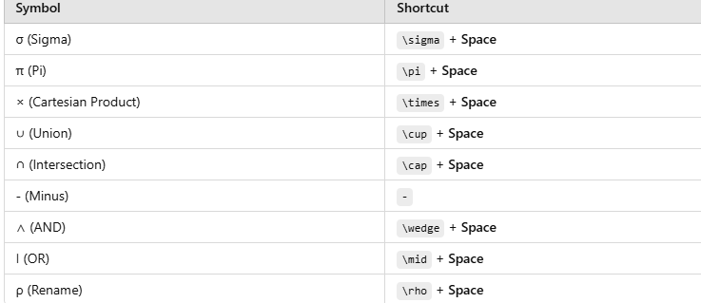
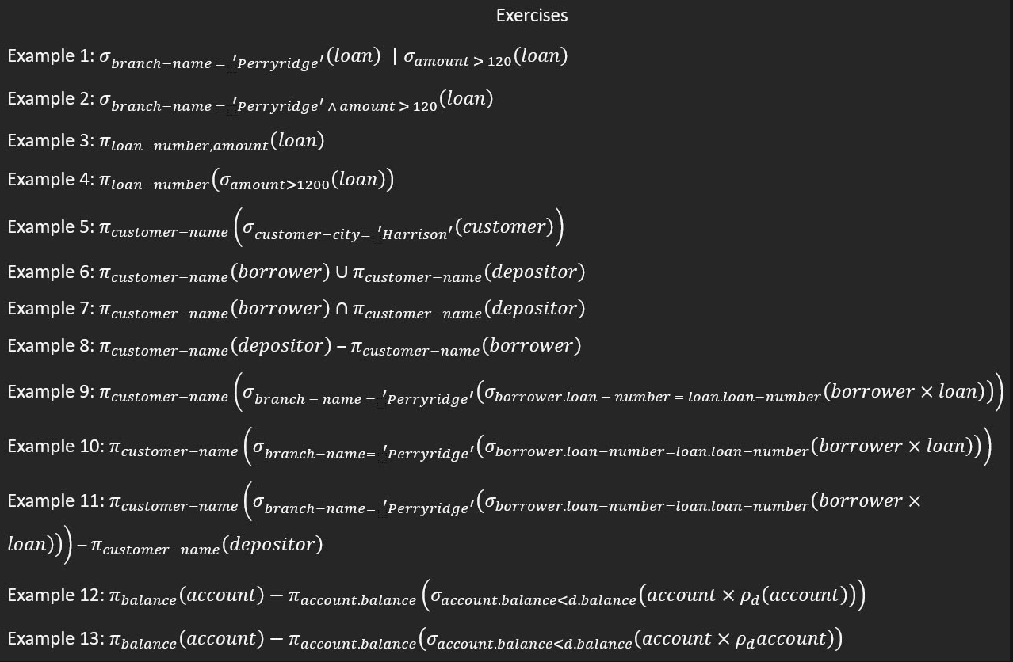
How to do in Word: 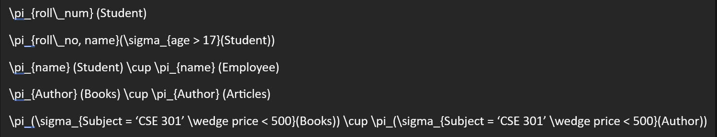

Exercies:

Example 1
σ_{branch-name='Perryridge'}(loan) ∣ σ_{amount>120}(loan)

Example 2
σ_{branch-name='Perryridge' ∧ amount>120}(loan)

Example 3
π_{loan-number, amount}(loan)

Example 4
π_{loan-number}(σ_{amount>1200}(loan))

Example 5
π_{customer-name}(σ_{customer-city='Harrison'}(customer))

Example 6
π_{customer-name}(borrower) ∪ π_{customer-name}(depositor)

Example 7
π_{customer-name}(borrower) ∩ π_{customer-name}(depositor)

Example 8
π_{customer-name}(depositor) − π_{customer-name}(borrower)

Example 9
π_{customer-name}(σ_{branch-name='Perryridge'}(σ_{borrower.loan-number=loan.loan-number}(borrower × loan)))

Example 10
π_{customer-name}(σ_{branch-name='Perryridge'}(σ_{borrower.loan-number=loan.loan-number}(borrower × loan)))

Example 11
π_{customer-name}(σ_{branch-name='Perryridge'}(σ_{borrower.loan-number=loan.loan-number}(borrower × loan))) − π_{customer-name}(depositor)

Example 12
π_{balance}(account) − π_{account.balance}(σ_{account.balance<d.balance}(account × ρ_d(account)))

Example 13
π_{balance}(account) − π_{account.balance}(σ_{account.balance>d.balance}(account × ρ_d(account)))

