SIT Restricted

- Declaration of Originality Form for ACW work and submission
This form must be completed and signed as a Team and submitted with your project submission.
Please complete the information below.

Module Name : INF2005 Cyber Security Fundamentals
Module Code: INF2005
Team No: P6-6
Member 1

Name: KOK YU XUAN JERRY Email: 2400815@sit.singaporetech.edu.sg
Student ID: 2400815
Member 2

Name: LEONG CHIYUNG Email: 2400602@sit.singaporetech.edu.sg
Student ID: 2400602
Member 3

Name: NICHOLAS HANDINATA Email: 2400840@sit.singaporetech.edu.sg
Student ID: 2400840
Member 4

Name: TAN TZE HAN Email: 2301483@sit.singaporetech.edu.sg
Student ID: 2301483

Member 5

Name: TAY YU XUAN JOLENE Email: 2402963@sit.singaporetech.edu.sg
Student ID: 2402963
Member 6

Name: THIAN YU XUAN RAYNARD Email: 2400617@sit.singaporetech.edu.sg
Student ID: 2400617
We confirm that this assignment is our own work and that we have:
Read and understood the content in this declaration of originality form. 
Clearly referenced, in both the text and the bibliography or references, all sources used in the work
Fully referenced (including page numbers, volume, chapter and issue numbers) all text quoted
Provided the sources for all tables, figures, data etc. that are not my own work
Not made use of the work of any other student(s) past or present without acknowledgement. This includes any of my own work, that has been previously, or concurrently, submitted for assessment, at this or any other educational institution.
Not sought or used the services of any professional agencies to produce this work.
In addition, we understand that any false claim in respect of this work will result in disciplinary action
Please read carefully, acknowledge with a tick and sign the declaration below.

DECLARATION:
We understand the University’s view on plagiarism and we certify that this report is our own work, except where indicated by referencing, and that we have followed the good academic practices noted above. We declare that this submission is our team’s original work, except where sources, libraries, tools or AI assistance have been properly acknowledged.
Member 1 Name: KOK YU XUAN JERRY Sign > 

Member 2 Name: LEONG CHIYUNG Sign >

Member 3 Name: NICHOLAS HANDINATA Sign > 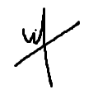

Member 4 Name: TAN TZE HAN Sign > 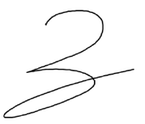

Member 5 Name: TAY YU XUAN JOLENE Sign > 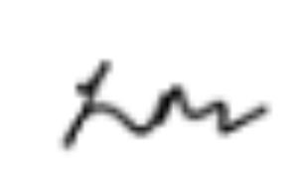

Member 6 Name: THIAN YU XUAN RAYNARD Sign > 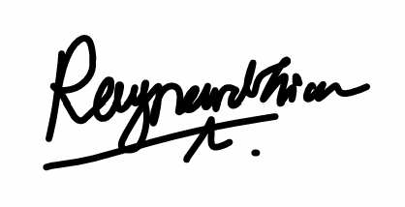

(B) Team Contribution and Distribution
Fill in the proportion that each member of your team (including yourself) contributed to the INF2005 ACW1 coursework assignment. Total team contribution must add up to 100%. [When work is submitted, it is considered as 100% - regardless of actual completeness]

Members |  | Components/Tasks Assigned* (%)
 |  | task1 steganography engine | task 2  image encryption | task3  audio encryption | task 4  payload/format | task 5  GUI
1 | KOK YU XUAN JERRY | 20 | 10 | 10 |  | 40
2 | LEONG CHIYUNG | 60 | 10 | 10 | 5
3 | NICHOLAS HANDINATA |  | 30 |  | 40 | 10
4 | TAN TZE HAN | 40 |  | 30 |  | 10
5 | TAY YU XUAN JOLENE |  | 40 | 40 | 5
6 | THIAN YU XUAN RAYNARD |  | 10 | 10 | 40 | 40
Total % (100%) |  | 100 | 100 | 100 | 100 | 100
* Name and add the components/tasks according to how your team plan the tasks and distribute the load.

We agreed to the above stated work distribution and contribution.
Member 1 Name: Kok Yu Xuan Jerry Sign > | Member 4 Name: Tan Tze Han Sign > 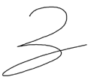
Member 2 Name: Leong Chiyung Sign > | Member 5 Name: Tay Yu Xuan Jolene Sign >
Member 3 Name: Nicholas Handinata Sign > | Member 6 Name: Thian Yu Xuan Raynard Sign >

Members’ Remarks (Optional)#:

#Eg, giving credit to deserving 1 – 2 member/s
** replace with member’s name.

