SQL Database Structure
Database systems, are reliable & systematic computerized
data storage and access mechanisms.
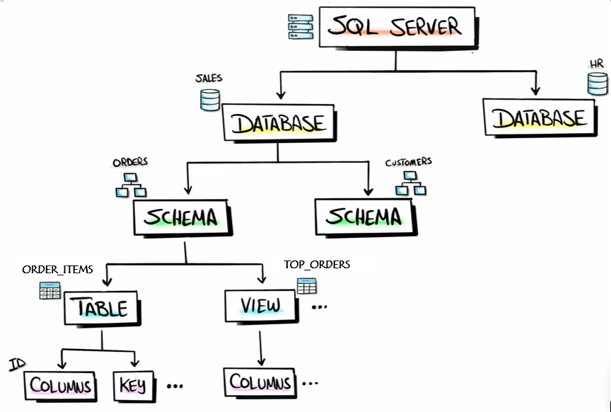
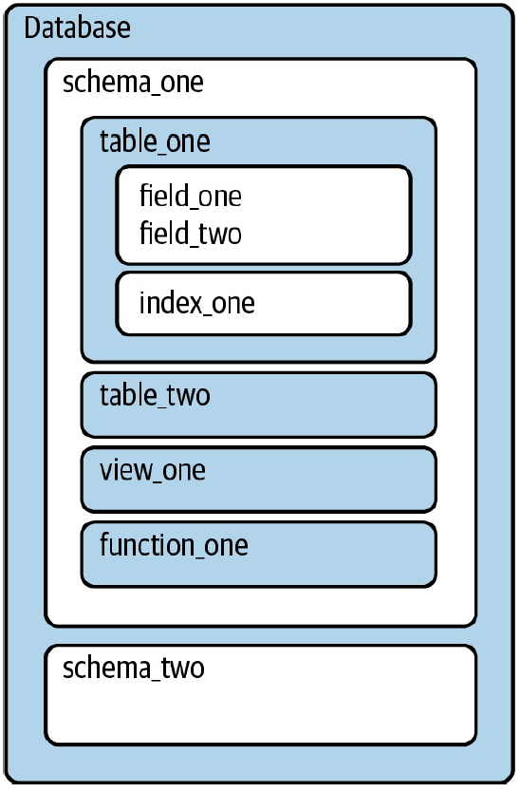
- Database schema can be thought as a working template with data, custom functions, and
built-in functions- eg. mathematical & ML operations in BigQuery.

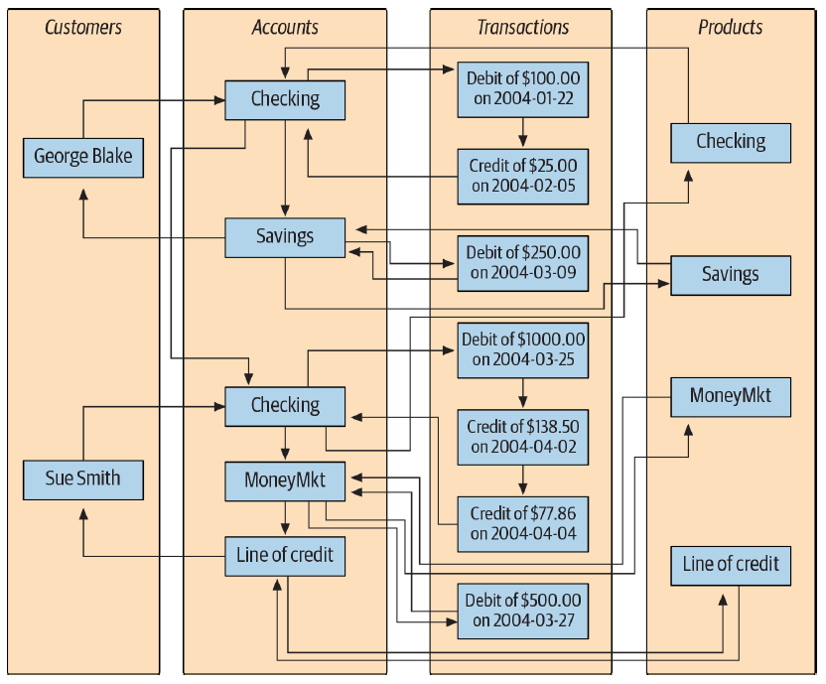
Fundamental data management structures- hierchical & network: file directory & relational model
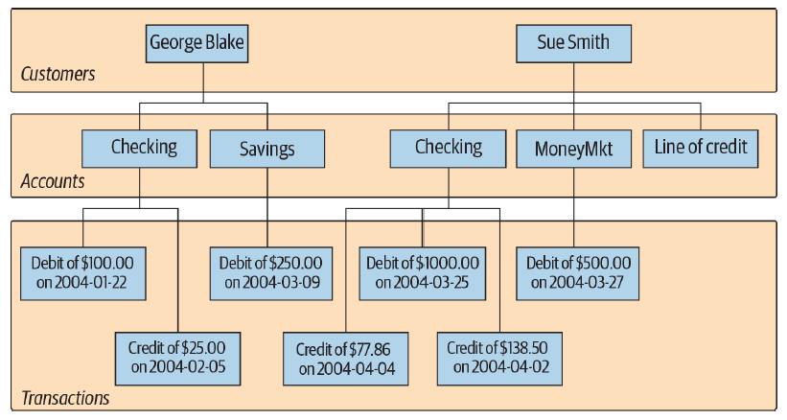
The single parent hierarchy may look clean & easy to follow even at large dataset, but it is difficult for
arbitrary retrieval due to its transversing constraint from the root nodes.

There are 2-broad categories intended for store & access of data: row-store & column-store.

Relational Model
- a row-store mapping designed for organizing data elements -how they relate to one another, and efficient at managing transactions in databases.
( Row vs. Col: optimized for store & retrieval of a long row—ie. samples, but slower for features. )

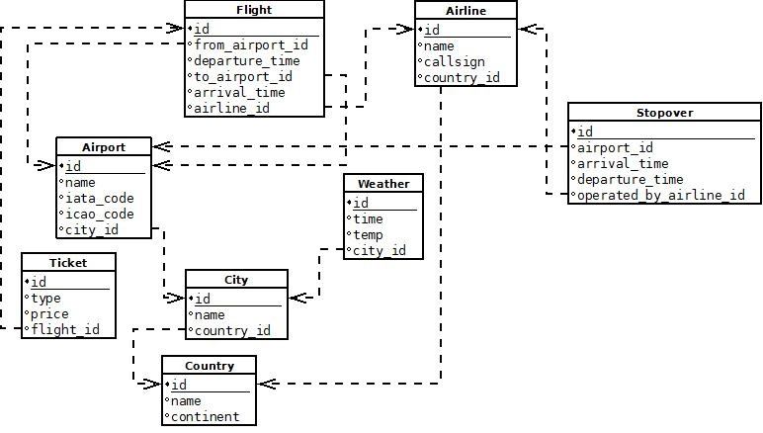
Visual representation of relationships to data created in a business’s operations.
(ie. probably in data dictionaries)
[ a design seeks to reduce the width of tables and avoid duplication & inconsistencies,
but called for many joins during processing of a complete dataset ]
A table might incl.—
(i) Primary key - unique identifier for a record in a table,
(ii) Foreign key - PK defined in other tables, as links btw tables,
(iii) Logical key - indexes that allow effective lookup from outside the program, eg. title
- Some databases may take a compound type (ie. multiple fields’ values) as primary key, which is the combination of natural & surrogate key that enforces uniqueness.
( the choice should be made carefully, as it is not allowed to be changed once assigned )
Usually the primary key is indexed,
- when a query takes long time to run, it can be useful to identify fields w/ indexing property and adding it to speed up searches on common joins.
( but – slow down commit as new values added at each insert )
#Beyond reporting, exploratory w/ complex queries & join patterns are often conducted than
bothering with optimizing indexes.
When building a relational model for an application,
#1 Start w/ first table –“the one {main} description of application” (eg. Music API = a map that manages tracks)
#2 Brainstorm to see what kind of information is helpful to include.
#3 Do not put the same string twice, separate main feature to its attrs using relationships.
#4 Create a connection table w/ foreign keys for many-to-many relation / ≥3 JOIN tables.
(as multiple values are generally not encouraged within a single cell in table – separating PK)
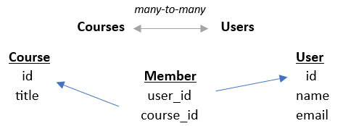
[ Through careful tuning & efficient interface to model design, the representation deduces
respective the capabilities to application ]
ie. efficient utilities supported by ideal navigation mapping & information retrieval.
Note: Sometimes, an entity relationship data model which proposes thinking of database
by emphasis of relationships btw collection of entities (tables) is first outlined.
Besides, Star & Snowflake schema are also available as fundamental modeling approach in
data warehouses, advocating series of -
fact table: events ^{[eg. retail store transaction]} & dimension tables: descriptors ^{[eg. customer & product]}
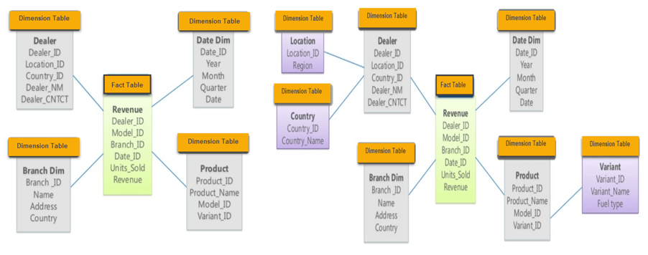
ie. extensible dimensions to make row-store databases more friendly to processing tasks.

When creating a relation table, it is required to specify the homogenous datatype to a field
(sometimes, with expected memory size – eg. int64) for efficient data storage & management.

Common SQL Datatypes: (refer. Columns_and_Data_Types for more information)
Type | Name | Description
String | CHAR(n)  /VARCHAR | Hold fixed / variable no. of characters up to a maximum length (n) for all values in the field.
String | TEXT(byte)  /BLOB | Holds context / binary of a long string that don’t fit in a VARCHAR.  (eg. Byte image content or free text entered by survey respondents)
String | ENUM(val1, val2, …)  /SET(val1, val2, …) | - Hold one str from the specified list, or a blank is inserted.  - Hold 0 or more than one str from the list.
Numeric | INT/SMALLINT  /BIGINT UNSIGNED | Holds general integer of size up to 2³² or, typically smaller / larger no. of digits with corresponding memory size at signed / unsigned.
Numeric | FLOAT/DOUBLE(n,d)  /DECIMAL(n,d) | Holds general floating-point or, double / higher unsigned values of total no. of digits (n) ^{default: 10-65} & decimal points (d) ⁰⁻³⁰ specified.
Logical | BOOLEAN | Holds only TRUE {non-zero} / False {0} values.
Datetime | DATETIME  /TIMESTAMP | Holds date & time in YYYY-MM-DD hh:mi:ss format  (with or without support of time zones depending on database)
Datetime | DATE/TIME  /INTERVAL | Holds date / time / a span of time values only  : YYYY-MM-DD, hh:mi:ss, ‘1 hour 30 minutes’.
Note: Optional display width: INT(4) :: 0005 may be used for displaying integer within a fixed width if needed.

[ ETL - Data engineering process ]
- Extract, batch/ stream retrieval of desired data via web scraping, databases, …, or gathered from different formats (XLSX, CSV, JSON, etc.).
- Transform, serialize structure, performs data quality cleaning, or aggregate the data so that it conforms to how data is managed in the program or storage system.
- Load, commit the [drafted / transformed] data to a data warehouse subjecting to if SQL process is deemed to be conducted in the database before it is loaded.
# Usually, data engineers would ensure data integrity & privacy within data
ecosystem following the process, and make it accessible to data users.



Creating & Populating a Database

- CREATE TABLE User (
id INTEGER NOT NULL PRIMARY KEY AUTOINCREMENT,
name TEXT
email TEXT
);
CREATE TABLE Course (
id INTEGER NOT NULL PRIMARY KEY AUTOINCREMENT,
title TEXT
);
CREATE TABLE Member ( #connection table
user_id INTEGER,
course_id INTEGER,
role INTEGER,
PRIMARY KEY (user_id, course_id) unique compound key table constraint
);
*MySQL - PRIMARY KEY (c1) / CONSTRAINT alias PRIMARY KEY (c1,c2) :: 1 or 2-cols specification
Table Constraint - FOREIGN KEY (cust_id) REFERENCES Customer(id) / … (prod_cate, prod_id) … (cate,id)
(For column constraint, MYSQL takes on DEFAULT value, AUTO_INCREMENT, NOT NULL)
- INSERT INTO User (name, email) VALUES (‘JANE’,‘jane@tsugi.org’),(‘Ed’, ‘ed@tsugi.org’),
INSERT INTO Course (title) VALUES (‘Python’), (‘SQL’)
INSERT INTO Member (user_id, course_id, role) VALUES (1,1,1), (2,1,0), …
# establishing the link btw tables by integer id representation in SQLite

- SELECT User.name, Member.role, Course.title FROM User JOIN Member JOIN Course
ON Member.user_id = User.id AND Member.course_id = Course.id
ORDER BY Course.title, Member.role DESC, User.name
Note:
- Alter the example DCL script and import it to the database to ease creation of data tables
esp. for large relational data. (refer. Database_CreateTables_script)
- Following up, external data could be imported (loaded) into the database’s tables accordingly.
( however, make sure the column specified as primary key is unique in imported data )

“ The no. of columns for a relational table is usually large enough, the constraint is often due to
disk memory size &/ maintainability on a server w.r.t the no. of rows for an application
rather than the software capability to process the information. “

SQL Data Preparation
- Data analysts often retrieve & manipulate sample data on database server apart from applications that rely on user’s machine power to optimize the computational resources.
When working with a new project, we need to fist familiarize with the available data:
- How the data is arranged in schemas & tables, and
- Check the fields & sort out how they are related in the organization’s process.

—Often databases keep only the current datasets (ie. collected data of one full / several working days);
Check data warehouse for the daily snapshots of changing data fields- the history, if at all.
DO NOT rush into writing query, instead brainstorm & visualize your idea on paper first.
- Sketch out table(s): Draw out the structure of each table that is involved.
- Map Relationships: Illustrate how the data flows btw tables if they’re combined,
extending params for arithmetic, comparison, or aggregation.
- Plan the Logic: Outline the main steps— aggregations, conditionals, filters, or unions
to apply. This allows catching mistakes early & save debugging time.

* This is crucial but often ignored, to determine whether you’re on the right track & avoid wasting time circling around, sorting out a confusion.

For example, to answer the question of—
“ How many people were of the official age for secondary education broken down
by region of the world in 2015? “

For this query, some additional tasks need to be performed before returning the result:
- Exclude rows with a missing region.
- Use the SUM(value) to calculate the total population for a given grain size.
- Sort by highest population region first.
SELECT summary.region, SUM(edu.value) secondary_edu_population
FROM
`bigquery-public-data.world_bank_intl_education.internation_education` AS edu
INNER JOIN
`bigquery-public-data.world_bank_intl_education.country_summary` AS summary
ON edu.country_code = summary.country_code
WHERE summary.region IS NOT NULL
AND edu.indicator_name = 'Population of the official age for secondary
education, both sexes (number)'
AND edu.year = 2015
GROUP BY summary.region
ORDER BY secondary_edu_population DESC

* Common table expression (CTE) is used when a common table is referenced by multiple subqueries.
A Subquery is incorporated in the event of,
- to overcome the hindrance of aggregates in WHERE clause as row-wise interpretation.
:: SELECT * FROM Employees ⇒ SELECT * FROM Employees
WHERE salary > AVG(salary) WHERE salary >
(SELECT AVG(salary) FROM Employees)
- to create an aggregated column that is aligned with each row value for comparison.
:: SELECT id, salary, AVG(salary) ⇒ SELECT id, salary,
FROM Employees ( SELECT AVG(salary) FROM Employees
WHERE id = outer_table.id )
FROM Employees AS outer_table
- when working w/ multiple tables, a virtual table may be created for main query
to facilitate sub-selection as a separate table via FROM clause
:: SELECT COUNT(*) FROM OR WITH cte_name AS (
(SELECT c1, c2, … FROM table) SELECT … FROM t1), … cte_name2(…)
or, to based on matching entities from both tables in WHERE clause.
:: SELECT * FROM Employees
WHERE dep_id IN
(SELECT dept_id_dep FROM departments);

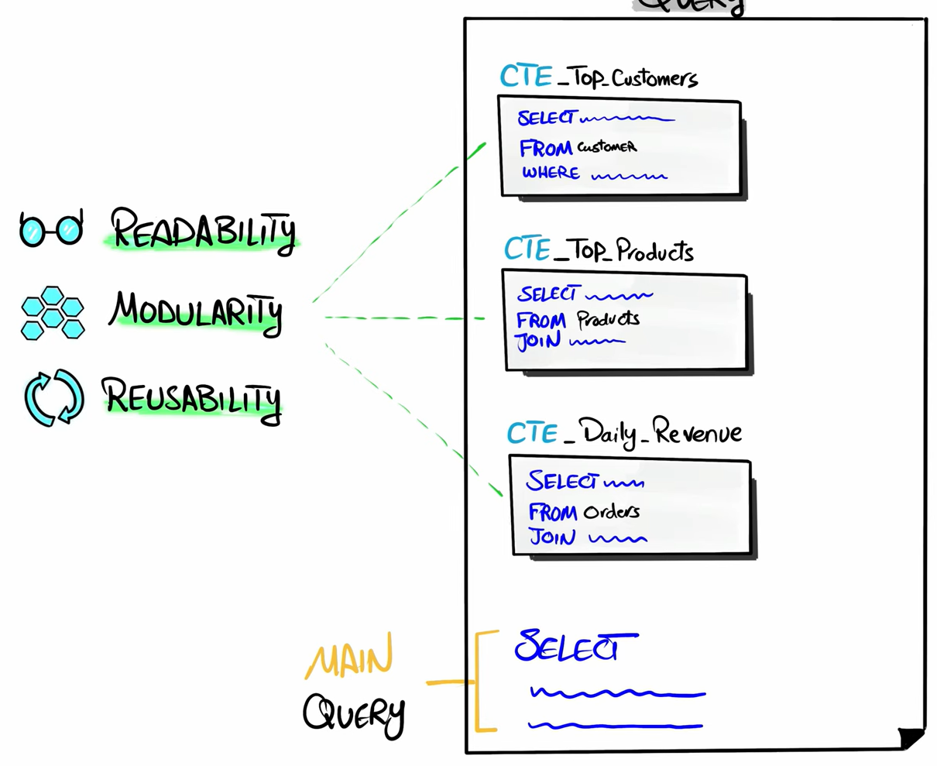

Profiling: Feature Distributions

Histogram / Frequency distribution:
SELECT fruit, COUNT(* / DISTINCT col_name) AS quantity --(1)
FROM fruit_inventory
GROUP BY 1; --output that facilitates data visualizations: histogram / bar chart
[# Output the feature distributions, or examine how frequently a typical class / value: unusual, sparse,
missing etc. appear in the data.]

To return the distribution of orders from a table that needs to be aggregated beforehand, with date, customer identifier, order identifier, & an amount, instead of simple unique identifier counting:
SELECT orders, COUNT(*) AS num_customers --(2)
FROM
(
SELECT customer_id, COUNT(order_id) AS orders
FROM orders
GROUP BY 1
) a
GROUP BY 1;
CREATE TABLE with roundtrip
A B (A-B)
B A (A-B)
A A (A-A)
LEAST(c1,c2)||’-’||GREATEST(c1,c2)
and aggregate by c3.
[# Count the no. of orders by each customer_id, then work out how many customers with the same size.]

# More complex distribution can be created at, (eg. to evaluate a few monthly sales stats for-
“ How many of each product is sold at each store? ” AND relates to inventory with if needed.)
WITH sales_history AS (
SELECT
EXTRACT('YEAR' FROM Date) AS YEAR --time grouping
, EXTRACT('MONTH' FROM Date) AS MONTH --time grouping
, ProductId --need to know which products are sold
, StoreID --need to know which stores are selling
, SUM(quantity) AS UnitsSold --how many (impacts inventory)
, AVG(UnitPrice) AS UnitPriceProxy --can be interesting
, COUNT(DISTINCT salesID) AS NumTransactions --unique transactions
FROM [project_name].sales.sales_info
GROUP BY YEAR, MONTH, ProductId, StoreID
)
SELECT --create inventory with monthly sales ref to verify stock level
inventory.*
,( SELECT AVG(UnitsSold) FROM sales_history
WHERE inventory.ProductID = sales_history.ProductID
AND inventory.StoreID = sales_history.StoreID) AS avg_quantity_sold_in_a_month
FROM [project_name].sales.inventory AS inventory
For each ProductID + StoreID, you’ll find:
• The current inventory of every product for each store
• The average monthly sales quantity for each product at every store

Binning:
# Discretize a continuous feature into a defined finite no. of bins / groups.
SELECT
CASE WHEN order_amount <= 100 THEN 'up to 100'
WHEN order_amount <= 500 THEN '100 - 500'
ELSE '500+' END AS amount_bin
,CASE WHEN order_amount <= 100 THEN 'small'
WHEN order_amount <= 500 THEN 'medium'
ELSE 'large' END AS amount_category
,COUNT(customer_id) AS customer
FROM orders
GROUP BY 1,2
;

n-Tiles:
# Instead of arbitrary-sized bins, particular shape bins can be achieved by
# using {rounding / logarithms / n-tiles} numeric function.
SELECT ROUND(sales,-1) AS bin SELECT LOG(10,sales) AS bin # for skewed dist.
,COUNT(customer_id) AS customers ,COUNT(customer_id) AS customers
FROM table FROM table
GROP BY 1 GROUP BY 1
; ;
[# Create equal-width bins.] [# Create increase size bins following a useful pattern.]
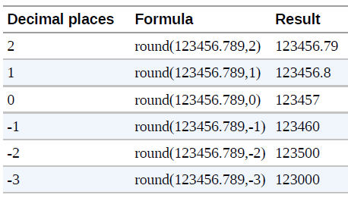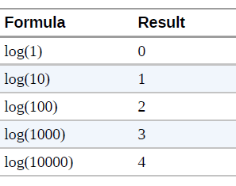
Note: Logarithm function will return null / error on >=0 value depending on database.
# Create n-quantiles of the data
SELECT ntile ** Both NTILE() & PERCENT_RANK() can be expensive to
,MIN(order_amount) AS lower_bound compute over large dataset as it requires sorting of rows.
,MAX(order_amount) AS upper_bound (filtering to only data needed can help optimize process)
,COUNT(order_id) AS orders
FROM
(
SELECT customer_id, order_id, order_amount
,NTILE(10) OVER (ORDER BY order_amount) AS ntile
FROM orders
) a
GROUP BY 1
;

Profiling: Data Quality
- One common consistency check is, comparing data against what is known to be true.
(eg. Compare the row counts in each system to verify that the data is complete with all rows
arrived & received when working with a replica of production database )

Detecting Duplicates:
( Often figuring out why duplicate occurs from its repeated trait is useful for improving work process )
—eg. accident with a hidden many-to-many JOIN, multiple tracking call in ETL, or manual steps etc.
SELECT records, COUNT(*) OR SELECT c1, c2, c3, ..., COUNT(*)
FROM FROM table
( GROUP BY 1,2,3...
SELECT c1, c2, … COUNT(*) AS records HAVING COUNT(*) > 1
FROM table ;
GROUP BY 1,2,3...
) a
WHERE records > 1
;
[# Returns total no. of duplicates and lists out all the rows for more detail. ]

Removing duplications by DISTINCT / GROUP BY:
# For nonduplicate records in a single table:
SELECT DISTINCT * FROM customer --(1)

# For nonduplicate records of customers that appear in the other table only:
SELECT DISTINCT a.customer_id, a.customer_name, a.customer_email --(2)
FROM customers a --alias
JOIN transaction b ON a.customer_id = b.customer_id

Another useful approach is to perform an aggregation that returns 1-row per entity:
—eg. we can return 1-record per customer with any aggregated info when we have a no. of transactions
by the same customers.
SELECT customer_id
, MIN(transaction_date) AS first_transaction_date
, MAX(transaction_date) AS last_transaction_date
, COUNT(*) AS total_orders
FROM table
GROUP BY 1
;

Data Cleaning

Handling missing value
SELECT DISTINCT t1.emp_name, t1.emp_dept, t2.location_name
FROM Employee_Data AS t1
RIGHT JOIN Department_Data AS t2 ON t1.emp_dept = t2.department_name
WHERE t1.emp_name IS NULL
;
emp_name emp_dept location_name
Gaurav HR Building 1 => NULL Marketing/Sales Building 3
Anjali IT Building 2 ...
NULL Marketing/Sales Building 3
...

[# We can often detect missing data by comparing values in two tables.]
Before making any changes, it is essential to evaluate the missing data first.
—Missing data is not always an ill-condition that needed to be fixed right away, but can be
an important signal to reveal underlying design flaws or biases in the data collection process.

If the data is to be included in a calculation, then the missing values ought to be fixed.
# To replace NULL value in a row,
i. CASE WHEN c1 IS NULL AND c2 = 'name' THEN expr1 ELSE c1 END AS col_name
::imputing values based on statistical metric/likelihood/interpolation
ii. LAG/LEAD(product_price) OVER (PARTITION BY product ORDER BY order_date)
::fill-forward / backward w/ insightful assumption about typical value (eg. price of same date).
iii. - SELECT c1, c2, COALESCE(min_num, c2 * 0.5) AS threshold
- SELECT product || '-' || COALESCE(subcategory, category, family, 'no product description')
AS product_and_subcategory
FROM stock
::replace NULLs with the first non-NULL value in the list.
product_and_subcategory
pork ribs – pork meat
tomatoes – vegetables
lettuce – leaf vegetables
hamburger – cow meat
hamburger – no product description
Note: ¹ Similar to Python, null value is contagious and any operation with it will result in NULL.
² In PostgreSQL & Oracle, NULL is considered larger than any non-NULL value when
ordered; Vice-versa for SQLite, MySQL & SQL Server.

* Beware of empty strings disguise as NULL, where there is no visible value present in a cell.
( empty string -'' is appropriate as value overcoming NOT NULL constraint in an explicit non-existing /
no suitable answer than missing )

# Collectively, LENGTH() & TRIM() can be used to check and remove unintended chr / spaces.

Rectifying non-standardized string of a class
CASE WHEN gender = 'F' THEN 'Female'
WHEN gender = 'female' THEN 'Female'
WHEN gender = 'femme' THEN 'Female'
ELSE gender
END AS gender_cleaned
CASE WHEN likelihood IN (0,1,2,3,4,5,6) THEN 'Detractor'
WHEN likelihood IN (7,8) THEN 'Passive'
WHEN likelihood IN (9,10) THEN 'Promoter'
END

@ for multiple columns consideration,
CASE WHEN likelihood <= 6 AND country = 'US' AND high_value = TRUE
THEN 'US high value detractor'
WHEN likelihood >= 9 AND (country IN ('CA', 'JP') OR high_value = TRUE) THEN 'some other label'
END
Note: The CASE statement works well only for a relatively short list of values that isn’t expected
to change. Otherwise, an utility table will be a better option.

Another use is to create dummy vars for statistical / numerical analysis.
SELECT customer_id
,CASE WHEN gender = 'F' THEN 1 ELSE 0 END AS is_female
,CASE WHEN likelihood IN (9,10) THEN 1 ELSE 0 END AS is_promoter
FROM table
;

Creating flags
—eg. identify if a customer belongs to a treatment group based on the no. of matching conditions from various transactions in a dataset that has multiple rows per entity: name / id.
SELECT customer_id
,MAX(CASE WHEN fruit = 'apple' AND quantity > 5 THEN 1
ELSE 0
END) AS loves_apples
,MAX(CASE WHEN fruit = 'orange' AND quantity > 5 THEN 1
ELSE 0
END) AS loves_oranges
FROM table
GROUP BY 1
;

Datetype Conversion
(Type conversion function): cast(c1 AS VARCHAR) or, c1::VARCHAR
# To manipulate a string field for numerical application:
SELECT REPLACE('$19.99', '$', '')::float or, CAST(REPLACE('$19.99', '$', '') AS float)
# To concatenate strings from different fields: (eg. time-series data)
SELECT (year || ',' || month || '-' || day)::date or, CAST(concat(year, '-', month, '-', day) AS date);
, COUNT(transactions) AS num_trx MAKE_DATE(2020, 09, 01);
FROM table
GROUP BY 1
;
[# Double pipe ||, is a concatenation operator to assemble values from separate columns.]
# If categorization of numeric values w/ upper / lower bound is needed:
CASE WHEN order_items <= 3 THEN order_items::VARCHAR
ELSE '4+'
END
[# This is especially handy when database does not support type coercion (eg. INT <-> FLOAT), and
requires data to be explicitly defined.]

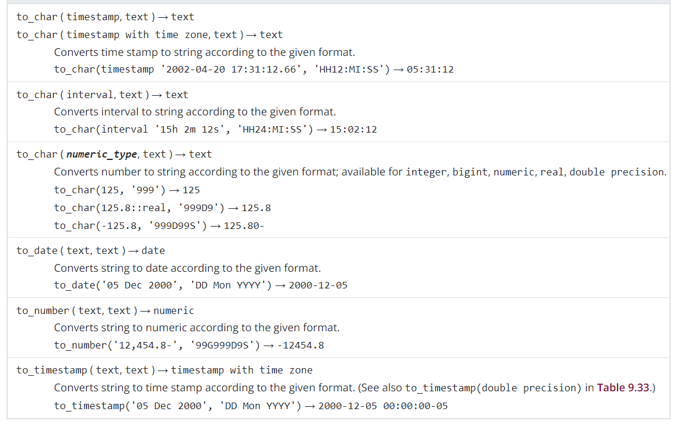
(For more pointed behavior, the dedicated datatype conversion function may be used.)

Converting datetime field into different levels of granularity
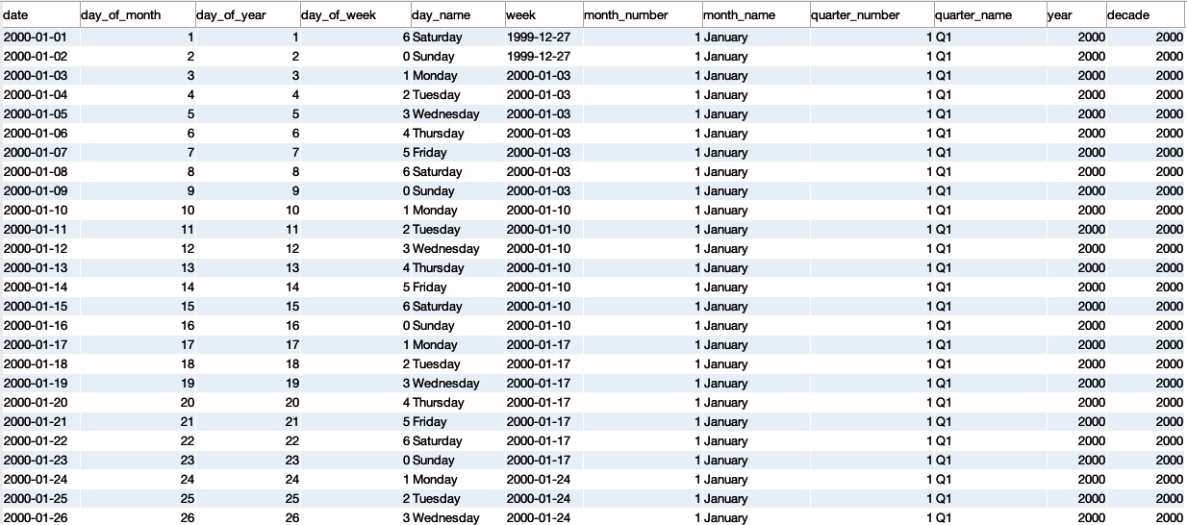
- A sample data dimension table with extensible breakdown of date components since a given date.

Through a JOIN to the created or manually generated date dimension table using generate_series(start, stop, step) function as followed:
SELECT a.generate_series AS order_date, b.customer_id, b.items ----(1)
FROM
(
SELECT * FROM GENERATE_SERIES('2020-01-01'::date, '2020-12-31'::date, '1 day')
) a
LEFT JOIN
(
SELECT customer_id, order_date, COUNT(item_id) AS items
FROM Orders
GROUP BY 1,2
) b ON a.generate_series = b.order_date
Note: With such a table we can ensure that a query returns a result for every date of interest,
whether or not there was a record for that date in the underlying dataset.

If a date dimension is not available in database, a subquery can be used to simulate one by SELECT -ing the DISTINCT dates from any source that has the timeseries needed and JOIN.
SELECT ----(2)
a.date, b.customer_id
, b.subscription_date, b.annual_amount / 12 AS monthly_subscription
FROM
(
SELECT DISTINCT sales_month
FROM RetailSales
WHERE sales_month BETWEEN '2020-01-01' AND '2020-12-31'
) a
JOIN CustomerSubscriptions b ON a.date BETWEEN b.subscription_date
AND b.subscription_date + INTERVAL '11 months'

Shaping Dataset

Often the decision on the shape depends on how data will be used downstream
- Smaller, aggregated, and highly specific datasets are preferred for visualizations
considering the repetitive & level of aggregation and slices, or timeline the end user will need to filter on.
- Generally, the notion of tidy data will follow as:
Each variable forms a column Each record forms a row Each entry in a cell

Pivoting
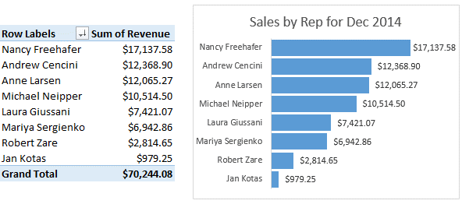
To create a pivot table which aggregates & shapes data into more compact and easily understandable form, each distinctive group of a feature is presented as a new column:
SELECT order_date
,SUM(CASE WHEN product = 'shirt' THEN order_amount ELSE 0 END) AS shirts_amount
,SUM(CASE WHEN product = 'shoes' THEN order_amount ELSE 0 END) AS shoes_amount
,SUM(CASE WHEN product = 'hat' THEN order_amount ELSE 0 END) AS hats_amount
FROM orders
GROUP BY 1
;
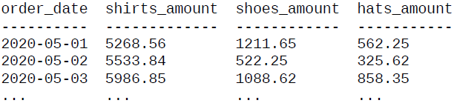
[# As SQL pivoting employs explicit categorization w/ CASE statement, it is not suitable for
rapid changing / expanding datasets and advisable to compute in other analysis tool.]

Note: ELSE statement is included for sum aggregation to avoid NULL, otherwise should be ignored in count / count DISTINCT where a substitute value could inflate unneccesary count.

Unpivoting
# To move data stored in columns into rows to create tidy data:
SELECT country,'1980' AS year,year_1980 AS population FROM country_populations
UNION ALL
SELECT country,'1990' AS year,year_1990 AS population FROM country_populations
UNION ALL
SELECT country,'2000' AS year,year_2000 AS population FROM country_populations
UNION ALL
SELECT country,'2010' AS year,year_2010 AS population FROM country_populations
;
Postgres -> SELECT country
,UNNEST(array['1980', '1990', '2000', '2010']) AS year
,UNNEST(array[year_1980, year_1990, year_2000, year_2010]) AS pop
FROM country_populations
;
* PostgresSQL offers array data structure for minor elements collection as object relational database.
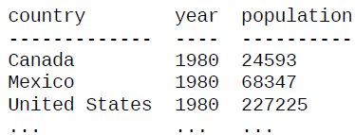

[# Integrate selections from multiple queries w/ compatible dtype using UNION statement.]

Recognizing that the pivot & unpivot are common, some databases have created its dedication functions that operate in similar manner: (Microsoft SQL Server & Snowflake)
SELECT ... SELECT *
FROM ... FROM country_populations
pivot(aggregation(value_c1) unpivot(population)
for label_c2 in (‘cate1’, ‘cate2’, ...)) for year in (year_1980, year_1990, ...)
GROUP BY ... ;
;
(Although the syntax is more compact than CASE construction, the desired cols still need to be
specified and it doesn’t solve the problem for newly arriving or rapidly changing sets of fields. )

Datetime Manipulation
- Time-series is a serial of records or measurements documented in datetime order,
often at regular intervals to outline changes over time.

Time Zones.
( Time zone may be localized or referred to the universal standard: UTC / older GMT )
- Converting time zone for a timestamp data using ‘at time zone statement’:
SELECT '2020-09-01 00:00:00 -0' at time zone 'pst'; # UTC(offset - 0) to PST
- Some databases offer dedicated functions - CONVERT_TIMEZONE( ) / CONVERT_TZ( )
SELECT CONVERT_TIMEZONE('pst', '2020-09-01 00:00:00 -0')

* Using standard UTC time as reference may be convenient, but it does not reflect the actual moment of the day an activity is being carried out.
(Check database’s documentation for the exact specification or lookout for timezone offset)

Note: However, timestamp values won’t necessarily have the time zone embedded, and may
require consulting with the source / vendor to figure out how the data was stored.

Date / Timestamp Format.
- Converting string / Unix epoach to appropriate datetime format:
TO_DATE(source, 'yyyy-mm-dd') or, TO_TIMESTAMP(source, 'yyyy-mm-dd HH:MI:SS')
- Abstracting the datetime data to desired period:
DATE_TRUNC('period', time) or, DATE_FORMAT(datetime_source, '%Y-%m-01') ^{MySQL}
::2020-10-01 00:00:00
- Extracting individual date / time part:
DATE_PART('component', timestamp) or, EXTRACT('YEAR_MONTH' FROM “2020-02-17”)
::return float dtype :: 202002
TO_CHAR(timestamp, 'Day'/'Month'/...)
::return text dtype
- Composing date & time from separate columns into a timestamp:
SELECT date_source + time_source AS timestamp
The standard time period incl.- microsecond, millisecond, second, minute, hour, day, week,
month, quarter, year, decade, century, millennium.
DATETIME math involves: the dates themselves / `INTERVAL` ^{ie. Python timedelta} - which defines the numeral system of date & time unit. [# year(s), month(s), day(s), hours, minute(s) & second(s)]
SELECT event_date FROM t1 WHERE event_date < current_date – INTERVAL '3 months'
SELECT time '05:00' + INTERVAL '3 hours' (Refer. PostgreSQL doc for complete functions & operators)
* Calculation may be included in JOIN during query but it will be slower than equality btw dates.

There are few areas on datetime records needed particular attention when aligning data from different sources with uniform JOIN / UNION.
- Consistent formatting & time zone to serialize the data (eg. UTC), or
isolate time zone to a separate field so that timestamp can be converted as needed.
- Look out for timestamps from different sources that are slightly out of sync (eg. recorded on client devices instead of common server), and can be fixed by adjusting the time window for complete records with BETWEEN & date math.
- When dealing with data from mobile apps, pay particular attention to how the timestamps were recorded- when the action happened on the device or arrived in the database (eg. real-time / store & forward) which datetime can be corrupted.

Exploring trends of time series data
With time series data, we often want to look for trends- to examine for unusual events and/or
depict the typical pattern in parts as comparisons or whole component in the data.
— ( ie. how a measured property / metric changes over time )

SELECT DATE_PART('year', sales_month) AS sales_year ---- Simple trends
,kind_of_business, SUM(sales) AS sales
FROM RetailSales
WHERE kind_of_business
IN ('Book stores','Sporting goods stores', 'Hobby, toy, and game stores')
GROUP BY 1,2
;
:: sales_year kind_of_business sales -- X: dates / timestamps ( here, yearly )
1992.0 Book stores 8327 -- Y: numerical values
1992.0 Hobby, toy, and game stores 11251
1992.0 Sporting goods stores 15583
... ... ...
[# Usually, data is prepared in SQL and fed into other charting tool to create visualizations. ]
! All currency trx / operations are usually adjusted for inflation to reflect their true nature.
- Create a smoother time series data (trend) by transforming datetime & aggregating at yearly level to help us gain a better understanding of the pattern, separating from the noise.

Comparing Components
(eg. to quantify the difference over time by: ¹ size / ² ratio – sales amt or, pct of total)
SELECT DATE_PART('year', sales_month) AS sales_year ----(1)
,SUM(CASE WHEN kind_of_business = "Women's clothing stores" THEN sales END)
-
SUM(CASE WHEN kind_of_business = "Men's clothing stores" THEN sales END)
AS womens_minus_mens
FROM RetailSales
WHERE kind_of_business IN ("Men's clothing stores", "Women's clothing stores")
AND sales_date <= '2019-12-01'
GROUP BY 1
;
sales_year womens_minus_mens / womens_pct_of_mens
1992.0 21636 212.5552608311229000
1993.0 22388 224.7339891588034500
1994.0 20553 204.8744019138756000
... ... ...

SELECT sales_year, (womens_sales / mens_sales - 1) * 100 AS womens_pct_of_mens
FROM ----(2)
(
SELECT DATE_PART('year', sales_month) AS sales_year
,SUM(CASE WHEN kind_of_business = "Womens's clothing stores" THEN sales
END) AS womens_sales
,SUM(CASE WHEN kind_of_business = "mens's clothing stores" THEN sales
END) AS mens_sales
FROM RetailSales
WHERE kind_of_business IN ("Men's clothing stores", "Women's clothing stores")
AND sales_month <= '2019-12-01'
GROUP BY 1
) derived_t
;

[# It shows that the gap decreased btw 1992 and about 1997, began a long increase through about 2011
(with a brief dip in 2007), and then was moving more or less flat through 2019. ]

Percentage of segment / category to Total
(eg. men’s & women’s clothing sales from Total / monthly sales from each year sales)

#1 Computing combined men's & women's sales from total sales:
SELECT sales_month, kind_of_business, sales, total_sales
,SUM(sales) OVER (PARTITION BY sales_month) AS total_sales
,sales / SUM(sales) * 100 OVER (PARTITION BY sales_month) AS pct_total
FROM RetailSales
WHERE kind_of_business IN ("Men's clothing stores", "Women's clothing stores")
;
-- OR --
SELECT sales_month, kind_of_business, sales / total_sales * 100 pct_total_sales
FROM
(
SELECT a.sales_month, a.kind_of_business, a.sales, SUM(b.sales) total_sales
FROM RetailSales t1
JOIN RetailSales t2 ON --Cartesian JOIN of 2 rows from t2 for each row of t1- total clothing
t1.sales_month = t2.sales_month
AND t2.kind_of_businness IN ("Men's clothing stores"
, "Women's clothing stores")
WHERE t1.kind_of_business IN ("Men's clothing stores"
, "Women's clothing stores")
GROUP BY 1,2,3
) subquery
;
sales_month kind_of_business sales ^{optional} total_sales ^{optional} pct_total_sales
1992-01-01 Men's clothing stores 701 2574 27.23
1992-01-01 Women's clothing stores 1873 2574 72.77
1992-02-01 Men's clothing stores 1991 2649 75.16
... ... ...
- Women’s clothing sales became an increasing pct of the total starting in the late 1990s.
- Seasonal patterns in men’s sales spike as pct of total in DEC & JAN, but by the late of 2010s
they’re damped almost to the point of randomness.

