AI ENVIRONMENT GENERATOR WITHIN UNITY
A Generative AI–Driven 3D Virtual Reality Language Learning Environment
───────────────────────────────────────────────────────
Rhine-Waal University of Applied Sciences
Faculty of Technology and Bionics · Innovative Technology

Submitted by
Pham Anh Hoang
Student ID: 35479

Project Report · September 2026

Built with the assistance of Claude AI (Anthropic) — which contributed significantly to
the design, implementation, and documentation of this project.

Keywords: Generative AI · Unity 6 · VR · Language Learning · LLM · Ollama · Gradio · Matplotlib

Abstract
This report documents GenAI 3D Virtual Reality Augmented, a project developed for the Innovative Technology course at Rhine-Waal University of Applied Sciences. The system connects large language model (LLM) AI generation to a live Unity 6 3D virtual environment, encouraging students to learn AI concepts through hands-on creative building rather than passive study. Two complementary modes are provided: a Builder Mode in which the user decorates a virtual doctor's office with AI-generated 3D objects and professionally inspired colour palettes, and a Learner Mode in which the user converses freely with an AI-powered bilingual NPC doctor to practise German medical vocabulary. The project originated from an open-source GitHub repository as a starting point, but numerous technical limitations led to a full redesign while preserving the core concept. Claude AI (Anthropic) contributed substantially to both the implementation and this report. The project is built entirely on free and open-source technologies: Unity 6 URP, Python 3.10, Gradio, Ollama, and Matplotlib.

Table of Contents
1. Prerequisites & Setup ...................................... 4
2. Introduction & Inspiration ................................. 4
3. System Architecture ........................................ 6
4. Builder Mode ............................................... 7
5. Learner Mode ............................................... 9
6. Quiz System ................................................ 10
7. Ollama Integration ......................................... 11
8. Technical Challenges ....................................... 11
9. Developing Areas ........................................... 12
10. Conclusion ................................................ 12
11. References & Credits ...................................... 13

1. Prerequisites & Setup
The following software must be present on a Windows 10/11 machine before running the project. A convenience script (setup.bat) automates installation of most items via winget and pip.

Prerequisite | Version / Notes
Unity Hub + Unity 6 | 6000.4.3f1 — includes Android module for Quest deployment
Python | 3.10 or newer — must be added to system PATH during install
Git | Any recent version — required to clone the repository
Ollama | Latest — install from https://ollama.com, then run: ollama pull llama3
CUDA (optional) | 11.8+ — only required for GPU acceleration of local AI models
Varjo Base (optional) | 4.16+ — only for users with a Varjo XR headset

1.1 Quick Start
- Right-click setup.bat → Run as administrator — installs prerequisites and all Python packages automatically.
- Open Unity Hub → Add → select the cloned folder → wait for asset import (approx. 5 minutes on first run).
- Double-click START_ALL.bat — launches all Python services on their respective ports.
- Open http://localhost:7860 in a browser to access the main Gradio interface.
- Press Play in the Unity Editor to start the live 3D environment.

Key Python packages declared in requirements.txt include: gradio ≥ 4.0, fastapi, uvicorn, torch, Pillow, and requests. All are installed automatically by START_ALL.bat if missing.
2. Introduction & Inspiration
2.1 Motivation: AI Through Creative Building
The core belief behind this project is that people learn best when they are creating something they care about. Everyone enjoys the idea of designing their own space — choosing the colours, placing the furniture, making it feel like their own. This project harnesses that instinct and channels it into AI and language learning.
Rather than sitting a student in front of a quiz or a lecture, the system invites them to build a 3D room. As they generate objects and choose colours using AI tools, they naturally engage with the technology behind those tools — prompting LLMs, interpreting generated code, adjusting parameters. At the same time, the environment they are building is a German medical doctor's office, so every object they create, every wall colour they select, and every conversation they have with the NPC doctor reinforces the medical German vocabulary they are supposed to learn. The creativity is not decorative — it is the learning mechanism.
The project is developed for the Innovative Technology course at Rhine-Waal University of Applied Sciences, which challenges students to apply current and emerging technologies in novel, practical ways. Building a generative AI environment from scratch — integrating LLMs, a 3D game engine, a web interface, and language learning — directly fulfils that challenge.
2.2 Starting Point & New Approach
Early in the project, an open-source GitHub repository was explored as a possible starting point. The concept it proposed — combining generative AI with Unity to produce VR environments — aligned with the project's direction. However, during initial implementation, numerous technical faults became apparent: deprecated Unity APIs, brittle AI integration that was not reproducible on a standard Windows machine, non-functional core features, and an architecture that did not cleanly separate the AI and Unity layers. The approach was fundamentally different enough from what this project needed that the implementations share almost nothing in common. Rather than patching a broken foundation, the decision was made to build from scratch — keeping the same central idea (AI-generated 3D environments for learning) but solving every structural problem properly with a new design.
2.3 Colour Inspiration: Professional Paint Standards
A distinctive feature of the project is that room colours are not arbitrary — they are drawn from the same colour standards used by professional interior designers and architects. Three reference systems were used:
- Dulux (https://www.dulux.co.uk) — the UK's leading paint brand. Dulux's curated colour families (Heritage, Scandi, Natural Whites) provided the warm neutral tones (soft cream, warm beige, muted sage) used as defaults for the medical room palette. Dulux colour codes are named and balanced for real-world interior harmony.
- PPG Paints (https://www.ppgpaints.com) — a global architectural coatings brand whose "Voice of Colour" palette system defines professionally validated colour combinations. PPG's medical and workplace colour guidance informed the contrast ratios between wall, floor, and ceiling in the AI colour generator.
- RAL Colour Standard (https://www.ral-farben.de) — the European industrial colour standard widely used in architecture, signage, and product design. RAL codes provide precise, unambiguous colour references that the AI prompt can cite by name (e.g., RAL 9010 Pure White, RAL 1013 Oyster White) to generate consistent, reproducible palettes.
The AI colour generator embeds rules derived from these systems — analogous schemes for wall/ceiling, complementary accents for trim, warm neutrals as defaults for clinical spaces — so that every randomly generated palette is aesthetically grounded rather than arbitrary.
2.4 Claude AI: A Collaborative Tool
A significant portion of this project — including the majority of the C# Unity scripts, Python microservices, Gradio interface code, debugging sessions, and this report — was built in collaboration with Claude AI, an AI assistant developed by Anthropic. Claude was used as a pair-programming partner throughout development: generating initial code, explaining Unity 6 API changes, debugging race conditions, and drafting documentation.
The use of Claude itself is consistent with the project's theme: demonstrating how AI tools can accelerate and enhance creative and technical work when used thoughtfully. The student directed all architectural decisions, defined the learning goals, tested and validated every component, and wrote all requirements — Claude translated those requirements into working code and assisted with their refinement. All work submitted represents the student's own understanding and design intent, implemented with AI assistance.
3. System Architecture
The system is divided into a Unity 6 3D runtime and a set of Python microservices that communicate with it over localhost HTTP and a shared JSON configuration file. This separation keeps the Unity render loop free of AI inference latency while allowing Python's AI ecosystem to handle all model calls.
3.1 Running Processes
Service | Port / Role
gradio_app_v2.py | 7860 — Main web UI: Builder Mode + Learner Mode
room_ai_gradio.py | 7865 — Standalone AI room generator with Matplotlib 3D preview
tts_server.py | 7866 — Neural TTS endpoint (in development — see Section 9)
Ollama | 11434 — Local LLM server (llama3, deepseek-coder, phi3, etc.)
Unity 6 (Editor/Build) | — 3D renderer, VR runtime, quiz HUD, NPC doctor sprite

3.2 Communication Layer
Python writes room configuration changes to room_config.json using an atomic write (tempfile.mkstemp + os.replace) so Unity never reads a half-written file. Unity's RoomAutoLoader polls this file every second and hot-reloads colours and room settings instantly without stopping play mode. All other inter-process communication uses localhost HTTP via FastAPI endpoints.
3.3 AI Backend: Ollama
All LLM inference — NPC conversation and object generation — is handled by Ollama, a local model server that runs entirely on the user's machine. Ollama requires no API key, no cloud subscription, and no internet connection after the initial model download. Models such as llama3, phi3, and deepseek-coder can be pulled once and used indefinitely. This keeps the system fully operational offline and ensures that student conversation data never leaves the local machine.

4. Builder Mode
Builder Mode is designed around the insight that creativity and learning reinforce each other. When a student is actively constructing their environment — choosing colours, placing furniture, describing objects in English and seeing them appear in 3D — they are simultaneously practising the vocabulary that belongs to that space. The act of building becomes an act of learning, and the finished room becomes a personal memory palace for the vocabulary it contains.
This mode is also an exercise in applied AI: the student must formulate clear natural-language prompts, interpret the 3D results, and iterate if the output is not right. These are exactly the skills that the Innovative Technology course aims to develop.
4.1 Original Vision: Six AI-Generated Walls
The original ambition was for all six surfaces of the room — four walls, floor, and ceiling — to be independently AI-generated with unique textures, patterns, and imagery, creating a fully generative interior. In practice this proved unworkable: current AI image generation is not synchronised enough to produce six visually coherent surfaces simultaneously. Results were inconsistent in colour temperature, style, and scale, and generation times were too slow (30–60 seconds per image × 6) for an interactive session.
The approach was revised: rather than generating image textures, the system uses AI to select a harmonious flat colour for each surface. The AI prompt embeds colour theory principles drawn from Dulux, PPG, and RAL standards — analogous hue schemes, warm neutrals for clinical spaces, complementary floor/ceiling contrast — so every generated palette is professionally grounded. Generation takes under one second instead of several minutes, and the results are visually consistent across all six surfaces. The colour picker in the Gradio interface also allows manual override for full creative control.

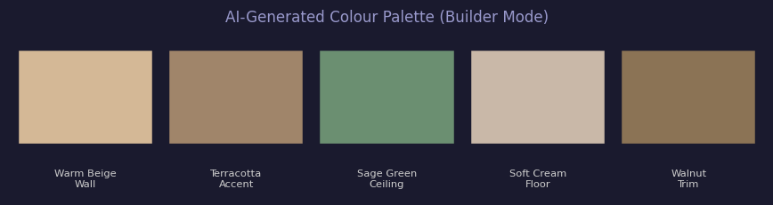
Figure 1 — AI-generated colour palette in Builder Mode.
Colours are selected following Dulux, PPG, and RAL colour theory rules for professional interiors.
4.2 AI Object Generation
The second pillar of Builder Mode is natural-language 3D object generation. The user types a description — "add a grand piano near the left wall", "place a coat rack by the door" — and the AI returns Unity C# code that spawns a detailed multi-primitive object at the correct position inside the room. Each object is composed of at least six Unity primitives (cubes, cylinders, spheres) to achieve recognisable proportions: a chair requires separate primitives for the seat, back panel, and four legs, each sized and coloured correctly.
The generated C# class uses [RuntimeInitializeOnLoadMethod(AfterSceneLoad)], meaning the object appears automatically the moment Unity enters play mode — no scene editing, no drag-and-drop. The class name is derived from the request (e.g., "grand piano near window" → GrandPiano_Window.cs), making it easy to remove individual objects by simply deleting the corresponding file from Assets.
4.3 Matplotlib 3D Preview
Before any code is written to Unity, the Gradio interface renders a lightweight 3D preview using Python's Matplotlib library. Two side-by-side viewports are shown: one displaying the generated object in isolation, and one showing it in context within the full room alongside all existing furniture. This allows the student to check placement and scale before the Unity compiler runs.
Using Matplotlib for 3D visualisation is a deliberate pedagogical choice: it is a standard library covered in the course curriculum, and repurposing it as a real-time scene previewer demonstrates that familiar tools can be applied in unexpected, creative ways far beyond their conventional use as chart-making tools.

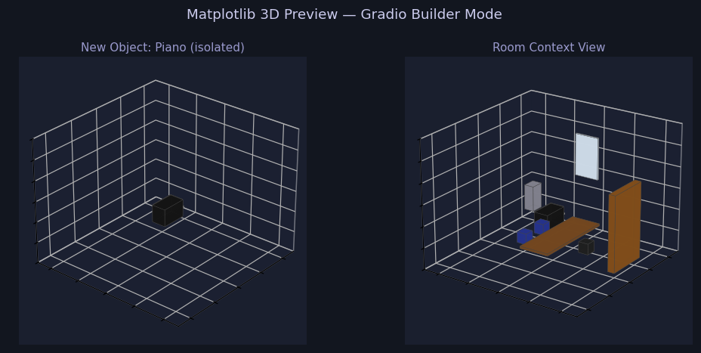
Figure 2 — Matplotlib 3D preview in Builder Mode.
Left: generated object in isolation. Right: object placed in the full room context with existing furniture.

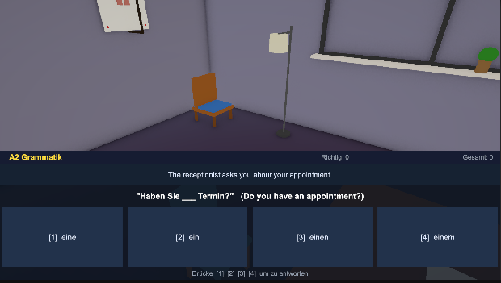
Figure 3 — Unity scene showing an AI-generated chair placed in the room corner.
The A2 Grammatik quiz UI is visible at the bottom, illustrating how Builder and Quiz modes coexist in the same scene.

4.4 Generated Objects Panel
The Gradio Builder Mode maintains a live list of every AI-generated C# script currently present in the Unity Assets folder. The student can see at a glance which objects have been added in the current session, and delete any of them directly from the browser — the corresponding .cs file is removed and Unity recompiles the scene without that object. Base room scripts (the permanent furniture and room structure) are filtered from this list so only student-generated additions appear.

5. Learner Mode
Learner Mode is designed for a different kind of engagement: focused, conversational language practice. Where Builder Mode is active and creative, Learner Mode is reflective and communicative. The two modes serve complementary purposes within a single learning session — build the room in Builder Mode, then sit down in Learner Mode and have a conversation in the environment you created.
Critically, Learner Mode does not require a VR headset. It runs entirely in the web browser through the Gradio interface. The AI component is fully maintained: the NPC doctor is still powered by a live LLM, still responds intelligently, and still produces the same bilingual German/English structure as in the full VR session. This makes the learning experience accessible on any device — a laptop in a library, a tablet at home — without requiring specialised hardware.
5.1 Free-Style AI Conversation
The defining feature of Learner Mode is that the student controls the learning style. Rather than following a fixed lesson plan, the student describes at the start of the session how they want to learn, and the AI adapts completely. Examples of learning styles that have been tested with the system:
- Full German immersion — "Reply only in German, no English." The AI responds entirely in German, maximising exposure to the language.
- Partial translation — "Reply in German but translate any word I might not know." The AI annotates selectively, reducing overload for beginners.
- Role-play scenario — "Pretend I am a new patient arriving for the first time." The AI conducts a realistic German intake interview.
- Grammar correction mode — "Correct every grammar mistake I make and explain the rule." The AI acts as a language tutor.
- Topic restriction — "Only use vocabulary about prescriptions and medication." The AI confines its vocabulary to a specific domain for targeted practice.
This flexibility means a single Learner Mode session can serve a complete beginner who needs full scaffolding and an advanced student who wants intense immersion — with no configuration changes, just a different opening message to the AI.
5.2 Bilingual Response Format
When no specific style is requested, the NPC doctor defaults to a structured bilingual format: German phrases appear first (prefixed with 🇩🇪) so the student must attempt comprehension before the English translation appears below (prefixed with 🇬🇧). Grammar notes and vocabulary tips appear in parenthetical lines. This default is calibrated for A2-level learners who need reassurance that they understood correctly but still benefit from seeing the German form first.
5.3 Hint System
A Hint button is always available. Clicking it asks the AI to provide additional context for the current conversation: the correct grammatical article for a noun just used, a related vocabulary cluster, or a pronunciation note. This on-demand scaffolding keeps the student in the conversational flow without needing to break out to a dictionary or grammar reference.
5.4 Comfort and Environment
A recurring theme in the project's design is the idea of comfort — making the learning environment feel welcoming rather than clinical or stressful. The warm colour palettes drawn from Dulux and PPG references, the personalised room the student has built themselves, and the conversational (rather than interrogative) style of the NPC doctor all contribute to a psychological setting where the student feels at ease making mistakes. Language learning research consistently shows that low-anxiety environments produce better retention; the project's aesthetic and conversational design choices are deliberate responses to this.

6. Quiz System
The quiz system provides structured, repeatable vocabulary practice alongside the free-form conversation of Learner Mode. It targets A2-level German medical vocabulary and grammar — the level appropriate for a student beginning a German-language clinical placement.
6.1 Question Types
QuizManager.cs implements three question categories drawn from realistic medical contexts:
- A2 Vocabulary — Object naming: "The doctor uses this to listen to your heart. Was ist das?" with four multiple-choice answers. Every object named in the quiz appears or could appear in the room the student has built.
- A2 Grammar — Fill-in-the-blank sentences from doctor–patient exchanges: "Ich habe ___ Kopfschmerzen" with article/case options. These reinforce German grammatical case in medical context.
- B1 Challenge — A harder question appears every tenth correct answer, providing progressive difficulty without disrupting the A2 flow for students who improve quickly.
All questions display four multiple-choice answers. Wrong answers show a contextual tip (e.g., "das Stethoskop — neuter noun, always das/ein"). Questions shuffle and loop so the quiz never ends and the order never repeats. A running score appears in the Unity HUD overlay.
6.2 Connection to the Built Environment
The quiz is deliberately linked to the room the student has constructed. Vocabulary questions name objects that the student has either placed themselves (piano, coat rack, lamp) or that appear in the base room (desk, chair, bookshelf, window). This spatial anchor — knowing that "das Stethoskop" is the object hanging from the NPC doctor's neck, three metres away — creates a richer memory trace than a decontextualised flashcard.

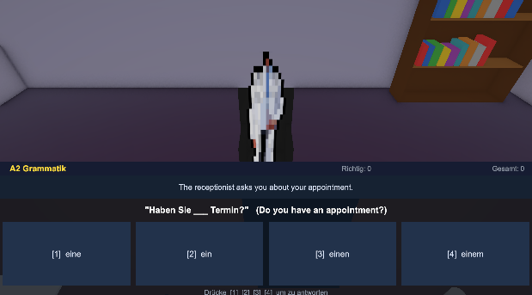
Figure 4 — A2 Grammar quiz running in Unity. The NPC doctor stands in the background while
"Haben Sie ___ Termin?" is displayed with four multiple-choice answers. Score shown top-right.

6.3 Wall Image Quiz (In Development)
An extension currently under development replaces the six procedural paintings on the right wall of the doctor's office with photographs corresponding to the current quiz question. When the question asks about a stethoscope, a large photograph of a stethoscope appears on the wall; when it asks about a blood pressure monitor, that image appears instead. The student will be able to walk up to the correct image and select it as their answer, turning the room walls themselves into an interactive answer panel. Sample images for all quiz items (augentropfen, blutdruckgeraet, mikroskop, etc.) are already included in the project — the remaining work is implementing the selection raycast and answer validation.

 | 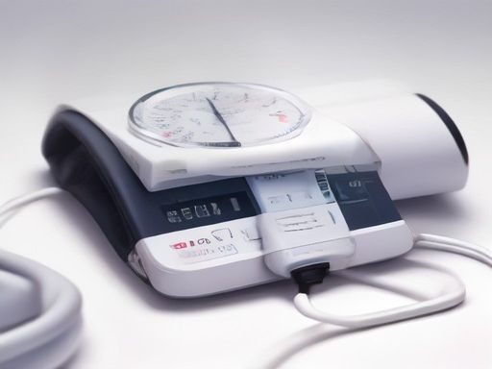 | 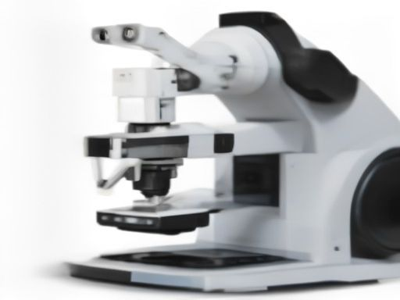
Figure 5 — Sample wall quiz images (already included in the project):
Augentropfen (eye drops) · Blutdruckgerät (blood pressure monitor) · Mikroskop (microscope).

7. Ollama Integration
Ollama is used as the local LLM backend for the NPC doctor conversation and the room object generator. The primary reason for choosing Ollama is offline capability: a student working without reliable internet — on campus between classes, on a train, or in a lab with restricted outbound access — should still be able to use the full system without interruption. Ollama runs entirely on the local machine and supports a wide range of models (llama3, llama3.1, phi3, deepseek-coder) that can be pulled once and used indefinitely without API keys or costs.
7.1 Solving the Long Response Time
The main drawback of local LLMs is latency. On a mid-range CPU without a GPU, llama3 can take 20–40 seconds to generate a full NPC response — long enough to break the conversational rhythm of a language learning session. Three measures were applied to reduce this:
- Streaming — the Gradio chat box renders each token as it arrives rather than waiting for the complete response. The student sees text appearing word by word within 1–2 seconds of sending, making the interaction feel responsive even when full generation takes longer.
- Smaller models — for conversation on machines without a GPU, phi3-mini (3.8 B parameters) is recommended over llama3 (8 B). It produces coherent bilingual responses at roughly 3× the token speed, with quality that is sufficient for A2 medical German conversation.
8. Technical Challenges
The following challenges were encountered and resolved during development.
- Hot-reload race condition — Python's open("w") truncates the file before writing; Unity sometimes read an empty config. Fixed with atomic writes (tempfile.mkstemp + os.replace) and only advancing the timestamp if parsing succeeded.
- URP colour shift — Global Volume post-processing altered rendered colours even on Unlit materials, making Unity colours differ from the Gradio preview. Fixed by cloning VolumeProfiles at runtime and disabling colour-grading components while keeping Bloom and Vignette active.
- Unity 6 API deprecations — FindObjectOfType and FindObjectsOfType were replaced with FindFirstObjectByType and FindObjectsByType(FindObjectsSortMode.None) across all affected scripts to eliminate build warnings.
- LLM output errors — Models occasionally emit named colour constants (Color.black) or miss the f suffix on float literals, causing C# compile errors. A regex post-processor corrects or discards invalid lines before the code is written to Assets.
- Original codebase faults — The reference GitHub repository used deprecated Unity APIs, broken AI integration, and non-reproducible setup steps. The decision to rewrite from scratch avoided accumulating technical debt on an unstable foundation.
9. Developing Areas
The following features are partially implemented and actively under development. Both are considered close to completion given the right technical references.
9.1 AI Doctor Voice (Text-to-Speech)
A text-to-speech pipeline is in place at the server level: tts_server.py uses Microsoft's edge-tts library with the voice de-DE-FlorianMultilingualNeural to synthesise natural German speech, and Unity's NPCVoice.cs can play the resulting audio with 3D spatial positioning so the voice appears to come from the doctor's location in the room. The Gradio Learner Mode also includes a browser-side speech implementation using the Web Speech API. The current issue is an intermittent echo artefact under certain Windows audio configurations. The root cause is under investigation and the feature is expected to be resolved shortly once the correct audio session management approach is identified from Unity and Windows audio documentation.
9.2 Interactive Wall Picture Quiz
The image pipeline for the wall picture quiz (Section 6.3) is functional — images download and display on the room walls correctly. The remaining work is adding a selection mechanism: the student should be able to aim at a wall image and click or gaze-select it to submit their answer. This requires implementing a Physics.Raycast against the wall MeshColliders, detecting which image was hit, comparing it to the correct answer, and displaying visual feedback (highlight on hover, green/red flash on selection). Unity's raycast interaction patterns are well-documented and the implementation is straightforward once the correct collider setup is confirmed from Unity community sources on GitHub.
10. Conclusion
GenAI 3D Virtual Reality Augmented demonstrates that AI tools can be integrated into a creative, student-driven learning experience without requiring a professional development team or expensive infrastructure. By grounding the project in the universal desire to build and personalise one's own space, it turns what could be dry AI exercises into something genuinely engaging: the student is not studying AI in the abstract — they are using it to create a room they care about.
The split between Builder Mode (creative, generative) and Learner Mode (conversational, adaptive) means the system serves multiple learning states without compromise. The colour system, inspired by Dulux, PPG, and RAL standards, ensures that the environments produced are aesthetically comfortable — reinforcing the principle that a relaxed, pleasant environment produces better language retention. The quiz system anchors vocabulary in the objects the student has personally placed, creating spatial memory traces that outlast what a flashcard could achieve.
Starting from a flawed open-source reference and rebuilding it properly was itself a valuable lesson in software engineering: recognising when a foundation is unsalvageable and having the confidence to start again with a clear design is a professional skill as important as any specific technology. The collaboration with Claude AI throughout the project is also a demonstration of the course's theme — that Innovative Technology means knowing which tools to reach for and how to use them effectively alongside your own judgment.
11. References & Credits
References
[1] Unity Technologies. (2024). Unity 6 Universal Render Pipeline Documentation. https://docs.unity3d.com/6000.0/Documentation/Manual/urp/
[2] Ollama Project. (2024). Run large language models locally. https://ollama.com
[3] Dulux. (2024). Dulux Heritage & Colour Collections. https://www.dulux.co.uk/en/colour-collections
[4] PPG Paints. (2024). Voice of Colour Palette System. https://www.ppgpaints.com/color
[5] RAL Farben. (2024). RAL Classic Colour Standard. https://www.ral-farben.de/en/all-ral-colours
[6] Gradio Team. (2024). Build machine learning demos in Python. https://gradio.app
[7] Council of Europe. (2020). Common European Framework of Reference for Languages (CEFR). https://www.coe.int/en/web/common-european-framework-reference-languages
[8] Hunter, J. D. (2007). Matplotlib: A 2D graphics environment. Computing in Science & Engineering, 9(3), 90–95.
[9] Anthropic. (2024). Claude AI — AI assistant for coding, writing, and analysis. https://claude.ai

Project Credits
The following individuals and tools made this project possible:
- Pham Anh Hoang (Student ID 35479) — project design, requirements definition, system integration, testing, and validation.
- Claude AI by Anthropic (https://claude.ai) — AI pair-programming assistant responsible for the majority of C# Unity scripts, Python microservices, Gradio interface code, debugging, and this report. Used under Anthropic's standard terms of service.
- Group XR — for headset testing and validation using VR hardware, enabling real-device checks of the Unity VR deployment pipeline.
- HR Team — for providing domain data and conversation input used to make the AI doctor's responses more contextually accurate and interactive.
- Rhine-Waal University of Applied Sciences — Innovative Technology course instructors for guidance and feedback.

