Fabric Beacon
Project insights — catalog discovery, documentation, Jira-scoped analysis
Version: 2026-10-09
Repo slug: pbi-discovery-platform · Public name: Fabric Beacon

Who this document is for
Leadership, enablement, and report developers who need a single Word companion to the repo setup guide (docs/DOCUMENTATION.md). It summarizes what Fabric Beacon does, how teams onboard, what is already signed off in engineering, and what still requires your tenant (QA sync, staging cert).

Executive summary
Fabric Beacon is the self-service web platform for Microsoft Fabric and Power BI catalog work: scoped workspace discovery, semantic model inspection, business documentation, governance signals, and Jira ticket analysis that matches assets only inside the ticket’s resolved [QA] workspace — never a whole-tenant fallback.
Engineering sign-off is GO — 100% for the defined new-user scope (About → Setup → Jira → Discovery/Documentation). Production rollout in your organization still needs live credentials, [QA] workspace sync, and optional staging certification per PLATFORM-NEXT-ACTIONS.md.

Sign-off snapshot
Gate | Status | Evidence
New-user journey (§0 DOCUMENTATION.md) | Shipped | About, Setup, Jira, Documentation UI + flow strip
Jira scoped to [QA] workspace | Shipped | test_jira_qa_routing_integration.py
Setup / catalog health resilience | Shipped | setup_status_safe.py, BackendHealthBanner
Documentation product (business-only) | Shipped | test_doc_export.py, test_feature_quality.py
Signoff pytest bundle | 50 tests green | PLATFORM-ENGINEERING-SIGNOFF-100.md §E
Full backend regression | 807+ tests | backend pytest (developer venv)
User launch copy | Ready | scripts/export-platform-copy.ps1 → Downloads + LAUNCH.md
Live tenant QA sync | Ops | Setup → select Jetts/LIFT [QA] → Sync
Staging cert / burn-in | Ops | PLATFORM-P0-P1-FIX-PLAN.md §4.2

How Fabric Beacon fits your stack
Concept | What it means here
Catalog-first UX | Analysts browse and search without opening Power BI Service for every question.
Scoped Jira intelligence | Ticket text → client [QA] workspace → matches only inside that scope.
Optional agentic path | Cursor MCP (pbi-discovery, discovery-guide) — not required for web analysts.
Human-in-the-loop | Secrets in root .env only; build/GitHub delivery dry-run by default; control-plane key in prod.
Guardrails | Rate limits, encrypted platform config, no browser token forms on /jira.
Sibling products | Paginate Forge (paginated RDL), Release Orchestrator, optional label automation (operators).

New user journey
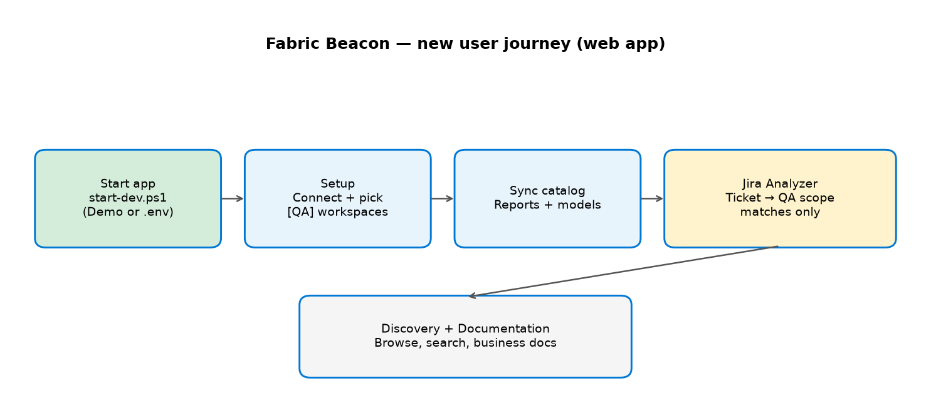
Always launch .\start-dev.ps1 (or -Demo) from the repo or Downloads copy — not frontend-only — so /api/setup/status and health checks succeed.
Step | Screen | URL
1 — Learn | About → Get started | http://localhost:5173/about
2 — Catalog | Setup → Connect, workspaces, Sync | http://localhost:5173/setup
3 — Ticket | Jira Analyzer | http://localhost:5173/jira
4 — Explore | Discovery / Documentation | http://localhost:5173/ · /documentation

Feature highlights
Area | What you get
Discovery | Workspace-scoped reports, paginated reports, dashboards (when tenant has them).
Inspector | Tables, columns, measures, DAX, relationships, RLS roles.
Search & reverse lookup | Find fields and measures across the synced catalog.
Lineage | Model-to-report graph where Scanner/metadata allows.
Governance | Health scores, stale datasets, workspace-filtered stats.
Documentation | Business narratives, Generate latest, collapsed quality panel.
Jira Analyzer | [QA] scope only; quality badge; blocked state when scope missing.
Ops | /ops dashboard + GET /api/platform/status for operators.

First-time setup (plain language)
- 1. Clone the repo or use the Downloads folder: %USERPROFILE%\Downloads\pbi-discovery-platform
- 2. copy .env.example .env at the repository root (one file for all secrets).
- 3. Demo (no Azure): .\start-dev.ps1 -Demo
- 4. Live catalog: fill PBI_PBI_* and optional PBI_JIRA_* in .env → .\start-dev.ps1
- 5. Open About → follow the four-step strip → complete Setup sync for your [QA] workspaces.
- 6. Restart the backend after any .env change.

Verification & artifacts
Artifact | Purpose
docs/DOCUMENTATION.md | Single onboarding reference for all users
docs/PLATFORM-ENGINEERING-SIGNOFF-100.md | Formal engineering GO — 100% scope
docs/RELEASE-COPY-SIGNOFF.md | Checklist before tagging a release copy
docs/PLATFORM-P0-P1-FIX-PLAN.md | Remaining ops + catalog depth tracking
LAUNCH.md (Downloads copy) | First-run steps in the exported user folder
docs/SLACK-ANNOUNCEMENT-DRAFT.md | Paste-ready Slack text + links

Slack & Confluence
Post the link to docs/DOCUMENTATION.md in your repo (not secrets). Use docs/SLACK-ANNOUNCEMENT-DRAFT.md for the full announcement. Attach this Word file for leadership summaries.

Regenerate this document
From the repository root (after pip install python-docx matplotlib):
python scripts/generate-fabric-beacon-insights-docx.py

