VIETNAM GENERAL CONFEDERATION OF LABOR
TON DUC THANG UNIVERSITY
FACULTY OF INFORMATION TECHNOLOGY



Ly Phuc Hai - 524H0013
Le Hoai An - 524H0077

FINAL REPORT
REQUIREMENTS ANALYSIS AND DESIGN

HO CHI MINH CITY, 2026
VIETNAM GENERAL CONFEDERATION OF LABOR
TON DUC THANG UNIVERSITY
FACULTY OF INFORMATION TECHNOLOGY

Ly Phuc Hai - 524H0013
Le Hoai An - 524H0077

FINAL REPORT
REQUIREMENTS ANALYSIS AND DESIGN

Advised by
Dr. Ho Thi Linh

HO CHI MINH CITY, 2026
ACKNOWLEDGEMENT
We would like to express our deepest gratitude to Dr. Ho Thi Linh, our instructor and supervisor, for her valuable guidance, dedication, and support throughout the completion of this final report on the SpaCare Management System for the Requirements Analysis and Design course. Her insightful feedback, thoughtful suggestions, and patience have greatly contributed to improving the quality of our work. Her knowledge and experience have also helped us gain a deeper understanding of requirements analysis, system modeling, and software design. We sincerely appreciate her encouragement and the time she has devoted to guiding our team throughout this project. It has been a privilege to learn from her, and we are truly grateful for her support and mentorship.
Ho Chi Minh city, 22nd October 2026.
Author
(Signature and full name)

Ly Phuc Hai

Le Hoai An

DECLARATION OF AUTHORSHIP
We hereby declare that this is our own project and is guided by Dr. Ho Thi Linh. The content research and results contained herein are central and have not been published in any form before. The data in the tables for analysis, comments and evaluation are collected by the main author from different sources, which are clearly stated in the reference section.
In addition, the project also uses some comments, assessments as well as data of other authors, other organizations with citations and annotated sources.
If something wrong happens, We’ll take full responsibility for the content of my project. Ton Duc Thang University is not related to the infringing rights, the copyrights that We give during the implementation process (if any).
Ho Chi Minh city, 22nd October 2026.
Author
(Signature and full name)

Ly Phuc Hai

Le Hoai An

TABLE OF CONTENTS
LIST OF FIGURES 5
LIST OF TABLES 6
CHAPTER 1. INTRODUCTION 1
1.1 Background and objectives 1
1.2 System scope 1
1.3 Submission structure 2
1.4 Coverage of the assignment requirements 2
CHAPTER 2. CURRENT-STATE SURVEY AND DESCRIPTION 3
2.1 Description of business operations 3
2.2 Stakeholders 3
2.3 Current business processes 4
2.4 Problems and limitations to be addressed 4
CHAPTER 3. REQUIREMENTS IDENTIFICATION AND SPECIFICATION 5
3.1 Functional requirements 5
3.2 Non-functional requirements 6
3.3 Requirements prioritization (MoSCoW) 6
CHAPTER 4. REQUIREMENTS MODELING WITH UML 7
4.1 Actors 7
4.2 Overall Use Case model 7
4.3 Detailed Use Case specifications 9
4.4 Data model (ERD) 14
4.5 Sequence and activity diagrams 14
CHAPTER 5. DATABASE DESIGN 17
5.1 Design principles 17
5.2 Relational schema 17
5.3 Key integrity rules 20
5.4 Data dictionary (excerpt) 20
CHAPTER 6. USER INTERFACE DESIGN 21
6.1 Design principles 21
6.2 Navigation flow 22
6.3 Wireframes of the main screens 22
CHAPTER 7. PROTOTYPE PLAN AND DEMO 23
7.1 Technologies 23
7.2 Demo scope 24
7.3 Sample data 25
7.4 Demo script (12–15 minutes) 25
7.5 Implementation plan 26
7.6 Results and submission links 26
CHAPTER 8. INSTALLATION AND RUN GUIDE 26
8.1 Installation 26
8.2 Running the demos 26
8.3 Using MySQL instead of H2 27
8.4 Common problems 27
CHAPTER 9. CONCLUSION 28
9.1 Achieved results 28
9.2 Limitations 28
9.3 Future directions 28
REFERENCES 29
APPENDIX A. TASK ASSIGNMENT TABLE 29

LIST OF FIGURES
Figure 4.1: Overall Use Case diagram
Figure 4.2: ERD part 1 – customers, staff, services and appointments
Figure 4.3: ERD part 2 – billing, loyalty, packages, inventory and commissions
Figure 4.4: Sequence diagram – Book appointment (UC-04)
Figure 4.5: Activity diagram – Payment and loyalty points (UC-07, UC-08)
Figure 4.6: Sequence diagram – Reschedule/cancel appointment (UC-05)
Figure 6.1: Navigation flow between the main screens
Figure 6.2: M1 – Login
Figure 6.3: M2 – Daily appointments (receptionist's main screen)
Figure 6.4: M3 – Book appointment
Figure 6.5: M5 – Payment
Figure 6.6: M6 – Customer profile and loyalty
Figure 6.7: M9 – Reports

LIST OF TABLES
Table 1.1: Coverage of the assignment requirements
Table 2.1: Stakeholders
Table 2.2: Problems of the current process
Table 3.1: Functional requirements
Table 3.2: Non-functional requirements
Table 3.3: MoSCoW prioritization
Table 4.1: Actors
Table 4.2: Use case list
Table 4.3: Specification of UC-01 (Log in and authorize)
Table 4.4: Specification of UC-04 (Book appointment)
Table 4.5: Specification of UC-05 (Reschedule/cancel appointment)
Table 4.6: Specification of UC-06 (Check in and perform service)
Table 4.7: Specification of UC-07 (Pay and issue invoice)
Table 4.8: Specification of UC-08 (Earn and redeem points)
Table 4.9: Specification of UC-10 (Assign shifts and record attendance)
Table 5.1: Accounts, customers, staff
Table 5.2: Services and appointments
Table 5.3: Invoices, payments and loyalty
Table 5.4: Shifts, commissions, inventory, reviews
Table 5.5: Data dictionary (excerpt)
Table 7.1: Technologies used
Table 7.2: Demo folders and the use cases they cover
Table 7.3: Sample data
Table 7.4: Demo script
Table 7.5: Implementation plan
Table 8.1: Demo folders and Java classes
Table 8.2: Common problems and fixes
Table A.1: Task assignment table (edit tasks and percentages to match the actual work)

INTRODUCTION

1.1 Background and objectives
Beauty and personal-care services in Vietnam are growing quickly, and the number of spas, salons, nail studios and cosmetic clinics keeps rising. Most small and medium-sized businesses still manage operations with notebooks, Excel files, Zalo/Facebook messages and the receptionist's memory. This causes double-booked appointments, customers arriving when no technician is free, hard-to-track working hours and commissions, lost supplies, and weak customer retention because there is no consistent loyalty program.
SpaCare is a spa/salon management system that digitizes the whole chain: service booking, staff management, payment and customer loyalty. The problem is also well suited to requirements analysis and design because it involves several actors, time and resource constraints (staff, rooms) and business rules for points, membership tiers and commissions.
The objectives are: (1) survey and describe the operations of a mid-sized spa/salon; (2) identify, specify and prioritize functional and non-functional requirements; (3) model the system with UML and an ERD; (4) design the database and the user interface; (5) build a UI prototype and a running Java program for the core functions.

1.2 System scope
The system does:
- Manage customers, services, combos and treatment packages.
- Book appointments (at the counter, by phone, online), detect scheduling conflicts and send reminders.
- Manage staff, shifts, attendance and commissions.
- Handle payment, invoicing, discounts and promotions.
- Run a loyalty program: points, membership tiers, point redemption and vouchers.
- Manage supplies/products at a basic level and provide statistical reports.
The system does not:
- Provide full financial accounting (general ledger, tax, detailed payroll); it only exports revenue and commission data.
- Handle medical records or clinical consultation of cosmetic clinics.
- Offer e-commerce with delivery, or integrate real payment gateways (simulated at prototype level only).

1.3 Submission structure
SpaCare_Final_Submission/
├── 01_Report/ report (Word and PDF)
├── 02_Slides/ presentation slides
├── 03_Demo/ demo only: one folder per function
│ ├── 01_Login/ UI/index.html Java/ (run.sh) GUIDE.md
│ ├── 02_Booking_Conflict/
│ ├── 03_Reschedule_Cancel/
│ ├── 04_CheckIn_Service/
│ └── 05_Payment_Loyalty/
├── 04_Database/ schema.sql, data.sql
├── 05_Presentation_Script/ timed script and demo script
├── 06_QA_Preparation/ prepared questions and answers
└── 07_Diagrams/ UML/ERD images

1.4 Coverage of the assignment requirements
The table maps every mandatory item of the assignment to the place where it is covered, so that the report can be checked against the requirements quickly.
Required item | Where covered
Cover page, inner cover, table of contents, lists of figures/tables, page numbering | Front matter
Project introduction: rationale, objectives, scope | Chapter 1
Survey and description of the current state | Chapter 2
Functional requirements (FR-01...), non-functional requirements, MoSCoW prioritization | Chapter 3
Use Case diagram, 7 use case specifications, ERD, 3 sequence/activity diagrams | Chapter 4
Database design (tables, keys, constraints, data dictionary) | Chapter 5
User interface design: wireframes and navigation flow | Chapter 6
Prototype plan/results: UI prototype and Java demo, demo script | Chapter 7, Chapter 8
Conclusion: results, limitations, future work | Chapter 9
Task assignment table and references | Appendix A, References

Table 1.1: Coverage of the assignment requirements

CURRENT-STATE SURVEY AND DESCRIPTION

2.1 Description of business operations
The surveyed organization is a mid-sized spa/salon with about 10–20 staff, 6–10 beds/chairs and 40–80 customer visits per day. It offers facial care, body massage, hair services (wash, cut, styling, coloring), nails and multi-session treatment packages, and also sells skin and hair care products.
Note for the group: this chapter should be cross-checked with interviews or observation of one or two real spas/salons and cited in the references.

2.2 Stakeholders
Stakeholder | Role and concerns
Customers | Convenient booking, being served on time, earning points and receiving offers
Receptionist | Receives bookings, checks customers in, takes payment; needs fast, low-error operations
Technician/Stylist | Knows own schedule, confirms completed services, tracks commission
Manager/Owner | Schedules shifts, monitors revenue, staff performance and stock, configures promotions
Cashier/Accountant | Reconciles invoices and payments, revenue reports
SMS/Zalo/Email provider (external) | Sends appointment reminders and promotions

Table 2.1: Stakeholders

2.3 Current business processes
- Booking: customers call, message on Zalo/Facebook or walk in. The receptionist records the booking in a notebook or Excel file and asks staff availability through a group chat.
- Reminders: done manually by phone or message, often forgotten.
- Reception and service delivery: the receptionist finds the name in the notebook, assigns a bed and a staff member, and staff tell the receptionist verbally when finished.
- Payment: the bill is added up with a calculator, written by hand or printed from simple POS software; discounts are applied from memory.
- Loyalty: paper cards or a notebook, easily lost and hard to verify.
- Attendance, commission and reporting: compiled by the manager at month end from handwritten notes and consolidated manually in Excel.

2.4 Problems and limitations to be addressed
No. | Problem | Consequence
1 | Manual booking with no automatic conflict check | Double-booked staff/beds; customers wait or complain
2 | No automatic reminders | High no-show rate
3 | Scattered customer data, no service history | Hard to personalize or advise
4 | Manual points and tiers | Errors, loss of trust, poor retention
5 | Hand-calculated commissions and working hours | Slow; disputes with staff
6 | No tracking of prepaid treatment packages | Customers forget remaining sessions; hard reconciliation
7 | Supplies not deducted per service | Losses, unexpected stock-outs
8 | Slow, non-real-time reports | Decisions made without data

Table 2.2: Problems of the current process

REQUIREMENTS IDENTIFICATION AND SPECIFICATION

3.1 Functional requirements
ID | Group | Requirement
FR-01 | Account | Log in/out and role-based authorization (Manager, Receptionist, Technician, Customer)
FR-02 | Customer | Create, search and update customer profiles (name, phone, birthday, notes, allergies) and view service history
FR-03 | Service | Manage service categories, services and combos (price, duration, required room/equipment)
FR-04 | Appointment | Create an appointment: choose customer, services, staff (or "any"), date and time
FR-05 | Appointment | Suggest free time slots and check conflicts for staff and rooms/beds
FR-06 | Appointment | Reschedule or cancel appointments according to policy (at least 2 hours in advance) and record the reason
FR-07 | Appointment | Send automatic reminders via SMS/Zalo/Email before the appointment
FR-08 | Service delivery | Check in customers and update status (confirmed, checked-in, in progress, completed, cancelled, no-show)
FR-09 | Staff | Manage staff profiles and skills (services each member may perform)
FR-10 | Staff | Assign shifts and manage work schedules and days off
FR-11 | Staff | Record attendance and calculate commissions per service/product
FR-12 | Payment | Create invoices from appointments; pay by cash, card, transfer/QR; print or export invoices
FR-13 | Loyalty | Automatically earn points based on invoice value
FR-14 | Loyalty | Manage membership tiers (Silver, Gold, Platinum), automatic upgrade and tier benefits
FR-15 | Loyalty | Redeem points for discounts/vouchers; manage promotions
FR-16 | Packages | Sell and track multi-session packages (remaining sessions, expiry date)
FR-17 | Inventory | Manage supplies/products: receipts, issues, stock, low-stock alerts; deduct supplies per service
FR-18 | Feedback | Customers rate services and staff after completion
FR-19 | Reporting | Revenue, staff performance, no-show rate and loyal-customer reports by period

Table 3.1: Functional requirements

3.2 Non-functional requirements
ID | Type | Description
NFR-01 | Performance | Search and booking operations respond in under 2 seconds with 50 concurrent users
NFR-02 | Security | Hashed passwords, role-based access control (RBAC), account lockout after 5 failed logins
NFR-03 | Data protection | HTTPS in transit; customers' personal data protected in line with Vietnam's Decree 13/2023/ND-CP
NFR-04 | Availability | At least 99% uptime during opening hours; daily backups
NFR-05 | Scalability | Support multiple branches; add services, tiers or reminder channels without changing core code
NFR-06 | Usability | Vietnamese interface; a new receptionist can learn it in under 1 hour; works on desktop and tablet
NFR-07 | Integrity | No double booking of a staff member or room in the same time slot; all point and payment transactions are logged
NFR-08 | Maintainability | Layered architecture, commented code, unit tests for core business logic
NFR-09 | Compatibility | Runs on Windows/macOS/Linux with JDK 17+; MySQL 8 or PostgreSQL database

Table 3.2: Non-functional requirements

3.3 Requirements prioritization (MoSCoW)
Priority | Requirements | Rationale
Must have | FR-01, 02, 03, 04, 05, 06, 08, 09, 10, 12, 13 | Core operations; the system cannot run without them
Should have | FR-07, 11, 14, 15, 16, 19 | High value and differentiating; can be handled manually in the short term
Could have | FR-17, 18 | Improve experience and control; deferred to a later phase
Won't have (this release) | Separate mobile app, real payment gateway, full accounting | Out of scope; future directions

Table 3.3: MoSCoW prioritization

REQUIREMENTS MODELING WITH UML

4.1 Actors
Actor | Description
Customer | Uses services; books online, views points and tier, leaves reviews
Receptionist | Takes bookings, checks customers in, handles payment, manages customer profiles
Technician/Stylist | Views personal schedule, updates service status
Manager | Manages services, staff, shifts, promotions, stock; views reports
Notification service (external) | Sends SMS/Zalo/Email reminders

Table 4.1: Actors

4.2 Overall Use Case model
ID | Use case | Primary actor | Related requirements
UC-01 | Log in and authorize | All | FR-01
UC-02 | Manage customers | Receptionist, Manager | FR-02
UC-03 | Manage services/combos | Manager | FR-03
UC-04 | Book appointment | Customer, Receptionist | FR-04, 05
UC-05 | Reschedule/cancel appointment | Customer, Receptionist | FR-06
UC-06 | Check in and perform service | Receptionist, Technician | FR-08
UC-07 | Pay and issue invoice | Receptionist | FR-12
UC-08 | Earn and redeem points | Receptionist, Customer | FR-13, 14, 15
UC-09 | Manage staff | Manager | FR-09
UC-10 | Assign shifts and record attendance | Manager | FR-10, 11
UC-11 | Manage promotions and membership tiers | Manager | FR-14, 15
UC-12 | Manage treatment packages | Receptionist, Manager | FR-16
UC-13 | Manage inventory | Manager | FR-17
UC-14 | View reports | Manager | FR-19
UC-15 | Review service | Customer | FR-18
UC-16 | Send reminders | Notification service | FR-07
UC-17 | Check scheduling conflicts | (System) | FR-05

Table 4.2: Use case list
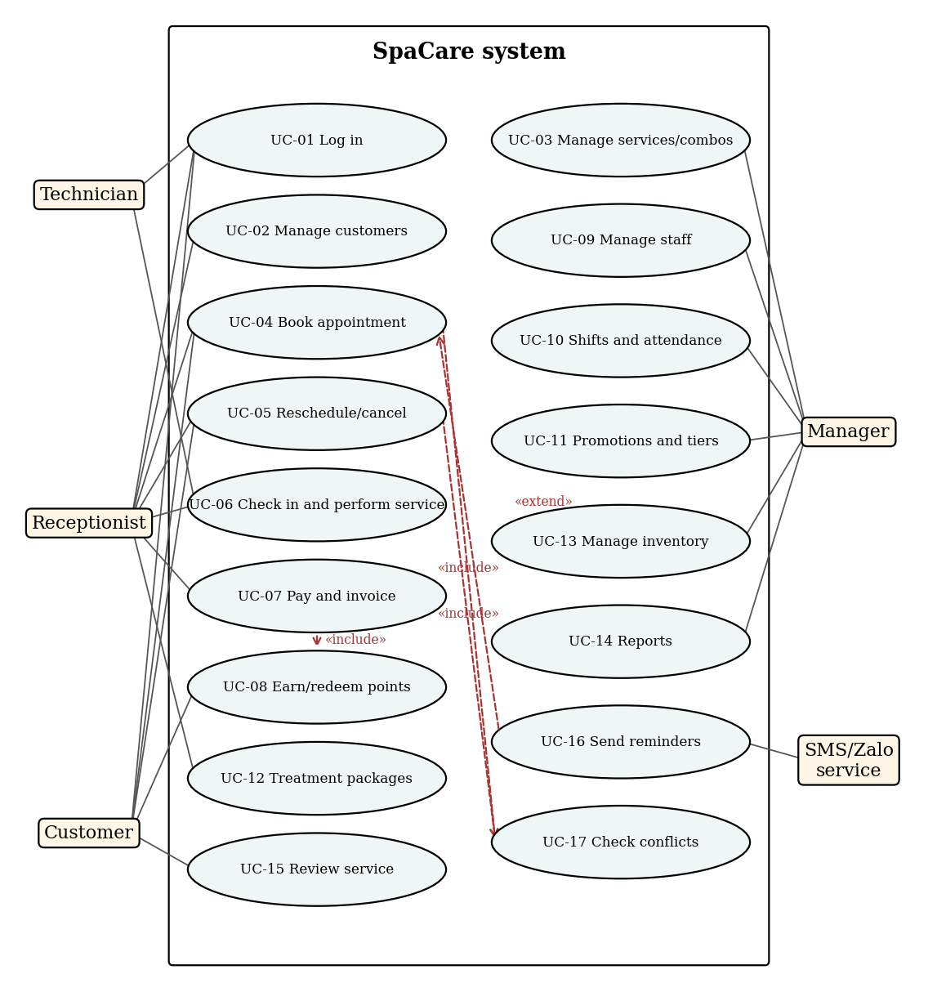

Figure 4.1: Overall Use Case diagram

4.3 Detailed Use Case specifications
Item | Content
Actors | Customer, Receptionist, Technician, Manager
Description | A user authenticates to access the functions allowed for their role
Preconditions | The account exists and is active
Postconditions | A session is created; the menu reflects the user's role
Main flow | 1. The user opens the login screen. 2. Enters username and password. 3. The system verifies the credentials (hash comparison). 4. The system determines the role and opens the matching home page
Alternative flow | 2a. The user selects "Forgot password": the system sends a reset link by email/SMS
Exception flow | 3a. Wrong credentials: show an error and increase the failure counter. 3b. 5 failures: lock the account for 15 minutes. 3c. Disabled account: deny access

Table 4.3: Specification of UC-01 (Log in and authorize)
Item | Content
Actors | Receptionist, Customer (online booking)
Description | Create an appointment for one or more services with a suitable staff member and time slot
Preconditions | The actor is logged in; at least one service is active; staff have assigned shifts
Postconditions | The appointment is saved as CONFIRMED; staff and room are reserved; a reminder is scheduled
Main flow | 1. Select or create the customer. 2. Select services/combo. 3. Select a staff member or "any". 4. Select the date. 5. The system sums the duration and shows free slots (UC-17). 6. Select a slot. 7. Add a note (optional) and confirm. 8. The system re-checks conflicts, saves the appointment and sends a confirmation
Alternative flow | 3a. "Any": the system assigns a qualified, free staff member. 2a. The customer uses a package: select a session from a valid package
Exception flow | 5a. No free slot: suggest other dates/staff. 8a. A conflict arises because someone just booked: show an error and return to step 5. 8b. The customer already has an overlapping appointment: warn and ask for confirmation

Table 4.4: Specification of UC-04 (Book appointment)
Item | Content
Actors | Customer, Receptionist
Description | Change the time of, or cancel, an existing appointment
Preconditions | The appointment status is PENDING or CONFIRMED
Postconditions | The appointment is updated (reschedule) or set to CANCELLED; the old slot is released
Main flow | 1. Find the appointment by phone number or code. 2. Choose "Reschedule" or "Cancel". 3. The system checks the policy (at least 2 hours before the start time). 4. Reschedule: choose a new slot (UC-17). Cancel: enter a reason. 5. The system saves the change and notifies the customer
Alternative flow | 3a. The receptionist/manager may override the policy with a reason
Exception flow | 3b. Past the deadline: reject and advise contacting the venue. 4a. The new slot conflicts: return to selection

Table 4.5: Specification of UC-05 (Reschedule/cancel appointment)
Item | Content
Actors | Receptionist, Technician
Description | Confirm the customer's arrival and track service status
Preconditions | A CONFIRMED appointment exists for today
Postconditions | Status moves CHECKED_IN, IN_PROGRESS, then COMPLETED; actual times are recorded; supplies are deducted
Main flow | 1. The receptionist finds the appointment and clicks Check-in. 2. The system notifies the technician. 3. The technician clicks "Start". 4. When finished, clicks "Complete". 5. The system records it and deducts supplies by usage norms
Alternative flow | 1a. Walk-in customer: quickly create an appointment, then check in
Exception flow | 1b. Customer more than 15 minutes late: keep or reschedule the slot. 1c. Customer does not show up: status becomes NO_SHOW after the slot ends

Table 4.6: Specification of UC-06 (Check in and perform service)
Item | Content
Actors | Receptionist
Description | Create an invoice for completed services, apply benefits and collect payment
Preconditions | At least one COMPLETED service is unpaid
Postconditions | A PAID invoice is stored; points are earned (UC-08); commissions are recorded
Main flow | 1. Select the appointment to pay. 2. The system creates a draft invoice. 3. Add retail products if any. 4. Apply tier discount, voucher and point redemption. 5. Choose the payment method and enter the amount. 6. The system confirms payment and closes the invoice. 7. Print or send the e-invoice. 8. The system adds points and updates the tier
Alternative flow | 5a. Split payment across methods. 5b. Deduct a session from a treatment package instead of paying
Exception flow | 4a. Voucher expired or used: show an error. 5c. Underpayment: keep the invoice as PARTIAL. 6a. Transfer cannot be confirmed: allow retry

Table 4.7: Specification of UC-07 (Pay and issue invoice)
Item | Content
Actors | Receptionist, Customer, System
Description | Add points by invoice value, upgrade tiers, redeem points for discounts
Preconditions | The customer is a member; the invoice is paid (for earning)
Postconditions | Point balance and tier are updated; the point transaction is logged
Main flow (earn) | 1. The system takes the invoice value after discounts. 2. Points = value / 10,000 VND, multiplied by the tier factor (Silver 1.0; Gold 1.2; Platinum 1.5). 3. Points are added to the account. 4. The system sums spending over the last 12 months and upgrades the tier at the thresholds (Gold from 10 million VND, Platinum from 30 million VND)
Main flow (redeem) | 1. The receptionist/customer chooses points to redeem at payment. 2. The system converts them (100 points = 10,000 VND), up to 50% of the invoice. 3. Points are deducted and logged
Exception flow | Not enough points: reject. Invoice refunded or voided: earned points are reversed. Points older than 12 months expire automatically

Table 4.8: Specification of UC-08 (Earn and redeem points)
Item | Content
Actors | Manager
Description | Schedule staff and record check-in/out times
Preconditions | Staff are active; shifts are defined
Postconditions | The schedule is saved; attendance data feeds payroll and commission
Main flow | 1. The manager selects the week and branch. 2. Assigns staff to shifts per day. 3. The system verifies no overlapping shifts and enough days off. 4. Save and publish. 5. Staff clock in/out daily
Alternative flow | Shift swap between two staff: manager approval
Exception flow | Assigning a shift to staff on leave: reject. Deleting a shift that has appointments: reschedule the appointments first

Table 4.9: Specification of UC-10 (Assign shifts and record attendance)
The tier thresholds, point multipliers and redemption rules above are the group's business assumptions and can be changed in the membership tier configuration.

4.4 Data model (ERD)
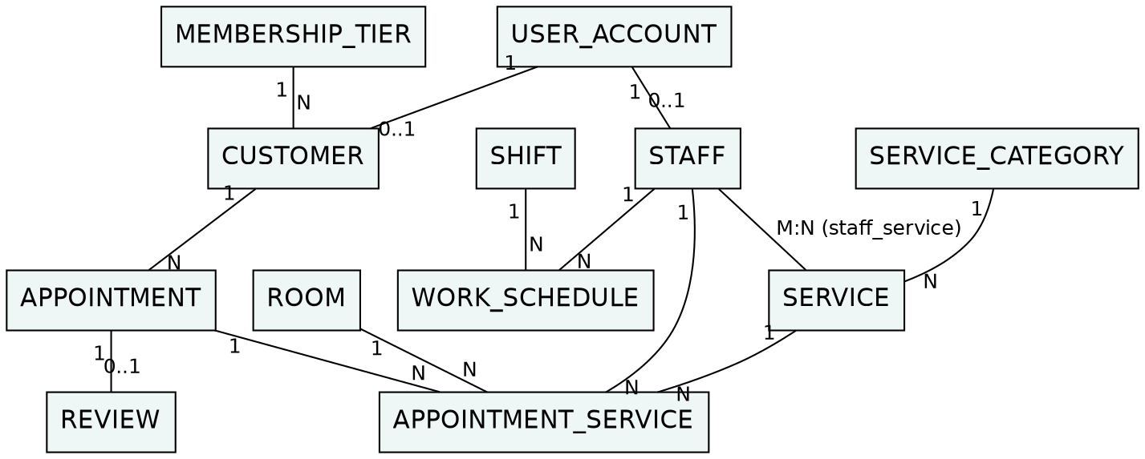

Figure 4.2: ERD part 1 – customers, staff, services and appointments
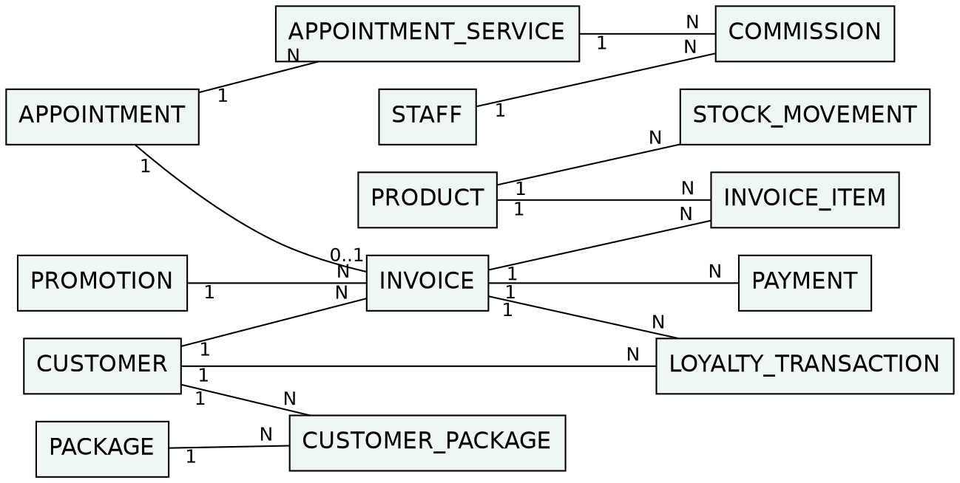

Figure 4.3: ERD part 2 – billing, loyalty, packages, inventory and commissions

4.5 Sequence and activity diagrams
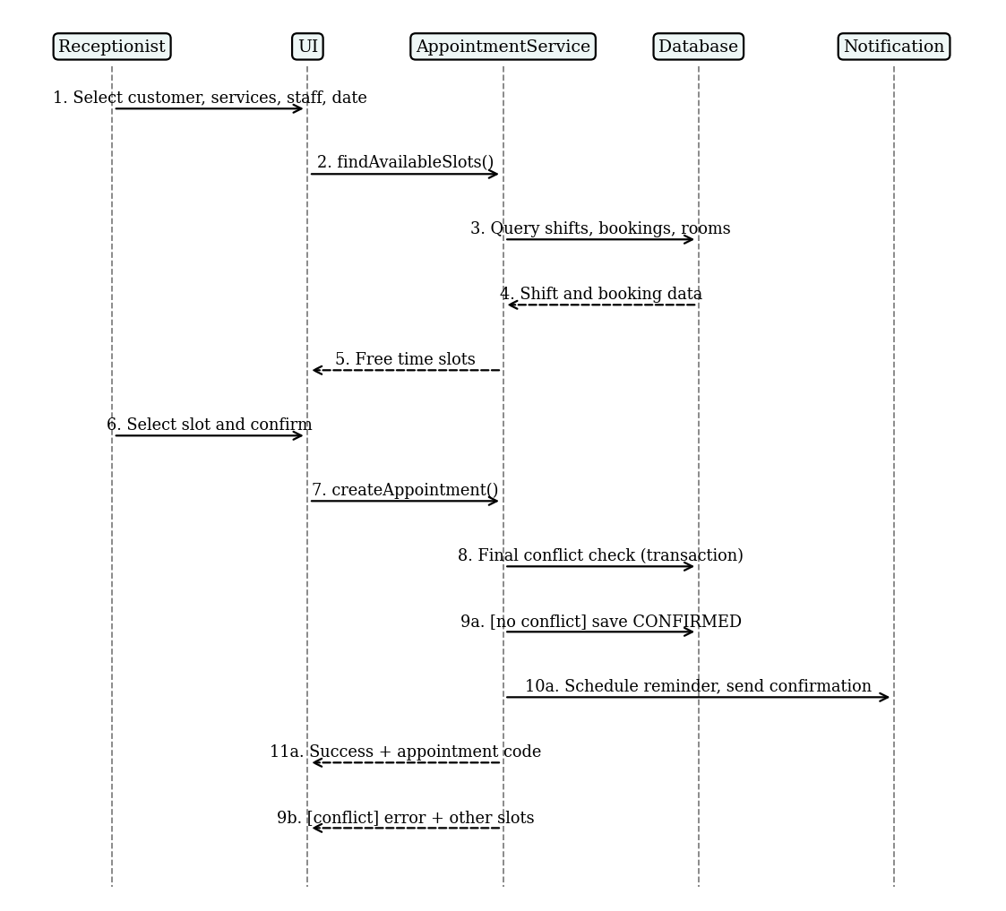

Figure 4.4: Sequence diagram – Book appointment (UC-04)
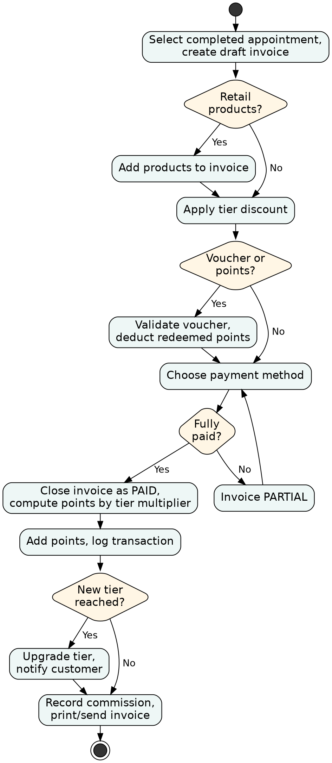

Figure 4.5: Activity diagram – Payment and loyalty points (UC-07, UC-08)
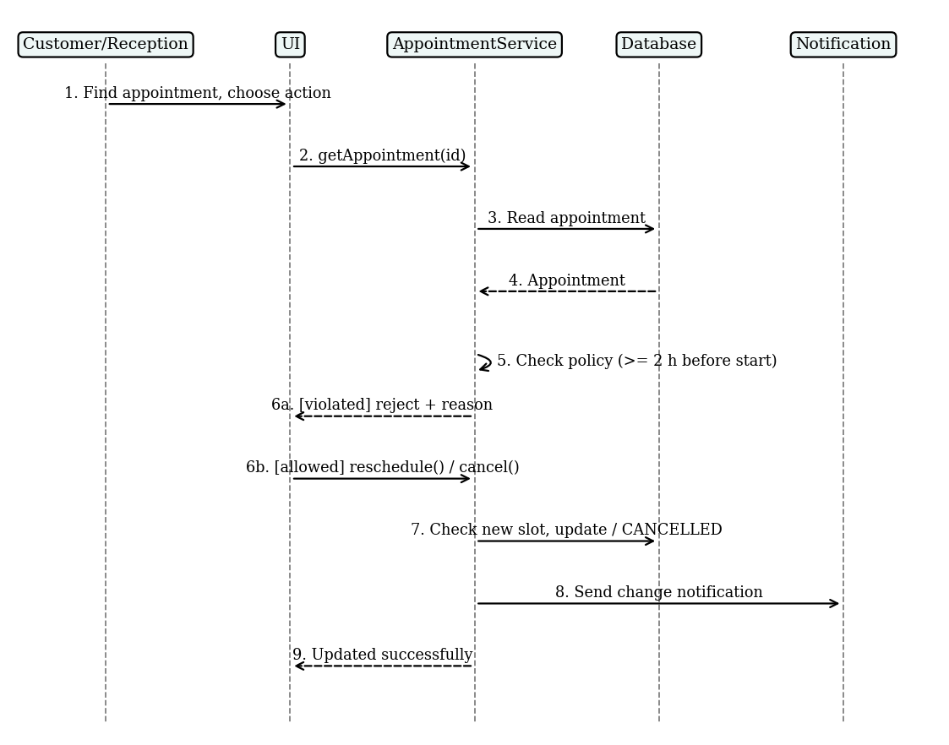

Figure 4.6: Sequence diagram – Reschedule/cancel appointment (UC-05)

DATABASE DESIGN

5.1 Design principles
The database is relational (MySQL 8 or PostgreSQL) and normalized to third normal form (3NF). Primary keys are auto-increment integers; table and column names are English snake_case, consistent with the Java source code. Notation: PK primary key, FK foreign key, UQ unique, NN not null.

5.2 Relational schema
Table | Main columns | Constraints
user_account | id PK, username UQ NN, password_hash NN, role NN, is_active, failed_attempts, locked_until | role limited to ADMIN, MANAGER, RECEPTIONIST, TECHNICIAN, CUSTOMER
membership_tier | id PK, name UQ NN (SILVER, GOLD, PLATINUM), min_spending, point_multiplier, discount_percent | min_spending ≥ 0; point_multiplier > 0
customer | id PK, user_account_id FK UQ, tier_id FK NN, full_name NN, phone UQ NN, email, birth_date, allergy_note, point_balance, spending_12m, created_at | point_balance ≥ 0
staff | id PK, user_account_id FK UQ, full_name NN, phone, position, hire_date, base_commission_rate, status | status in ACTIVE, ON_LEAVE, RESIGNED
branch | id PK, name NN, address, phone | Supports multiple branches (NFR-05)

Table 5.1: Accounts, customers, staff
Table | Main columns | Constraints
service_category | id PK, name UQ NN | –
service | id PK, category_id FK NN, name NN, price NN, duration_min NN, room_type, is_active | price ≥ 0; duration_min > 0
staff_service | staff_id FK, service_id FK | Composite PK (staff_id, service_id)
room | id PK, branch_id FK NN, name NN, room_type, is_active | UQ (branch_id, name)
appointment | id PK, customer_id FK NN, branch_id FK NN, start_time NN, end_time NN, status NN, channel, note, cancel_reason, created_by FK | status in PENDING, CONFIRMED, CHECKED_IN, IN_PROGRESS, COMPLETED, CANCELLED, NO_SHOW; end_time > start_time
appointment_service | id PK, appointment_id FK NN, service_id FK NN, staff_id FK NN, room_id FK, start_time NN, end_time NN, price_at_booking NN, customer_package_id FK | No overlapping interval for the same staff_id or room_id

Table 5.2: Services and appointments
Table | Main columns | Constraints
promotion | id PK, code UQ NN, type, value NN, valid_from, valid_to, usage_limit, min_invoice | value > 0; valid_to ≥ valid_from
invoice | id PK, appointment_id FK UQ, customer_id FK NN, promotion_id FK, subtotal NN, tier_discount, promo_discount, point_discount, total NN, status NN, created_at, cashier_id FK | status in DRAFT, PARTIAL, PAID, VOID; total ≥ 0
invoice_item | id PK, invoice_id FK NN, item_type, service_id FK, product_id FK, quantity NN, unit_price NN | quantity > 0; exactly one of service_id/product_id is set
payment | id PK, invoice_id FK NN, method NN, amount NN, paid_at, reference_code | method in CASH, CARD, TRANSFER, QR; amount > 0
loyalty_transaction | id PK, customer_id FK NN, invoice_id FK, type NN, points NN, balance_after NN, created_at, expires_at | type in EARN, REDEEM, EXPIRE, ADJUST; balance_after ≥ 0
package | id PK, name NN, service_id FK NN, total_sessions NN, price NN, valid_days | total_sessions > 0
customer_package | id PK, customer_id FK NN, package_id FK NN, remaining_sessions NN, purchased_at, expires_at | 0 ≤ remaining_sessions ≤ total_sessions

Table 5.3: Invoices, payments and loyalty
Table | Main columns | Constraints
shift | id PK, name NN, start_time NN, end_time NN | end_time > start_time
work_schedule | id PK, staff_id FK NN, shift_id FK NN, work_date NN, check_in, check_out, status | UQ (staff_id, work_date, shift_id)
commission | id PK, staff_id FK NN, appointment_service_id FK, invoice_item_id FK, amount NN, period | amount ≥ 0
product | id PK, name NN, sku UQ, unit, sale_price, stock_qty NN, reorder_level | stock_qty ≥ 0
service_product | service_id FK, product_id FK, qty_per_use NN | Composite PK; usage norm per service
stock_movement | id PK, product_id FK NN, type, quantity NN, reason, created_at | type in IN, OUT; quantity > 0
review | id PK, appointment_id FK UQ, rating NN, comment, created_at | rating between 1 and 5

Table 5.4: Shifts, commissions, inventory, reviews

5.3 Key integrity rules
- Conflict prevention: within one transaction, before inserting an appointment_service row, verify that no non-cancelled row for the same staff_id (or room_id) overlaps the interval [start_time, end_time). PostgreSQL can add an EXCLUDE constraint on time ranges; with MySQL use row locking (SELECT ... FOR UPDATE).
- Points integrity: customer.point_balance is a derived total and is always updated in the same transaction that writes the loyalty_transaction row.
- Soft delete: customers, staff and services with history are never physically deleted, only deactivated.
- Passwords: only hashes are stored, never plain text.

5.4 Data dictionary (excerpt)
Attribute | Table | Type | Meaning
status | appointment | VARCHAR(15) | Appointment lifecycle state
duration_min | service | INT | Service duration in minutes, used to compute end_time
point_multiplier | membership_tier | DECIMAL(3,2) | Points multiplier by tier
spending_12m | customer | BIGINT | Spending over the last 12 months, used for tier evaluation
price_at_booking | appointment_service | BIGINT | Price at booking time, unaffected by later price changes
balance_after | loyalty_transaction | INT | Point balance after the transaction, for reconciliation

Table 5.5: Data dictionary (excerpt)
The demo program uses a simplified subset of this schema (resources/schema.sql): the appointment table keeps start_time/end_time directly and branch_id is omitted.

USER INTERFACE DESIGN

6.1 Design principles
The interface is in Vietnamese and keeps the number of steps low for receptionists. Calm colors (teal, beige) match a spa brand, appointment states are distinguished by both color and text label, and layouts work on desktop and tablet. The wireframes below are sketches; the colored mockups are built in Figma (see Chapter 7).

6.2 Navigation flow
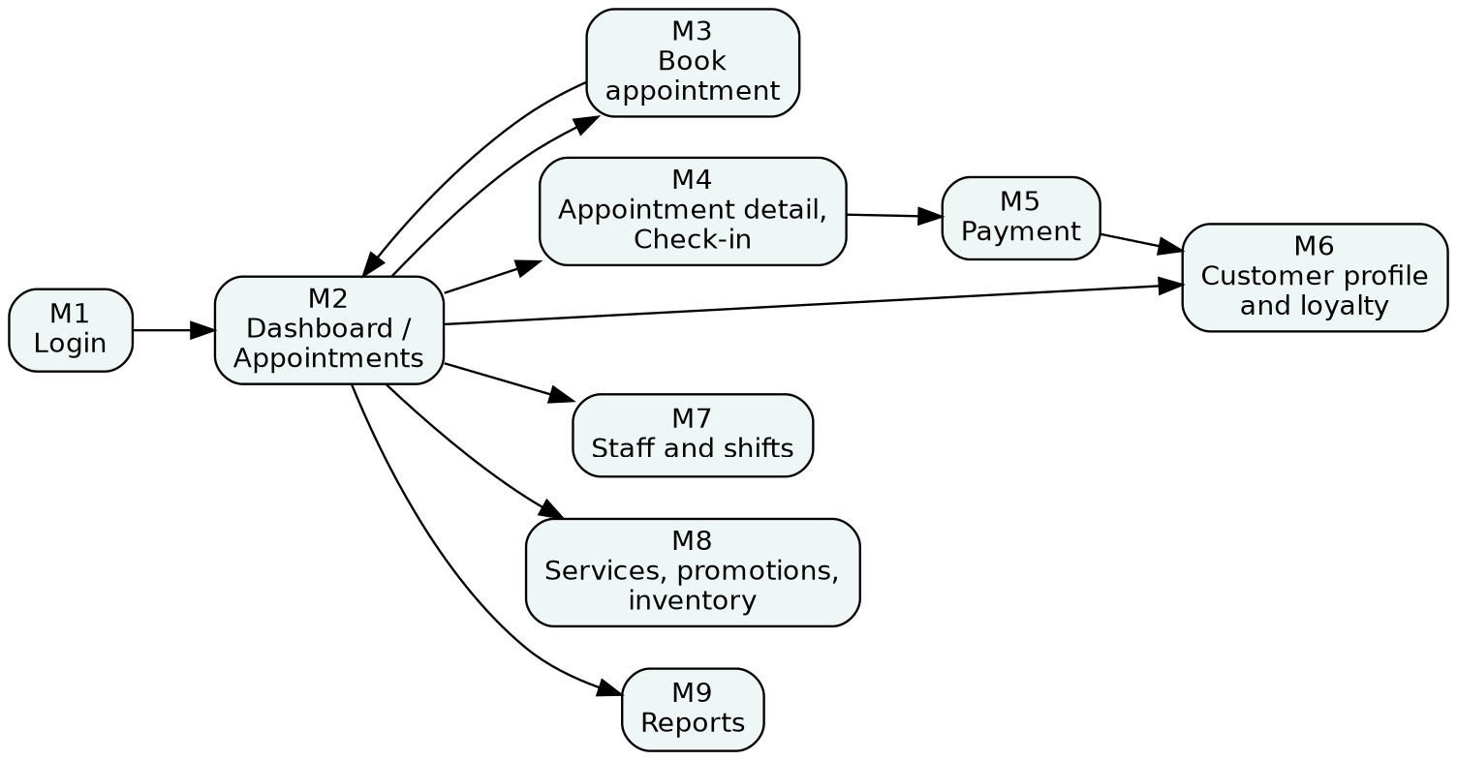

Figure 6.1: Navigation flow between the main screens

6.3 Wireframes of the main screens
+--------------------------------------+
| [SpaCare logo] |
| Username: [______________________] |
| Password: [______________________] |
| [ ] Remember me Forgot password?|
| [ LOG IN ] |
+--------------------------------------+

Figure 6.2: M1 – Login
+--------------------------------------------------------------+
| SpaCare | Appointments | Customers | Staff | Reports | [User] |
+--------------------------------------------------------------+
| < Today 12/11/2026 > Branch: [D1 v] [+ New appointment] |
+------+----------------+----------------+----------------+----+
| Time | Lan (Spa) | Minh (Stylist) | Ha (Nail) | |
| 09:00| [Massage-An] | | [Nail-Chi] | |
| 10:00| [Massage-An] | [Cut+Wash-Binh]| | |
| 11:00| | [Color-Hoa] | [Gel-Mai] | |
+------+----------------+----------------+----------------+----+
Legend: Confirmed | Checked-in | In progress | Completed

Figure 6.3: M2 – Daily appointments (receptionist's main screen)
+---------------------------------------------------------+
| BOOK APPOINTMENT |
| Customer: [Search phone/name__] [+ New] Tier: Gold |
| Services: [Select service/combo v] [+ add] |
| Relaxing hair wash 60m 150,000d [x] |
| Staff: ( ) Any ( ) [Select staff v] |
| Date: [12/11/2026] Free slots: [09:00][10:30]... |
| Note: [______________________________] |
| [ Cancel ] [ CONFIRM BOOKING ] |
+---------------------------------------------------------+

Figure 6.4: M3 – Book appointment
+---------------------------------------------------------+
| INVOICE #INV-0123 Customer: Thu H. (Gold) |
| Service Qty Unit price Amount |
| Body massage 90m 1 500,000 500,000 |
| + Product: Serum 1 300,000 300,000 |
| Subtotal 800,000 |
| Gold tier discount 5% -40,000 |
| Voucher [____] [Apply] 0 |
| Redeem points: [__] (420 available) 0 |
| TOTAL 760,000 |
| Method: (Cash)(Card)(Transfer)(QR) |
| [ Cancel ] [ PAY & PRINT ] |
+---------------------------------------------------------+

Figure 6.5: M5 – Payment
+---------------------------------------------------------+
| Thu H. | 0903 *** 123 | Tier: GOLD | Points: 420 |
| Progress to Platinum: [#######---] 18/30 million VND |
| [Info] [Service history] [Point history] [Packages] |
| 05/11 Body massage 90m - Lan - 500,000d +50 points |
| 20/10 Facial care - Ha - 650,000d +78 points |
| Active package: Hair removal x10 (6 left) |
+---------------------------------------------------------+

Figure 6.6: M6 – Customer profile and loyalty
+---------------------------------------------------------+
| Period: [November 2026 v] [Export Excel] |
| [Revenue] [Appointments] [No-show %] [New customers] |
| Revenue by day: bar chart |
| Top services | Staff performance | Tier distribution|
+---------------------------------------------------------+

Figure 6.7: M9 – Reports

PROTOTYPE PLAN AND DEMO

7.1 Technologies
Component | Choice
UI prototype | Single-file HTML prototypes (clickable), one per function; Figma optional
Demo program language | Java 17
Interface | Console application (alternatives: JavaFX/Swing, Spring Boot + Thymeleaf)
Database | H2 in-memory for the demo, MySQL 8 for production, accessed via JDBC
Project tooling | Maven, Git (GitHub/GitLab)
Testing | JUnit 5 for core logic (conflict checking, points calculation, tier upgrade) – planned

Table 7.1: Technologies used
The program follows a layered architecture: presentation (Main) → service (AppointmentService, BillingService) → data access (JDBC, class Db) → database. Separating the service layer allows independent testing and easy replacement of the interface.

7.2 Demo scope
The demonstration has two mandatory parts, and both are organized as five demos, one per main function. Every demo has its own folder in 03_Demo with a separate UI prototype (UI/index.html), a separate Java program (Java/) and a GUIDE.md.
Demo | Function (folder) | Use cases | UI prototype / Java program
1 | Login and roles (01_Login) | UC-01 | Role-based welcome, lockout after 5 failures / LoginDemo
2 | Booking and conflict (02_Booking_Conflict) | UC-04, UC-17 | Booking form with busy slots / BookingDemo
3 | Reschedule and cancel (03_Reschedule_Cancel) | UC-05 | Reschedule and cancel panel / RescheduleDemo
4 | Check-in and service (04_CheckIn_Service) | UC-06 | Status flow buttons / ServiceDemo
5 | Payment and loyalty (05_Payment_Loyalty) | UC-07, UC-08 | Invoice, points, tier upgrade / PaymentDemo

Table 7.2: Demo folders and the use cases they cover
UI/prototype part. The prototypes reflect the screens and business flows designed in Chapter 6 (M1 Login, M2 Appointments, M3 Book, M4 Check-in, M5 Payment, M6 Loyalty).
Java part. Real Java code runs live on the presenter's machine and implements the main use cases UC-01, 04, 05, 06, 07 and 08, which is 6 of the 7 specified use cases (86%) and above the required 3–5 functions. UC-10 (shifts and attendance) is specified and its sample shift data is loaded, but its screens are left to future work.

7.3 Sample data
Data | Sample content
Accounts | admin, letan01, ktv_lan, ql_hoa (password 123456)
Services | Body massage 90m (500,000 VND), Relaxing hair wash 60m (150,000 VND), Basic facial 60m (400,000 VND), Women's haircut 45m (200,000 VND), Gel polish 60m (250,000 VND)
Staff | Lan (spa), Ha (nail/skin), Minh (stylist, morning shift only); other staff work 08:00–20:00
Customers | Thu H. (Gold, 420 points), Mai (Silver, 80 points, 9.5 million VND spent, close to Gold), Linh (Platinum)
Rooms | Room 1, Room 2, Nail area, Hair area

Table 7.3: Sample data

7.4 Demo script (12–15 minutes)
Step | Content | Presenter | Time
1 | Problem, scope and requirements (slides) | Ly Phuc Hai | 2 min
2 | Use cases, ERD and database design (slides) | Le Hoai An | 2 min
3 | Demo 1 – Login and roles: UI then Java | Ly Phuc Hai | 1.5 min
4 | Demo 2 – Booking: UI then Java, deliberate double booking shows the conflict error | Ly Phuc Hai | 2.5 min
5 | Demo 3 – Reschedule and cancel: UI then Java | Ly Phuc Hai | 1.5 min
6 | Demo 4 – Check-in and service: UI then Java | Le Hoai An | 1.5 min
7 | Demo 5 – Payment and loyalty: UI then Java; Mai crosses the threshold and is upgraded to Gold | Le Hoai An | 2.5 min
8 | Conclusion, limitations, future work (slides) | Ly Phuc Hai | 1 min

Table 7.4: Demo script
Sample data for each demo is listed in Table 7.3 and in the GUIDE.md of the demo folder; every demo starts from the same data so the results can be repeated. Total about 14.5 minutes.

7.5 Implementation plan
Week | Work | Output
1 | Survey, scope | Chapters 1–2
2 | Requirements analysis | Chapter 3
3–4 | UML and ERD modeling | Chapter 4
5 | Database design, schema and sample data | Chapter 5, SQL files
6 | UI design, Figma | Chapter 6, Figma link
7–8 | Java implementation of 5 functions, testing | Source code
9 | Finalize report, rehearse presentation and demo | Report, slides

Table 7.5: Implementation plan

7.6 Results and submission links
- UI prototype: 03_Demo/0X_*/UI/index.html (open in any browser); online version: https://claude.ai/artifact/Hhosp81pQ4vsk1JUsfkBcx; Figma link (optional): [paste link here]
- Java source: 03_Demo/0X_*/Java in the submitted zip, or repository link: [paste GitHub/GitLab link here]
- Demo accounts and run instructions: see Chapter 8 and the README files.

INSTALLATION AND RUN GUIDE

8.1 Installation
Install JDK 17 or later and Maven 3.8 or later. No database installation is needed: the demo uses H2 in memory and creates the schema and sample data on every start.

8.2 Running the demos
Each demo is started from its own folder in 03_Demo. The UI part needs no installation: open UI/index.html in a browser. The Java part is started with one command:
cd 03_Demo/02_Booking_Conflict/Java
./run.sh (Windows: run.bat)

Each Java program starts a fresh in-memory database and uses tomorrow's date, so the demos can be run in any order. The Windows .bat file switches the console to UTF-8; in an IDE run the main class with -Dfile.encoding=UTF-8.
Demo | Folder / class | Use cases | What it proves
1 | 01_Login / LoginDemo | UC-01 | Roles, wrong passwords rejected, lockout after 5 failures
2 | 02_Booking_Conflict / BookingDemo | UC-04, UC-17 | Free slots, double booking refused, adjacent booking allowed, skill and shift checks
3 | 03_Reschedule_Cancel / RescheduleDemo | UC-05 | Reschedule honors conflicts, cancel frees the slot, status rules
4 | 04_CheckIn_Service / ServiceDemo | UC-06 | Status machine CONFIRMED, CHECKED_IN, IN_PROGRESS, COMPLETED
5 | 05_Payment_Loyalty / PaymentDemo | UC-07, UC-08 | Tier discount, 50% redemption limit, points earned, Mai upgraded to Gold, invalid payments refused

Table 8.1: Demo folders and Java classes
Lines marked [BỊ TỪ CHỐI] in the output are intended: they show business rules rejecting invalid actions.

8.3 Using MySQL instead of H2
Create a database named spacare, add the mysql-connector-j dependency to pom.xml and start with -Ddb.url=jdbc:mysql://localhost:3306/spacare -Ddb.user=root -Ddb.pass=....

8.4 Common problems
Problem | Fix
Vietnamese text is garbled | Run chcp 65001 (Windows) or use -Dfile.encoding=UTF-8
Unsupported class file version | Use JDK 17 or later
mvn not found | Install Maven and add it to PATH, or run spacare.Main from an IDE
No free slots appear | Slots are only offered in the future and inside the staff shift; use tomorrow's date
"Conflict" error when booking | Expected when the staff member or all rooms are busy; choose another slot

Table 8.2: Common problems and fixes

CONCLUSION

9.1 Achieved results
The report surveys the current state of a mid-sized spa/salon; defines 19 functional and 9 non-functional requirements prioritized with MoSCoW; models the system with 17 use cases (7 specified in detail), an ERD and three sequence/activity diagrams; designs a database of more than 20 tables with integrity constraints; designs six main screens with a navigation flow; and provides a Figma prototype and a Java program demonstrating the core functions.

9.2 Limitations
- Business rules (tier thresholds, point multipliers, cancellation policy) are the group's assumptions and have not been validated with many real venues.
- The Java program implements only part of the functions; reminders and electronic payment are simulated, and the interface is a console application.
- No load testing has been performed and there is no customer-facing mobile app yet.

9.3 Future directions
- Mobile/Web booking app and a Zalo Mini App for customers.
- Integration with payment gateways (VNPay, MoMo) and legally compliant e-invoicing.
- Service recommendations and no-show prediction using data analysis.
- Multi-branch chains with unified permissions and reports.

REFERENCES
[1] I. Sommerville, Software Engineering, 10th ed., Pearson, 2015.
[2] C. Larman, Applying UML and Patterns, 3rd ed., Prentice Hall, 2004.
[3] R. Elmasri and S. Navathe, Fundamentals of Database Systems, 7th ed., Pearson, 2016.
[4] ISO/IEC/IEEE 29148:2018, Systems and software engineering – Life cycle processes – Requirements engineering.
[5] Object Management Group, Unified Modeling Language Specification, Version 2.5.1, 2017.
[6] Government of Vietnam, Decree 13/2023/ND-CP on personal data protection, 2023.
[7] Oracle, Java SE 17 Documentation; H2 Database Engine documentation.
[8] [Add: surveyed venues, reference spa-management software or websites, design templates, images and libraries used in the project.]

APPENDIX A. TASK ASSIGNMENT TABLE
No. | Full name | Student ID | Tasks | Contribution | Signature
1 | Ly Phuc Hai | 524H0013 | Chapters 1–3; use case specs; Java: booking, conflict check, login | 50%
2 | Le Hoai An | 524H0077 | Chapters 4–6; ERD and database; Figma prototype; Java: payment, loyalty points | 50%
 |  |  | Total | 100%

Table A.1: Task assignment table (edit tasks and percentages to match the actual work)

