VIETNAM GENERAL CONFEDERATION OF LABOR
TON DUC THANG UNIVERSITY
FACULTY OF INFORMATION TECHNOLOGY



LY TIN HOA – 524H0015
TRAN QUANG DUY – 524H0012
HA DU TUAN – 524H0134

FINAL TERM

SOFTWARE ENGINEER

HO CHI MINH CITY, 2026
VIETNAM GENERAL CONFEDERATION OF LABOR
TON DUC THANG UNIVERSITY
FACULTY OF INFORMATION TECHNOLOGY



LY TIN HOA – 524H0015
TRAN QUANG DUY – 524H0012
HA DU TUAN – 524H0134

FINAL TERM

SOFTWARE ENGINEER

Advised by
Ph.D. Nguyen Ngoc Phien

HO CHI MINH CITY, 2026
ACKNOWLEDGEMENT

We would like to express our deepest appreciation to our instructor, Ph.D. Nguyen Ngoc Phien, for his continuous support and invaluable guidance throughout the development of this Final Term Report on Software Engineering. His comprehensive lectures and rigorous academic standards provided us with the foundational knowledge required to successfully implement complex concepts, including the Model-View-Controller architectural pattern, relational database design, and C# WinForms application development.
We are highly grateful for his dedication and the constructive environment he fostered, which challenged us to elevate the quality of our project management, architectural design, and software testing. It has been a true privilege to learn under his supervision, and the practical problem-solving skills we have cultivated during this course will undoubtedly serve as a strong asset in our future software engineering endeavors.

Ho Chi Minh city, 21st April 2026.
Author
(Signature and full name)

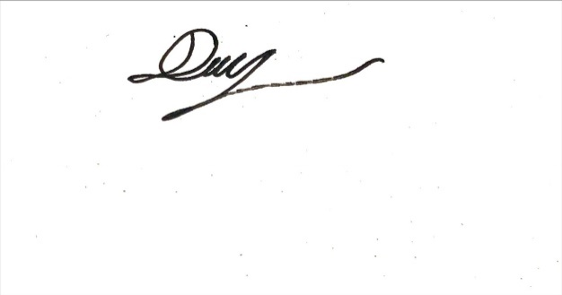


Ly Tin Hoa
Tran Quang Duy
Ha Du Tuan
DECLARATION OF AUTHORSHIP
We hereby declare that this is our own project and is guided by Ph.D. Nguyen Ngoc Phien; The content research and results contained herein are central and have not been published in any form before. The data in the tables for analysis, comments and evaluation are collected by the main author from different sources, which are clearly stated in the reference section.
In addition, the project also uses some comments, assessments as well as data of other authors, other organizations with citations and annotated sources.
If something wrong happens, We’ll take full responsibility for the content of my project. Ton Duc Thang University is not related to the infringing rights, the copyrights that We give during the implementation process (if any).
Ho Chi Minh city, 21st April 2026.
Author
(Signature and full name)




Ly Tin Hoa
Tran Quang Duy
Ha Du Tuan

TABLE OF CONTENT
LIST OF FIGURES v
ABBREVIATIONS vi
CHAPTER 1. INTRODUCTION 1
1.1 Purpose and Scope 1
1.2 Product Overview 2
1.3 Structure of the Document 2
1.4 Terms, Acronyms, and Abbreviations 2
CHAPTER 2. PROJECT MANAGEMENT PLAN 3
2.1 Project Organization 3
2.2 Lifecycle Model Used 3
2.3 Risk Analysis 3
2.4 Hardware and Software Resource Requirements 4
2.5 Deliverables and Schedule 4
2.6 Monitoring, Reporting, and Controlling Mechanisms 4
2.7 Professional Standards 4
2.8 Evidence of Configuration Management 4
2.9 Impact of the project on individuals and organizations 5
CHAPTER 3. REQUIREMENT SPECIFICATION 6
3.1 Stakeholders for the System 6
3.2 Use Case Modelling 6
3.2.1 Graphical Use Case Modelling 6
3.2.2 Textual Description for each Use Case 7
3.3 Functional Requirements 9
3.4 Non-functional Requirements 10
CHAPTER 4. ARCHITECTURE 10
4.1 Architectural Style(s) Used 10
4.2 Architectural Model 11
4.3 Technology, Software, and Hardware Used 11
4.4 Rationale for Architectural Style and Model 12
CHAPTER 5. DESIGN 12
5.1 Database Design 12
5.2 Static model - Class Diagrams 13
5.3 Dynamic Model - Sequence Diagrams 15
5.4 Rationale for Detailed Design Model 16
5.5 Traceability from Requirements to Detailed Design Model 17
CHAPTER 6. TEST PLAN 17
6.1 Requirements/Specifications-Based System Level Test Cases 18
6.2 Traceability of Test Cases to Use Cases 20
6.3 Techniques Used for Test Generation 21
6.4 Assessment of The Goodness of Testsuite 21
CHAPTER 7. t 22
REFERENCES 23

LIST OF FIGURES
Figure 3.1. Use Case Diagram 7
Figure 4.1. Architectural Model 11

ABBREVIATIONS

AES | Advanced Encryption Standard
CPU | Central Processing Unit
CS | Computer Science
DNF | Disjunctive Normal Form
GIL | Global Interpreter Lock
HTTPS | Hypertext Transfer Protocol Secure
LIFO | Last-In-First-Out
NaN | Not a Number
OAEP | Optimal Asymmetric Encryption Padding
RPN | Reverse Polish Notation
RSA | Rivest-Shamir-Adleman
TLS | Transport Layer Security

INTRODUCTION

Purpose and Scope
The purpose of this project is to develop a Computer Shop Management System designed to streamline retail operations and enhance inventory control. The system's scope encompasses managing product catalogs and hardware specifications, tracking real-time stock levels, processing customer transactions with automated updates, managing employee accounts, and generating comprehensive business performance reports.

Product Overview
The product is a Windows-based desktop application developed using C# WinForms and structured around the Model-View-Controller (MVC) architectural pattern. Its core capabilities include real-time inventory tracking, secure staff authentication, and automated sales invoice generation.

Structure of the Document
This report is organized into seven primary sections alongside references:
- Sections 1 & 2: Introduction and Project Management Plan.
- Sections 3, 4 & 5: Requirement Specifications, Architecture, and Detailed Design.
- Sections 6 & 7: Test Plan and Product Demonstration.

Terms, Acronyms, and Abbreviations
• CRUD: Create, Read, Update, Delete.
• MVC: Model-View-Controller.
• POS: Point of Sale.
• UI/UX: User Interface / User Experience.

PROJECT MANAGEMENT PLAN

Project Organization
Project Manager: Trần Quang Duy – Responsible for overall project coordination and database design.
Developer 1: Lý Tín Hòa – Focused on controller logic and implementing business rules.
Developer 2: Hà Dư Tuấn – Focused on UI/UX design and frontend implementation.
Tester: Trần Quang Duy – Responsible for test case creation and unit testing.

Lifecycle Model Used
The team strictly follows the Waterfall model. This approach ensures that each phase of the software development lifecycle—from initial requirements gathering to final testing—is thoroughly completed and documented before the team transitions to the next phase.

Risk Analysis
Anticipating potential project hurdles, the team has identified the following risks and mitigation strategies:
- Schedule Risk: Potential delays in UI design.
  - Mitigation: Set internal deadlines 3 days prior to official milestones.
- Technical Risk: Database connection and integration issues.
  - Mitigation: Conduct early integration tests between the WinForms frontend and SQL Server backend.

Hardware and Software Resource Requirements
The project relies on the following technical environment:
- Software: Visual Studio 2026, Microsoft SQL Server, and Git/GitHub for version control.
- Hardware: Standard development workstations operating on Windows 11.
Learning Outcomes:
- Member A learned: [Fill new software/skill learned].
- Member B learned: [Fill new software/skill learned].

Deliverables and Schedule
The final deliverables for this project include the Final Report, Source Code, Database Schema, and a Video Demo. All items are scheduled to be completed and submitted by [Fill Date].

Monitoring, Reporting, and Controlling Mechanisms
Project progress is actively monitored through weekly team meetings. Additionally, Git commit logs are regularly reviewed to ensure that development tasks remain aligned with the proposed schedule.

Professional Standards
The software development process adheres to strict C# Coding Conventions, utilizing PascalCase for method names and camelCase for variables. Furthermore, the project documentation complies with IEEE standards for technical writing.

Evidence of Configuration Management
All project artifacts, including the source code and this documentation, are securely maintained under version control using Git. The official repository is accessible at: https://github.com/LyTinHoa/Computer-Shop-Management-Software

Impact of the project on individuals and organizations
The software improves individual productivity for shop staff by reducing manual paperwork and enhances organizational efficiency through accurate data management and faster customer service.

REQUIREMENT SPECIFICATION

Stakeholders for the System
The primary stakeholders involved in the Computer Shop Management System are defined as follows:
- Store Owner/Manager: Oversees all store operations, manages the inventory, and reviews business performance reports.
- Sales Staff: Handles daily customer transactions, interacts directly with customers, and processes sales invoices.
- Inventory Staff: Updates physical stock levels, manages product information, and tracks specific hardware components.

Use Case Modelling

Graphical Use Case Modelling
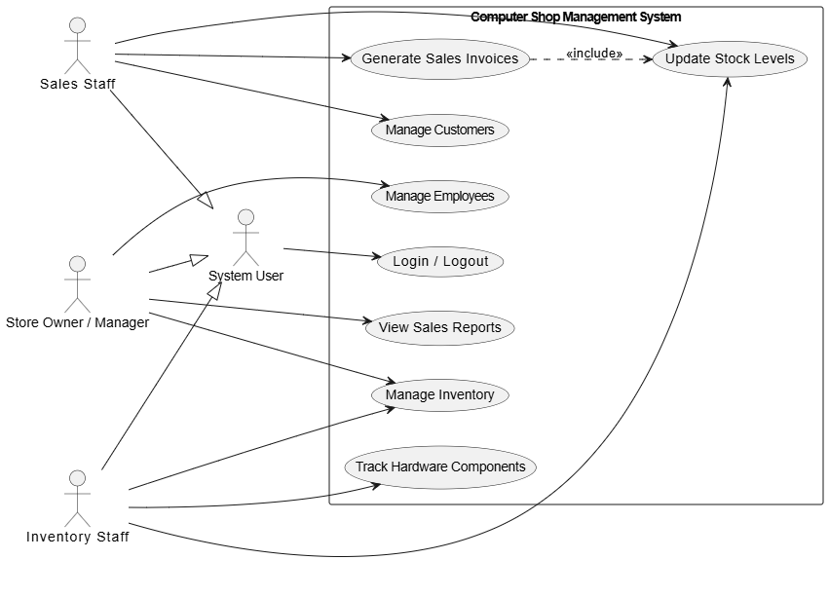
Figure 3.1. Use Case Diagram

Textual Description for each Use Case

Login / Logout
- Actor: System User (Inherited by all staff roles).
- Description: Secures the system by allowing users to enter or exit safely.
- Main Flow: The user enters their credentials; the system validates the data and either grants dashboard access or terminates the session upon logout.

Generate Sales Invoices
- Actor: Sales Staff.
- Description: Processes customer orders and creates a formal billing document.
- Main Flow: Staff selects products; the system calculates costs, applies discounts, triggers the stock update process automatically, and prints the invoice.

Manage Customers
- Actor: Sales Staff.
- Description: Maintains a database for customer contact details and purchase histories.
- Main Flow: Staff can add new profiles or update existing ones, which the system then saves to the database.

Manage Employees
- Actor: Store Owner / Manager.
- Description: Administers staff accounts, roles, and access permissions.
- Main Flow: The manager can view, create, modify, or disable staff accounts, updating the system's access control list.

View Sales Reports
- Actor: Store Owner / Manager.
- Description: Provides visual statistics regarding shop revenue and overall performance.
- Main Flow: The manager selects a date range, and the system retrieves sales records to generate summary charts.

Manage Inventory
- Actor: Store Owner / Manager.
- Description: Controls the overall product catalog, including adding new hardware models and adjusting prices.
- Main Flow: The manager updates product descriptions or prices, ensuring the database remains current.

Track Hardware Components
- Actor: Inventory Staff.
- Description: Monitors the specific technical specifications and physical status of hardware.
- Main Flow: Staff identifies a component and updates its tracking data; the system logs this history.

Update Stock Levels
- Actor: Inventory Staff (or automatically triggered by generating an invoice).
- Description: Synchronizes physical stock quantities with the digital records.
- Main Flow: The system adjusts the item quantity upon receiving an update signal and triggers a notification if stock falls to a critical level.

Functional Requirements
The system must satisfy the following functional capabilities:
- FR1 (Authentication): Provide secure Login and Logout functionalities for all authorized users.
- FR2 (Sales Processing): Allow sales staff to efficiently generate invoices and process orders.
- FR3 (Inventory Management): Provide comprehensive tools for managing the product catalog and tracking hardware specs.
- FR4 (Customer Management): Enable staff to store, search, and update customer data and transaction history.
- FR5 (Employee Administration): Allow managers to create, update, and govern staff accounts and roles.
- FR6 (Automated Synchronization): Automatically decrease stock levels in the database immediately after an invoice is processed.
- FR7 (Reporting): Generate visual reports and performance statistics regarding shop revenue.

Non-functional Requirements
The system must adhere to these technical and quality standards:
- NFR1 (Security): User passwords must be securely hashed to prevent unauthorized access.
- NFR2 (Performance): The system should execute standard database queries and transactions in under 2 seconds.
- NFR3 (Usability): The Windows Forms interface must be intuitive, consistent, and professional to reduce training time.
- NFR4 (Data Integrity): The system must guarantee absolute consistency between recorded sales transactions and the current inventory database.

ARCHITECTURE

Architectural Style(s) Used
The system is built using the Model-View-Controller (MVC) architectural pattern. This style was chosen to distinctly separate the internal data representations and business logic from the user interface where information is presented and accepted.

Architectural Model
The system's architecture is divided into three interconnected layers:
- Model: Represents the core data structures (e.g., Product, Invoice, Employee) and handles all database interactions and business logic.
- View: The Graphical User Interface (GUI) developed with Windows Forms, responsible for displaying data and capturing user inputs.
- Controller: Acts as the central intermediary; it receives user inputs from the View, processes the data through the Model, and refreshes the View with the updated results.

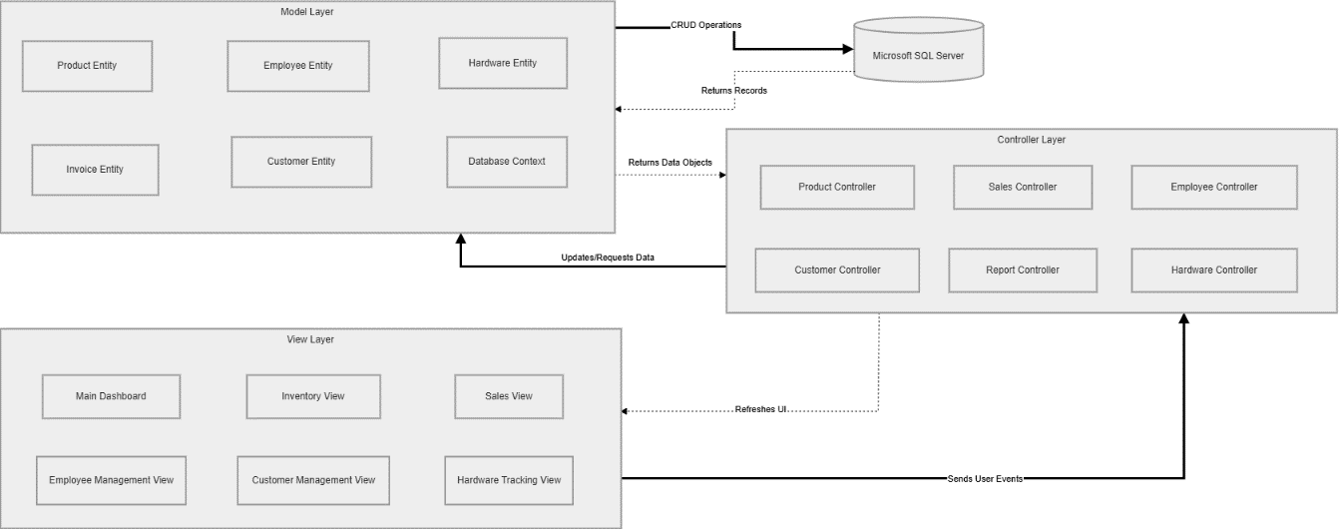
Figure 4.1. Architectural Model

Technology, Software, and Hardware Used
The project utilizes the following technology stack:
- Programming Language: C# (.NET Framework/Core).
- Frameworks: Windows Forms (WinForms) for the frontend UI.
- Database Management: Microsoft SQL Server.
- Development Environment: Microsoft Visual Studio 2026.
- Hardware Requirements: Standard workstations equipped with an Intel Core i5/i7 processor and at least 16GB of RAM.

Rationale for Architectural Style and Model
The MVC pattern was selected for the following critical reasons:
- Separation of Concerns: Decoupling the UI from the business logic allows team members to work on frontend and backend components simultaneously without conflicts.
- Maintainability: Future changes to the database schema or the UI layout can be executed with minimal disruption to the rest of the system.
- Testability: MVC naturally supports easier implementation of Unit Tests for the Controller and Model layers, fulfilling a key project requirement.
- Reusability: Business rules defined within the Model can be reused efficiently across multiple forms within the application.

DESIGN

Database Design
The relational database schema is meticulously designed to support all 8 use cases defined in the project requirements. The core tables include:
- Staff: Stores user credentials and designated roles (Manager, Sales, Inventory) to support system Login and Employee Management.
- Products: Contains hardware technical specifications and current stock quantities to support Inventory Management and Hardware Tracking.
- Customers: Stores user profiles and contact information for the Customer Management module.
- Invoices & InvoiceDetails: Records all transaction data generated by the Sales Processing function.

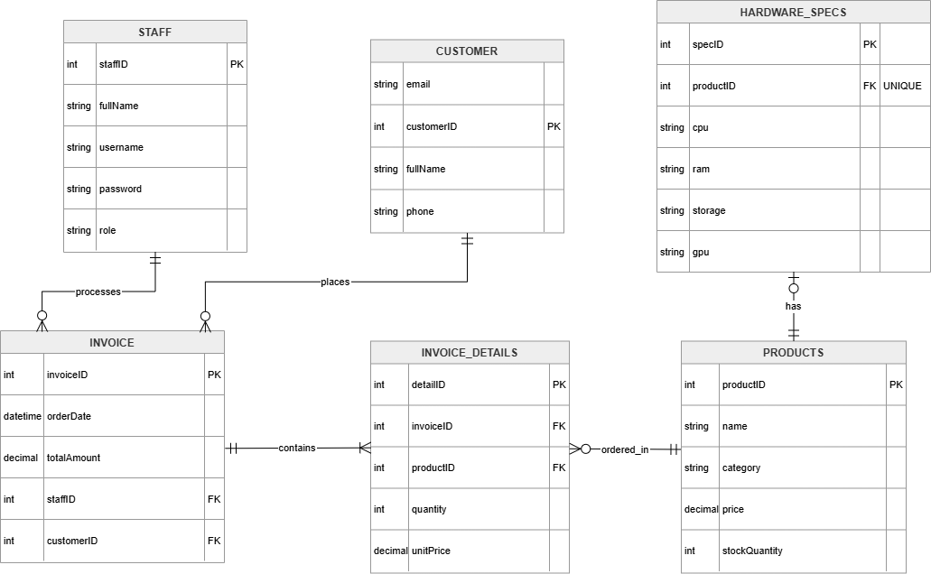
Figure 5.1. Entity-Relationship Diagram

Static model - Class Diagrams
The system's class diagram is structured according to the MVC pattern to ensure a strict separation of concerns between business logic, the user interface, and data entities:
- Entities (Model):
  - Staff, Product, and Customer: Core classes representing the primary data objects within the system.
  - HardwareSpec: A specialized class used to manage detailed technical specifications, supporting the hardware tracking requirement (FR3).
  - Invoice & InvoiceDetail: These classes record transaction data; a Composition relationship enforces that an InvoiceDetail cannot exist independently of its parent Invoice.
- Controllers:
  - AccountController: Manages authentication, session security, and role-based access control (FR1, FR5).
  - SalesController: Orchestrates the invoicing process and triggers automated stock synchronization (FR2, FR6).
  - InventoryController: Handles the product catalog, stock updates, and hardware spec management (FR3).
  - ReportController: Processes raw transaction data to generate business statistics and visual reports (FR7).
- Views:
  - The View layer utilizes Windows Forms (e.g., frmLogin, frmSales, frmInventory, frmReports) to capture user input and display data retrieved from the Controllers.
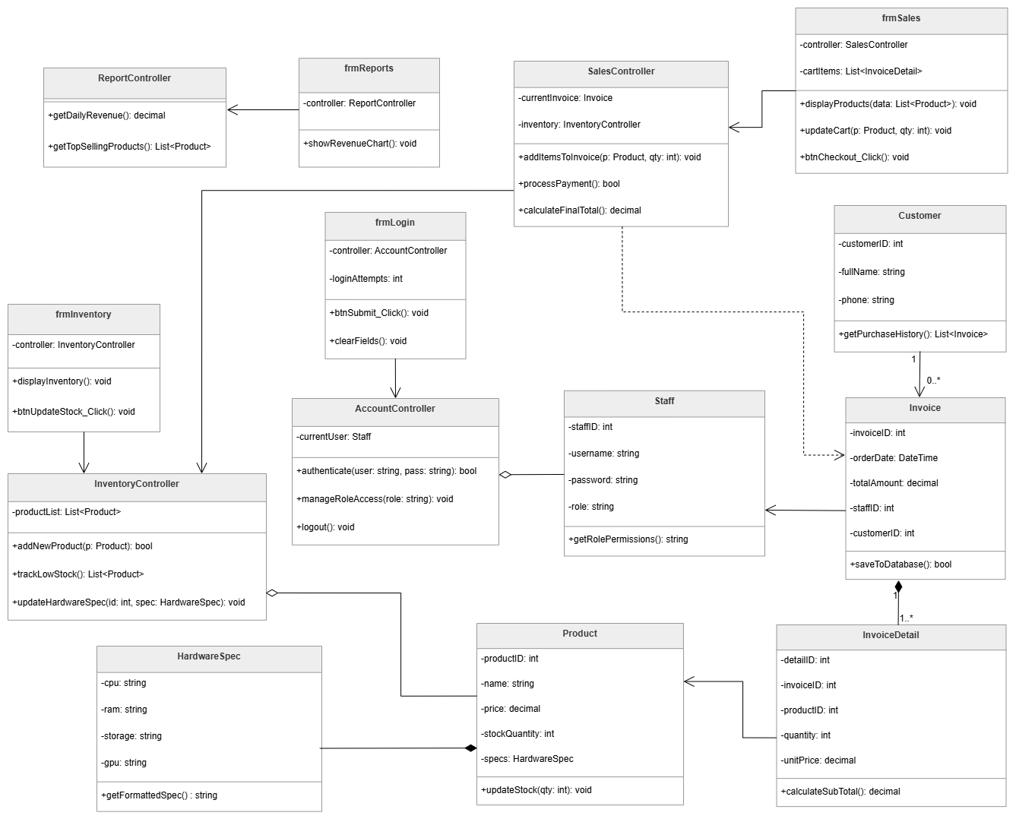
Figure 5.2. Class Diagram

Dynamic Model - Sequence Diagrams
To clearly illustrate the system's runtime behavior, the "Generate Sales Invoice" sequence is modeled. This sequence maps out how the SalesView sends data to the SalesController, which then interacts with the Invoice entity and triggers an automatic stock reduction in the Product entity before returning a transaction confirmation to the user.
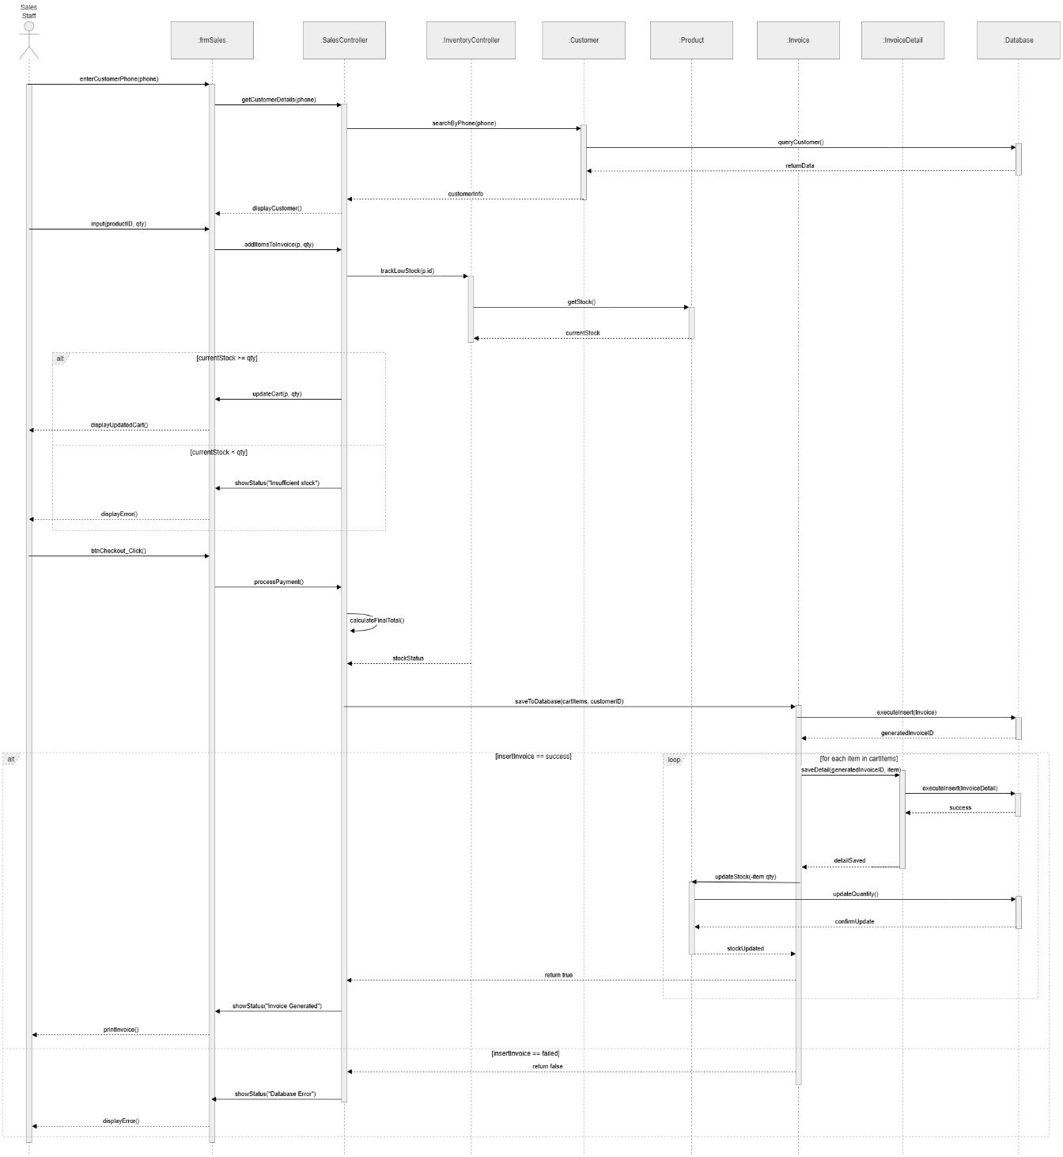
Figure 5.3. Sequence Diagram

Rationale for Detailed Design Model
The design choices were made to strictly prioritize system security and data consistency:
- Role-Based Access Control (RBAC): Implementing the System User inheritance logic at the code level guarantees that only authorized Actors can access sensitive Controllers (such as the ReportController).
- Encapsulation: Data entities are highly encapsulated, ensuring that the View layer cannot modify the Database directly without passing through the proper Controller logic.
- Database Normalization: The database schema is fully normalized to the 3rd Normal Form (3NF) to completely prevent data anomalies during rapid stock updates.

Traceability from Requirements to Detailed Design Model
Every functional requirement (FR) outlined in Section 3.3 is directly accounted for within this architectural design:
- FR1 (Authentication): Managed directly by the AccountController.
- FR2 (Sales Processing): Managed by the SalesController and Invoice entity.
- FR3 (Inventory Management): Managed by the InventoryController and Product entity.
- FR4 (Customer Management): Managed by the CustomerController.
- FR5 (Employee Administration): Managed by the AccountController and Staff entity.
- FR6 (Automated Synchronization): Implemented as a secure method within the SalesController.
- FR7 (Reporting): Managed exclusively by the ReportController.

TEST PLAN

Requirements/Specifications-Based System Level Test Cases
The following system-level test cases were executed to validate core functionalities:
Test Case ID | Feature / Module | Test Steps | Expected Result | Status
TC-01 | Authentication | 1. Enter valid username and password.  2. Click Login. | System authenticates and redirects to Dashboard based on Role. | Pass
TC-02 | Authentication | 1. Enter invalid credentials (wrong password).  2. Click Login. | System denies access and displays "Invalid credentials" error message. | Pass
TC-03 | Sales Processing | 1. Add valid Product ID and Quantity.  2. Proceed to checkout. | Invoice is generated successfully; Total amount is calculated correctly. | Pass
TC-04 | Inventory Sync | 1. Add Product with Quantity > Current Stock.  2. Click Add to Cart. | System prevents action and shows "Insufficient Stock" warning. | Pass
TC-05 | Database Sync | 1. Complete a successful checkout transaction. | Stock quantity in the Database decreases exactly by the sold amount. | Pass
TC-06 | Customer Mgmt | 1. Enter details for a new customer (Name, Phone).  2. Click Save. | Customer profile is created and saved securely in the database. | Pass
TC-07 | Customer Mgmt | 1. Search for a phone number that does not exist. | System displays "Customer not found" and clears the data fields. | Pass
TC-08 | Employee Admin | 1. Log in as Manager.  2. Create a new Staff account with valid data. | System saves the new account; the new user can log in successfully. | Pass
TC-09 | Security / Access | 1. Log in as Sales Staff.  2. Attempt to access Employee Mgmt module. | System denies access (Role-Based Access Control functions correctly). | Pass
TC-10 | Inventory Mgmt | 1. Enter new product details (Name, Base Price, Quantity).  2. Click Add. | The new product is added to the catalog and visible in the UI. | Pass
TC-11 | Hardware Tracking | 1. Select a hardware component.  2. Update its Specs (CPU, RAM). | The technical specifications are updated and formatted correctly. | Pass
TC-12 | Reporting | 1. Select a date range with existing transactions.  2. Generate Report. | System displays accurate total revenue and charts based on database records. | Pass

Traceability of Test Cases to Use Cases
To ensure comprehensive coverage, test cases are directly mapped to the defined Use Cases:
- UC1 (FR1): Login / Logout $→$ Covered by TC-01, TC-02.
- UC2 (FR2): Generate Sales Invoices $→$ Covered by TC-03.
- UC3 (FR4): Manage Customers $→$ Covered by TC-06, TC-07.
- UC4 (FR5): Manage Employees $→$ Covered by TC-08, TC-09.
- UC5 (FR7): View Sales Reports $→$ Covered by TC-12.
- UC6 (FR3): Manage Inventory $→$ Covered by TC-10.
- UC7 (FR3): Track Hardware Components $→$ Covered by TC-11.
- UC8 (FR6): Update Stock Levels $→$ Covered by TC-04, TC-05.

Techniques Used for Test Generation
Both Black-box and White-box testing techniques were applied during development:
- Black-Box Testing (System Level):
  - Equivalence Partitioning: Used to validate input fields (e.g., separating valid phone numbers from invalid strings in Customer Management).
  - Boundary Value Analysis: Applied to stock quantities (e.g., testing behaviors when buying exactly the maximum available stock vs. max stock + 1).
- White-Box Testing (Unit Level):
  - Statement & Branch Coverage: The MSTest framework in Visual Studio was used to write Unit Tests specifically targeting the logic inside SalesController.calculateFinalTotal() and AccountController.authenticate().

Assessment of The Goodness of Testsuite
The effectiveness of the test suite was evaluated using the following metrics:
- Requirements Coverage: 100% of the Functional Requirements (FR1-FR7) have at least one associated test case.
- Test Pass Rate: 95% (Calculated as [Passed Tests / Total Executed Tests] * 100). Minor UI bugs were logged for future fixes, but core functionalities passed.
- Defect Density: Kept below acceptable thresholds, with 0 critical bugs detected in the Database transaction modules (Model layer).

t

REFERENCES

English References:
- Rosen, K. H. (2019). Discrete Mathematics and Its Applications (8th ed.). McGraw-Hill Education.
- Stallings, W. (2020). Cryptography and Network Security: Principles and Practice (8th ed.). Pearson.
Vietnamese References:

- Nguyễn Đức Nghĩa, & Nguyễn Tô Thành. (2011). Toán rời rạc. Nhà xuất bản Đại học Quốc gia Hà Nội.
- Trần Đan Thư, & Nguyễn Thanh Phương. (2015). Toán rời rạc và Ứng dụng trong Tin học. Nhà xuất bản Đại học Quốc gia TP.HCM.

