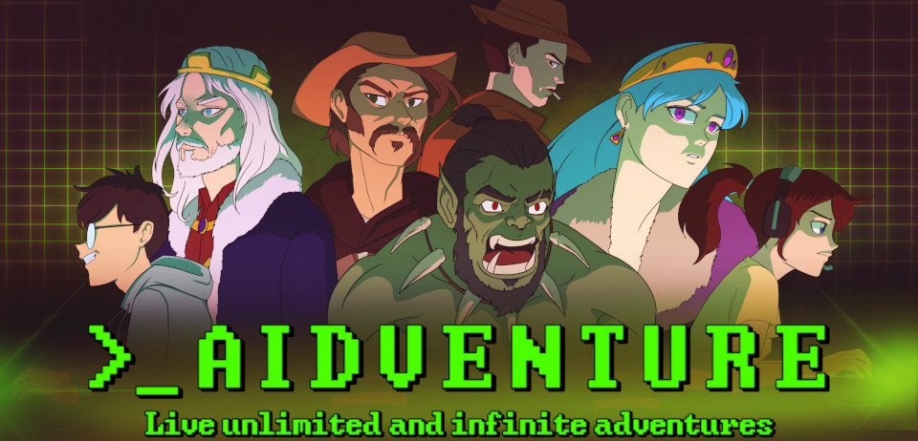

AIdventure

Live unlimited and infinite adventures, the only limit being your imagination.

France, 20 August 2022.
Lyaaaaa Games is a one-man independent game studio, on a quest to design the games the community deserves. The studio has released AIdventure: Text adventure game with an AI. Live unlimited and infinite adventures, the only limit being your imagination. This is the ultimate local alternative to Aidungeon.
Watch the trailer here
“Protect Europe from the overpopulation by enforcing the tough Law on life, a life for a birth. Or flip the table and fight the cruel plutocracy to free humanity.
Survive the zombie apocalypse, but will your humanity survive in the process?
Inherit a corrupt kingdom and survive the court's intrigues.
Survive the harsh Dark Ages in the skin of a peasant, witch or squire. Wake up within a tube in a post-apocalyptic world. Plunder on the seven seas or just help your neighbour's wife with her plumbing problems. The choice is yours.”
Community-friendly, the game lets you unleash your creativity by writing and sharing your own stories with other players. No rules, no censorship, the only limit is your imagination, not someone else's.
Features:
- Customisable - Don't like the AI? Don't like the settings? Change them!
- Memory system - The AI has both a short and long term memory.
- Easy to use interactions - Choose the mode of interaction with the AI between Say/Try/Do/Story.
- RPG system - Create your character's stats and fail or succeed in your own actions.
- Generate multiple AI's responses - If you hesitate you can ask the AI to generate another response.
- Story editor - You can edit whenever you want your story.
- Scenario editor - Feeling creative? You can create a new scenario or edit an existing one.
- Community friendly - Stories and scenarios are stored in JSON files. It's easy to share and add new content to your game.
- Steam Workshop – Scenarios can be uploaded and downloaded on the Steam Workshop.
- No censorship - Keep control of your stories.
- Privacy safe - Your data remain on your PC and only you can access it.
- 27 scenarios - From fantasy to Lovecraft or Zombies, the starting scenarios will help you discover the game
- GPU support - The game supports CUDA to improve the performances.
- Automatic translation : Live your adventure in your native language! The supported languages here.
- Lore book - Build coherent stories with the lore book!

AIdventure is available to purchase on Itch.io [Link] and Steam [Link] for both Windows and Linux. Join the community on Discord [Link] and Reddit [Link]!

For more information, press inquiries and key requests, please contact lyaaaaa@lyaaaaagames.com

Presskit
How to play the game, guide

Lyaaaaa Games
https://www.lyaaaaagames.com
“On a quest to design the games the community deserves.”
Follow Lyaaaaa Games on Twitter and Youtube

Vinicius Gepeto
The artist who made the art.
Follow him on Twitter

