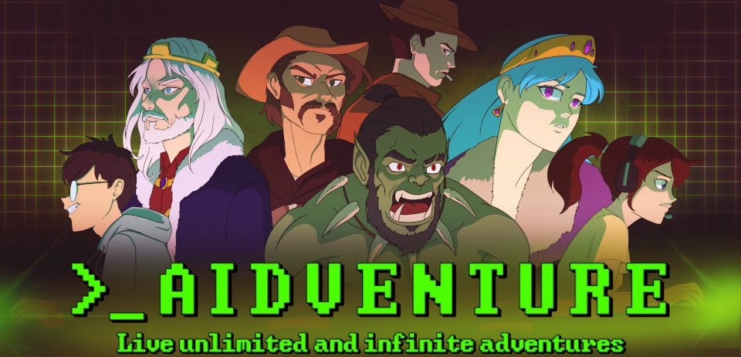

AIdventure

How to discover the game (Steam version)
Aidventure has many options and might be overwhelming the first time you try it! But fear not, this guide is here to help you!

1. Download the game

2. Run the game

3. Now start a new game by clicking on “New Story”
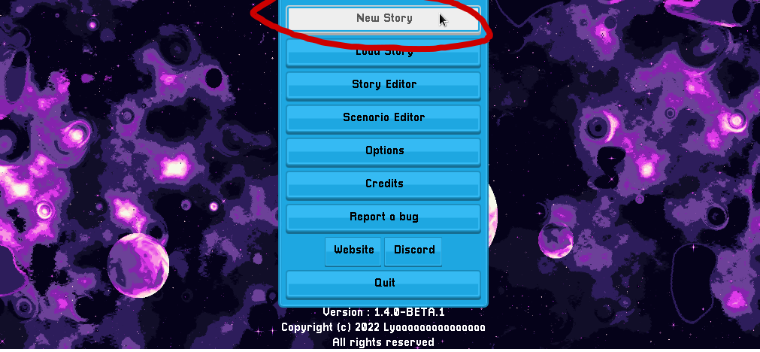
- Select the scenario you would like to play
- Create your character’s stats
- Name your game

4. Select your AI
You will be offered a large choice of AIs. It might be hard to choose one. Click on the “Select a model” button
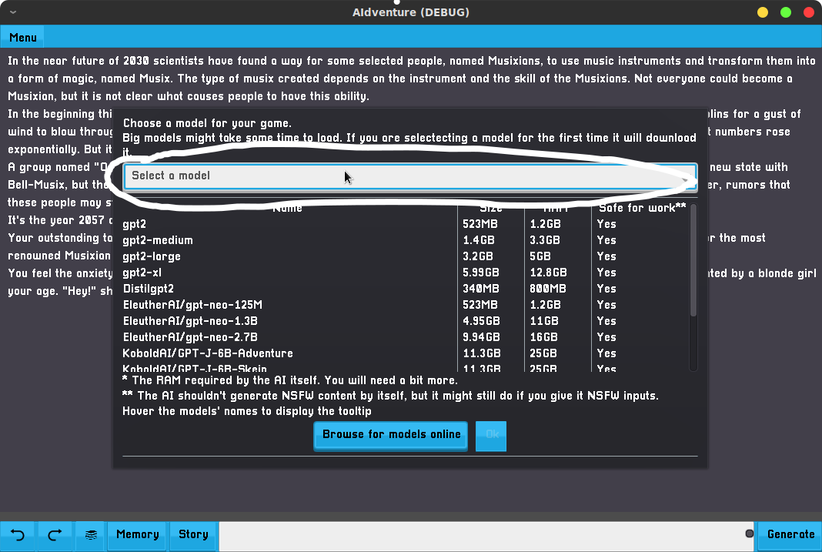
By default, the game is shipped with the gpt2-large which offers a good trade-off between speed and quality. But if you want a better experience, you can try gpt2-xl or GPT-Neo-2.7B-Picard.
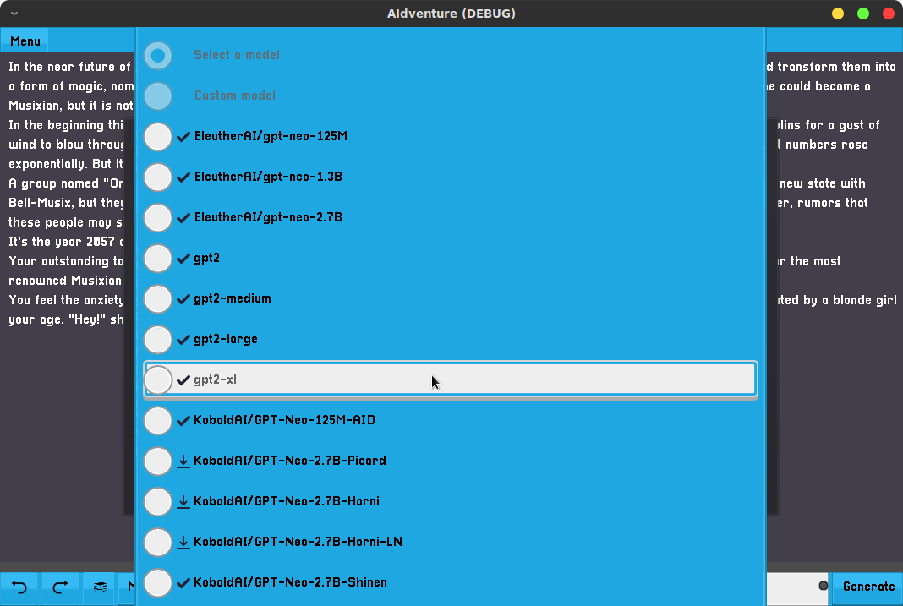

5. Play the game
You can now have fun and write anything you want. Enjoy.

About
AIdventure is available to purchase on Itch.io [Link] and Steam [Link]. Join the community on Discord [Link] and Reddit [Link]!

For more information, press inquiries and key requests, please contact lyaaaaa@lyaaaaagames.com

Presskit

Lyaaaaa Games
https://www.lyaaaaagames.com
“On a quest to design the games the community deserves.”
Follow Lyaaaaa Games on Twitter and Youtube

Vinicius Gepeto
The artist who made the art.
Follow him on Twitter

