- BACKGROUND:
The Charlesworth Group is a leading publishing services company, specializing in academic publications with offices in the UK, USA and China. Charlesworth provides tailored solutions for publishing needs with dedicated service for authors to edit and improve papers ready for submission
QuScient Technologies is an award-winning full-service provider of innovative technology and business process optimisation services to Universities and Colleges around the world. QuScient is a global company with delivery centres in India and USA.
Charlesworth wishes to develop a software system that acts as an online interface for authors and editors to make textual corrections at real time in XML content, which are in production. In line with the expectation above, this proposal from QuScient to Charleshworth is for developing the subject system.
- QUSCIENT’S EXPERTISE:
QuScient’s focus is on cost savings, process improvements, and revenue increase for our clientele. We believe that our tried and tested technology development, consulting and business process improvements will make a significant difference to our clients.

ProRetentionTM, our flagship product for student lifecycle management focuses on enquirer retention, student retention, student success and improved student experience. This product is a comprehensive student service overlay with an aim to creating multiple touch points to students from enquires to graduation and beyond.

QuScient offers domain specific software, call centre, domain specific data processing and digital marketing services.
- SOFTWARE SERVICES – CAPABILITIES:

Microsoft Technologies

We have an extensive team with expertise in .NET application development and SQL Server-driven database application development. We have developed solutions for process management, document management, error/escalation management, and performance tracking. All our solutions can be backward integrated and can be configured to work with existing legacy applications.

Windows Workflow Foundation | Using WWF, we have used both sequential and state machine workflow to automate business processes
Windows Communication Foundation | Using WCF, we have written Windows services as well as web services to PUSH/PULL data between systems
SharePoint and InfoPath | We have extensively worked on SharePoint to build portals, manage documents, etc.
SQL Reporting and Analysis Services | Using SSRS, we have developed and delivered reporting tools for clients to develop reports on their own and share it across users. We have extensively used SSAS by providing Cubes to customers to generate multidimensional reports
.NET Framework | Using .NET framework, we have built both web-based and Windows-based systems for our clients
Content Management Systems | We have expertise in the following areas:  1. Nuke  2. SDL Tridion  3. Site Finity  4. Orchard

Common Application Framework

CAF or software application automation is certainly a term much in vogue in today's computer-driven world. Around the world automation is believed, and with good reasons, to appreciate quick ROI by saving time and costs and to increase business and IT process reliability and speed while minimizing chances of human error. A software application may contain complex algorithms, but in today’s business world its worth depends solely on its ability to support a business in achieving its goals in less time, at less cost, and with greater accuracy.

CAF is not just an automation tool but a complete suite for your business that can adapt to your business needs. Implementation of CAF not only automates the process of application development but also helps you control your business with proactive alerts and workflows. There are various pluggable components that complement each other as part of the framework, which help you to enhance your existing application development process in terms of speed, accuracy, and flexibility.

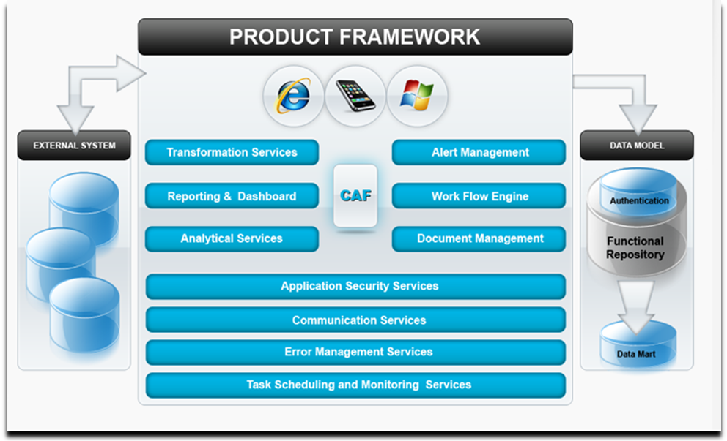

J2EE

Using community processes, evolving J2EE platforms make the experience of using our software increasingly engaging and feature rich. At QuScient, we constantly and proactively track J2EE technologies to provide effective IT solutions to our customers. This division functions with the objective of collaborating with the customer to realize business benefits through the effective adoption of J2EE technology.

Using J2EE, we at QuScient have developed

  - B2B integration framework
  - wrapper classes for JMS, JDBC, EJB, and Java Mail
  - reporting components
  - enterprise application using technologies such as EJB, JDBC, JTA, JNDI, and JAXP
  - web application using servlets and JSP

Other Tools

We have used third-party tools for enterprise application development to provide intuitive interfaces as well as used rapid application development tools to reduce delivery timeline.

Some of the key tools are:

Telerik | Telerik Extensions for ASP.NET MVC extend the ASP.NET MVC platform by delivering reusable UI controls built specifically for MVC
Adobe Flex | Adobe Flex is a software development kit (SDK) released by Adobe Systems for the development and deployment of cross-platform rich Internet applications based on the Adobe Flash platform
Dynamic Cube | DynamiCube is an open, interactive OLAP tool, implemented as an Internet-enabled lightweight ActiveX control
ASPOSE | Aspose simplifies common but complex file formats. It provides highest-quality file format components for .NET, Java, SQL Server Reporting Services (SSRS), SharePoint, and JasperReports
Fusion Chart | Fusion Charts is essentially a set of Adobe Flash (SWF) files that take in XML data and render charts, graphs and gauges using that data. These charts, graphs and gauges can be viewed in any browser using Flash Player 9 or above. So, they can work on Windows, Macintosh, or Linux
Any Chart | Any Chart is a flexible Flash/JavaScript (HTML5)-based solution that allows users to create interactive and great-looking flash charts. It is a cross-browser and cross-platform charting solution intended for everybody who deals with creation of dashboard, reporting, analytics, statistical, financial or any other data visualization solutions

Open Source

Investments in IT tend to be prohibitively huge due to high cost of purchase of proprietary software. Moreover, commercial software, its cost notwithstanding is often rigid and may not be entirely amenable to your specific requirements. At QuScient, we can help you to select the best-suited Open Source software and rein in the cost of purchase of commercial software.

We have extensive programming experience using LAMP (Linux, Apache, MySQL, PHP) Components.

We have executed several projects using technologies such as:
- Drupal
- Joomla
- Wordpress
- OSCommerce

Frameworks

Our Open Source team has leveraged the following frameworks to build solutions:

Zend

An open source software development framework implemented in PHP and based on modular MVC (model view controller) design.

Cake PHP

This rapid development framework has an extensible architecture for developing, maintaining, and deploying mid and large scale applications. It is designed using MVC and ORM within the convention over configuration paradigm.

Ruby on Rails

Web development framework written using the Ruby programming language. Ruby is an object-oriented programming language similar to the Perl and Python programming languages. Ruby on Rails provides a framework that enables applications to be developed in a faster and simpler manner.

ExtJS

A cross-browser JavaScript library for building rich Internet applications, this framework works on the JSON paradigm. It comes with a wide range of widgets such as grids, tab panels, Windows panels, advance forms, toolbars, and menus.
- Software Development Methodology
We adopt agile software development methodology where requirements and solutions evolve through collaboration between self-organizing, cross-functional teams.
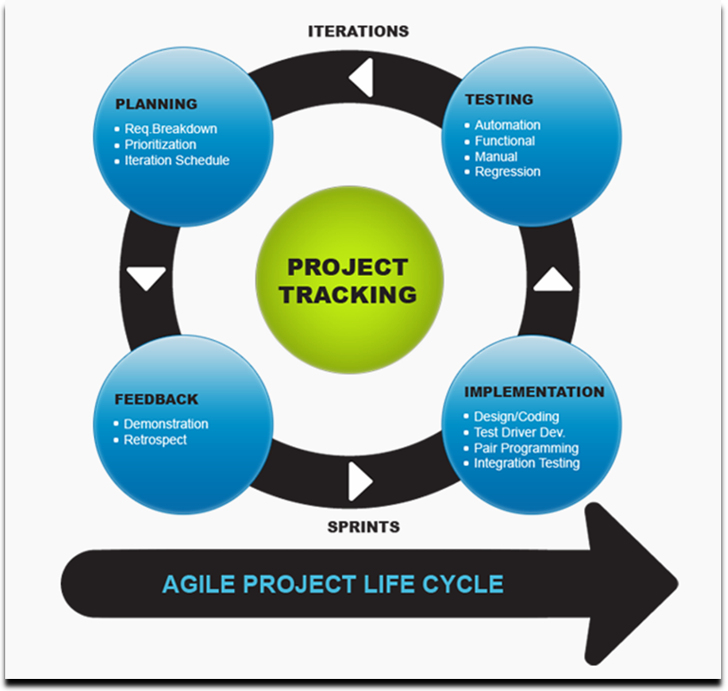
- Quality Assurance and Testing
We have been providing mission-critical software-testing services. Studies prove that organizations spend nearly 50% of their efforts on constant testing needs. With our standardized and proven testing practices, we offer independent software verification and validation services.
We provide expert solutions in defining performance targets and metrics, test planning, designing, preparing and executing strategies for test cases, selecting testing tools, setting benchmarks to analyze test results, and identifying defect-tracking mechanisms. We also work with customers in defining and streamlining their QA process.

We have expertise in manual testing and in using automated tools with specific focus on preparing and executing test cases, analyzing test results, tracking and identifying defects, and removing performance bottlenecks. QuScient’s testing methodology covers testing both new systems as well as legacy systems.

We provide system integration, regression analysis, and user acceptance testing using industry standard methodologies. We also offer specialized testing in localization, data warehousing, and security. We help in the creation of test environment and management, identification of automation methodologies, and implementation after the ROI analysis.

- SCOPE / REQUIREMENT (HIGH LEVEL):
The proposed system, at a high level, shall provide a workflow platform for production teams and authors across different geographies to manage their daily work allocation and review (editing) transactions online.

Details:

  - Production files / documents (XML/HTML/PDF/DOC) that require authoring can be dropped in a folder.
  - The service running on the server shall identify vendor details and the meta-information associated with the file based on file name codification.
  - The system shall have necessary configuration facility to determine how files need to be assigned. It can be based on vendor or specified criteria.
  - Based on the configuration, the system shall assign production files to users. This includes authors, editors, co-editors, et al.
  - Once files (documents) are assigned, the system shall transmit an email to the user to whom the document is assigned. (ME: individual staff allocated to job and held on the record?)
  - Users will have a robust editing interface for performing editorial activities.
  - Upon completion of editorial work, files can be submitted for review.
    - Also, during submission, system shall check the files for proper XML validations (ME: this depends on the quality of the converter.)
    - In case of improper XML codes, files may be sent back to the user for editing/correction
  - Upon successful validation, the system shall check files for the levels of review and assign the same for review. (ME; additional coding for each file to ascertain the levels of checking and cerification for each customer. Who would manage the coding, can’t have anyone doing it)
  - Reviewer would be allowed to review the entire file/document or a particular section based on the rules defined in the configuration set
  - When changes are required, reviewer will be able to annotate the document. All annotations will have date and time tag to section of the document that is being annotated.
  - Once successful completion of review, files can be forwarded to approver based on rules defined in the configuration set
  - Similar to the review process, when further changes are required, approver will be able to annotate the files and send it to the user who edited the file and the editor-reviewer-approver cycle will repeat
  - On final approval, two files shall be generated; one PDF and another XML file for further processing.

- Project Management

  - Development will be carried out at QuScient, Chennai, India
  - Waterfall model will be followed for developing this application/system (ME: need to ensure that the brief from CW is watertight, otherwise will potentially end up costing loads if make changes based on initial offering, which is probably why they have taken this approach to the project)
  - QuScient shall deploy a Project Manager, who will coordinate with Charlesworth’s subject matter expert / Project Manager. (ME: what is the background to the PM? Need to see a CV to make a proper selection and speak to them first)
  - Responsibilities of QuScient’s Project Manager will be to:
    - Prepare a detailed System Requirement Specification (SRS) and obtain sign-offs from Charlesworth project manager. (ME: What will be included in the SRS?
    - Prepare mock ups / prototypes as needed (ME: need to ensure that the prototypes are clearly established as part of the plan. Otherwise it’s easy shift focus of project0.
    - Prepare a detailed delivery and a roll out plan that would cover the following:
      - Development milestones
      - Testing and release milestones
      - UAT /Sign off milestones
      - Go-Live milestones
    - Circulate weekly status reports and provide updates on software releases besides arranging progress review meetings.

- Time Lines
We estimate that the project will take Three (3) calendar months to complete after formal approvals are received from Charlesworth

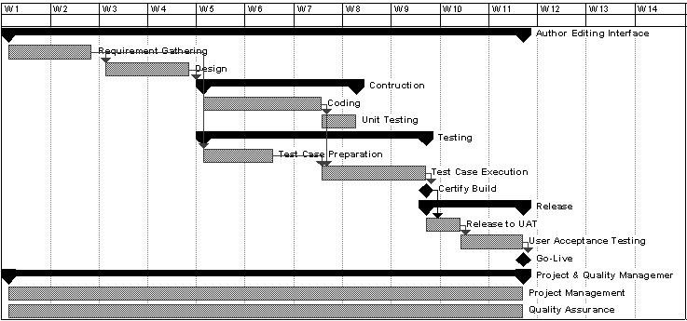
- Fee for Services:
QuScient will charge a fixed fee of US$ 33,825 (ME: need some separate quotes)

  - Fee includes requirement documentation/scoping, design, development, testing and deployment
  - Fee does not include future support, maintenance and change management related costs (ME: what are these likely to be. SL: what do you estimate it’s going to look like
  - Solution will be hosted in a secure third party facility.
    - Fee does not include hosting charges, which will be approximately $4500 per year. Hosting charges will paid by Charlesworth directly to the provider
  - Above fee is based on projects scope defined in Section-F

- Payment Schedule:
- 50% on term sheet sign-off (far to high for something being developed from scratch with no domain expertise)
- 40% on completion of development & Testing
- 10% on completion of user acceptance
- Change Request and Related Charges:
Any change to business requirement during development or post development will go through change management process to determine the amount of effort required to incorporate those changes. This estimated effort needs to be approved by Charlesworth before the changes are considered in the development cycle (ME: what is the definition of a change request?)

Any changes to the flow, features, logic, and data structure will be treated, as a change request item and will be charged at $30/hour

