Nobleza, Princess Nicol

2-D3

QUIZ 1

Survey Questionnaires and Results

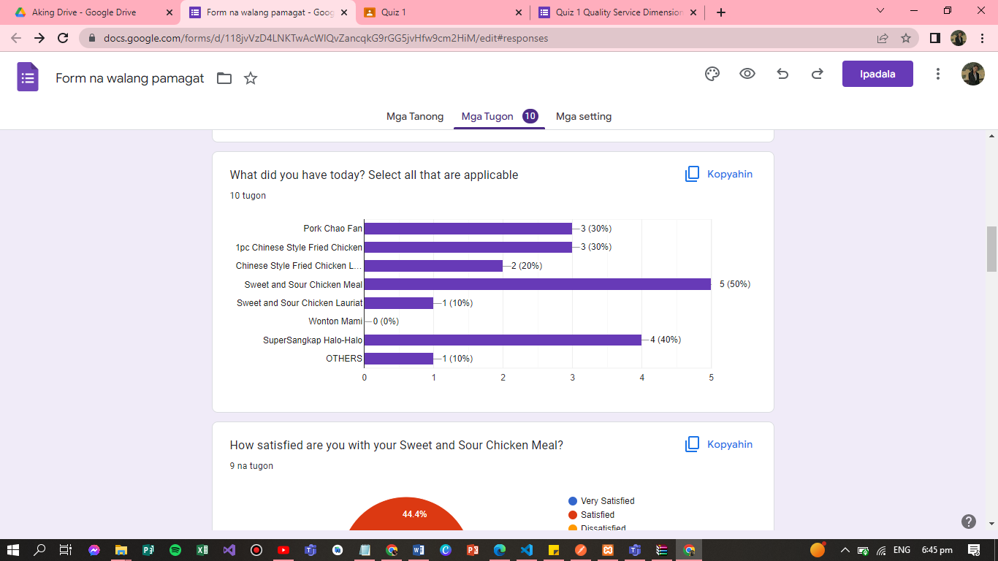

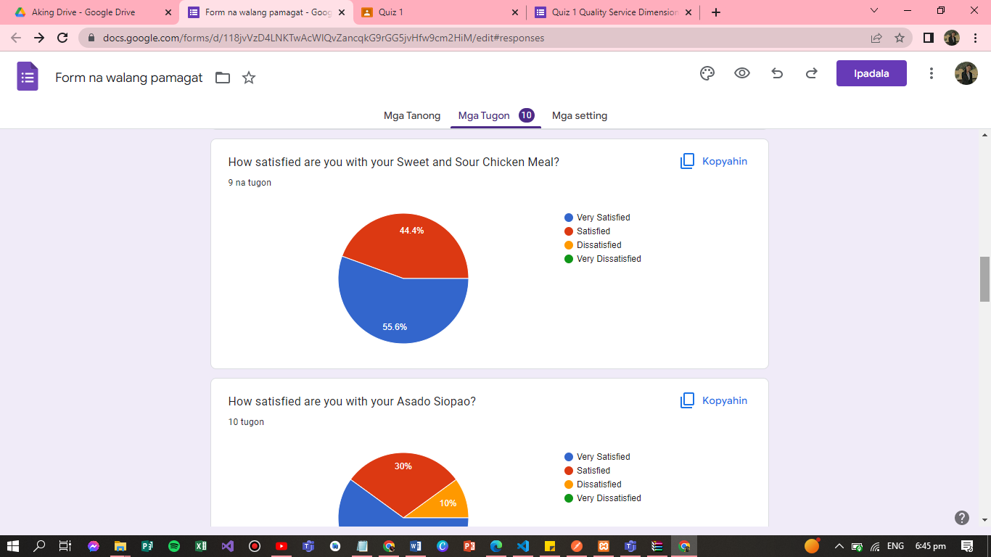

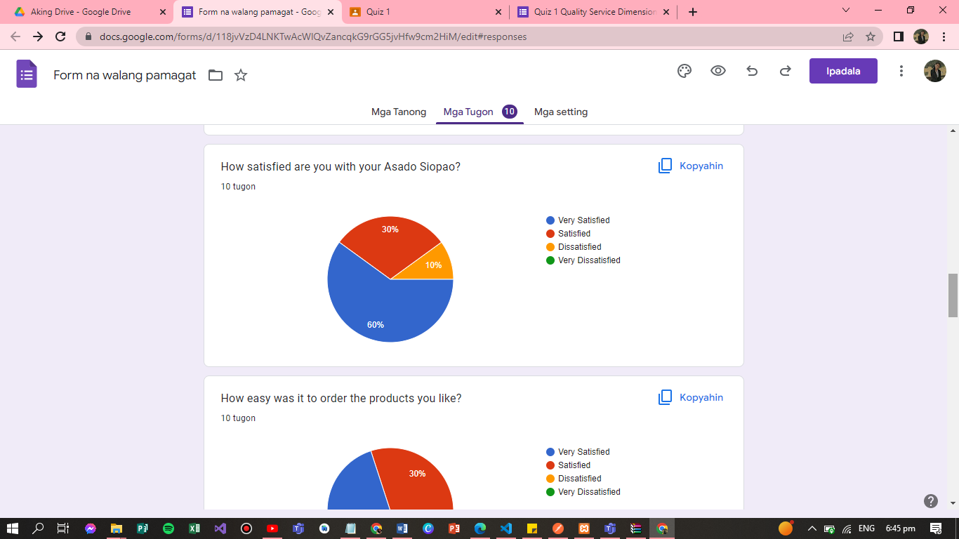

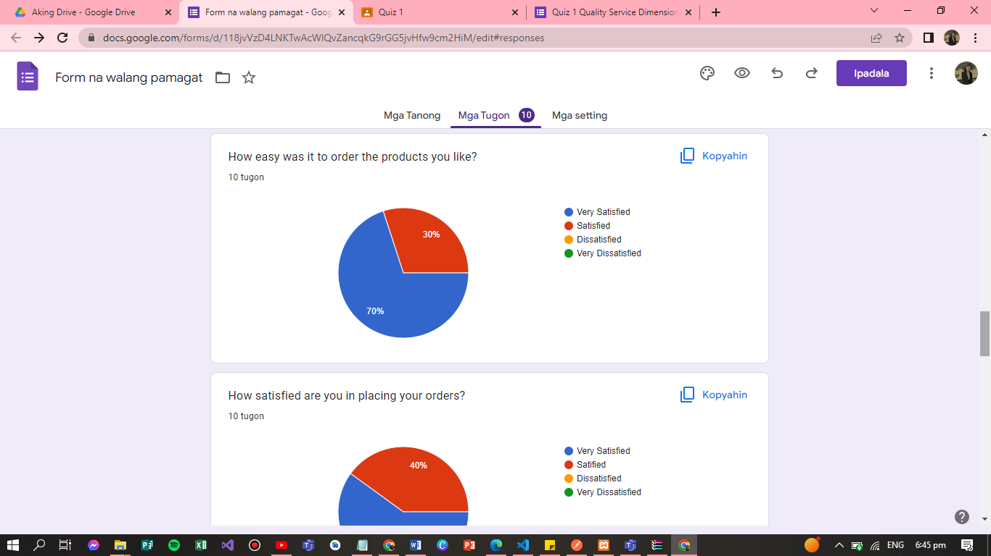

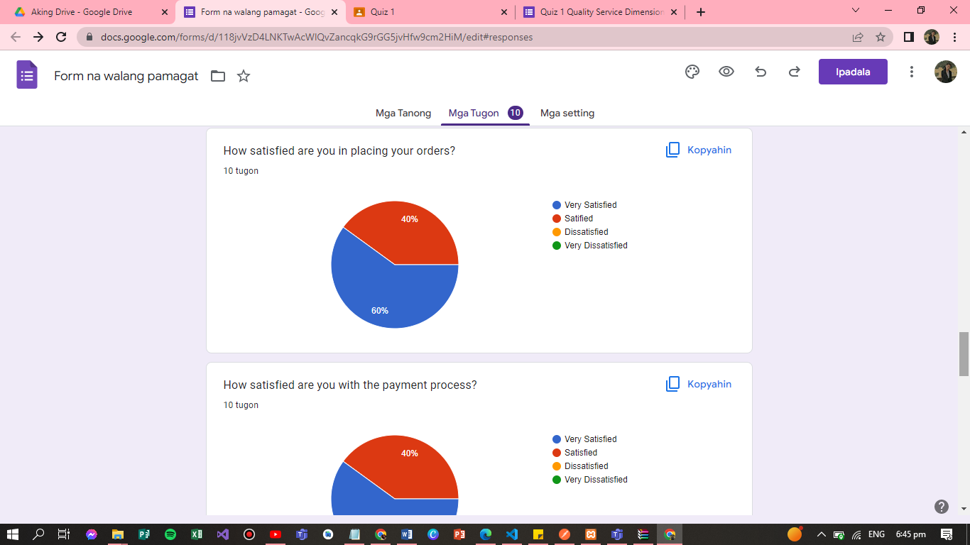

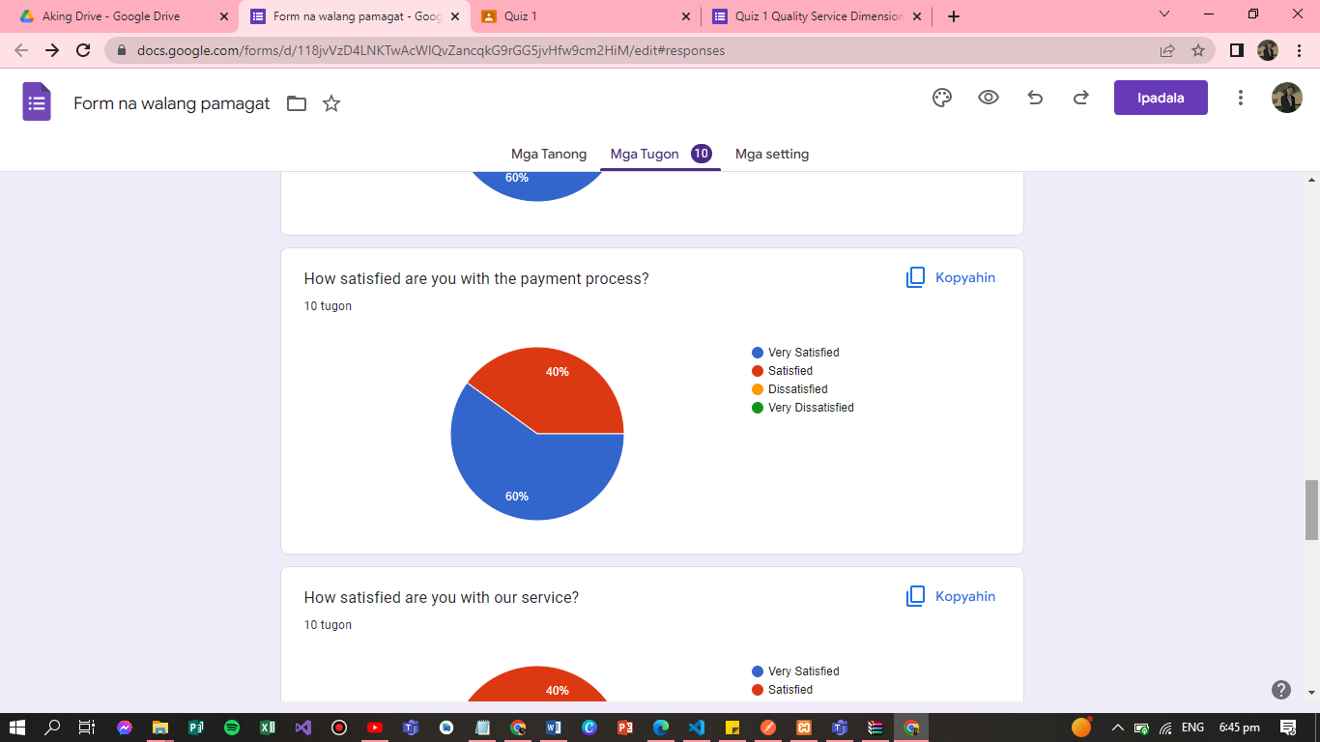

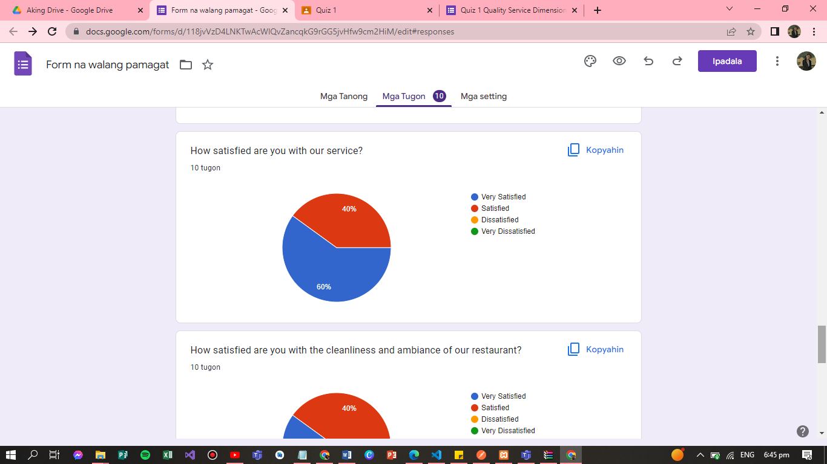

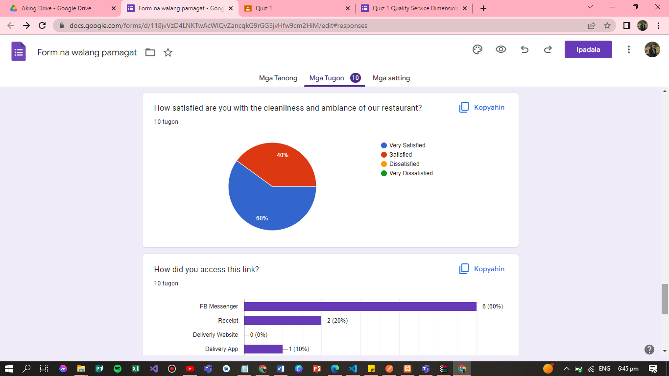

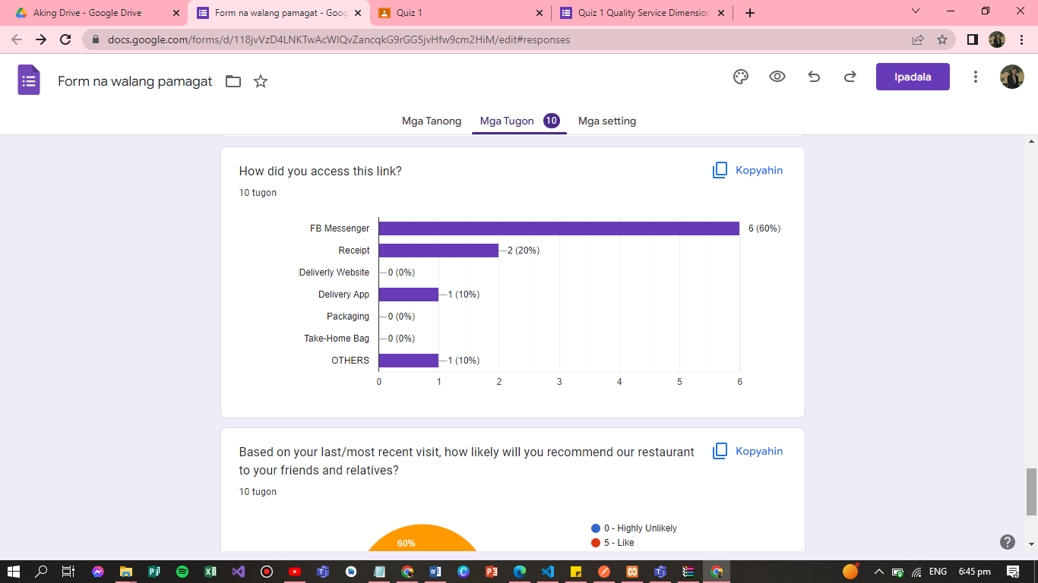

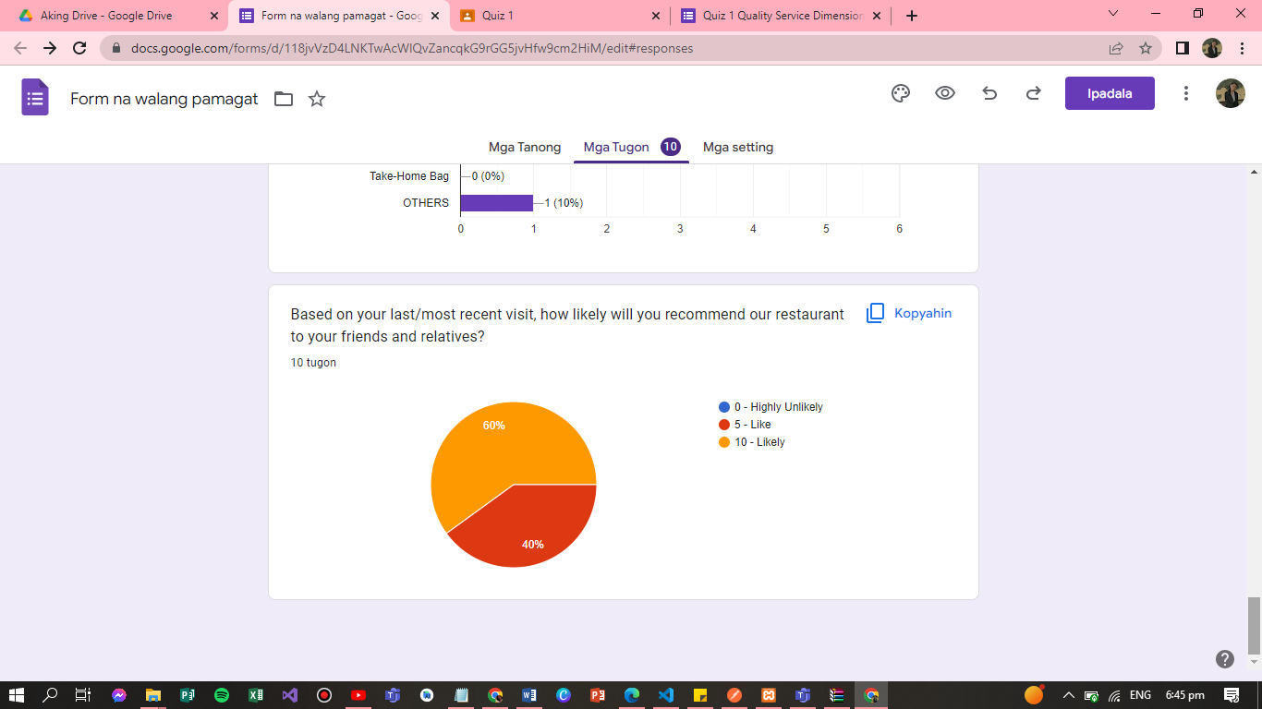

<iframe src="https://docs.google.com/forms/d/e/1FAIpQLScWZRwH7LREkXcM0Kl-S5SdOSzlSvVJX9zVrSUlrOpoN2dHjw/viewform?embedded=true" width="700" height="520" frameborder="0" marginheight="0" marginwidth="0">Naglo-load…</iframe>