**“eOMHeritage: An Online Reservation and Appointment System for Oriental Mindoro Heritage Museum with QR Code”**

A Research/Capstone Project   
Presented to the Faculty of the  
College of Computer Studies  
**MINDORO STATE UNIVERSITY**Calapan City Campus  
Masipit, Calapan City, Oriental Mindoro

In Partial Fulfillment  
of the Requirements for the Degree  
**BACHELOR OF SCIENCE IN INFORMATION TECHNOLOGY**

by

**DARLENE ANGEL G. FAJARITO  
LYCA MAY NOBLEZA**

May 2023

**Chapter I**

**INTRODUCTION**

**Project Context**

The emergence of technology has greatly impacted various industries, including tourism. Travelers nowadays are not just interested in visiting new places, but also in learning about the local history, culture, and ethics. In Oriental Mindoro, the Heritage Museum promotes the province's arts, culture, and tourism through the presentation and display of various cultures and artifacts. The museum provides a reservation for users to promote and view the preservation of items and artifacts. As explained by Meuter et al. (2019), an online reservation system is a web-based program that enables customers to conveniently and safely make reservations and bookings using any web-enabled device. As the proponents gathered information about the Heritage Museum, they discovered that the Heritage Museum is lack of an existing system to manage their data, inventory, bookings, appointments, and attendance records. The collections in the museum require a proper inventory management system for best practices, consistent management, and security purposes. Currently, the museum use google form for reservations, which is difficult to maintain and manage. Inventory tracking is only documented, and there is no proper catalog list of items. Additionally, the Tourism office manually records attendance, making it hard to keep track of the data. The institution also has no official website wherein they only use social media platforms to promote and inform user to book for a visit and make appointment in the function hall.

With this, the proponents aim to develop a system to help museums showcase their cultural artifacts effectively. The system will focus on cataloging and digital inventory management to enable organizations to handle all their catalog data. The system will also include a booking reservation module that will enable users to book their visits to the museum. The system also incorporates an appointment booking for the function hall which users will easily make appointments and fill up fields without needing to do it walk-ins. The proponents will also provide a QR code scanner to accept attendance records and the system will generate unique QR code of every user’s reservation. Users then use the generated QR code as they go to the museum, and their information will be recorded automatically, solving issues associated with manual attendance methods.

The proponents therefore conclude that creating a system that incorporates reservation and booking of appointments, inventory management, and attendance tracking through QR code scanning is necessary for the Oriental Mindoro Heritage Museum. The system will replace the manual process of maintaining the museum's inventory and managing user’s information. Instead of using Google forms to schedule a visit, users can use an application to book a visit and provide necessary information. The goal of the study is to develop a Cross Platform Web Application System for the museum.

**Objectives of the Study**

Generally, this study aims to develop an eOMHeritage: An Online Reservation and Appointment System for Oriental Mindoro Heritage Museum with QR Code.

Specifically, it aims to;

1. provide an official website that will serve as the primary online platform for visitors who intend to schedule a visit to the museum.

2. develop a system that incorporates an appointment booking feature that enable visitors to effortlessly schedule and secure bookings for the function hall.

3. create a system that will generate a unique QR code for each user’s reservation, allowing real-time tracking of attendance.

4. design a system that will help the Oriental Mindoro Heritage Museum to manage and properly organize cultural items and artifacts.

5. integrate a system that includes a souvenirs display allowing visitors to browse and reserve items they want to purchase before making payment at the establishment.

**Scope and Limitation of the Study**

The study is primarily focused on developing a Cross Platform Official Website for Oriental Mindoro Heritage Museum.

The scope of this study includes the booking and reservation which allows interested people to book an appointment schedule in visiting the museum as well as the conference. As the schedule is completely booked, it will be managed by the admin. Then the guest will get response through his email once the reservation is already approved. Upon arrival of the attendees, they will be required to scan a QR Code in which it will automatically record attendance. It is a contactless and digital form of tracking attendance for the museum, which all will guarantee a safe and hygienic platform for attendees and guests. Also, this system has inventory collection of items and artifacts which is exclusively access by the admin of the museum. This is to ensure that data catalogs are digitally manage and control as well as to protects artifacts (including those that are not displayed), stored inventory, and pieces undergoing restoration. Also, the system provides an online reservation for souvenirs wherein visitors are able to purchase and add items on their reservation visit.

The limitation of the study includes the following: (a) only few information about the museum is displayed in the website including the little background of the museum, contact details and services like reservation for museum visit and functional hall rental. (b) Inventory collection of items and artifacts can only be view and access by the management administrator. (c)The reservation for visits and for such meetings in the conference is directly done through the website only. (d) Also, this system is only being limited to the bookings, reservation and attendance aspect, not everything of the information aspect about the museum. (e) Additionally, the system does not include a payment feature associated with the conference hall rental and souvenir shop, it only accepts reference number from G-cash as a way to assure that the reservation is legit and authentic.

**Significance of the Study**

This study will be considered beneficial to the following:

**Oriental Mindoro Heritage Museum.** The outcome of this study will significantly benefit the museum’s operational capabilities. It will be served as their own official site equipped with various features such as improve booking and reservation management, accurate attendance tracking, efficient artifact inventory management and the ability to facilitate online purchase and reservations for souvenirs.

**Provincial Tourism Office of Oriental Mindoro.** With this study, it can serve as an online platform to showcase the Oriental Mindoro Heritage Museum’s offerings. By sharing data and resources through the system, the Provincial Tourism Office can strengthen relationships and foster collaboration that can contribute to the growth and success of the museum while enhancing the overall tourism landscape of Oriental Mindoro.

**Visitors.** This study will be beneficial especially to the people who are interested to go to the museum. It allows visitors to plan their visit efficiently by checking availability, select preferred time slots and secure their visit without the need for long queues or on-site arrangements. Moreover, it helps them browse and explore souvenirs available for purchase. They have the ability to add selected items to their reservation streamlines the purchase process, saving time and effort during the visit.

**Researchers.** They will develop new technological solutions that can improve the efficiency and effectiveness of museum operations. Also, they can use the insights gained from their studies to develop innovative technologies that can enhance the visitor experience and make museum operations more efficient.

**Future Researchers.** It will serve as reference for future proponents and it will serve as a basis for further development and improvement of the reservation and attendance systems for museums. Future researchers can build upon the existing study and improve upon the features and functionalities of the system to make it more efficient and effective.

**Conceptual Framework**

The concept of this study is to develop cross-platform web application system for Oriental Mindoro Heritage Museum. The input contains the guest that will visit the museum to see the cultural and history offered by OMHM. The process emphasizes the comprehensive and structured process of development of the website to ensure the quality of its performance. The system development methodology used by proponents is the Agile Method. The proponents should be able to develop the “eOMHeritage: An Online Reservation and Appointment System for Oriental Mindoro Heritage Museum with QR Code” according to the development process in the methodology and evaluate the project to enhance it before its deployment.

**INPUT PROCESS OUTPUT**

**eOMHeritage: An Online Reservation and Appointment System for Oriental Mindoro Heritage Museum with QR Code**

**Heritage Museum**

Planning

Requirements

Analysis

Design

Coding

Unit Testing  
and Acceptance

Testing

* User Registration
* Email verification
* Booking Appointment and Reservation
* Attendance using QR Code
* Announcement Post
* Feedback Post
* Add Catalogues

**Figure 1. Conceptual Framework of the Study**

**Definition of Terms**

To further explain the study explicitly, the researchers defined the words operationally as:

**Agile Method.** A project management and software development approach that helps teams deliver value to their customers faster and with fewer headaches.

**Cross-Platform**. a software program that can be used on different devices and operating systems without needing significant changes.

**OMHM**. Also known as Oriental Mindoro Heritage Museum located at Barangay Ibaba, East, Calapan City.

**QR Code.** It is used to record the attendance of every visitor entering the museum. It will be generated once the visitor books a reservation.

**Chapter II  
REVIEW OF RELATED LITERATURE/SYSTEM**

This chapter presents the review of related literature that provides the researchers a strong foundation for the study. The researchers gathered data from trusted scholar sites to ensure the credibility and quality of information collected. These will make path for the researchers to develop a comprehensive and well-structured capstone project anchored to the given objectives of this study.

According to Wang, et.al., (2023), The Smart Museum Project in China advocates a digital museum-based paradigm that combines new technology with all-pervasive connectivity, syncretic applications, and complete perception. With further explanation of the definition, connotation, structure, and outreach of the smart museum, we present historical context for its growth and its influence on museum activities in this article. We think museums ought to seize digital opportunities so they may transform from computer-based technology labs into sustainable, intelligent, synergistic knowledgescapes.

Based on research into the real-world experiences of organizations (February, 2022) like the Museum Computer Network Association MCN (Museum Computer Network), the Canadian Heritage Information Network, and the Main Computing Center of the Russian Federation's Ministry of Culture, it is concluded that using information and communication technologies in the museum setting is necessary to raise the standard of exhibits.

The study of Kurdi, B., Alzoubi, H., Akour, I., & Alshurideh, M. (2022) Without an inventory management system, organizations cannot function efficiently or manage all the catalog data that is kept in the system.

MerriamWebster.com (2022) defined the proper documenting, typically in the form of an inventory, of the actual heritage resources is necessary for the conservation and management of built cultural assets. An itemized list of current assets is one of the simplest definitions for an inventory. A survey is commonly used to decide what information will be included in the inventory list, but an inventory can also refer to the procedure for compiling this list in the form of a survey. (From this point on, the process will be referred to as "survey" and the list that is produced as "inventory.

Streimikiene, D., Svagzdiene, B., Jasinskas, E., & Simanavicius, A. (2021) discussed that one of the most innovative and dynamic industries in the world is tourism. Planning and developing tourism responsibly require finding balances between the needs of society's environmental, economic, and social sectors. The management of sustainable tourism development must maintain a high level of customer satisfaction, ensure that consumers have a significant experience, raise their awareness of sustainability issues, and spread sustainable tourism practices among them. In this article, the significance of the sector's aim for sustainable development is examined from the standpoint of enhancing its competitiveness.

In the study conducted by Romero, C. A. T., Ortiz, J. H., Khalaf, O. I., & Ortega, W. M. (2021), Regulatory compliance requirements are frequently needed for agile projects; these requirements are distinguished by having few clients and being explicitly and thoroughly stated.

According to the research of Maleriado, M. A. C., and Carreon, J. R. The amount of paper utilized by the teachers will undoubtedly decrease significantly in 2021 thanks to the implementation of the QR code as an attendance system. Since everything is done digitally, no paper is utilized in this process that needs to be recycled.

The study of Beerbaum, D. O. (2021) discussed that the idea of agility methodology is constrained by design thinking, where each individual customer is taken into account in the product offering, leading to a variety of different and heterogeneous requirements and backlog. The regulatory compliance requirements are defined by a small number of customers but are by definition rather explicitly defined and defined. The fundamental nature of such demands and inheritant that periodic adjustments are not essential and required.

As mentioned by Paré, G. et. al (2021), Appointment scheduling systems offer a practical and simple way for patients to schedule appointments with their healthcare professional while enabling online contact.

According to Emmanuel, A. A., Adedoyin, A. E., Mukaila, O., & Roseline, O. O. (2020), Booking appointments for attendance purposes through QR code is also an incorporated feature. Anyone who wants to encode products with integrated QR codes should use a smartphone scanner. It also reduces the need for manually entering the name of the guess in the logbook when visiting a museum by making encoding the code simpler and easier than ever before.

As mentioned by (Zhang, J., Liu, S., Fan, J., Huang, J., & Pei, M. (2020), The market economy has had an impact on the museum's development. The museum has evolved through time from a typical cultural institution with the primary goal of collecting things to a service-oriented business that offers public entertainment. Because service-oriented architecture (SOA) has received a lot of attention from researchers and practitioners over the past two decades, the museum is continually developing its artistic services.

Additionally, Pascoal, S., Tallone, L., & Furtado, M. (2020, October) claimed that Covid-19 has had a significant impact on cultural heritage because it has reduced face-to-face engagement and the number of visitors to historical museums.

Biørn-Hansen, A., Rieger, C., Grønli, T. M., Majchrzak, T. A., & Ghinea, G. (2020) said that Cross-platform development frameworks have been popular due to the heterogeneity of the top mobile platforms in terms of user interfaces, user experiences, programming languages, and ecosystem. These facilitate the development of mobile applications, or "apps," that can run on the target platforms (usually Android and iOS) with little or no platform-specific code.

López-Guzmán et al. (2020) concludes that their intention when they travel is not just to see new places; it is also to learn about local history, culture, and ethics. By doing so, they hope to move beyond the typical travel experiences and have real, meaningful encounters based on their own perspectives. Similarly, from the viewpoint of tourism, while tourism has developed into an industry to support travel and strengthen a nation's economy, it also enables local communities to provide a chance for the tourists to learn about and appreciate their culture, promoting their own heritage and historical stories.

Craik, J. (2020) mentioned that visitors form their opinions of a satisfying destination based on a variety of motivations and perceptions. The tourist's visit creates an experience that gives him the power to decide whether to return, recommend, and promote the location as a prominent part of his historical heritage experience. Culture and heritage play a significant role in the need for information of the area visited.

According to Verity Burke, Dolly Jørgensen, and Finn Arne Jørgensen (2020) “In the Clouds” demonstrates how a museum could use online tools to bring visitors to the exhibit from their homes, while still maintaining a focus on the physical installation. The digital version of the exhibit became a stopgap solution while the museum waited for better times, when they could again welcome visitors to the museums. Stavanger Art Museum was able to open again for the summer season to positive acclaim.

Klymash, M., Demydov, I., Uryvskyi, L., & Pyrih, Y. (2020, February) describes that the Feedback is very important in every platform for suggestions and user experience when using the system. Some of literature studies the architecture of a development system for building interactive e-government platforms on feedback systems, which are based on the most effective web crawler architectures.

As mentioned by Adedokun A, Idris O, and Odujoko T. (2019) Today, emerging nations employ online appointment scheduling tools to raise the caliber of a facility's services.

In accordance with Kumar, et. al (2019), Effective online medical appointment, is an internet tool that enables patients to schedule appointments after registering online. A more Convenient Approach People use internet transactions as a method to live more conveniently, safely, and comfortably.

As stated by Meuter, Ostrom, Roundtree, & Bitner, (2019) An online scheduling system is a web-based program that enables customers to conveniently and safely make online reservations and bookings using any web-enabled device (e.g., PC, cell phone, or tablet). The manual scheduling mechanism was replaced by online scheduling. Expert communities have long utilized various self-organization practical tools, such as natural voice response systems, web-based services, intelligent kiosks, portable self-administrations, and individual medical care devices.

According to Jones, Menon-Johansson, Waters, Sullivan, (2019), Clinical arrangements have typically been arranged over the phone or in person with schedulers. The ability to find a convenient arrangement is, however, constrained not only by the availability of scheduled slots but also by the schedulers and telephone lines because of these old methods that necessitate their intervention.

Mohd Noor Shah, N. F., & Ghazali, M. (2019, August) said that there are many different types of digital technology that have been developed to improve visitor experience in museums, but the key to creating better-designed digital technology applications will be to understand what the user is expecting.

As stated by Shettar and Indrayani (2019), QR codes are two-dimensional matrix barcodes that are used to make it simple for smartphone users to retrieve digital information. With the introduction of smart and web-enabled mobile phones over the past decade, commercial and business-oriented use of these QR codes has steadily increased.

Paul, S., Chatterjee, A., & Guha, D. (2019) discussed that in any production system, inventory management is a crucial component of customer service and cost reduction. Inventory management for businesses that have gone worldwide and have thousands of components and hundreds of warehouses is a time-consuming process that requires a lot of effort. The foundation of traditional warehouse marking and tracking systems for robotic arms used for inventory picking and dropping.

In the study carried out by Grayson et al. (2019), Staff members that are qualified, talented, and committed to the inventory process are needed for the construction and upkeep of historic inventories. The risk is that once foreign engagement ends, inventory maintenance ceases in emerging countries where other foreign specialists are brought in to assist in creating a survey and inventory system. For instance, a system was created and locals were taught how to use it in Sana'a. However, as the project manager, Daniele Pini, laments, "after five years, the GIS we built up is absolutely useless because it's never been updated."

Ruhanen, L., & Whitford, M. (2019) defined that the socio-economic prospects that are typically promised by cultural heritage items created for the tourism industry might be great for the communities involved, but tourism can also be difficult since Indigenous cultural products and cultural identity can be difficult to maintain independently.

Sharp (2019) claimed that the most significant sites in terms of cultural heritage are listed on the UNESCO World Heritage List. The selected locations may become highly sought-after vacation spots for travelers interested in cultural heritage, which contributes to unsustainable tourism. More than 2 million people visit the Angkor Archaeological Park in Cambodia each year, and the pressure this puts on the site is having an adverse effect on the centuries-old buildings.

Butler and Pearce, 2019; Mason, 2019; Telfer and Sharpley, (2019) stated that the local community must be the one to provide tourists with a tourism product based on efforts and the management of natural and cultural resources; but, by doing so, it also puts limitations on the local community's ability to improve tourism. Because of these factors, the local community is increasingly acknowledged as being crucial to the growth and future of tourism.

Nyaupane et al. (2019) added that Less tourists are better because they allow for greater interaction with important community resources like live culture and heritage and prevent outsiders from intruding on locals' private spaces. It's crucial to remember that tourism will only create a certain amount of revenue if fewer people travel there.

As what Speno, L. (2019) stated, Cultural heritage cities must set themselves apart from the competitors by incorporating regional cultures, centuries of history, art, and traditions passed down from generation to generation into their cultural offerings. As a result, heritage tourism is crucial for cities with historic monuments.

As Hayat, F., Rehman, A. U., Arif, K. S., Wahab, K., & Abbas, M. (2019, July) mentioned in their study that the Agile software development methodologies are extensively employed in the software industry because of their adaptability to changing requirements and flexibility in managing cost, scope, and software quality in accordance with client demands.

**Chapter III  
METHODOLOGY**

**Development Method**

The research method used in this study is “Survey / Interview” method that aims to collect data from the clients by answering basic interview questions with an open-ended answer where they can response based on their complete understanding and knowledge. This is the method used by the researchers for its ability to collect and gathered rich information and give the interviewee more control over the information revealed.

Figure 1 shows the researchers’ Agile methods as their guides in developing the project. The process focused primarily in dividing tasks into smaller iterations or portions that did not directly involve long term planning. Each iteration is considered as a short time “frame” and it involves a team which goes through the entire development life cycle including requirements gathering, designing, coding/developing, and testing before presenting and demonstrating a functional system to the client.

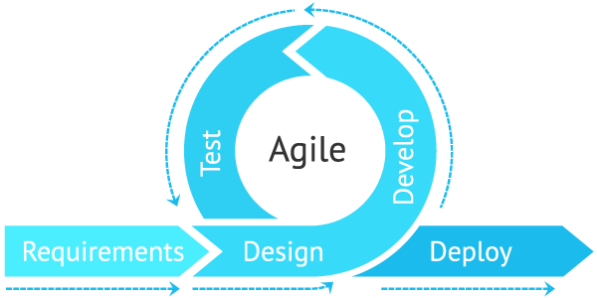

**Figure 1. Agile Method**

The sequential phases in Agile model are:

**1.** **Requirements gathering**

In this phase, the researchers had conducted a simple interview with the client regarding with the system proposal and at the same time ask questions to determine the primary function needed for website development. The researchers ensured that all of the client’s relevant needs were understood and met. Moreover, the researchers analyze the requirement needed to develop the proposed project. The front-end requirement for the website is combined with bootstrap and CSS development framework while the back-end requirement for the development is Laravel Framework. It is used for building interactive user interfaces and web application.

**2. Designing**

This phase is all about the specifics in preparation of developing the system. This is the plan that is going to be made later. After determining the requirements needed, the researchers studied and visualize the possible look of the website, what are the included modules in the system and its functionality, the interface relationship and dependencies between modules. As the researchers aim to develop a web application, the interfaces (including the frontend and backend) should be relevant to each other. For the web interface, the color scheme that will be use is green and yellow shade undertone. The researchers based this according to the establishment’s logo design and relevance to the usual theme of that kind of institution. Moreover, in terms of website modules and functionality, the researchers will cover the main functions of booking and reservation along with attendance through QR Code scan, and Museum Inventory. In the front-end interfaces, users have access to read and view services, create and cancel reservation. While the backend interface, database’s contents including tables and its fields are managed. Proponents choose Phpmyadmin as the database to complete the backend services. This provides authentication and backups to makes it easy to plug and play the integration into the frontend.

**3. Coding/Developing**

Once the system design phase is over, next is the development and coding of the plan for the website. In this phase proponents starts to build the entire system by writing code using the chosen specific framework. Here it applies all the propose plans and designs to be able to integrate a well-functional website. It will be the longest phase of the development process and the most challenging part. The proponents divided the tasks into units and assigned parts on each member of the team. Every proponent should be aware to the stages that has gone through and as a team, collaboration should be applied to determine the flow of the coding process. The researcher further believe that this phase is essential to the success of this proposal because it all depends on how well-programmed the system is to ensure that the website functions efficiently and continues to perform well.

**4. Testing**

After the software is complete, then it is deployed in the testing environment. The researchers start testing each module and functionality of the entire system. This is done to assure that the integrated website/application works in accordance to the client requirements before it’s released. To ensure full functionality, the team should test and measure it through checking that the code is readable and understandable, finding errors and bugs and performing trial runs.

**5. Deploy**

Once the testing phase is successfully executed, the final deployment process starts. The researchers should prepare to release the integrated system. This is where it transformed to a fully developed website/app and is ready to be used in a real environment by the clients and user.

**Gantt Chart**

Figure 2 shows the chronological events that the website underwent. To better carry out each plan after creating the mentioned website, the project is being developed in accordance with the Gantt chart.

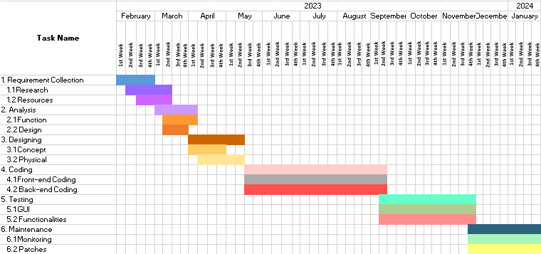

**Figure 2. Gantt Chart**

**Requirements Specification**

To maximize the use of the proposed project, the users must be knowledgeable and properly oriented to the system. This includes the software interface, software requirements and the functional requirements.

**Functional Requirements**

Functional requirements pertain to the process and function of the system. This includes how the system should work form its administrator down to the end-users of the website.

**Security Interface**

The system provides authentication before logging into the account wherein user’s data will be inputted which ensures that all data are secured. The system will validate the data inputted by the user.

**Technical Background**

Technical background presents the needed requirements to successfully execute the website’s development. It provides the technicalities of the project. Below consists of the hardware and software specifications that the researchers utilized.

**Hardware Specifications**

|  |  |  |  |
| --- | --- | --- | --- |
| **QUANTITY** | **UNIT** | **ITEM** | **SPECIFICATIONS** |
| 1 | PC | Lenovo Laptop | Intel(R)Pentium(R)Silver N5030 CPU @ 1.10GHz 1.10GHz 4.00 GB RAM, 64-bit operating system, x64-based processor. |
| 2 | PC | Hp Laptop | Intel(R)Pentium(R) CPU B960 @ 2.20GHz 2.20GHz 2GB RAM, 64-bit operating system, x64-based processor |

**Table 1. Component’s Specifications**

Table 1 shows all the detailed specifications consists of component’s size, system’s operating system, memory capacity and storage.

**Software Specifications**

|  |  |  |
| --- | --- | --- |
| **Software** | **Specifications** | |
| **Minimum** | **Recommended** |
| Operating System | Windows 7 Ultimate 64-bit | Windows 10 64-bit |
| phpMyAdmin | phpMyAdmin version 5.2.1 | phpMyAdmin version 5.2.1 |
| Visual Studio Code | VS Code version 1.63 | VS Code version 1.74 |

**Table 2. Software Specifications**

Table 2 shows the specifications of the software used for this study. The researchers used the most recent operating system and versions of the mentioned above for optimal use and performance of production.

**System Analysis and Design**

The researchers made sure to follow the development process model in order to construct the website. In each stage, the researchers analyze the design and coding in order to plan for the next possible steps to avoid confusion and errors that the development stage may face.

The project design presents the system overview and architecture.

**System Overview**

The web application development is constructed through gathering important information and details to consider. This study makes sure that the system is able to comply with the expected features and function as included in the proposed project. The proponents consider the overall audience that will use the application in order to develop a user and admin interface as well as the function to provide.

The system “**eOMHeritage: An Online Reservation and Appointment System for Oriental Mindoro Heritage Museum with QR Code**”is an online booking which provides functions for both user and admin interfaces.

First, the user should visit the website provided to access the web application. Once there, they can log in or sign up using their registered accounts. Upon logging in, they will be directed to the landing page of the Oriental Mindoro Heritage Museum's web application. The landing page contains information about the museum, contacts, and various sections offering services such as booking visitations and reserving the function hall. It also includes a news feed, announcements, user profiles, a souvenir section, and a generated QR code for attendance.

In the Booking Appointment section, users can create and schedule appointments based on their preferred date and time, as long as it aligns with the museum's announced availability. The News Feed section allows users to read comments and feedback from previous museum visitors. The Announcement section displays announcements posted by the administrator. The Souvenir Section enables users to browse and reserve souvenir items when booking a visit. Lastly, after submitting a reservation, the system generates a QR code containing the user's information, which is used for entrance and recording attendance at the museum.

For the admin interface, administrators need to log in or register to access the main page. Within the Administrators' Interface, admins can view users' attendance logs and booking information, allowing them to confirm or cancel reservations and send email notifications to users. Admins also have the ability to create announcements for users and manage the museum's catalog, including creating, updating, and archiving catalog lists.

The design of the system will be based on the color of their logo which is green and yellow. The proponents will make sure that it considers the users in terms of design, simple navigation of functions, and the ease of usage. The system will protect the information of the users through a reliable framework.

**System Architecture**

Figure 3 shows the system architecture of the OMHMS. The user should register and login in order to access all the user features and functions of the system. The website application interface enables users to access the system on both websites and mobile devices. Similarly, administrators need to register and log in to access the admin interface

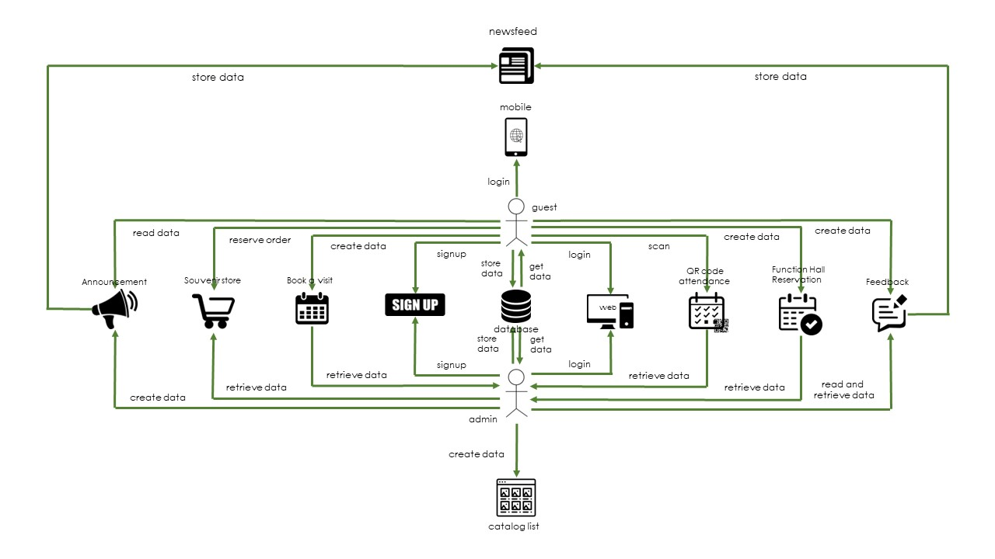

**Figure 3. System Architecture of System Development**

**Use Case Diagram**

Figure 4 shows the process to be done by the guests and administrator in the developed web application. This view presents the guests and admin perception of the functionality provided by the proponents of the project.

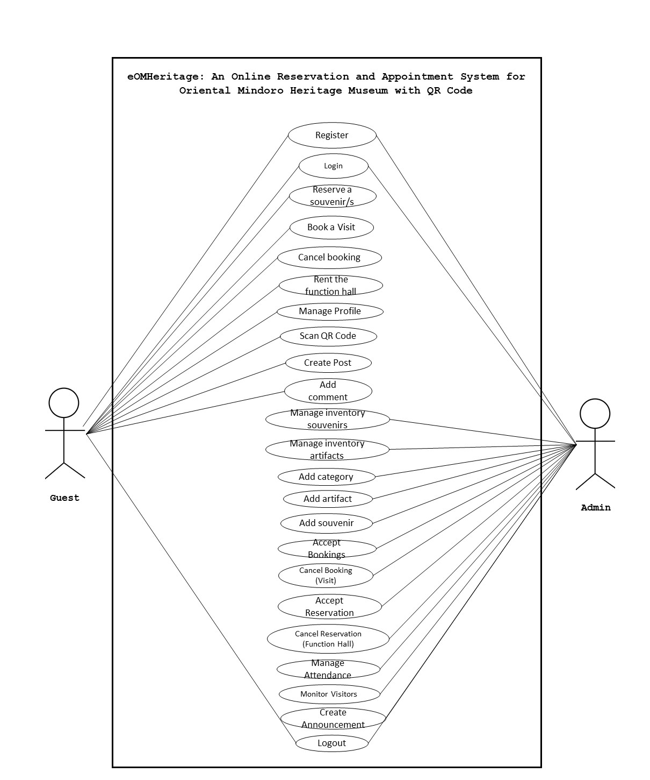

**Figure 4. Use Case Diagram for the Developed System**

**Activity Diagram**

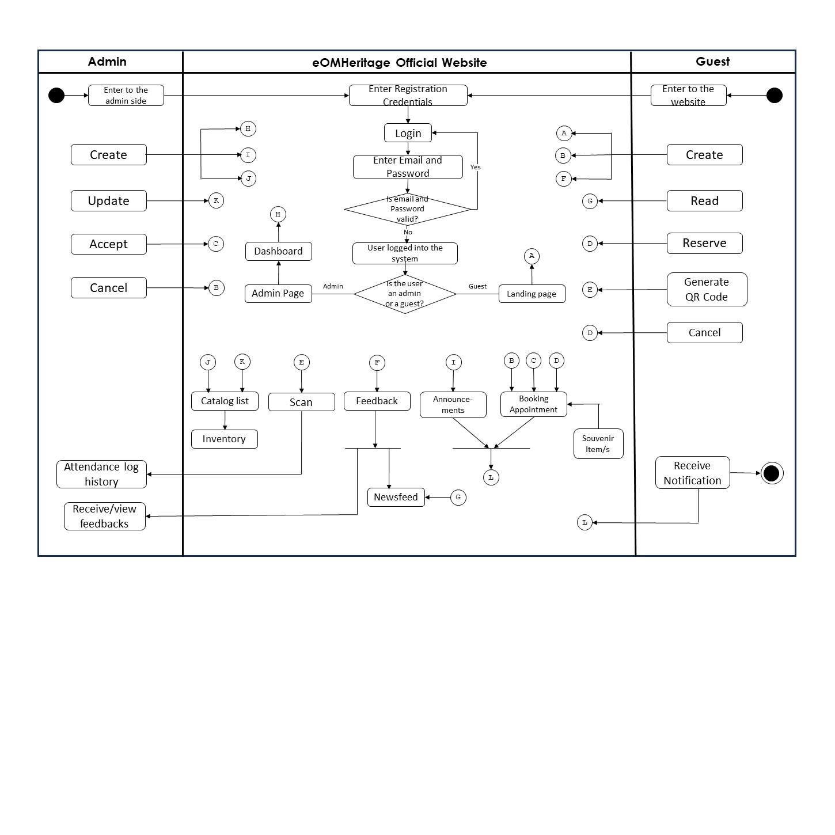 Figure 5 shows the activity diagram of the eOMHeritage Official Website. The intended activities of the admin and users are presented below.

**Figure 5. Activity Diagram**

**Data Flow Diagram (DFD)**

The researchers study the flow of manual process of current system and made a data flow diagram that will help to identify the flow of data within an application and how the data moves between different processes in the system.

**Context Diagram**

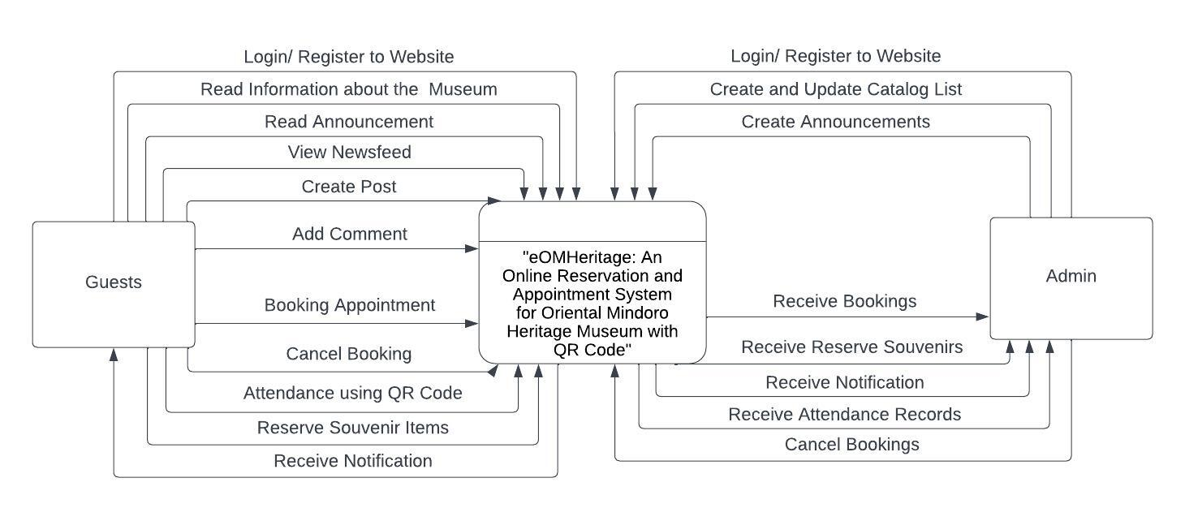Figure 6 shows the diagram of the proposed website. The user who is register and login to the website will be redirecting to the land page of eOMHeritage and this opens up the feature he/she can access through the eOMHeritage Official Website.

**Figure 6. Context Diagram of the Proposed System**

**Diagram 0**

Figure 7 shows the diagram 0 of the proposed system. The user must register first and login into the system and wait for a verification email to verified their account. The user/guest will can able to access all the features of the website once the login or registration is completed where they can use the different types of features and functions in the system.

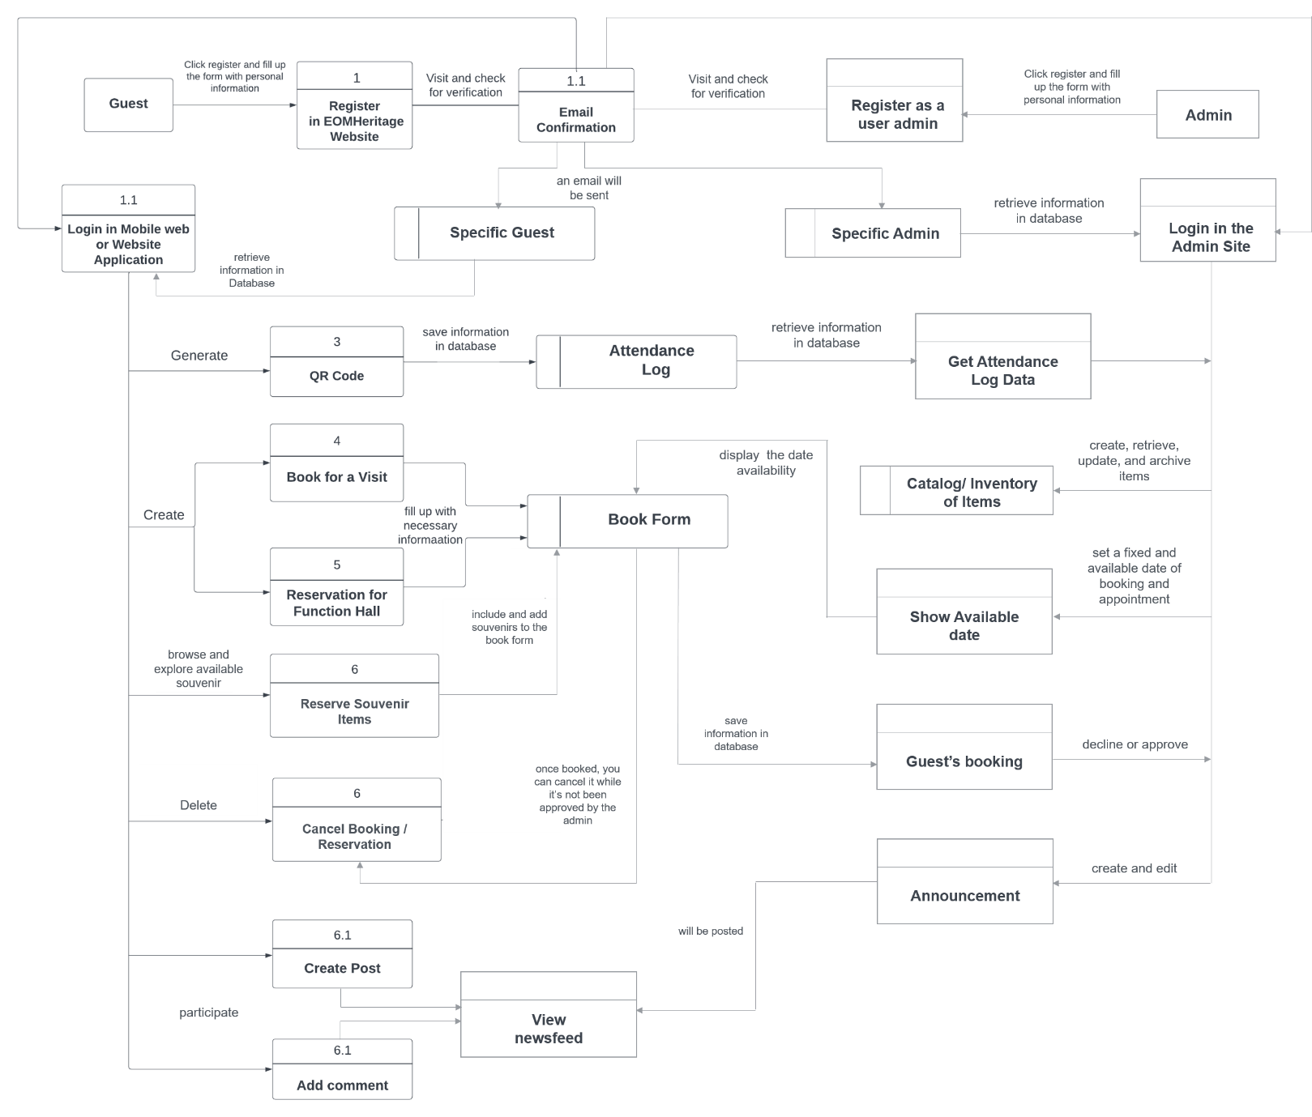

# Figure 7. Data Flow Diagram of the Proposed System

**Database Schema**

The design of the database that contains many elements of the website is one of the crucial stages of website development. This gives users access to the attributes of existing entities and explains how to use the website.

This displays the tables' descriptions, corresponding data types, and utilized fields. It gathered, organized, and verified the definitions of particular data terms. Additionally, it demonstrates how one object is related to another.

**Testing and Evaluation**

Testing process is a critical part of the development process. In this stage, the system’s functionality and capability was tested through different trials and scenarios that will further elaborate what it needs for improvement.

The researchers used the following types of testing for the proposed project.

**Unit Testing**

**Participants:**

The developers of the website and mobile app will also be the one who will conduct the unit testing. There are no other people involve to test the developed system. This is for the reason that only them are the ones who understand the process of development, the errors and the leak holes of the said website.

**Methodology:**

Implementing a testing process requires carefully developing a scenario. It might be an actual situation or issues that could influence the system, wherein the developer/s executes a series of tasks utilizing the website being tested. The purpose is to see how the system functions and engage with the user.

**System Testing**

**Participants**

Members of the proposed mobile and web application will be the one who will conduct the testing of the system. This is because he/she is the one whom the system would be responsible with.

**Methodology**

In system testing conducting many trials is one of the basic parts the developer would meet. Those problems will also encounter in the process of the developing. Documenting any seen problems and resolve the problem and resolve it with the best solution the developer had.

* **Performance Testing**

**Participants:**

The proponents will also test the performance of the software.

**Methodology:**

The quality of a website's performance depends on the developers' efforts to ensure that it delivers its intended service and functions with maximum efficiency.

* **Usability Testing**

**Participants:**

The test should include client, proponents, and the end-users.

**Methodology:**

The developers must gather information about their users' experiences with the website. They should observe how the user perceives the system, and they should gather any suggestions or recommendations that they have for the betterment of system development.

* **Security Testing**

**Participants:**

The software developer is the participant of this test.

**Methodology:**

The developers are responsible for securing the website’s safety from internal and external threats to protect all the information that should be kept exclusively for the site only. The developers must include all efficient function of managing the data to avoid attacks through input from users.

**Appendix A**

**Bibliography**

Wang, S., Duan, Y., Yang, X., Cao, C., & Pan, S. (2023).   
 ‘Smart Museum’in China: from technology labs to   
 sustainable knowledgescapes. Digital Scholarship in   
 the Humanities.

Kolobkova, V. A., & Romanov, A. A. (2022, February).   
 Development of Museum Informatics in Russia and   
 Abroad. In Proceedings of the International Scientific   
 Conference “Smart Nations: Global Trends In The   
 Digital Economy” Volume 1 (pp. 154-162). Cham:   
 Springer International Publishing.

Kurdi, B., Alzoubi, H., Akour, I., & Alshurideh, M. (2022).   
 The effect of blockchain and smart inventory system on   
 supply chain performance: Empirical evidence from   
 retail industry. Uncertain Supply Chain Management,   
 10(4), 1111-1116.

Definition of INVENTORY. (n.d.). Merriam-webster.com.   
 Retrieved December 13, 2022

Streimikiene, D., Svagzdiene, B., Jasinskas, E., &   
 Simanavicius, A. (2021). Sustainable tourism   
 development and competitiveness: The systematic   
 literature review. Sustainable development, 29(1),   
 259-271.

Romero, C. A. T., Ortiz, J. H., Khalaf, O. I., & Ortega, W.   
 M. (2021). Software architecture for planning   
 educational scenarios by applying an agile   
 methodology. International Journal of Emerging   
 Technologies in Learning (Online), 16(8), 132.

Beerbaum, D. O. (2021). Applying Agile Methodology to   
 regulatory compliance projects in the financial   
 industry: A case study research. Available at SSRN   
 3834205.

Paré, G., Raymond, L., Castonguay, A., Grenier Ouimet, A.,   
 & Trudel, M.-C. (2021). Assimilation of medical   
 appointment scheduling systems and their impact on the   
 accessibility of primary care: Mixed methods study.   
 JMIR Medical Informatics, 9(11), e30485.

Emmanuel, A. A., Adedoyin, A. E., Mukaila, O., & Roseline,   
 O. O. (2020). Application of smartphone qrcode scanner   
 as a means of authenticating student identity card.   
 International Journal of Engineering Research and   
 Technology, 13(1), 48-53.

Zhang, J., Liu, S., Fan, J., Huang, J., & Pei, M. (2020).   
 NK-CDS: A creative design system for museum art   
 derivatives. IEEE Access, 8, 29259-29269.

Pascoal, S., Tallone, L., & Furtado, M. (2020, October).   
 The impact of COVID-19 on cultural tourism: Virtual   
 exhibitions, technology and innovation. In   
 International Conference on Tourism, Technology and   
 Systems (pp. 177-185). Springer, Singapore.

Speno, L. (2019). Heritage Tourism Handbook: A How-to-Guide   
 for Georgia. Georgia Department of Natural Resources.

Craik, J. (2020). The culture of tourism. In Touring   
 cultures (pp. 123-146). Routledge.

Hayat, F., Rehman, A. U., Arif, K. S., Wahab, K., & Abbas,   
 M. (2019, July). The influence of agile methodology   
 (Scrum) on software project management. In 2019 20th   
 IEEE/ACIS International Conference on Software   
 Engineering, Artificial Intelligence, Networking and   
 Parallel/Distributed Computing (SNPD) (pp. 145-149).   
 IEEE.

Paul, S., Chatterjee, A., & Guha, D. (2019). Study of smart   
 inventory management system based on the internet of   
 things (IOT). International Journal on Recent Trends   
 in Business and Tourism (IJRTBT), 3(3), 27-34.

Richards, G. (2018). Cultural tourism: A review of recent   
 research and trends. Journal of Hospitality and   
 Tourism Management, 36, 12-21.

Ruhanen, L., & Whitford, M. (2019). Cultural heritage and   
 Indigenous tourism. Journal of heritage tourism,   
 14(3), 179-191.

Pascoal, S., Tallone, L., & Furtado, M. (2020, October).   
 The impact of COVID-19 on cultural tourism: Virtual   
 exhibitions, technology and innovation. In   
 International Conference on Tourism, Technology and   
 Systems (pp. 177-185). Springer, Singapore.

Mohd Noor Shah, N. F., & Ghazali, M. (2018, August). A   
 systematic review on digital technology for enhancing   
 user experience in museums. In International   
 Conference on User Science and Engineering (pp. 35-  
 46). Springer, Singapore.

Adedokun A, Idris O, Odujoko T. Patients' willingness to   
 utilize a SMS-based appointment scheduling system at a   
 family practice unit in a developing country. Prim   
 Health Care Res Dev. 2019;17(2):149-56. doi:   
 10.1017/S1463423615000213. [PubMed: 25851031].

Klymash, M., Demydov, I., Uryvskyi, L., & Pyrih, Y. (2020,  
 February). A Brief Survey on Architecture of Feedback   
 Systems for Interactive E-Government ICT Platforms. In   
 2020 IEEE 15th International Conference on Advanced   
 Trends in Radioelectronics, Telecommunications and   
 Computer Engineering (TCSET) (pp. 458-461). IEEE.

Hema Kumar, S., Uday Kiran, J., Ambeth Kumar, V. D.,   
 Saranya, G., & Ramalakshmi, V. (n.d.). Effective   
 online medical appointment system. Ijstr.org.   
 Retrieved April 13, 2023

**Appendix B**

**Evaluation Form**

The level of performance of project PAuCet was evaluated using ISO 25010 criteria in terms of functional suitability, reliability, performance efficiency, usability, security, compatibility, maintainability and portability that is shown below.

**Oriental Mindoro Heritage Museum Official Website**

Name (optional):

Respondent:

OIC Provincial Tourism Head Officer

Provincial Tourism Staff

IT Expert

**Directions:** Using the scale below, evaluate the overall performance of the website according to ISO 25010 based questionnaires by checking the appropriate answer.

***5 – Strongly Agree   
4 – Agree   
3 – Moderately Effective   
2 – Disagree   
1 – Strongly Disagree***

|  |  |  |  |  |  |
| --- | --- | --- | --- | --- | --- |
| **STATEMENTS** | **1** | **2** | **3** | **4** | **5** |
| **A. Functional Suitability** | | | | | |
| **COMPLETENESS**: The set of functions covers all the specified tasks and user objectives. |  |  |  |  |  |
| **CORRECTNESS**: The function provides the correct results with the needed degree of precision. |  |  |  |  |  |
| **APPROPRIATENESS**: The function facilitates the accomplishment of specified tasks and objectives. |  |  |  |  |  |

|  |  |  |  |  |  |
| --- | --- | --- | --- | --- | --- |
| **B. Reliability** | | | | | |
| **MATURITY**: A system, product or component meets for reliability under normal operation. |  |  |  |  |  |
| **AVAILABILITY**: A product or system is operational and accessible when required for use. |  |  |  |  |  |
| **FAULT TOLERANCE**: A system, product or component operates as intended despite the presence of hardware or software results. |  |  |  |  |  |
| **RECOVERABILITY**: In the event of an interruption or a failure, a product or system can recover the data establish the desired state of the system. |  |  |  |  |  |

|  |  |  |  |  |  |
| --- | --- | --- | --- | --- | --- |
| **C. Portability** | | | | | |
| **ADAPTABILITY**: A product or system can effectively and efficiently be adapted for different or evolving hardware, software or other operational or usage environment. |  |  |  |  |  |
| **DURABILITY**: A product or system can withstand technology evolution and changes without costly redesign, reconfiguration or recoding. |  |  |  |  |  |
| **INSTALLABILITY**: A product or system can be successfully installed and/or uninstalled in a specified environment. |  |  |  |  |  |
| **REPLACEABILITY**: A product can replace another specified software product for the same purpose in the same environment. |  |  |  |  |  |
| **AFFORDABILITY:** A product or system can increase efficiency and productivity by reducing the time and costs involved in delivering instruction. |  |  |  |  |  |

|  |  |  |  |  |  |
| --- | --- | --- | --- | --- | --- |
| **D. Usability** | | | | | |
| **APPROPRIATENESS / RECOGNIZABILITY**: Users can recognize whether a product or system is appropriate for their needs. |  |  |  |  |  |
| **LEARNABILITY**: A product or system enables the user to learn how to use it with effectiveness, efficiency in emergency situations. |  |  |  |  |  |
| **OPERABILITY**: A product or system is easy to operate, control and appropriate to use. |  |  |  |  |  |
| **USER ERROR PROTECTION**: A product or system protects users against making errors. |  |  |  |  |  |
| **ACCESSIBILITY**: A product or system can be used by people with the widest range of characteristics and capabilities to achieve a specified goal in a specified context of use. |  |  |  |  |  |

|  |  |  |  |  |  |
| --- | --- | --- | --- | --- | --- |
| **E. Performance Efficiency** | | | | | |
| **TIME-BEHAVIOR**: The response and processing times and throughput rates of a product or system, when performing its functions, meet requirements. |  |  |  |  |  |
| **RESOURCE UTILIZATION**: The amounts and types of resources used by a product or system, when performing its functions, meet requirements. |  |  |  |  |  |
| **CAPACITY**: The maximum limits of the product or system, parameter meet requirements. |  |  |  |  |  |

|  |  |  |  |  |  |
| --- | --- | --- | --- | --- | --- |
| **F. Security** | | | | | |
| **CONFIDENTIALITY**: The prototype ensures that data are accessible only to those authorized to have access. |  |  |  |  |  |
| **INTEGRITY**: A system, product or component prevents unauthorized access to, or modification of computer programs or data. |  |  |  |  |  |
| **NON - REPUDATION**: Actions or events can be proven to have taken place, so that the events or actions cannot be repudiated later. |  |  |  |  |  |
| **ACCOUNTABILITY:** The actions of an entity can be traced uniquely to the entity. |  |  |  |  |  |
| **AUTHENTICITY:** The identity of a subject or resources can be proved to be the one claimed. |  |  |  |  |  |

|  |  |  |  |  |  |
| --- | --- | --- | --- | --- | --- |
| **G. Compatibility** | | | | | |
| **CO-EXISTENCE**: A product can perform its required functions efficiently while sharing a common environment and resources with other products, without detrimental impact on any other product. |  |  |  |  |  |
| **INTEROPERABILITY**: Two or more systems, products or components can exchange information and use the information that has been exchanged. |  |  |  |  |  |

|  |  |  |  |  |  |
| --- | --- | --- | --- | --- | --- |
| **H. Maintainability** | | | | | |
| **MODULARITY**: A system or computer program is composed of discrete components such that a change to one component has minimal impact on other components. |  |  |  |  |  |
| **REUSABILITY**: An asset can be used in more than one system, or in building other assets. |  |  |  |  |  |
| **ANALYZABILITY**: It is possible to assess the impact on a product or system of an intended change to one or more of its parts, or to diagnose a product for deficiencies or causes of failures, or to identify parts to be modified. |  |  |  |  |  |
| **MODIFIABILITY**: A product or system can be effectively and efficiently modified without introducing defects or degrading existing product quality. |  |  |  |  |  |
| **TESTABILITY:** Test criteria can be established for a system, product or component and tests can be performed to determine whether those criteria have been met. |  |  |  |  |  |

**Participants of the Study**

The respondent of this study is composed of 3 officials. Including the 5 Provincial Tourism Staffs, 45 guest and visitors and 3 IT Experts. The Provincial Tourism Staffs are all the current members of the Tourism Department in Calapan City. The guests and visitors are those people who are willing to book an appointment while the IT Expert are some BSIT Graduates and IT Personnel of Oriental Mindoro Heritage Museum.

**Table 3. Respondents of the Study**

|  |  |  |
| --- | --- | --- |
| **Respondents** | **Number of Respondents** | **Percentage** |
| Provincial Tourism Staffs | 5 | **9%** |
| Guests and Visitors | 45 | **85%** |
| IT Experts | 3 | **6%** |
| **TOTAL** | **53** | **100%** |

Table 3 shows the respondents of the study with the number of each type of respondents along with percentage in the population.

**Data Gathering Instrument**

The researchers used the ISO 25010 based questionnaires to acquire the needed evaluation of the respondents. Likert scale-type questionnaire was adopte

**Table 4. Five Point Likert Scale**

|  |  |  |
| --- | --- | --- |
| **Numerical Value** | **Statistical Limit** | **Verbal Description** |
| 5  4  3  2  1 | 4.50 – 5.00  3.50 – 4.49  2.50 – 3.49  1.50 – 2.49  1.00 – 1.49 | Strongly Agree  Agree  Moderately Agree  Disagree  Strongly Disagree |

5 – Strongly Agree, 4 – Agree, 3 – Moderately Agree, 2 – Disagree, and 1 – Strongly Disagree.

**Implementation Plan**

The researchers created a plan for the implementation just in case someone decided to use this suggested system, they will transfer both the system itself and the supporting documentation. The people that will be in charge of updating and maintaining the system will use it as a guide.

The implementation activities that the researchers can provide to the user who wants to use the created system are shown in Table 5.

**Table 5. Implementation Activities (Tentative Days/Date)**

|  |  |  |  |
| --- | --- | --- | --- |
| **Activities** | **No. of days** | **Start Date** | **End Date** |
| **Discussion with user** | **2** | **02/21/2023** | **02/22/2023** |
| **Development of User Manual** | **3** | **08/05/2023** | **08/07/2023** |
| **Loading of Actual Data** | **7** | **09/04/2023** | **09/10/2023** |
| **Deployment Letter** | **1** | **09/18/2023** | **09/18/2023** |
| **System Deployment and Monitoring Period** | **45** | **09/25/2023** | **11/09/2023** |
| **User Training** | **7** | **11/13/2023** | **11/20/2023** |
| **System Monitoring** | **45** | **11/22/2023** | **01/06/2024** |