***Lab 2***

***Moses***

***Section A: Design and GUI (120 Marks)***

1. ***Create a new JavaFX application project in your chosen Java IDE.***
2. ***Name the project using your name.***
3. ***Design the GUI interface for your JavaFX application, including a Table View, Buttons such as Insert, Update, Delete, and View Data to display data from the MySQL database tables and input fields for CRUD operations.***
4. ***Take a screenshot of your GUI layout, ensuring it includes your name, student ID, and date.***

***Section B: Database Connection (180 Marks)***

1. ***Implement the database connection code in your JavaFX application.***
2. ***Ensure it includes the necessary database URL, username, and password.***
3. ***Take a screenshot of the code where you establish the database connection.***

***Section C: Data Models and ORM (120 Marks)***

* ***Create Java classes that represent the structure of your database tables.***
* ***These classes will be used to model the data you retrieve from and insert into the database.***
* ***Use Object-Relational Mapping (ORM) techniques to simplify database interactions.***

***Section D: Open JDBC Jar (120 Marks)***

1. ***Download and include the appropriate JDBC driver (for example, MySQL Connector/J) in your project.***
2. ***Ensure that your project's build path includes the JDBC driver JAR file.***

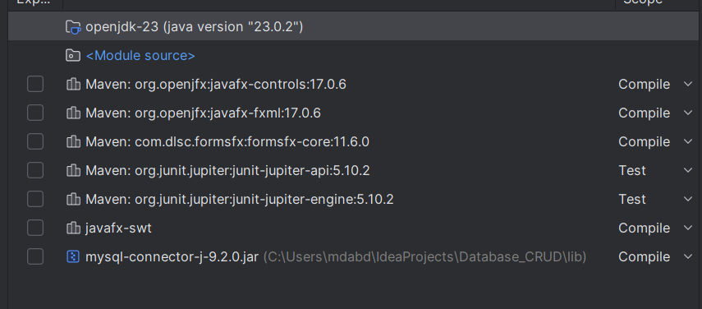

***Section E: Load Data in Table View (120 Marks)***

1. ***Write code to retrieve data from the MySQL database tables and load it into the Table View component.***
2. ***Implement an event handler to trigger this action on button click.***

***Section F: Insert Data into Database (120 Marks)***

1. ***Write code to insert data into the database when a button is clicked.***
2. ***Ensure that the input fields on the GUI are used to gather data for insertion.***

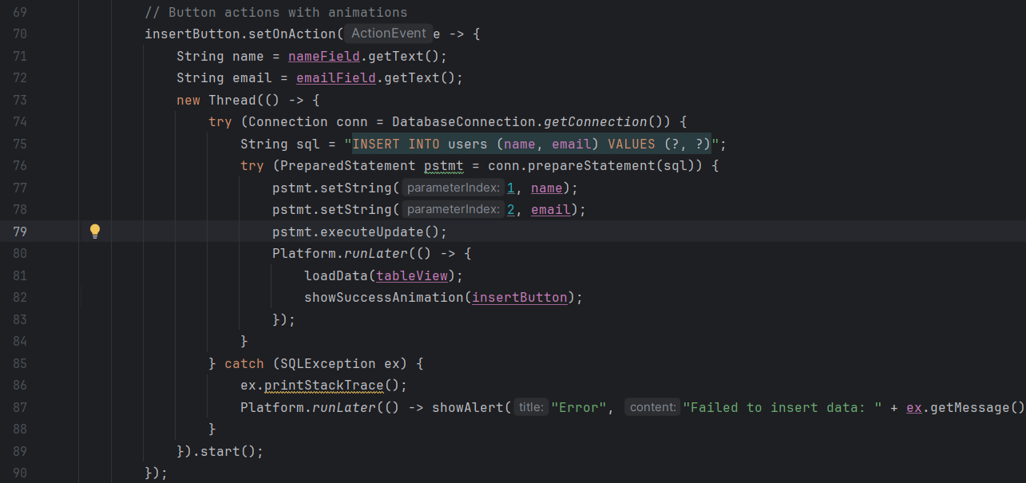

***Section G: Update Data in Database (120 Marks)***

1. ***Write code to update existing data in the database when a button is clicked.***
2. ***Allow the user to provide an ID to identify the data to update.***

***  
LUFFY WAS REPLACED BY JINBE.***

***Section H: Delete Data from Database (120 Marks)***

1. ***Write code to delete data from the database when a button is clicked.***
2. ***Provide the option for the user to specify an ID for data deletion.***

***Jinbe was removed from table.***

***WORKBENCH.***

***Section I: GitHub and Documentation (180 Marks)***

1. ***Upload your JavaFX project to a GitHub repository.***
2. ***Create a DOCX or PDF document including:***
3. ***Screenshots of your GUI layout with your name, student ID, and date.***
4. ***Screenshots of your database table structures and sample data.***
5. ***Screenshots of relevant portions of your code.***
6. ***A link to your GitHub repository.***

[***https://github.com/Lycanroc0409/Lab2Javafx.git***](https://github.com/Lycanroc0409/Lab2Javafx.git)

***“THE ZIP FILE AND THE WORD FILE CAN BE DOWNLOADED AND USE FROM THE REPOSITORY”***

