# Scope and Limitation

The Scholarship |Information System cover the major scholarship management process of Cavite State University – Office of Student Affairs including: Scholarship application for new and old scholars, Storing and retrieving of scholarship records, Monitoring of duty hours, displaying of scholarship results and report generation.

Users of the system have their own account with different access levels. Staff should have their account before they can apply for the scholarship. Administrators have a total access to the system.

**Account Management Module.** This module holds the overall security of the system. It is responsible for the Log In and accessing the data of the students and the security of it. This module will also provide the content of the system such as mission and vision which are the located at the homepage of the system.

**Student Profile Module.** This module contains the information of the student including type of scholar, grade, and schedule.

**Scholarship Application Module.** This module will be used during the Scholarship Application Program. This module will provide accurate and faster input-process-output scholarship coordinator.

**Scholar Monitoring Module.** This module monitor the duty hours rendered by the

student. The staff will check the record and performance of the student from the time they started the duty. This will served as the basis of their Scholarship Application for the following year.

**Report Generation Module.** This module allows the generation of reports that the University needs to submit to the different Office, Colleges and Branch. The reports will include the total number of scholar according to the type of scholarship program and colleges, the summary of grade and duty hours of scholars.

The system can only be used for scholarship purposes only. It does not cover the automatic checking of the grade point average (GPA) to know what type of scholarship applicants can avail and the credentials that the user has sent to the administrator.

# Theoretical Framework

The theoretical framework is a collection of interrelated concepts that will guide the researcher in developing the proposed study.

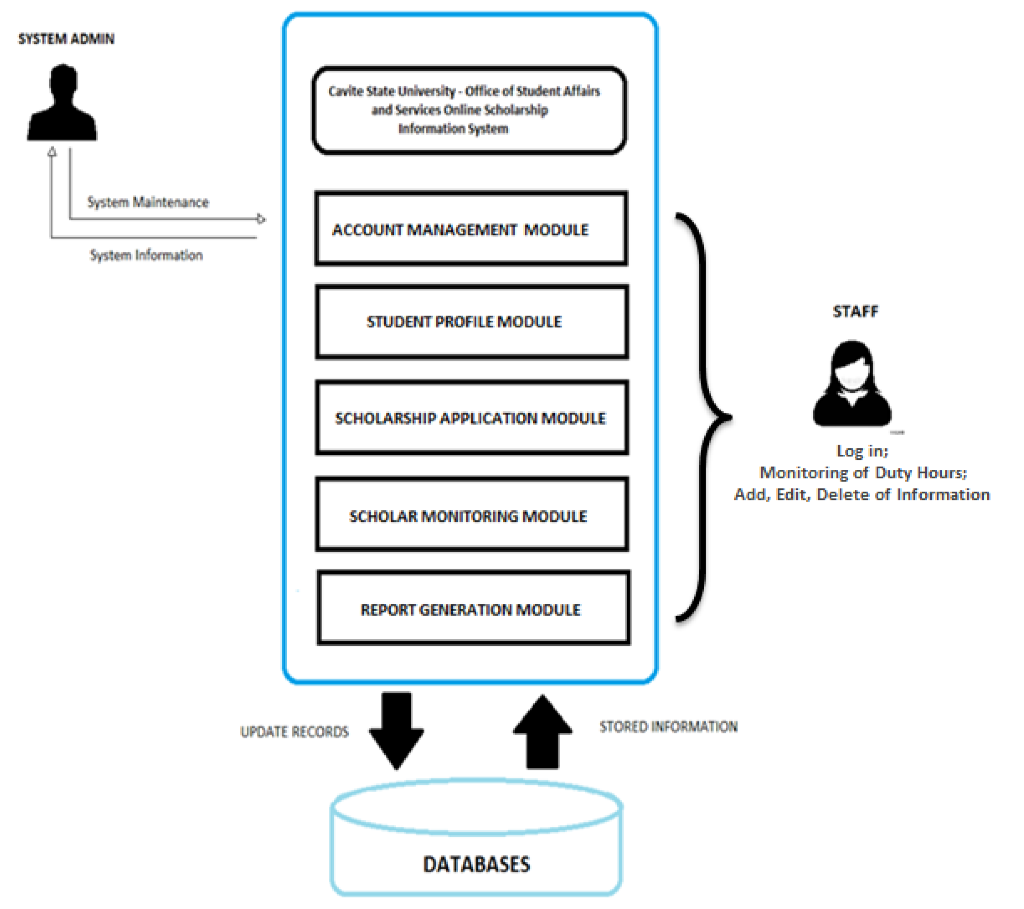

Figure 2: Theoretical Framework (Different Modules)

The Scholarship Information System for Cavite State University – Office of Student Affairs and Services provides a secured and efficient mode of handling and monitoring files. It is divided into different modules namely: Account Management Module, Student Profile Module, Scholarship Application Module, Scholar Monitoring Module and Report Generation Module.

In any system, distinguishing the identity of the user is essential. It is also important to limit the access of a user, depending on the needed information. The **Account Management Module** will enable setting of username and password of the staff. It verifies the staff and its prescribed level of access. This module will also provide the content of the system such as mission, vision and other features that provides information to the user which are located at the homepage of the system.

It is difficult to classify a certain student based on their scholarship type, especially in a group of individuals with a greater population. In this case, the **Student Profile Module** will help in identifying a student with a specific scholarship. This module also contains the information of the student including type of scholar, grade, and schedule.

**Scholarship Application Module** will be used during the scholarship application program. This module will provide accurate and faster input-process-output student data. It will help the organization to keep student information in a secured database.

It is a big challenge by the staff to monitor the duty hours of Job Experience Program (JEP) scholars. The **Scholar Monitoring Module** will help monitors the duty hours rendered by the student. The staff will check the record and performance of the student from the time they started the duty.

The Head of Scholarship and Financial Assistance produces different reports every semester. Since the Office is using manual system, making reports are difficult to facilitate. **Report Generation Module** allows the generation of reports that the University needs to submit to the different office and colleges. The reports will include the total number of scholar according to the type of scholarship program and colleges, the summary of grade and duty hours of scholars.