How do Cassette Tapes Work?
Design Document
CT6015 Creative Visualisation and Animation
Lycia Stenson
Contents
Introduction 2
Choosing the Subject 2
Target Audience 2
Software and Techniques 2
Research 2
Development 2
Challenges 3
References 3

Introduction
This design document follows the planning, research, and development of an interactive visualisation called ‘How Do Cassette Tapes Work?’ covering the methods used and how successful they were and any improvements made informed by this.

Choosing the Subject
The Compact Cassette was chosen as the subject, with a target audience of children and young people, as this is something not generally well understood by young people but is still recognisable in pop culture due to shows like Stranger Things for example.

Target Audience
The target audience of ‘How Does a Cassette Tape Work?’ is children and teenagers aged 10-19, but can also appeal to older young people.

Software and Techniques
As an interactive visualisation, a game engine is the core necessary technology. Godot provides all the functionality needed for this project. For 3D modelling Blender as I have experimented with it before and it is very accessible for self-learning. With little 3D modelling experience there will not be UV unwrapping or textured models, as dedicating the amount of time necessary to develop these skills would not allow the project to be developed within the time frame.

Research
The first information needed to be researched were dimensions of the objects which will be present in the visualisation, such as the cassette shell, case, and the tape itself. This was crucial to create accurately proportioned 3D models.

Development
For programming, Godot’s high-level language has been used as it is quick to iterate and develop with. On large scale projects the use of another language like C# or C++ can be beneficial but for this project GDScript’s high-level nature will not result in performance issues.
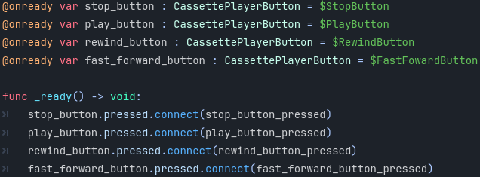
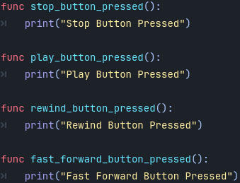

Challenges
Development challenges largely stemmed from the visualisation being developed as a solo project by a programmer with little prior experience of 3D modelling. The necessary techniques to create the assets were researched, opting to streamline the process by focusing on simpler modelling techniques, with block materials per object without the use of UV unwrapping or more advanced topology techniques.
Additionally, there were challenges with the implementation of the interactive project. It was necessary to research some less familiar features of Godot such as the use of audio tracks and the animation system. The different animated parts of the cassette player model, such as the buttons and the door, required either multiple AnimationPlayer nodes or the use of an additional AnimationTree node. Instead of researching the in-depth use of the AnimationTree node, separate AnimationPlayer nodes were used for each of the animated components.

References
O’Kelly, T. The Cassette Housing. Available at: http://www.ant-audio.co.uk/Tape_Recording/Library/Cassette_Housing.pdf (Accessed October 26th 2024)
TDK Representative Product Line Package: D Normal-bias Audio Tapes. Available at: https://web.archive.org/web/20070620193131/http://legacyproducts.tdk.com/support/pdfs/d.pdf (Accessed October 26th 2024)
Kuzmin, B. (2024) 80s Retro Synth Wave. Available at: https://pixabay.com/music/synth-pop-80s-retro-synth-wave-223103/ (Accessed December 22nd 2024)
freesound_community (2022) TAPE HISS Tandberg TCD 310 B. Available at: https://pixabay.com/sound-effects/tape-hiss-tandberg-tcd-310-b-20284/ (Accessed January 3rd 2025)

