Ocean Liner Tycoon
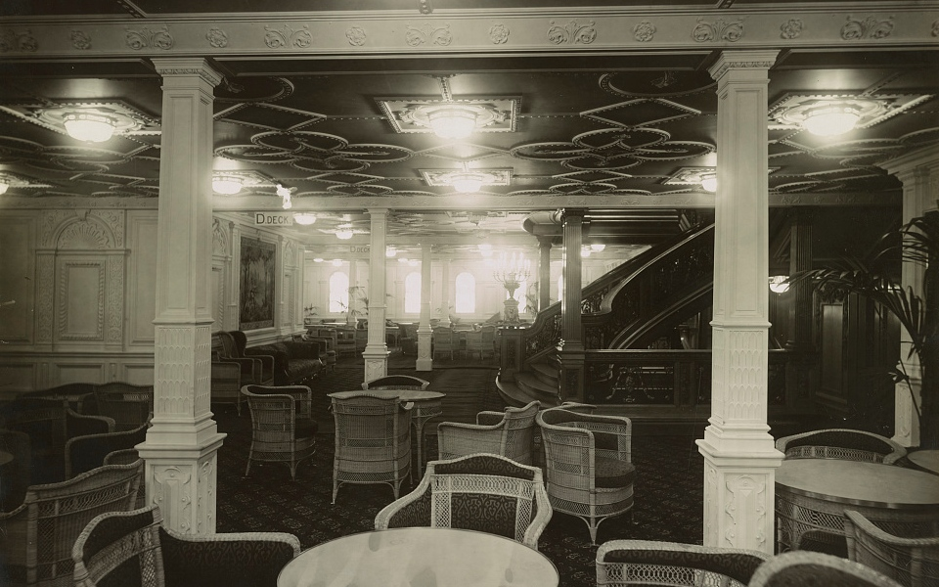
Hello this is some text
Game Concept
Overview
‘Ocean Liner Tycoon’ is a mobile tycoon game focusing on the era of ocean liner travel. Players will grow their fleet of ocean liner ships by satisfying their passengers’ wants and needs as they travel to their destinations.
Genre
A mobile tycoon game.
Target Audience
The game will target two audiences. The primary audience will be people with an interest in ocean liners. This audience will be drawn to the game as it relates to their interests. The game will also target a secondary audience with an interest in the Titanic due to pop culture. The Titanic keeps ocean liners in the public conscience, and ‘Ocean Liner Tycoon’ will leverage this to market to a wider audience.

