ANAlytic Description of a Geometrical model of gps - altimetry∗

Jaroslav Černý¹, Milada Kočandrlová1

The satellite altimetry is one of the most important method for the study of the geoid. A wide list of its application in different branches of geosciences exists nebo is known. The procedure of the altimetry method is similar to the GPS method. One satellite altimetr transmits a short signal to the Earth. It reflects back to the satellite or to the CHAMP satellite (Challenging Minisatellite Payload for Geophysical Research and Application). The problem is to locate the point of reflection.
Let us fix a cartesian frame of reference in the space such that the origin is in the satellite S₁ (CHAMP) and the satellite S₂ (GPS) lies on the y axis. The coordinate plane yz is determined by the velocity vector of the satellite S₁, and the x axis is perpendicular to this plane. Three quadrics are defined by the situation
All points P that reflect a signal of the constant length 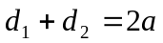, which is transmitted from the satellite S₁ to the satellite S₂ lie on an ellipsoid of revolution

(1) 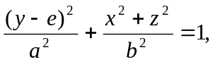

where 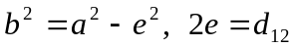 (distance of satellites).
A straight circular cone is formed by all points P in which the signal transmitted from the satellite S₂ is reflected to the satellite S₁, with the satellite S₂ velocity vector and the reflected ray vector forming the angle θ. S₁ is the vertex of the corresponding conical surface, the axis of revolution is determined by the satellite S₁ velocity vector. The bias slope of the elements of the conical surface and the axis of revolution is θ. The equation is derived from the conical surface equation in the basic position, i.e. with the vertex in the satellite S₁ and with the axis in the z axis

(2) 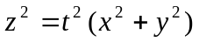.

Using the rotation around the x axis under the angle of the x axis and the velocity vector of the satellite S₁ gives us the desired equation. We use t for the cotangent of the angle θ, s for sine, and c for cosine. The reflecting points lie on the right circular cone

(3) 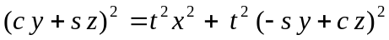.

The intersection curve of the ellipsoid of revolution (1) and the right circular cone (2) is a curve of the forth order, which is projected as a hyperbola into the two rotation axes plane. The implicit equation of this hyperbola is derived by removing the variable x from the equations (1) and (2) and proceeding accordingly

(4)
If we denote

then the equation (4) can be written in the following form

(5) 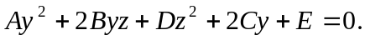

The matrix of the quadratic form to the conic section (5) is singular. Therefore this conic section is a pair of intersecting lines. The coordinates of their common point are given by the following formula
(6) 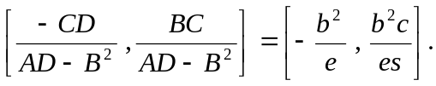

The following equation holds for the intersection points 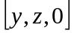 (homogeneous coordinates) of both lines (5) and the line of infinity

(7) 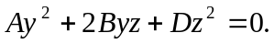

The solution of this equation

(8) 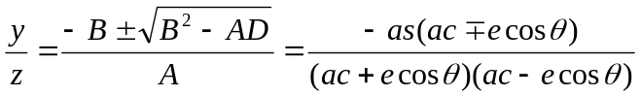

defines the vectors of both lines

(9)

The following equations give parametric description of the singular conic section (5)

(10) 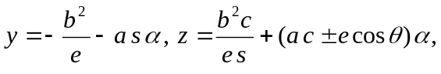
where α is a real parameter. The intersection quartic of the ellipsoid and the cone splits into two ellipses. If we eliminate the parameter α from the equation (10) we obtain the equation of the planes of these ellipses

(11) 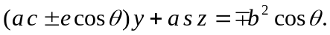

We describe one part of the cone (3) by means of the parametric equations

(12)

We denote ρ the plane which intersects this surface. Then the equation of ρ is

(13) 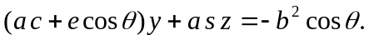

If we eliminate the parameter v from the parametric equation of the cone (12) we obtain the parametric equation of the ellipse E

(14) 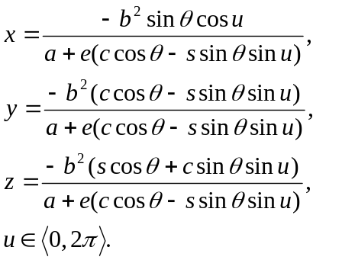

The plane ρ intersects the reference ellipsoid. The intersection is an ellipse E_{r}. We know its equation. The required reflection points are common points of the ellipse E and the ellipse E_{r}. Some numerical methods are used to found all common points. The right point is uniquely defined by means of the reflection theorem. Fig. 1 shows the situation.

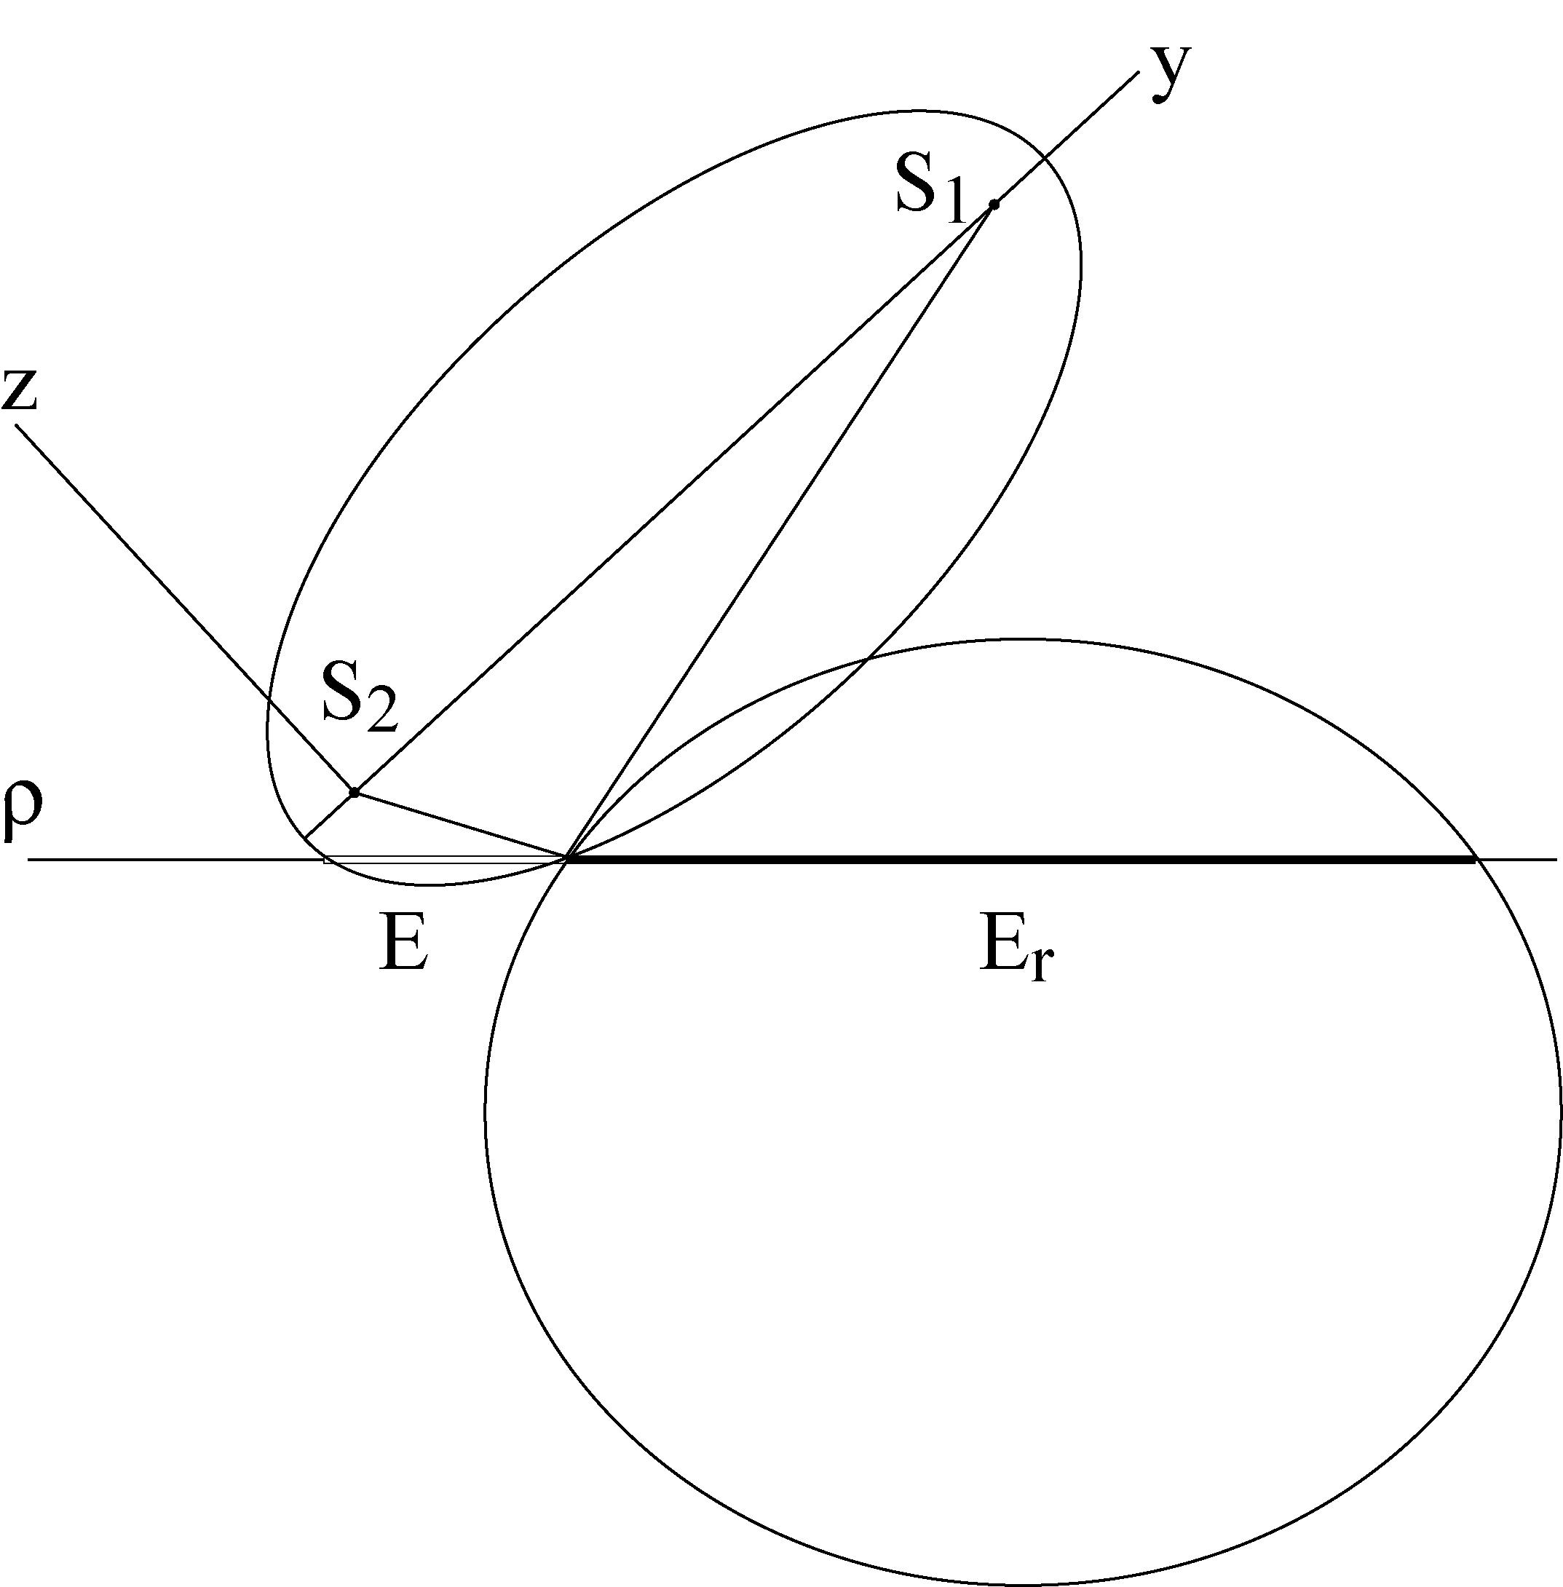 Fig. 1

The next procedure shows a geometric approach to finding the right reflection point. There are five possible situations of mutual position of two ellipses in a plane which have at most four common real points, see Fig. 2.
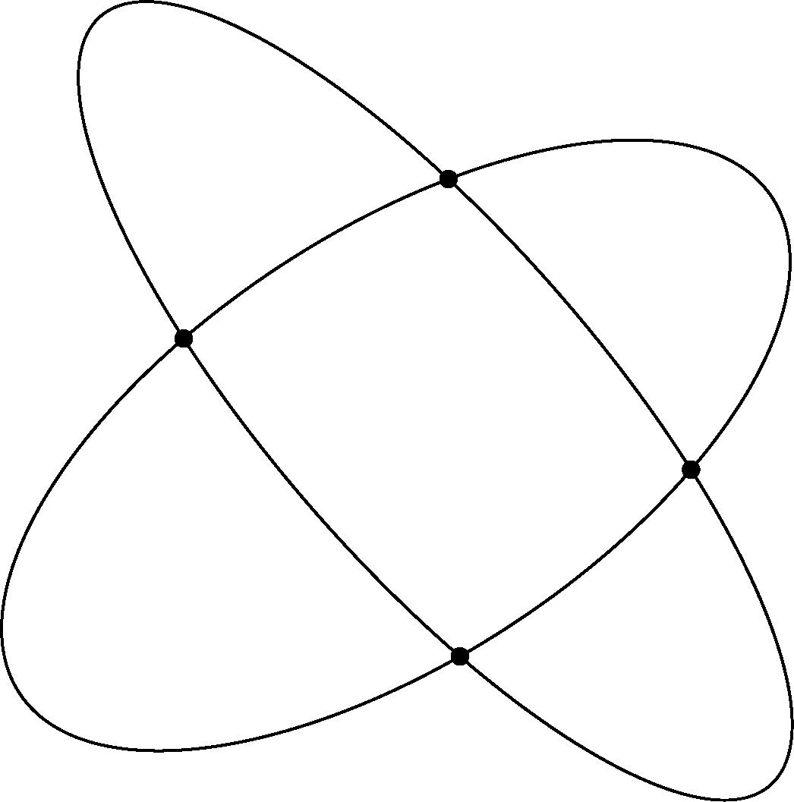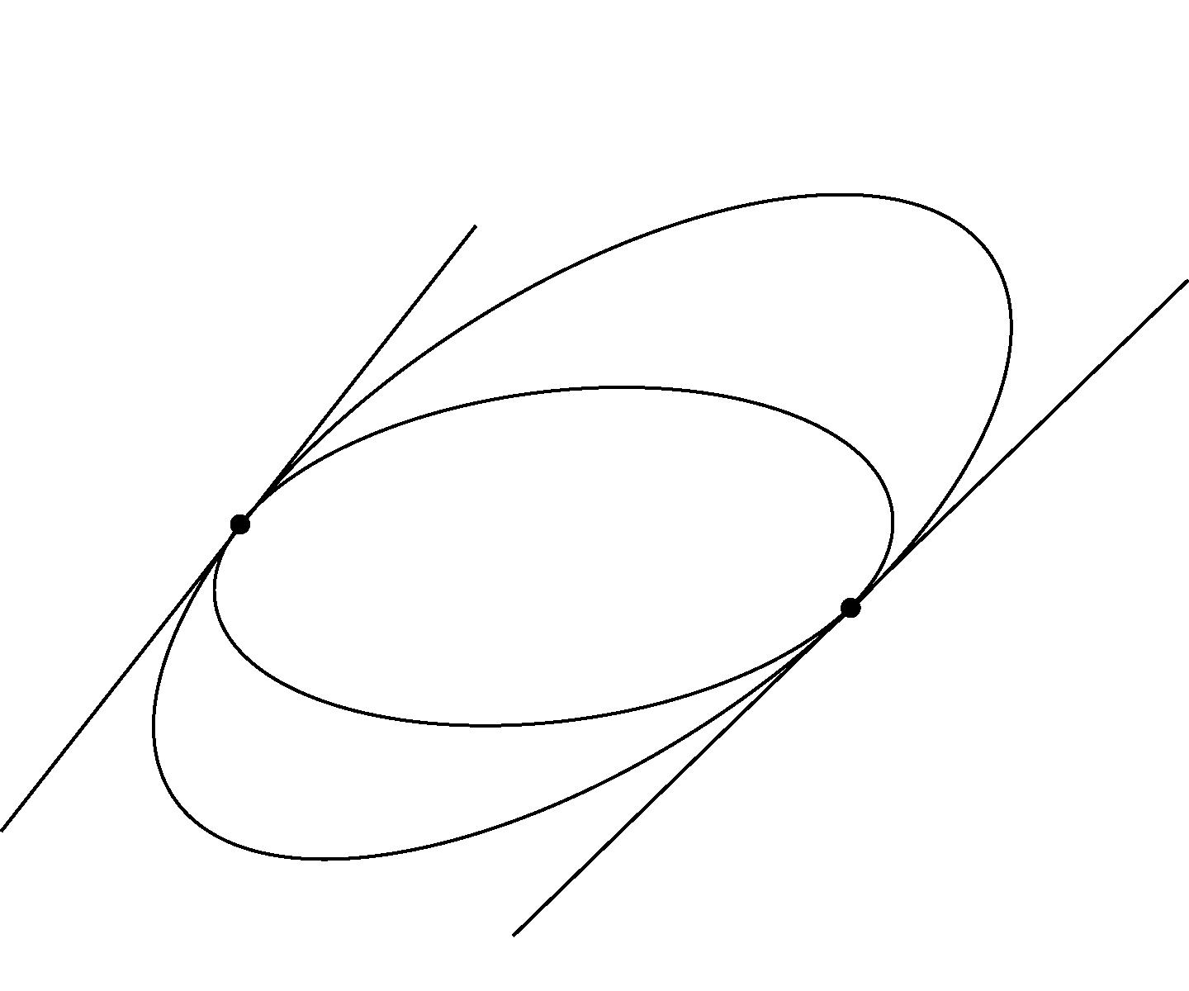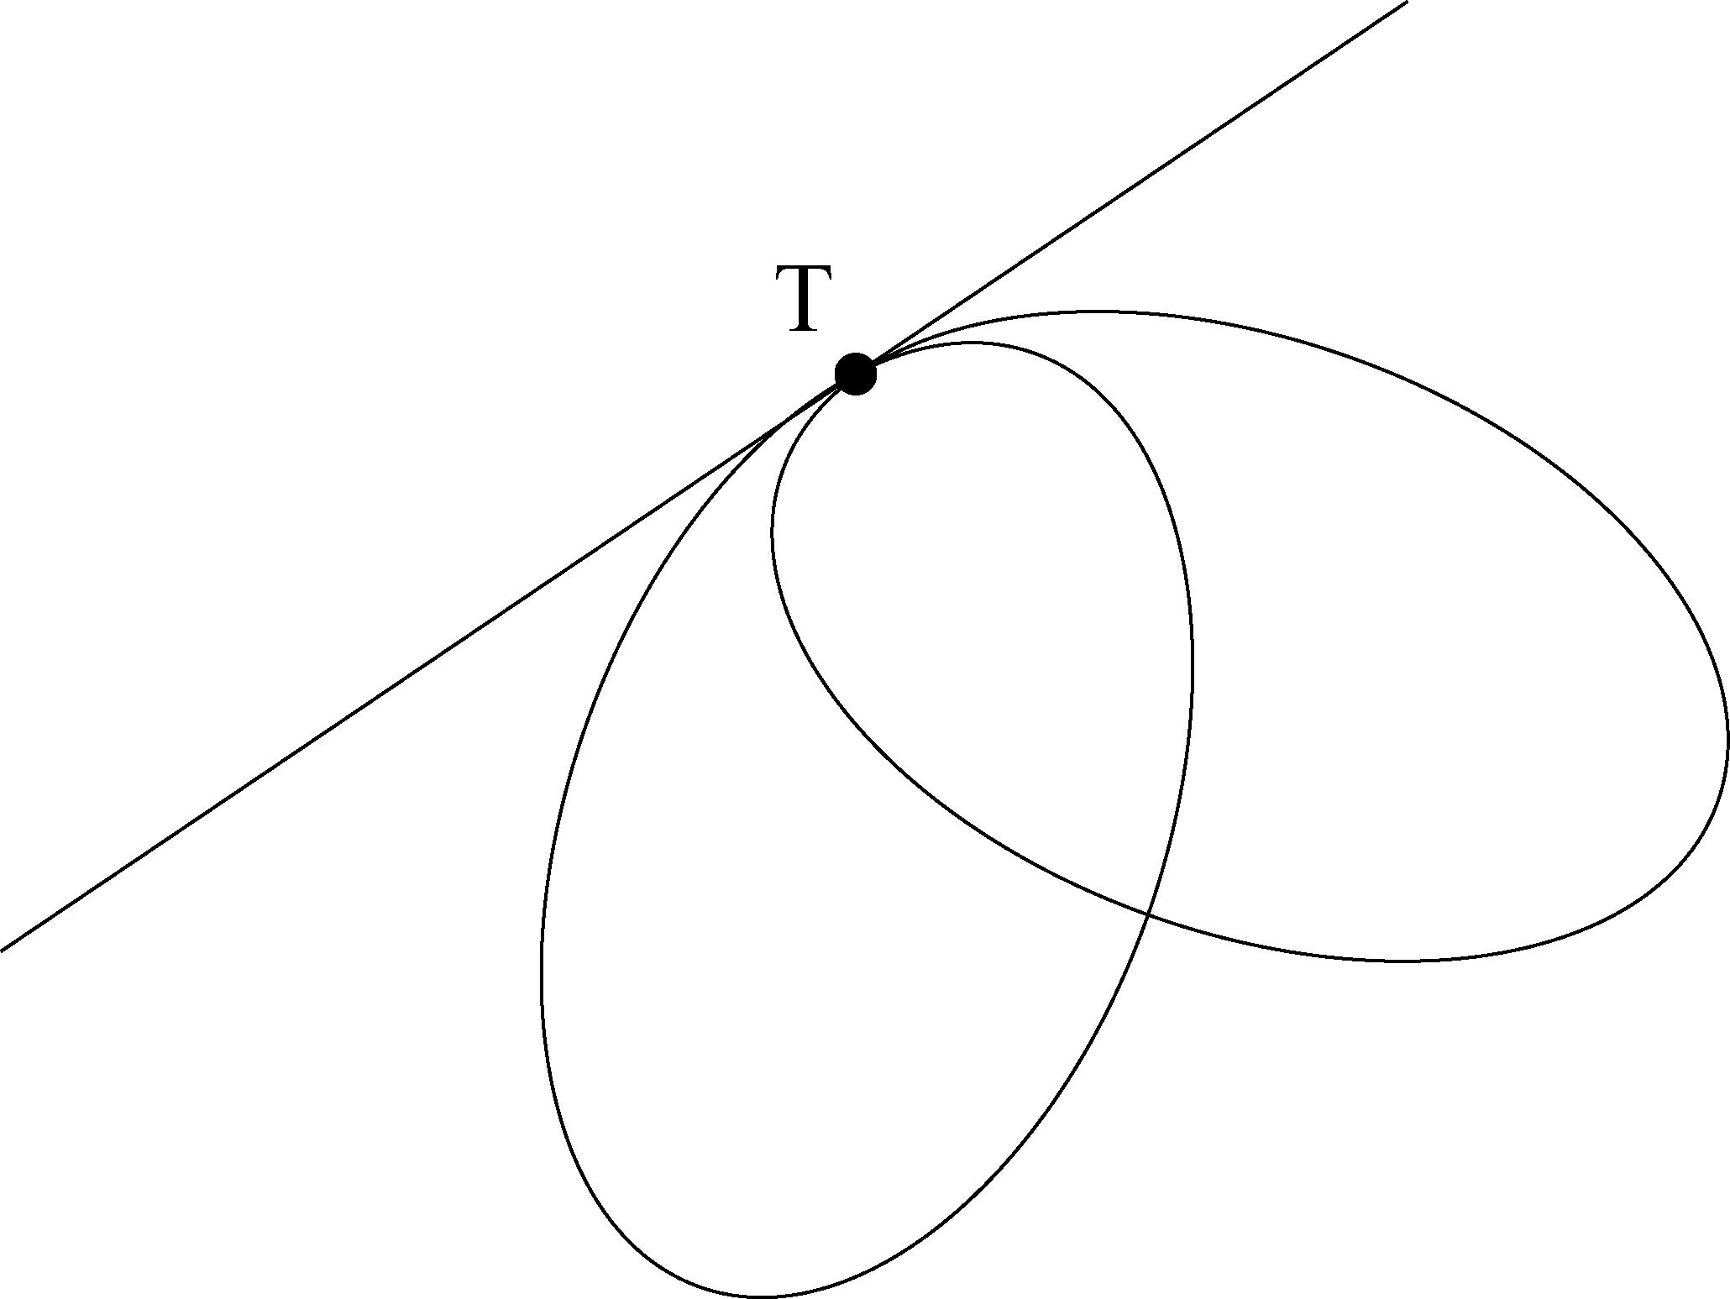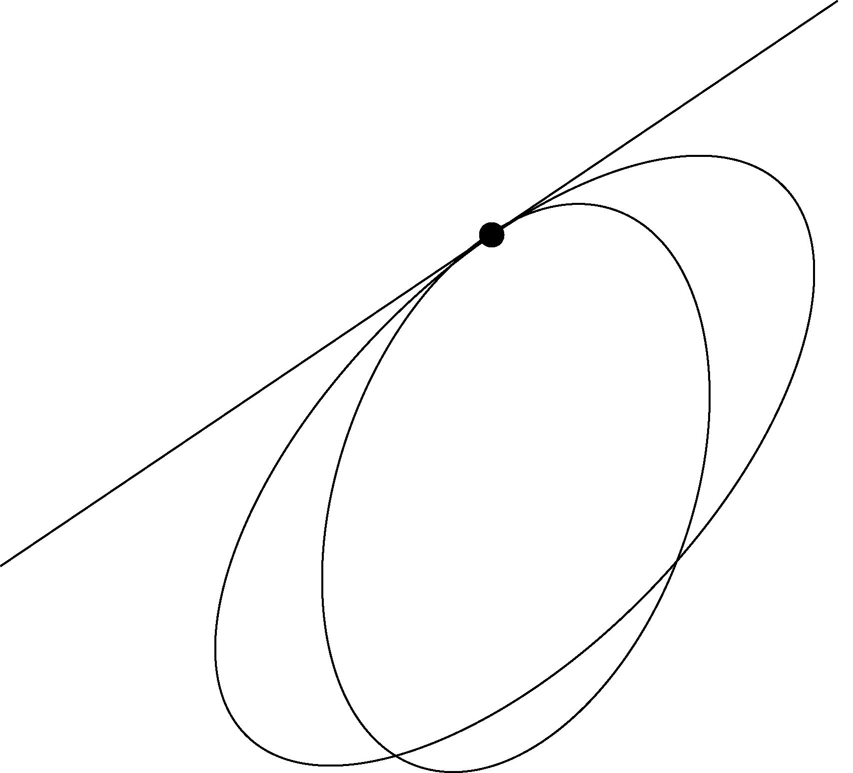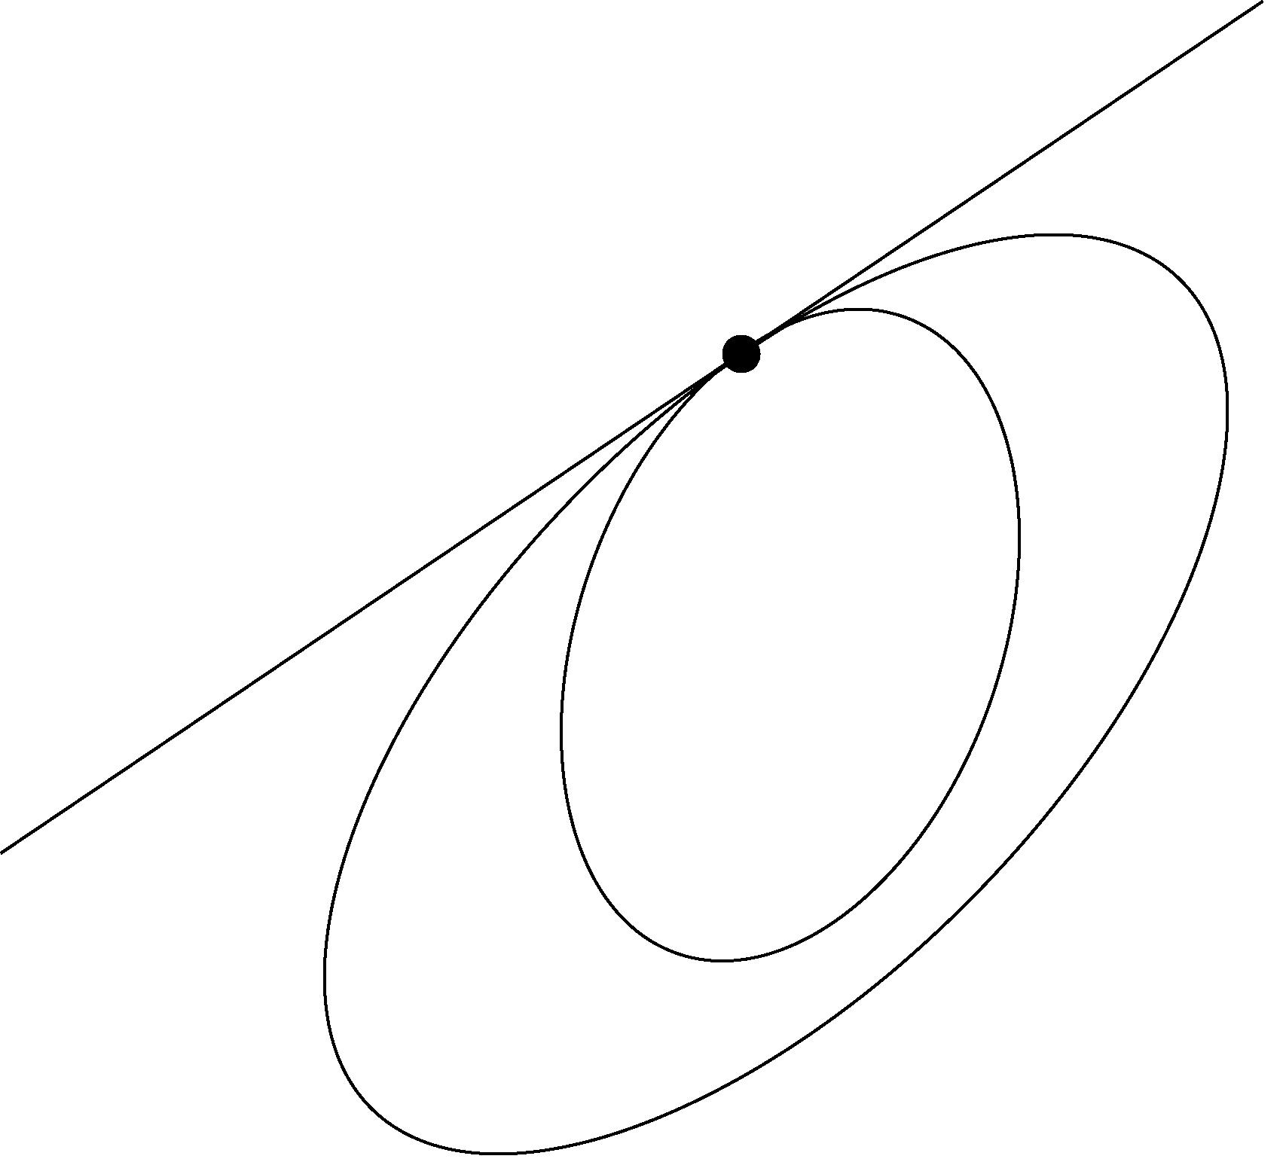

Fig. 2

A pair of ellipses defines a bundle of conic sections which all pass through the knots of the bundle (common points of the basic ellipses). The bundle is described by means of the ellipses E and E_{r} equations. Consider only such example that the ellipses have four real common points. If we choose a suitable system of coordinates in the plane ρ the bundle is described by the equation

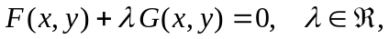

where F and G are equations of ellipses E and E_{r}. The bundle obtains a family of singular conic sections, pairs of intersecting or parallel lines. They are described by means of a system of linear equations. Since we are searching the knots of the bundle we can find them as common points of the singular conic sections, thus solving a system of linear equations. The practical solution applies the numerical approach.
The illustrative picture Fig. 3 shows the reference sphere, the ellipsoid of revolution (1) and the conical surface (2). The Fig. 4 shows both ellipses E and E_{r} in the plane ρ.

The research has been supported by the grant MSM 210000010 „Applied Mathematics in Technical Sciences“.

References:
[1] Wagner, C., Klokočník, J., Reflection Altimetry for Oceanography and Geodesy, IAPSO – IABO Symp., Mar del Plata, 2001
[2] Kočandrlová, M., Geometrický model úlohy GPS – altimetrie, Sborník 27. konference VŠTEZ, Hejnice 2002, ISBN 80-7015-864-6, pp. 110-114
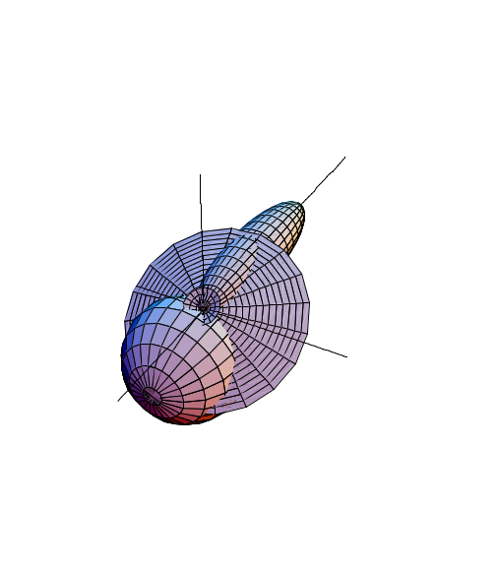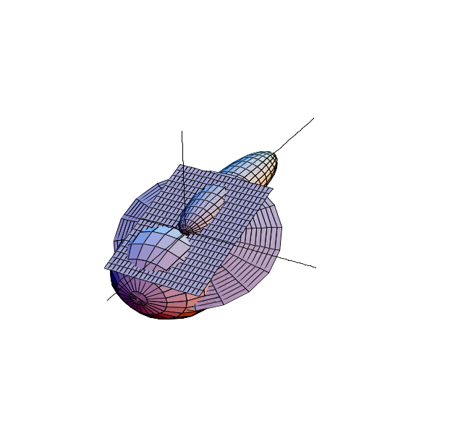
Fig. 3 Fig. 4

 Keywords: Altimetry, surface, curve, quadrics.
1 Dept. of Mathematics, Faculty of Civil Engineering CTU, Thákurova 7, 16629 Praha 6, cerny@mat.fsv.cvut.cz

