SHOPPING SYSTEM DOCUMENTATION  
FOR GROCERY STORE

Prepared for internal use and system development reference  
Date: July 2025

Table of Contents

Overview 1

Objectives 2

Key Features 3

User Roles & Permissions 4

System Workflows 5

Integration Points 6

Security & Compliance 7

Performance & Scalability 8

Reporting & Analytics 9

Support & Maintenance 10

Requirements Research & Analysis 11

***SHOPPING SYSTEM DOCUMENTATION FOR GROCERY STORE***

**1. Overview**

The Grocery Store Shopping System is a comprehensive digital platform designed to streamline the shopping experience for both customers and store staff. It supports online and in-store purchases, inventory management, order fulfilment, and payment processing. The system aims to increase efficiency, improve customer satisfaction, and optimize store operations.

**2. Objectives**

* **Provide a seamless shopping experience.**

*The system achieves this by offering a unified platform accessible via web and mobile, integrating core functionalities like registration, authentication, catalog browsing, cart management, and streamlined checkout. Real-time sync across all user sessions ensures a consistent experience whether users are online or in-store. Features such as persistent carts, secure login (JWT-based), and responsive UI/UX design contribute to frictionless navigation and purchases.*

* **Enable efficient product browsing, search, and selection.**

Efficient product discovery is powered by robust APIs with support for keyword search, category-based filtering, and sorting options (price, popularity). A caching layer (Redis) and pagination in API responses ensure fast load times, even during peak traffic. Additionally, content delivery via a CDN accelerates image and static content delivery.

* **Manage real-time inventory and stock updates.**

Inventory is updated in real time through an event-driven architecture using message queues (e.g., Kafka) and change data capture from the operational database. Stock managers have dedicated APIs for adjusting quantities, and the system proactively alerts when thresholds are met. Inventory synchronization latency is monitored and triggers alerts if it exceeds SLA.

* **Handle secure order processing and payment transactions.**

Order processing is secured through RBAC for endpoints and uses parameterized queries to prevent SQL injection. Payment transactions leverage tokenization and third-party gateways to reduce PCI compliance overhead, while all sensitive data is encrypted in transit (TLS 1.3) and at rest (AES-256). MFA is enforced for administrative roles, and regular vulnerability scanning and WAF rules mitigate common threats.

* **Support administrative and reporting tasks.**

The admin portal includes features for managing users, products, inventory, promotions, and order statuses via CRUD APIs. Reporting capabilities leverage ETL pipelines that move data from the OLTP database to a warehouse, enabling sales dashboards, inventory turnover analysis, and promotional performance metrics. Admins can export reports in multiple formats (CSV, PDF) and embed dashboards directly in the portal via BI integration.

**3. Key Features**

**3.1. Customer Features**

* **User Registration & Login**: Secure access using credentials or social login.
* **Product Catalogue**: Browse items by category, brand, or search keywords.
* **Product Details**: View price, description, nutritional facts, availability.
* **Shopping Cart**: Add, update, or remove items before checkout.
* **Wishlist**: Save products for later purchase.
* **Order Placement**: Choose delivery or in-store pickup options.
* **Payment Gateway**: Support for credit/debit cards, digital wallets, and loyalty points.
* **Order Tracking**: Real-time updates on order status and delivery.
* **Customer Support**: Integrated help centre or live chat.
* **Account Management**: Update personal details, view order history.

**3.2. Admin/Store Staff Features**

* **Product Management**: Add/edit/delete items, categories, and pricing.
* **Inventory Management**: Track stock levels, manage restocking alerts.
* **Order Management**: Monitor incoming orders, update statuses, and coordinate deliveries.
* **Customer Management**: Access customer information and order history.
* **Promotions Management**: Create and manage discounts, bundles, and coupons.
* **Reports & Analytics**: Sales reports, stock levels, customer trends, and performance metrics.
* **User Role Management**: Assign roles and permissions (admin, manager, cashier, etc.).

**4. User Roles & Permissions**

|  |  |  |  |  |  |  |  |  |  |  |  |  |  |  |  |
| --- | --- | --- | --- | --- | --- | --- | --- | --- | --- | --- | --- | --- | --- | --- | --- |
| |  |  |  | | --- | --- | --- | | **Role** | **Description** | **Permissions** | | Customer | End user shopping for groceries | Browse, buy, manage account and orders | | Cashier | In-store staff handling checkout | Manage POS transactions, assist customers | | Stock Manager | Responsible for inventory and supply | Update stock, restock alerts, monitor low-inventory items | | Admin | Store owner or system manager | Full access to all system modules and settings | |

**5. System Workflows**

**5.1. Customer Shopping Workflow**

* User logs in or registers.
* Browses or searches for products.
* Adds desired items to the cart.
* Proceeds to checkout and selects delivery or pickup.
* Makes payment through preferred method.
* Receives confirmation and tracks order until fulfilment.

**5.2. Inventory Management Workflow**

1. Admin adds or updates product listings.
2. System tracks stock levels in real time.
3. Restock alerts are triggered for low inventory.
4. Admin or stock manager updates inventory on restocking.

**5.3. Order Fulfilment Workflow**

1. Order is received and verified.
2. Order is picked and packed.
3. Delivery staff or customer collects the order.
4. Order status is updated to "completed" in the system.

**6. Integration Points**

1. **Payment Gateways**: Integration with providers like Stripe, PayPal, Square.

The system supports secure payment processing by integrating with multiple third-party gateways, including Stripe, PayPal, and Square. These integrations are facilitated via RESTful APIs with token-based authentication, and sensitive payment data is never stored on the platform; instead, tokenization provided by the gateway ensures PCI-DSS compliance. Transactions are executed over HTTPS (TLS 1.2/1.3) and logged for auditing.

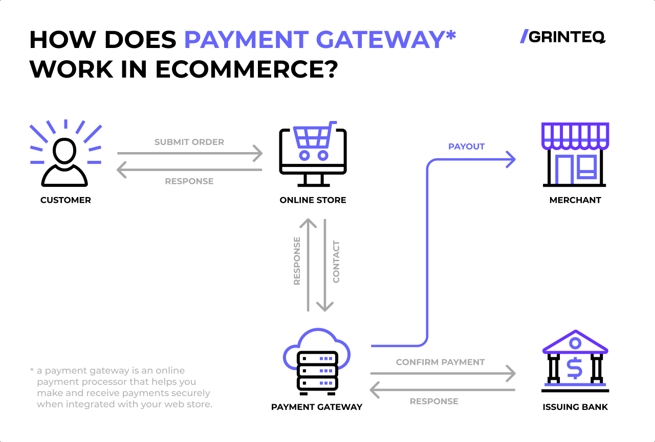

1. **Email/SMS Services**: Order confirmations, promotions, and alerts.

Email and SMS notifications are implemented through external messaging APIs such as Twilio (for SMS) and SendGrid or AWS SES (for email). These services handle transactional communications like order confirmations, shipping updates, and promotional campaigns. Integration occurs via secure REST APIs, and message templates are stored centrally to ensure consistent branding and compliance with CAN-SPAM/GDPR requirements.

1. **Inventory APIs**: Integration with warehouse or third-party inventory systems.

The platform offers dedicated APIs for inventory management that can be integrated with external warehouse systems or third-party ERP solutions. Synchronization is achieved using event-driven updates via message queues (Kafka/PubSub) and periodic batch jobs for reconciliation. These integrations maintain near real-time stock accuracy and support threshold-based alerts for reordering.

**7. Security & Compliance**

1. **User Authentication**: Enforced via secure login and session management.

1. **Data Protection**: Compliance with GDPR/CCPA for customer data.
2. **Payment Security**: PCI-DSS compliant handling of payment information.

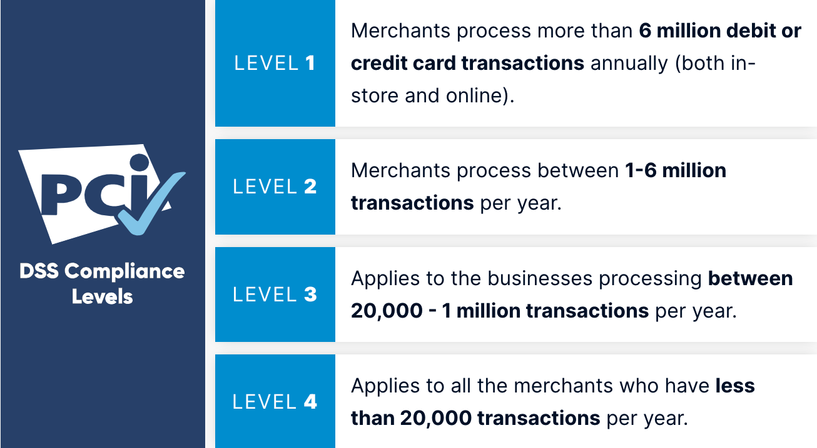

1. **Role-Based Access**: Prevents unauthorized access to sensitive modules.

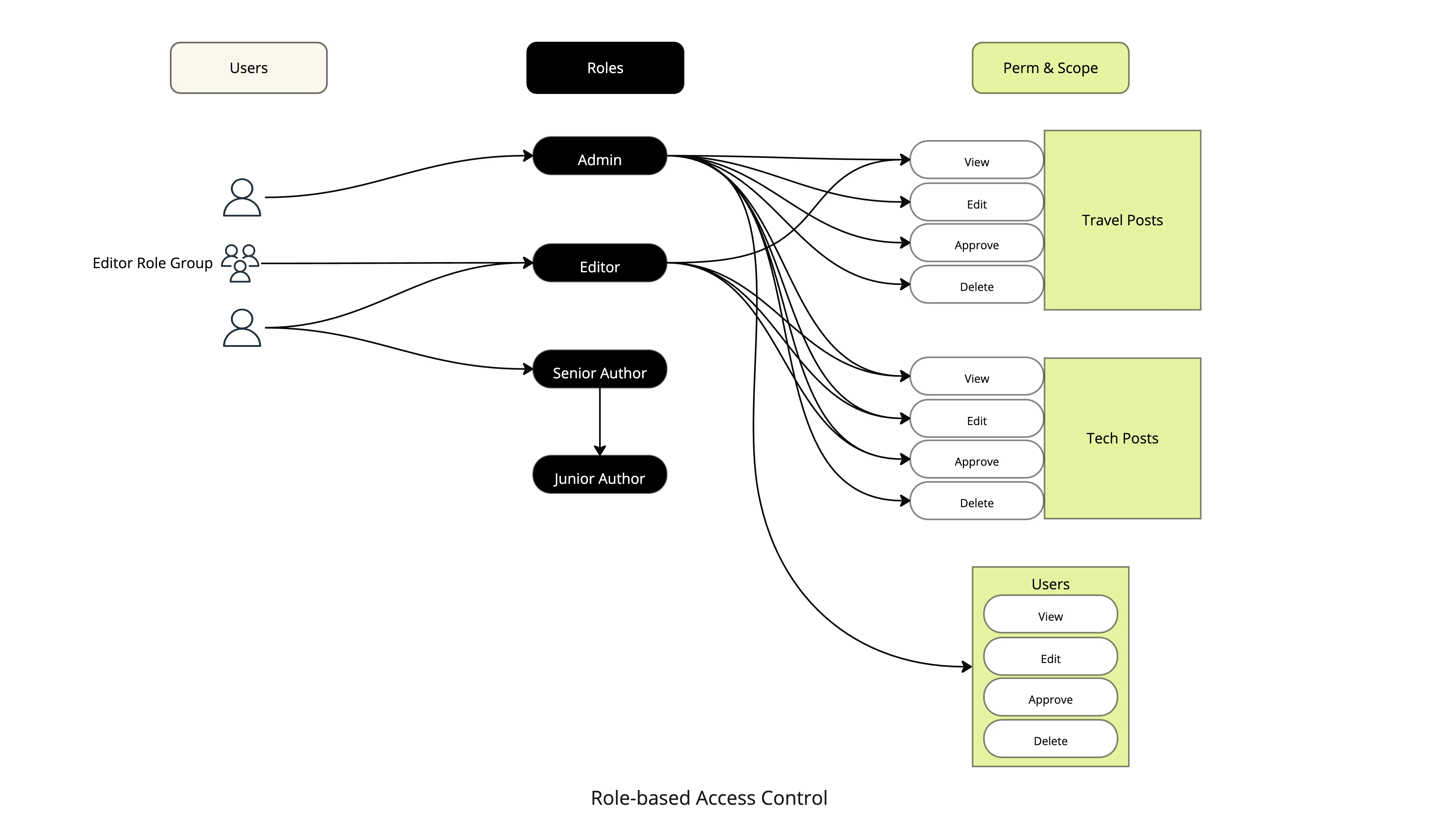

**8. Performance & Scalability**

1. Designed to handle high volumes of concurrent users and transactions.
2. Supports scalable database and infrastructure for seasonal or promotional spikes.
3. Optimized product search and filtering for fast user experience.

**9. Reporting & Analytics**

1. **Sales Reports**: Daily, weekly, and monthly breakdowns.
2. **Customer Behaviour**: Insights into buying patterns and preferences.
3. **Inventory Reports**: Turnover rates, fast/slow-moving items.
4. **Marketing Analytics**: Promo performance, campaign ROI.

**10. Support & Maintenance**

1. Regular system updates and patches.
2. Customer support portal for issue resolution.
3. System backup and disaster recovery plans in place.

11. Requirements Research & Analysis  
  
To ensure the system meets stakeholder needs and remains scalable, a structured research process was followed. This included collecting data, analyzing findings, evaluating solutions, and documenting precise system requirements.  
  
11.1. Practical Skills Applied  
  
**- PA0201: Conduct Research to Collect Data**  
 - Interviews with store managers, staff, and customers to gather insights.  
 - Surveys and questionnaires distributed to frequent shoppers.  
 - Observation of in-store workflows and bottlenecks.  
  
**- PA0202: Analyse Data**  
 - Categorized and quantified customer pain points such as checkout delays, stock unavailability, and difficulty locating products.  
 - Evaluated system usage data from existing digital tools (if applicable).  
  
**- PA0203: Discuss and Evaluate Possible Solutions**  
 - Compared potential solutions (POS upgrades, mobile app, self-checkout kiosks).  
 - Cost-benefit analysis of features like inventory automation and real-time tracking.  
 - Consulted with IT and operational teams for feasibility.  
  
- **PA0204: Document Requirements Specifications** - Compiled user stories, functional and non-functional requirements.  
 - Created detailed flow diagrams for core workflows (shopping, checkout, restocking).  
 - Requirements were reviewed and validated by stakeholders.  
  
11.2. Applied Knowledge Areas  
  
**- AK0201: Types of Data** - Quantitative: Sales trends, customer feedback ratings.  
 - Qualitative: Open-ended survey responses, interview transcripts.  
  
**- AK0202: Feasibility Study**  
 - Technical feasibility (can our tech stack support the new features?).  
 - Operational feasibility (can store staff use it efficiently?).  
 - Financial feasibility (does it fit within budget?).  
  
**- AK0203: Data Gathering Techniques** - Structured interviews, online surveys, focus groups, on-site observations.  
  
**- AK0204: System Life Cycle** - Applied waterfall model with detailed requirement-gathering phase.  
 - Built prototypes before full-scale development.  
  
**- AK0205: Modelling Techniques** - Used flowcharts and entity-relationship diagrams to map processes.  
 - User journey maps were created to visualize the shopping experience.  
  
**- AK0206: Facilitation Skills and Tools**  
 - Stakeholder meetings facilitated with presentation decks and collaborative tools like Miro and Google Docs.  
 - Workshops conducted to align vision and clarify scope.