1. 4 Source Port,Destination Port,Length,Checksum

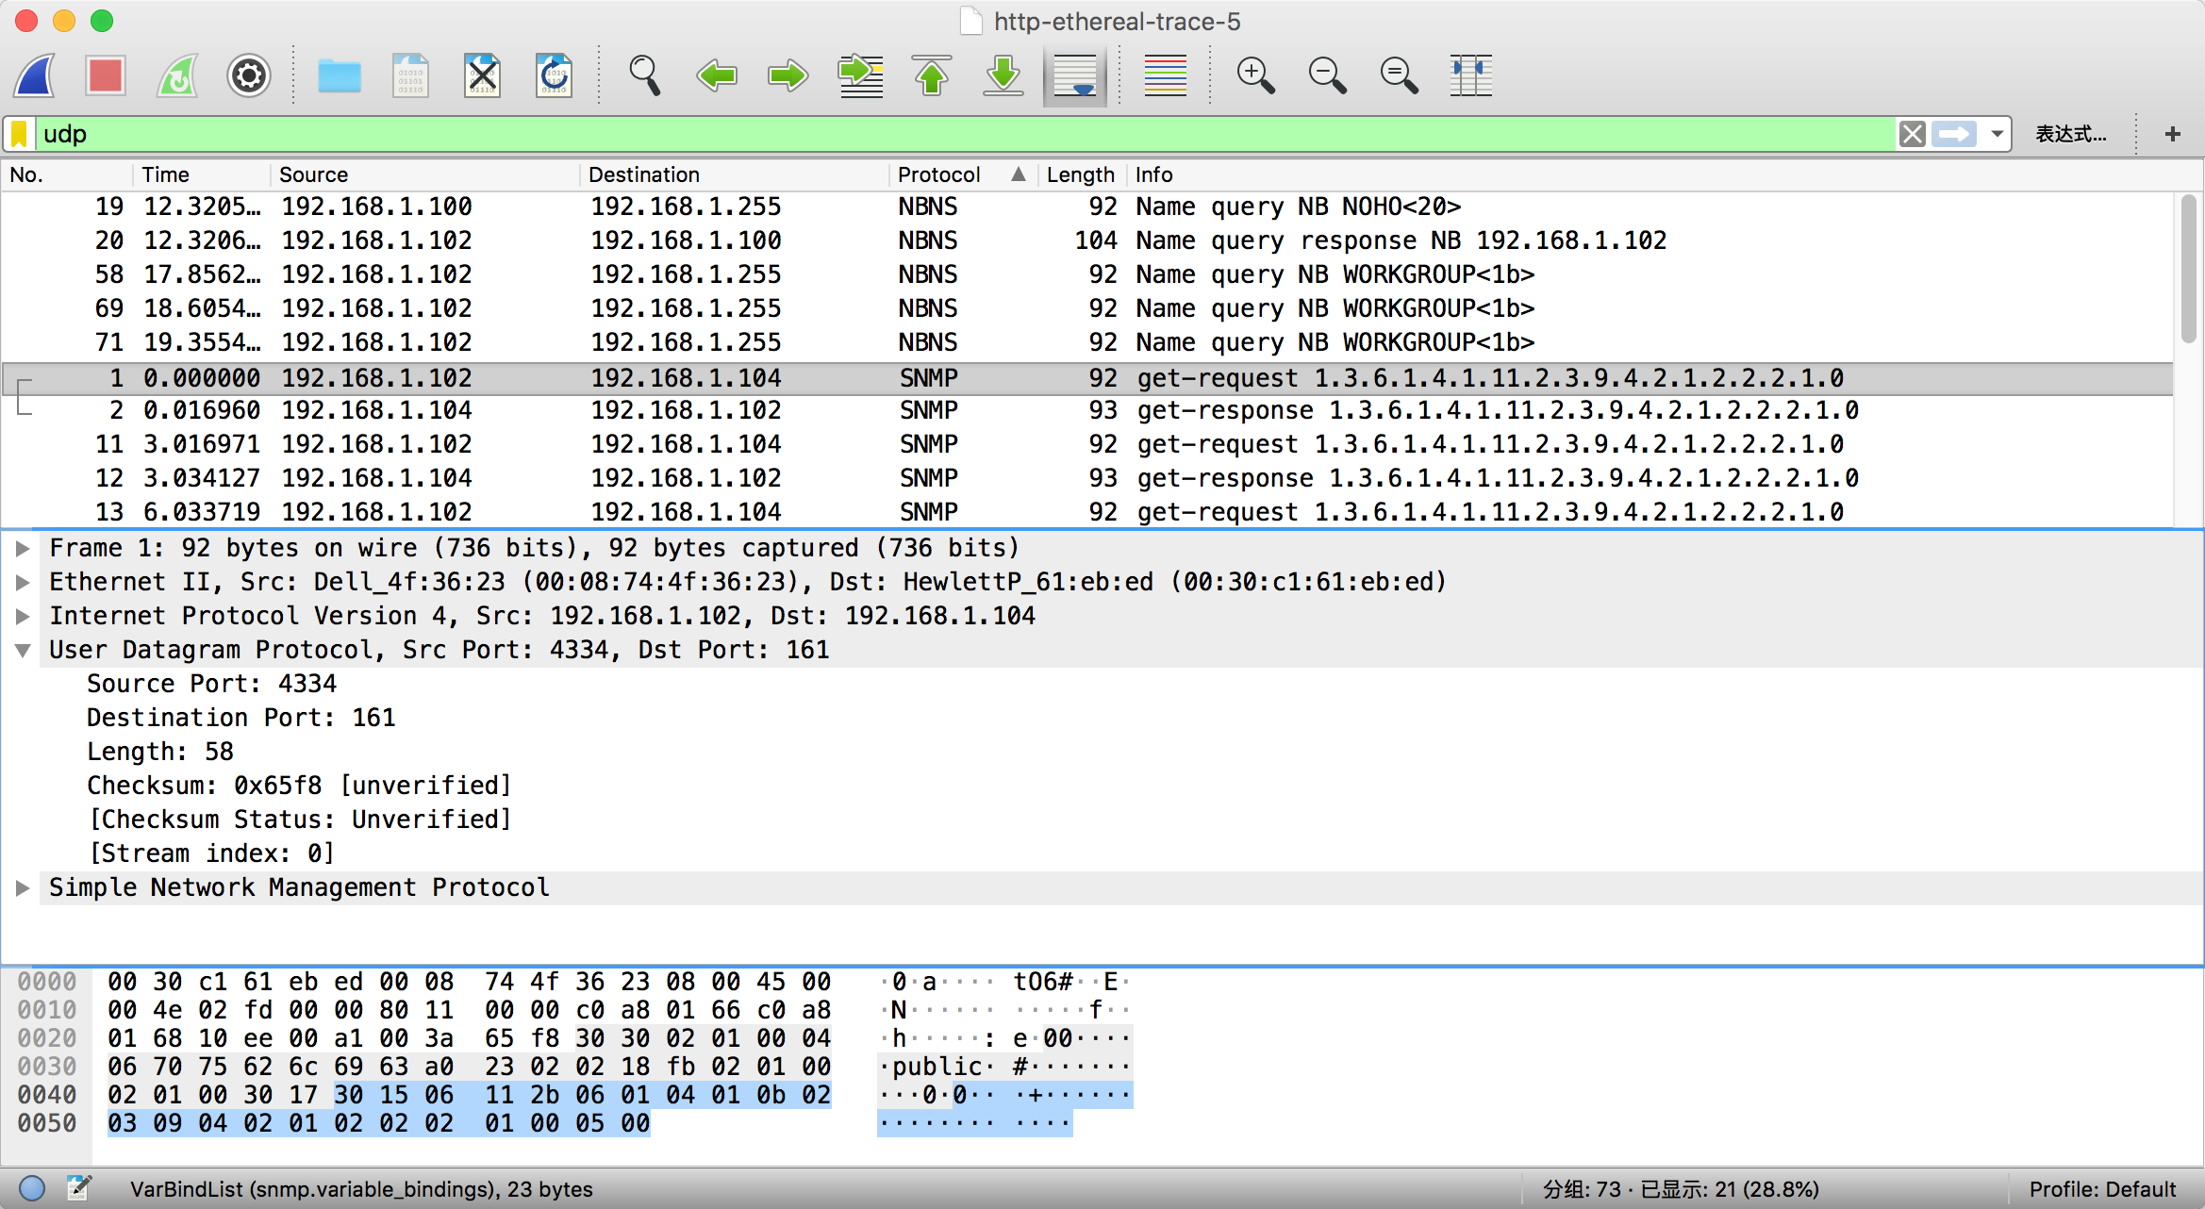

2. 2 bytes long

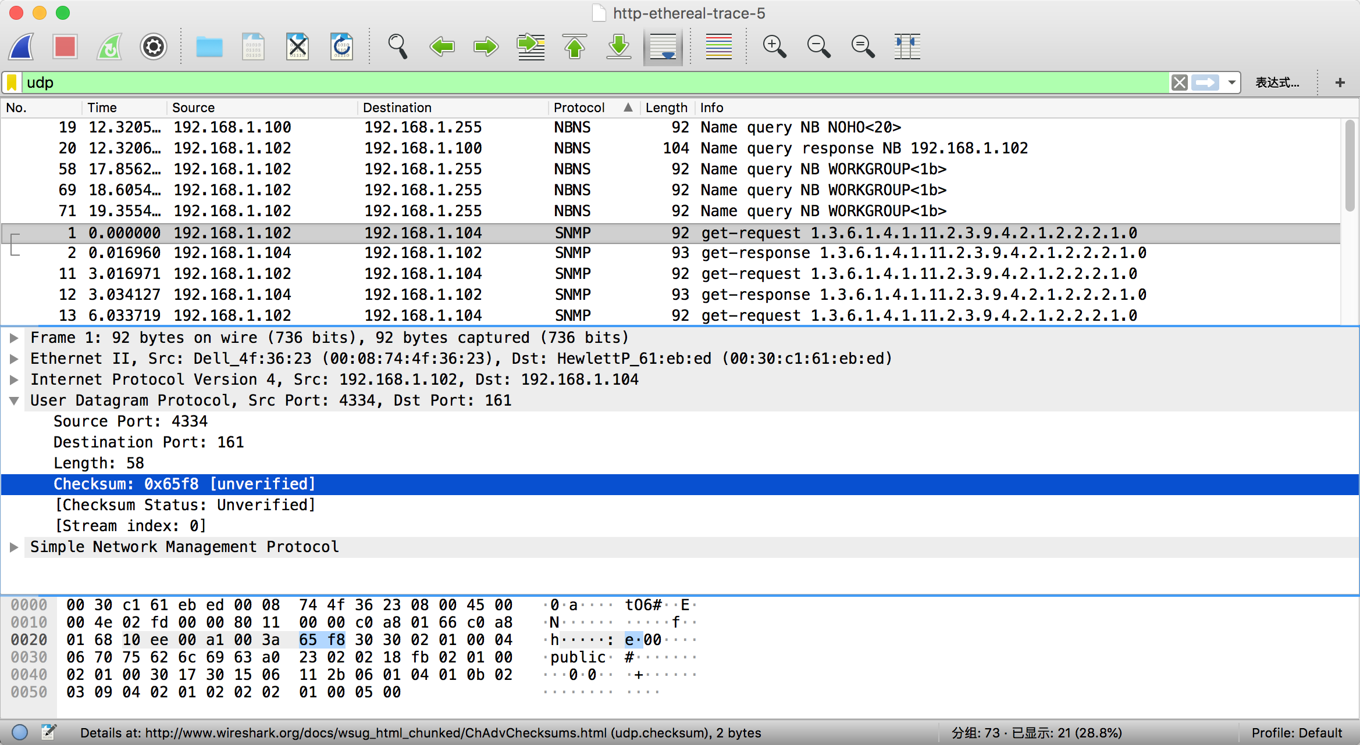

3. It is the sum of the 8 header bytes and the remaining data bytes encapsulated in the packet



4. The maximum payload is 2^16-8=65527 bytes

5. The largest possible source port number is 65535

6. The protocol number for UDP is 17 in decimal notation and 0x11 in hexadecimal notation.

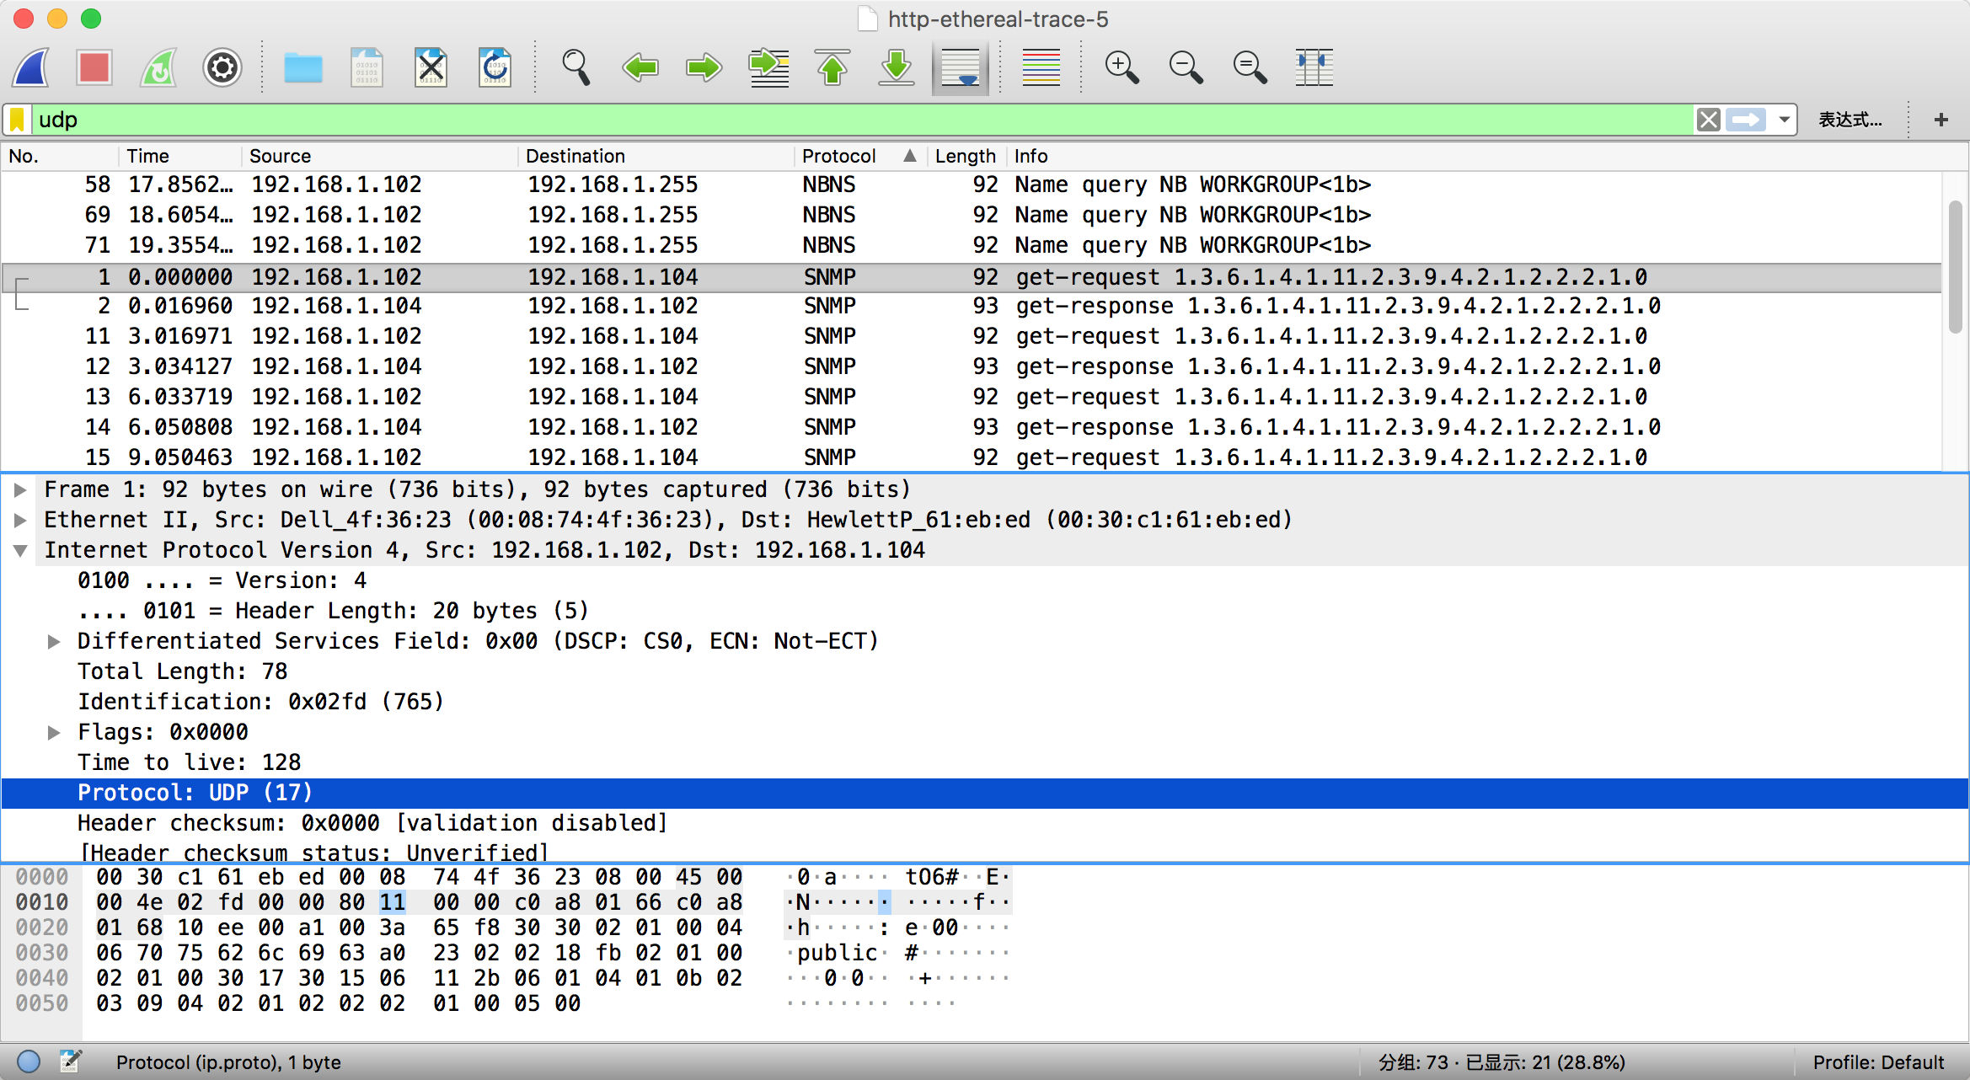

7. Relationship:The source port on the send message is the destination port of the receive message. In contrast, the destination port on the send message is the source port of the receive message.

send



reply:

