1.IP address of client: 192.168.1.100

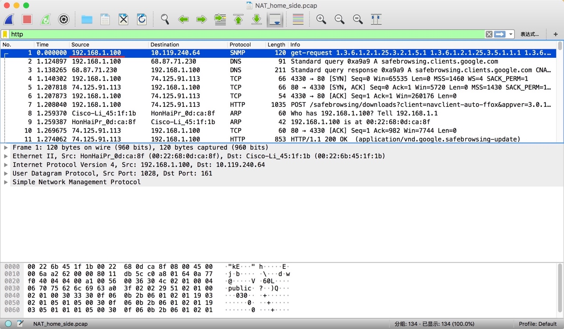

2. 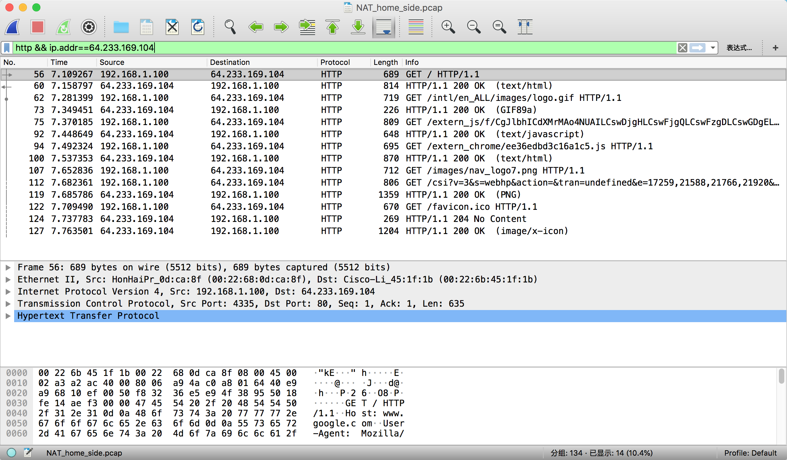

3. source: 192.168.1.100,4335 destination: 64.233.169.104,80

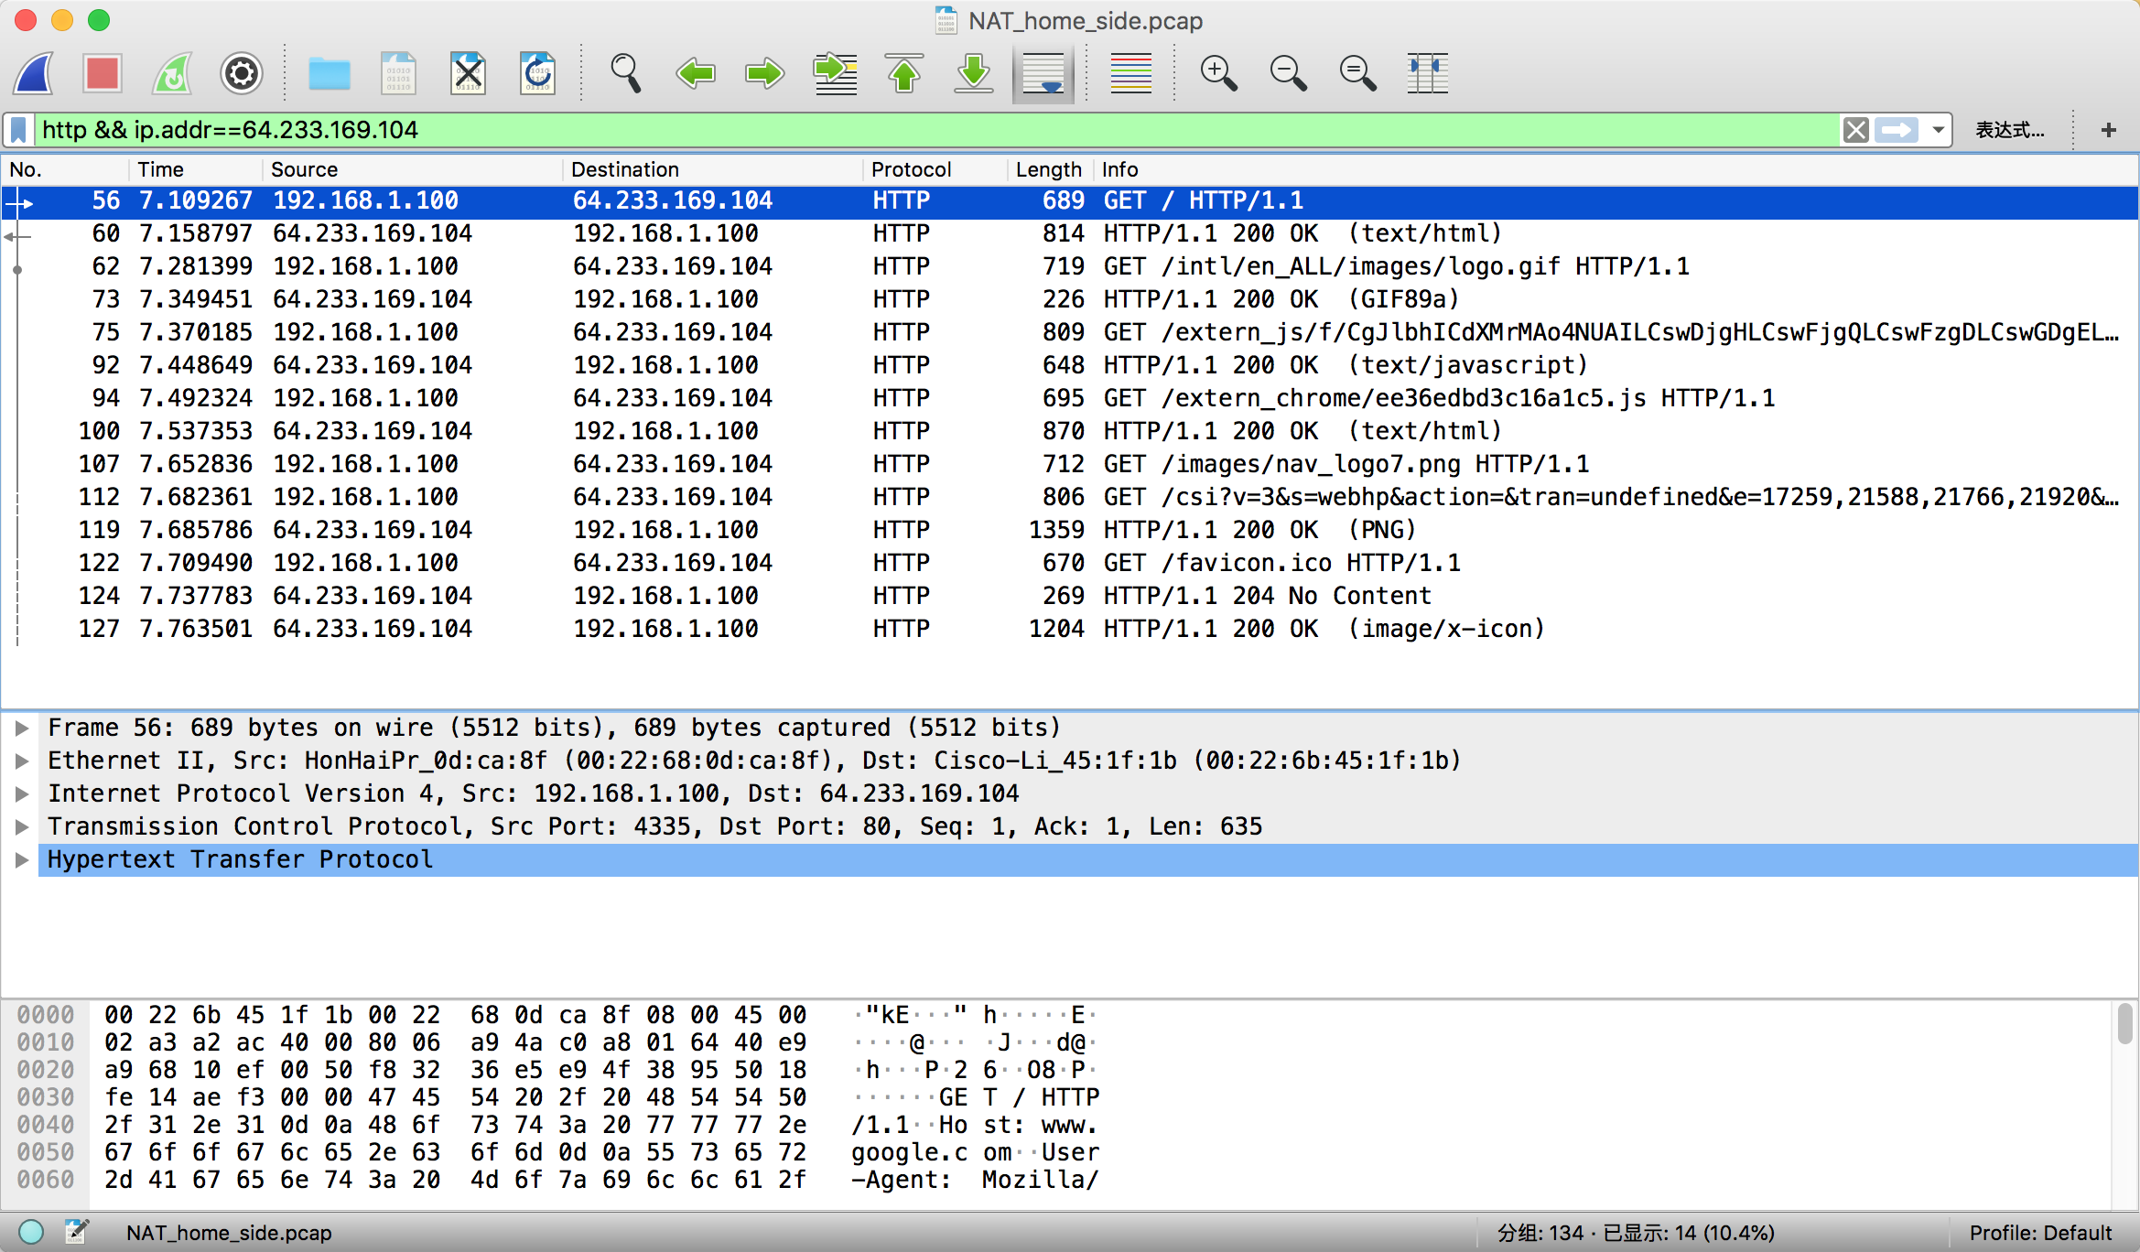

4. time: 7.158797 source : 64.233.169.104,80 destination : 192.168.1.100,4335

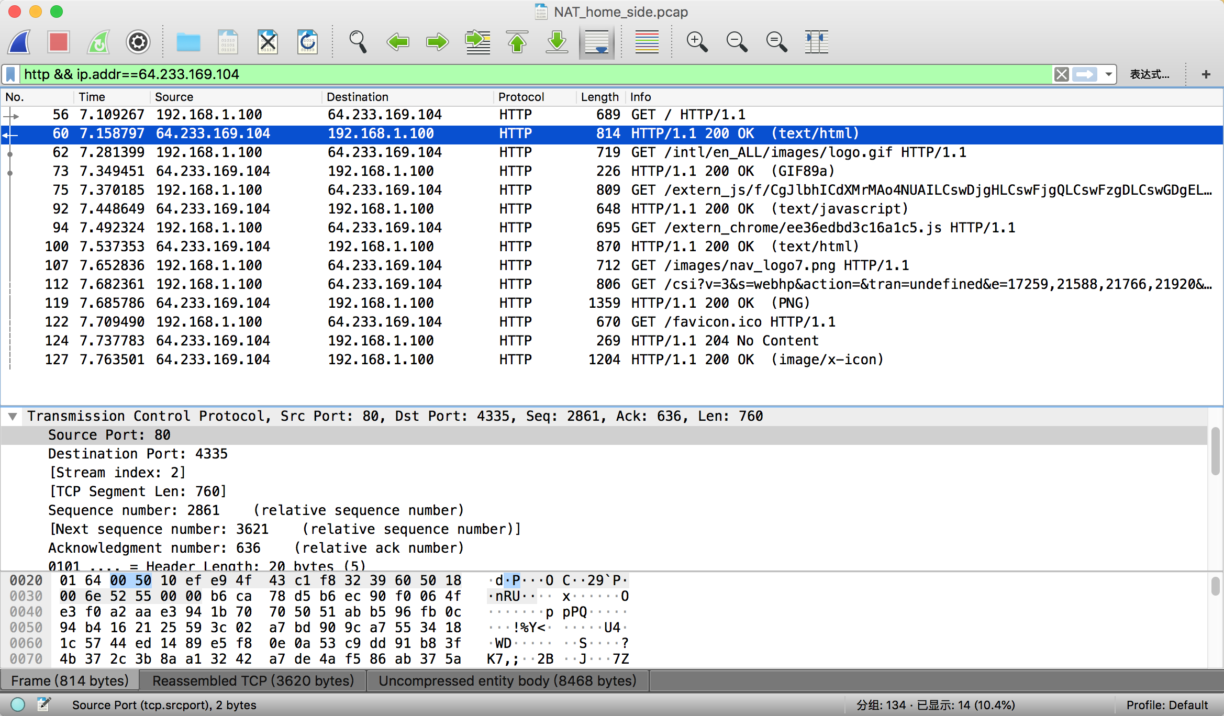

5. time : 7.075657 Source : 192.168.1.100,4335 destination: 64.233.169.104,80

source : 64.233.169.104,80 destination : 192.168.1.100,4335 time: 7.109481

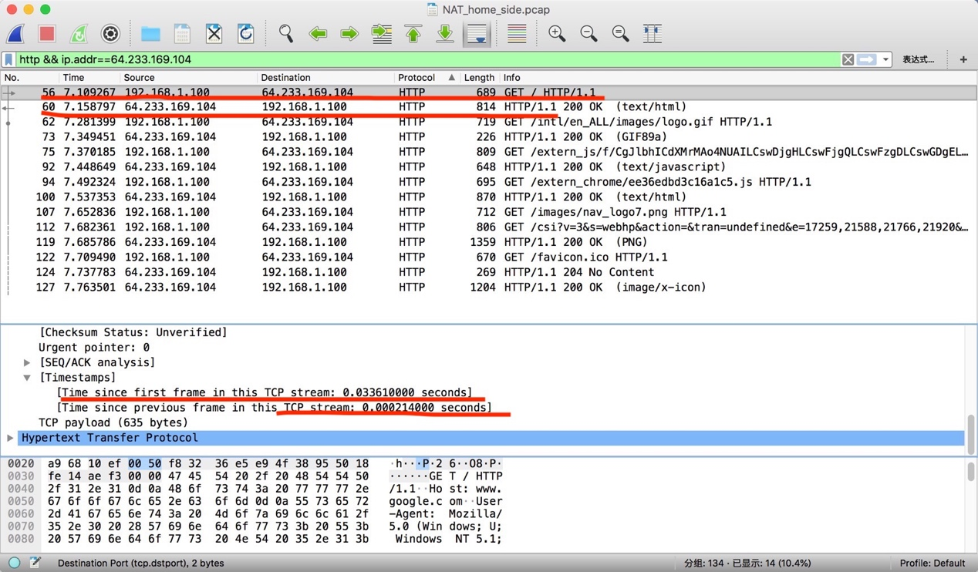

6. time : 6.069168 source : 71.192.34.104,4335 destiantion :64.233.169.104,80

only the source IP address changed.

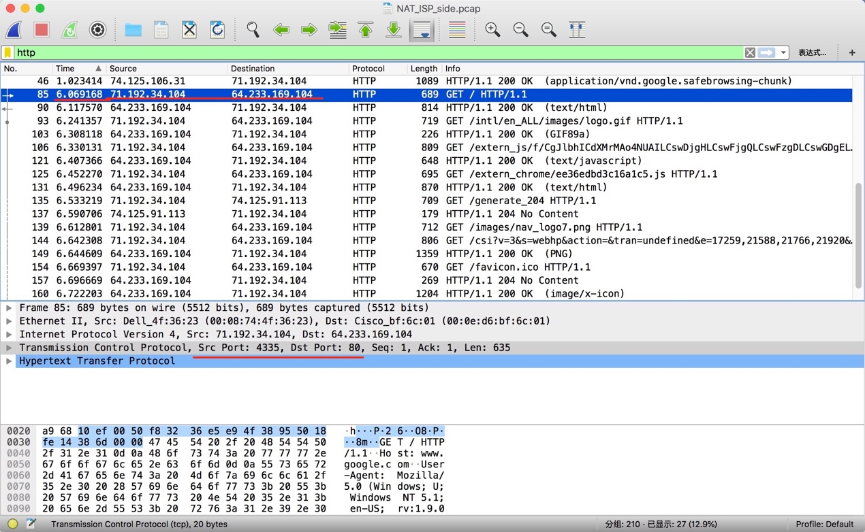

7. No HTTP GET message chaged. Version:No , Header Length : No , Flags:No

Checksum : Yes Reason : because the IP source address changed,checksum changed too,including the value of source IP.

8. time : 6.117570 source :64.233.169.104,80 destination 71.192.34.104,4335

only the destiantion IP address changed.

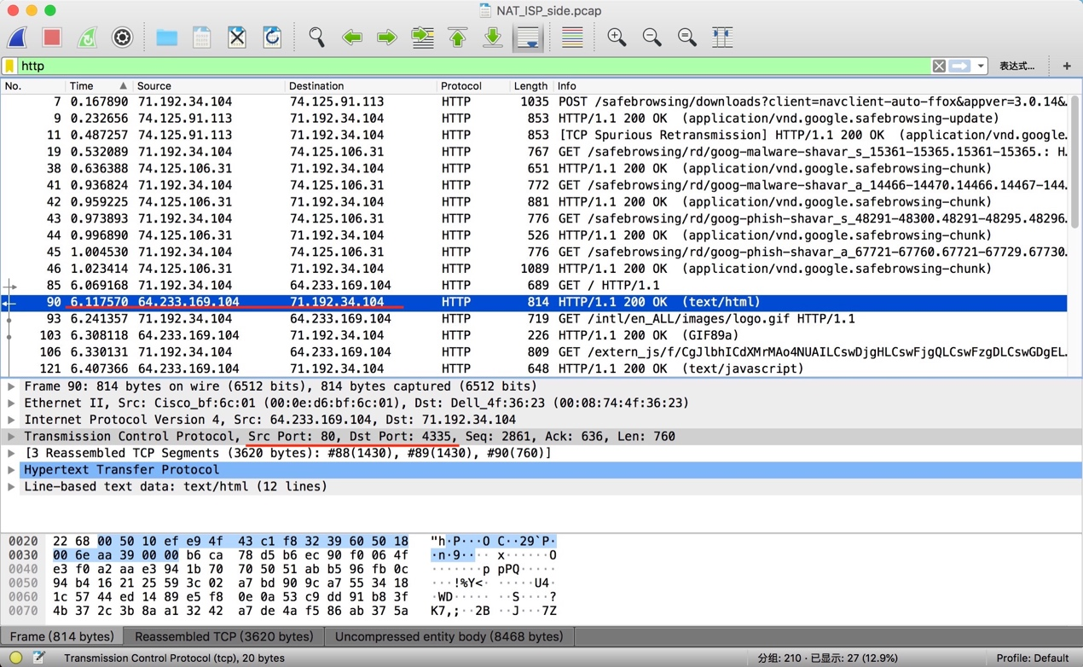

9. time: 6.035475 and 6.069582

SYN: source : 71.192.34.104,4335 destination : 54.233.169.104,80

ACK: source : 64.233.169.104,80 destination : 71.192.34.104,4335

SYN source IP address changed. ACK destination IP address changed. The port number are unchanged.

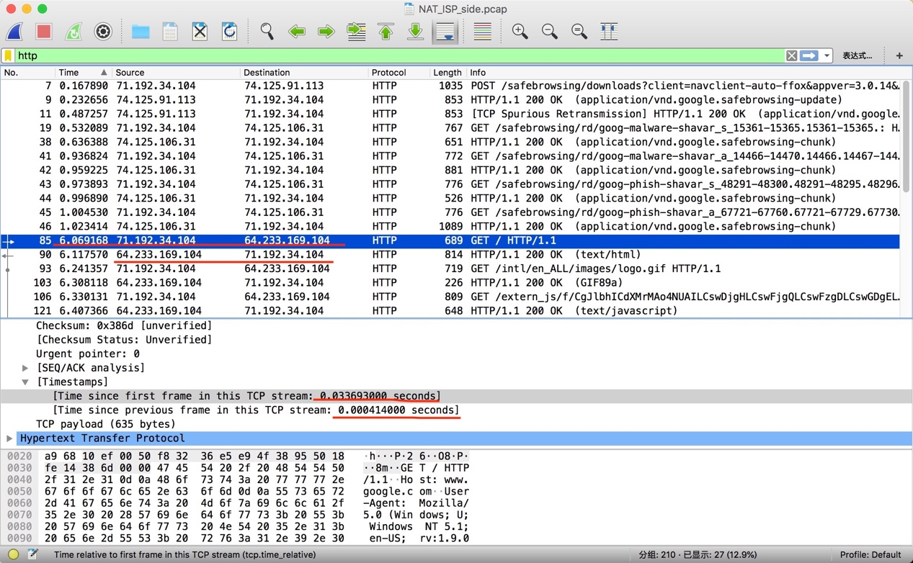

10.NAT translation table

|  |  |  |
| --- | --- | --- |
|  | WAN side | LAN side |
| Ip地址 | 71.192.34.104 | 192.168.1.100 |
| 端口号 | 4335 | 4335 |