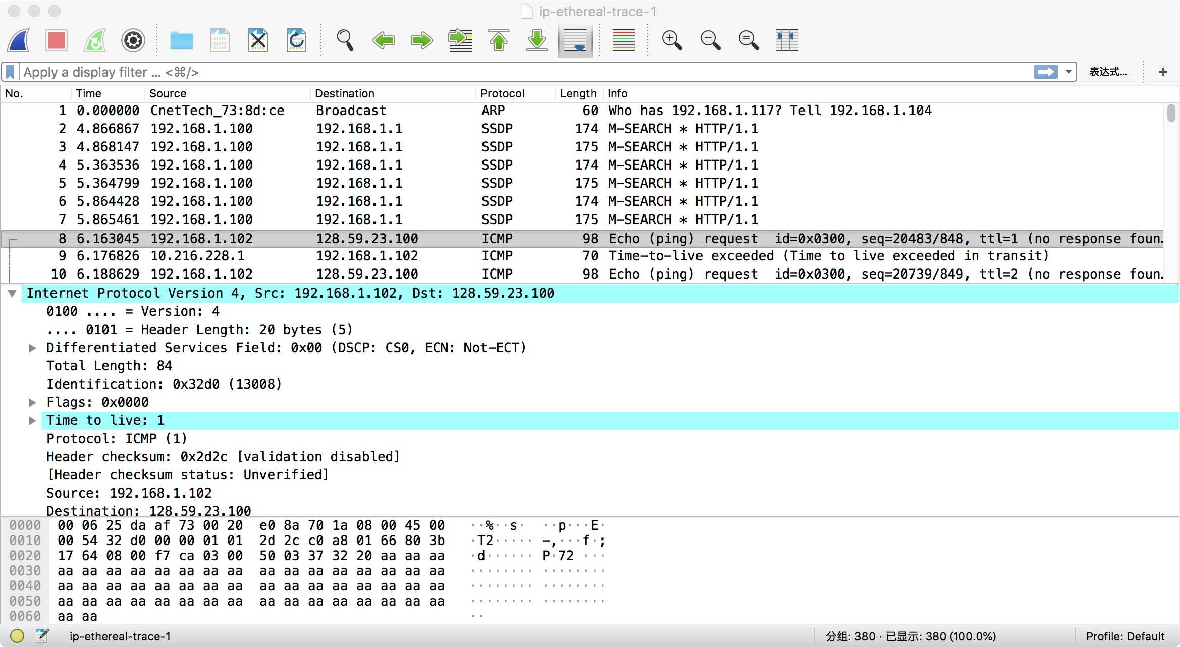

192.168.1.102

2. Protocol: ICMP(1)

3. 20 bytes in the IP header. 64 bytes in the payload of the IP datagram because total bytes are 84.

4.

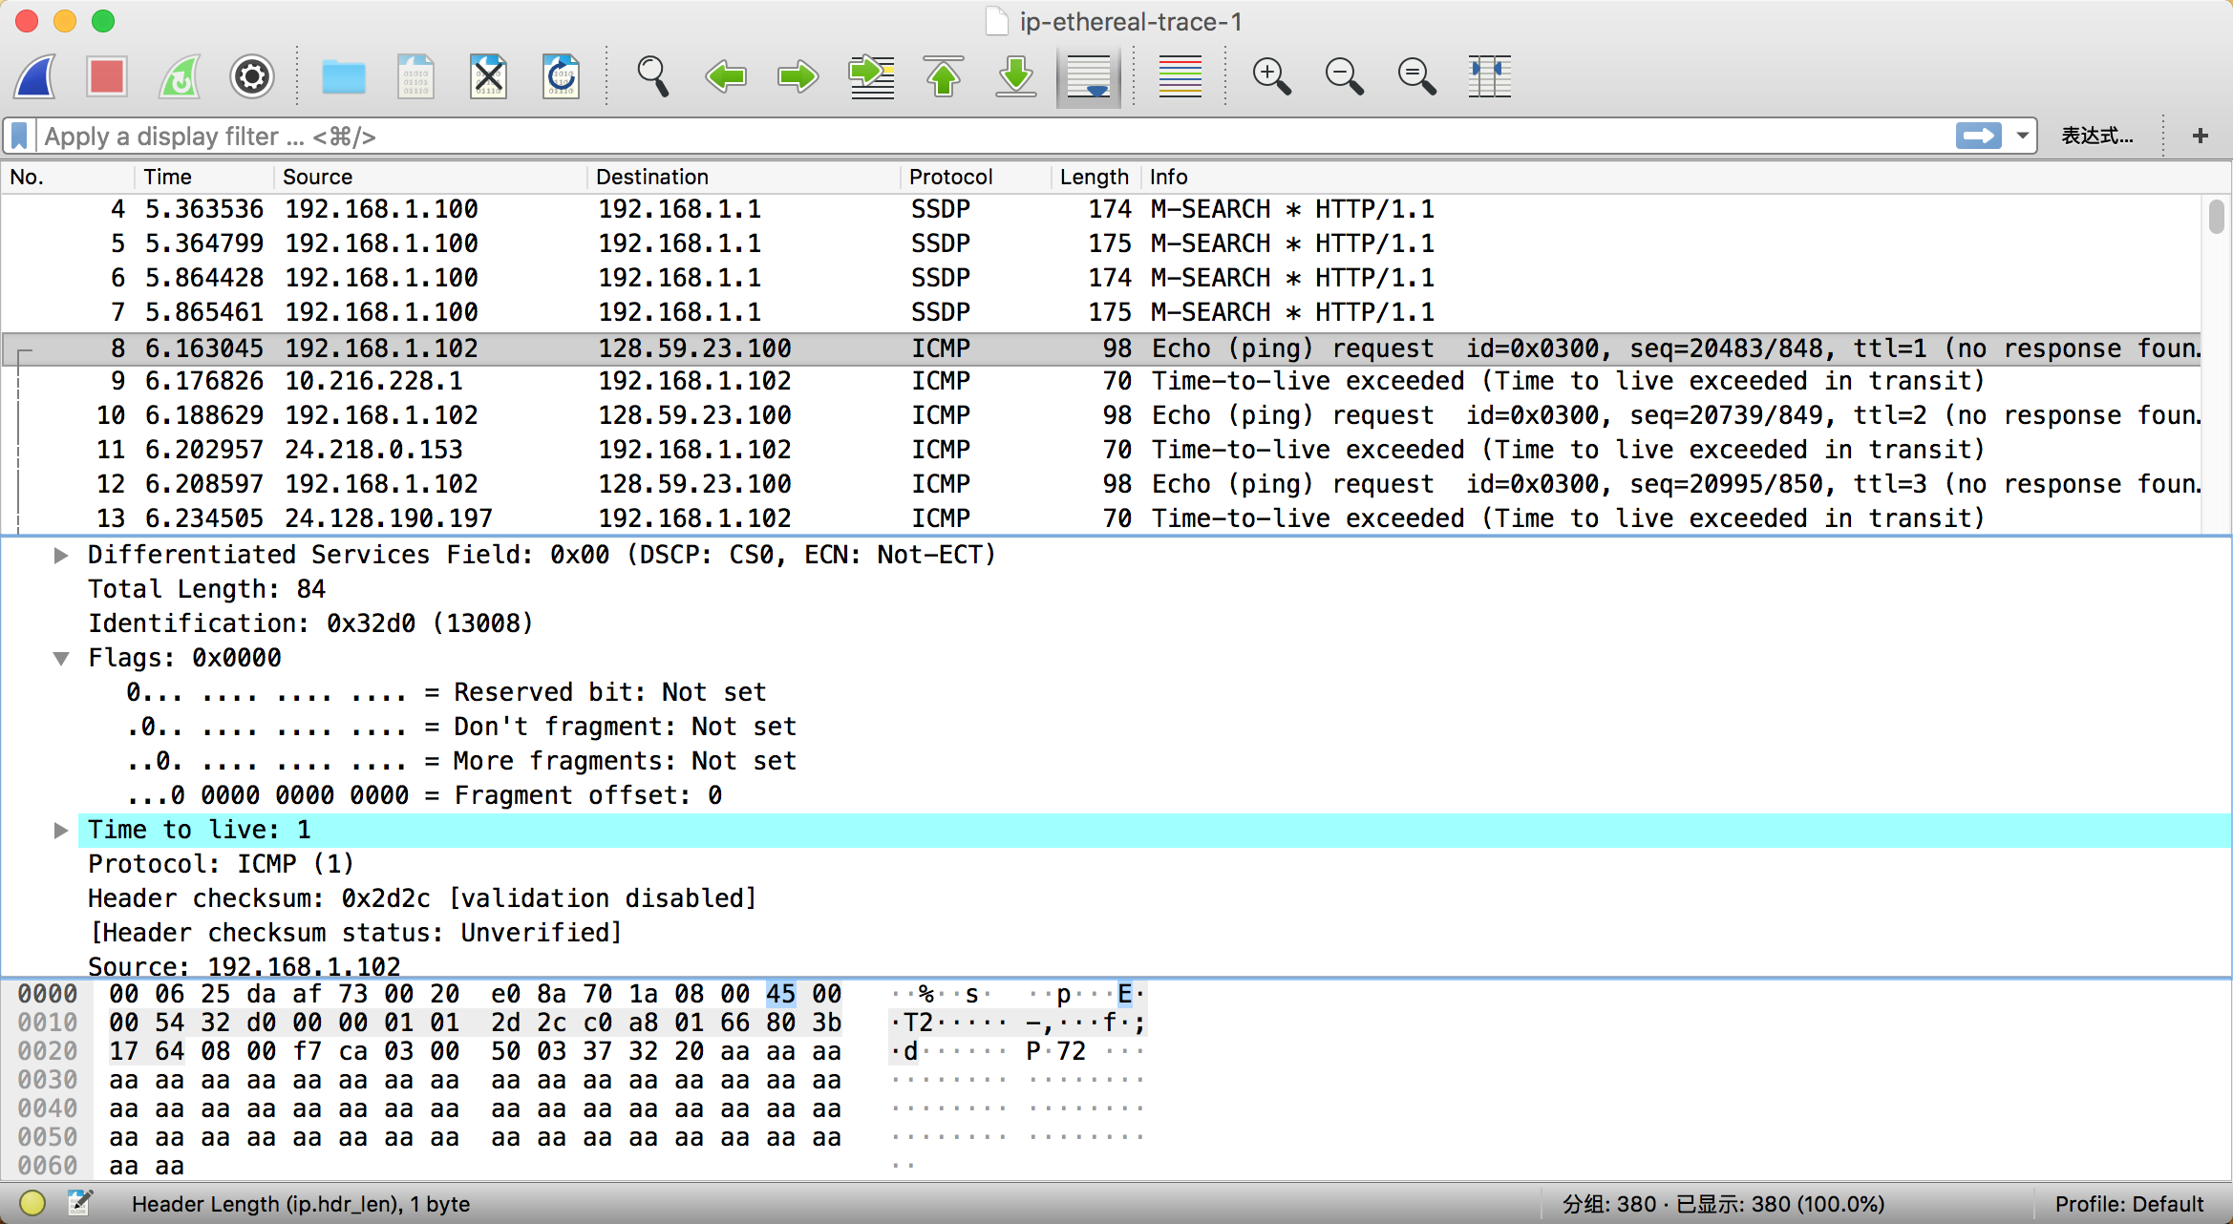

fragment offset = 0 , so data is not fragmented.

5. Identification, Time to live and Header checksum

6. stay constant:

* Version(all packets are IPv4),
* header length(ICMP packets)
* source IP(the same source)
* destination IP(the same destination)
* Differentiated Services(ICMP use the same Type of Service class)
* Upper Layer Protocal(ICMP packets)

must stay constant:

* Version(all packets are IPv4)
* header length(ICMP packets)
* source IP(the same source)
* destination IP(the same destination)
* Differentiated Services(ICMP use the same Type of Service class)
* Upper Layer Protocol (ICMP packets)

must change:

* Identification(IP packets must have different ids)
* Time to live(traceroute increase)
* Header checksum(header changes)

7.

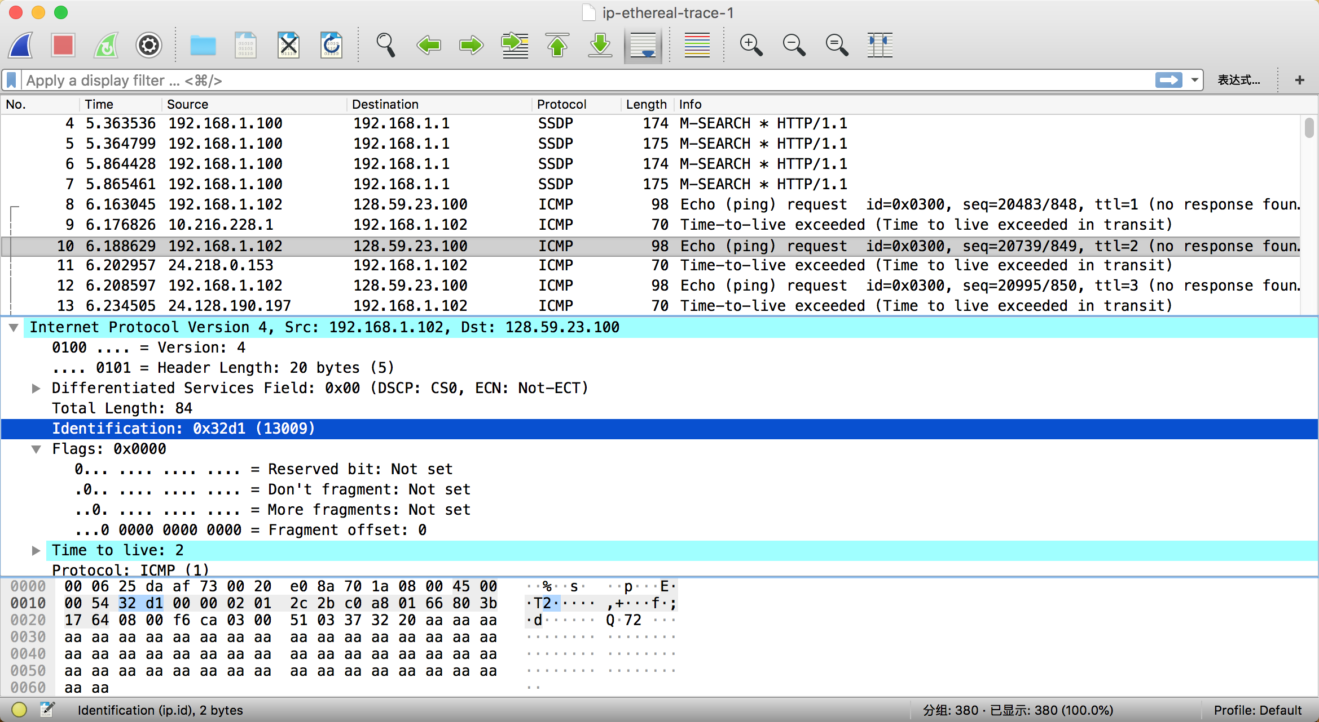

Identification fields increase with each ICMP ping request.

8.

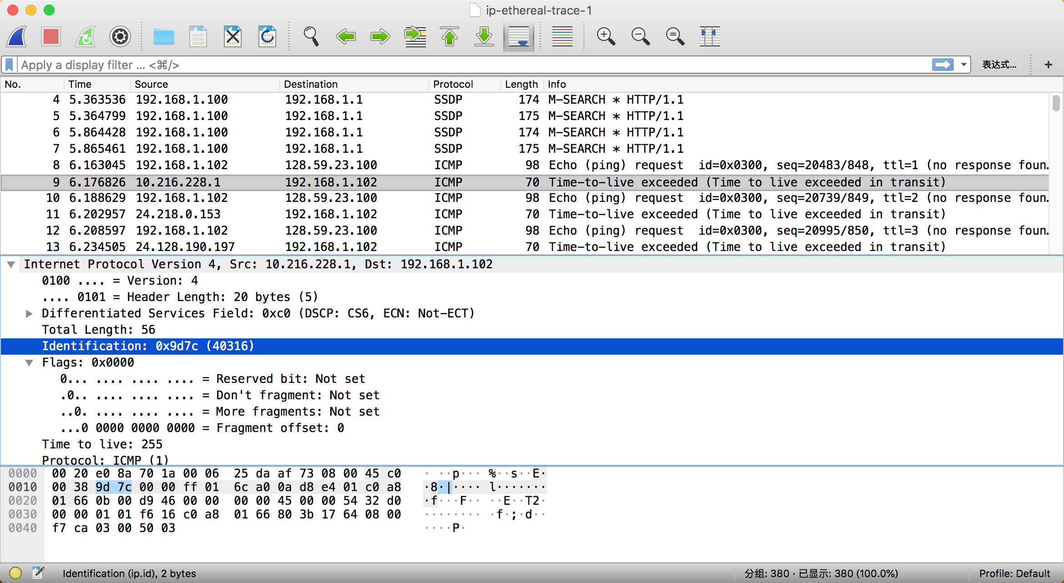

Identification is 40316

TTL is 255

9.Identification changes always because it's a unique value.The same identification means fragments of one. TTL doesn't change because the first hop router is always the same.

10.Yes

11.

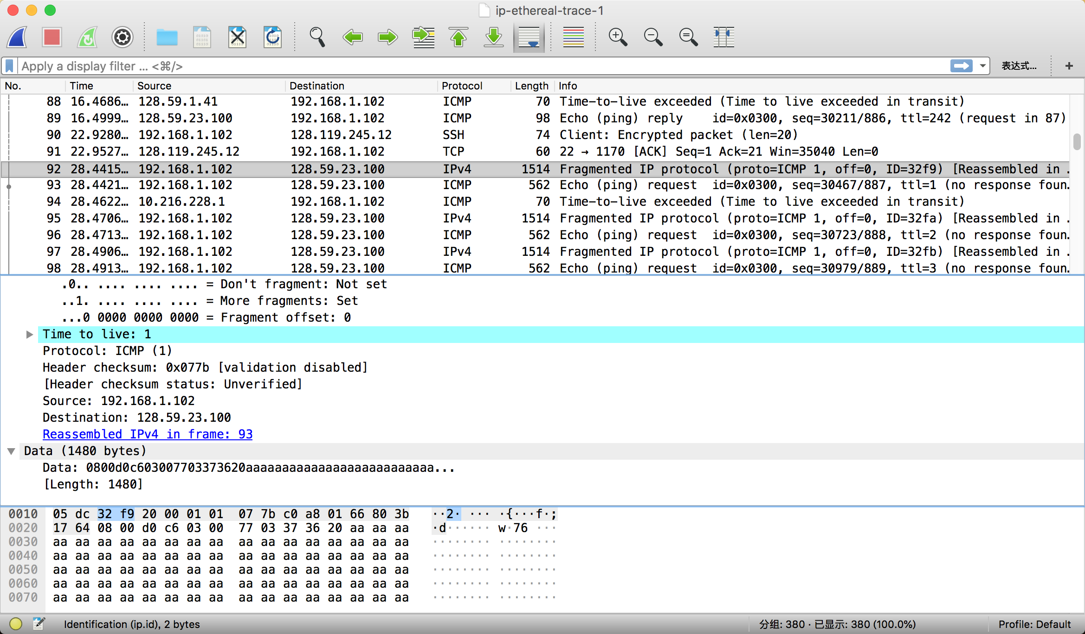

information1 : More fragments

information2 : offset is 0

total length : 1480

12.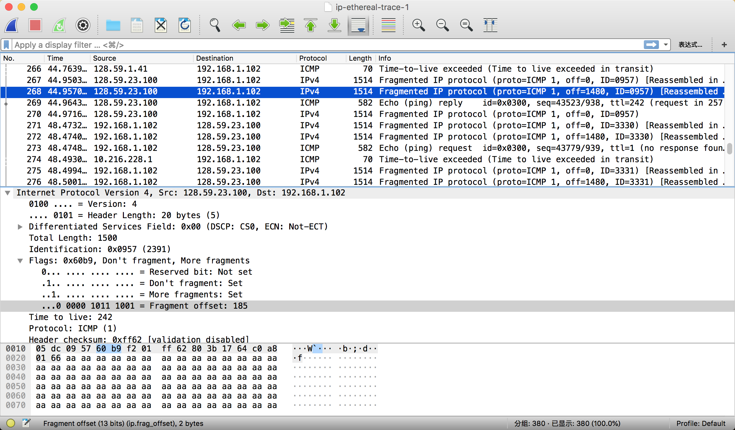

fragments offset is 185. There are more fragments because more fragments is set.

13. The IP header fields that changed between the fragments are: total length,flags, fragment offset, and checksum.

14. 3 packets are created

15. fragment offset, checksum, total length, flags