**Titanic**

This report is about analysis of Titanic dataset. There are 891 observations, with 12 variables in the dataset. We will analyze whether the class, gender and age are associated with the survival rate.

**Pclass VS Survival rate**

Below table shows the summary of no. of passengers, no. of survived passengers and the survival rate of each class.

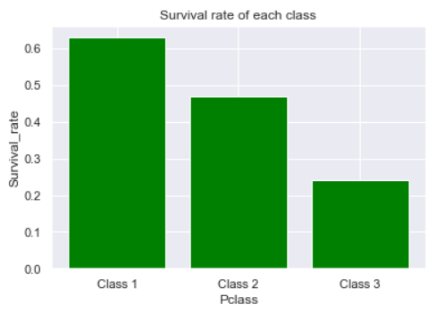

**Graph 2 – survival rate of each class**

|  |  |  |  |
| --- | --- | --- | --- |
|  | **Count** | **No. of survived** | **Survival rate** |
| **Class 1** | 216 | 136 | 0.63 |
| **Class 2** | 184 | 87 | 0.47 |
| **Class 3** | 491 | 119 | 0.24 |

**Table 1 – Summary of each class passengers**

From the statistics showed, Class 1 has higher survival rate than Class 2 and Class 3. In Titanic, Class 1 is the upper class, Class 2 is middle class and Class 3 is low class.

**Sex VS Survival rate**

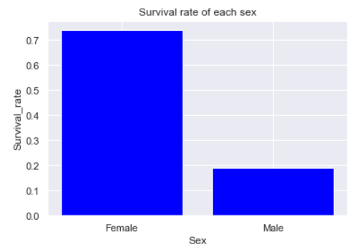

**Graph 4 – survival rate of each sex**

Below table shows the summary of no. of passengers, no. of survived passengers and the survival rate of each class.

|  |  |  |  |
| --- | --- | --- | --- |
|  | **Count** | **No. of survived** | **Survival rate** |
| **Female** | 314 | 233 | 0.74 |
| **Male** | 577 | 109 | 0.19 |

**Table 3 – Summary of each class passengers**

From the figures above, it shows that female has a higher survival rate than male. Graph 3 illustrates the survival rate of each sex.

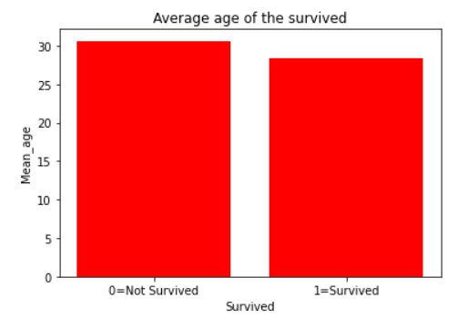

**Graph 5 – survival rate of each sex**

**Age VS Survival rate**

From the figures below, we can see that the average age of the survived and not survived does not have big difference (30.63 and 28.34) respectively.

Therefore, based on the age information we cannot conclude the age has large association with the survival rate.

**Conclusion**

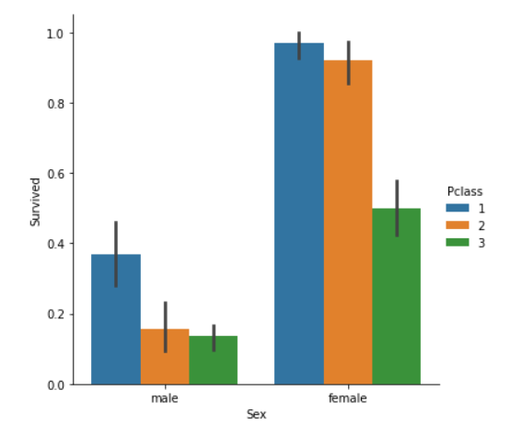

**Graph 6 – survival rate of each sex and Pclass**

To conclude, the sex and Pclass have greater association with the survival rate while the age does not have much information to tell. (Figure 6 illustrates the Pclass and sex have greater association with the survival rate).