# Calculator Assignment

The task is to design and implement a basic functioning calculator. As a model, an image of the standard view of the Windows calculator follows (this is the Windows 7 look and feel; if you’re running 8 or 10, you’ll get something different):

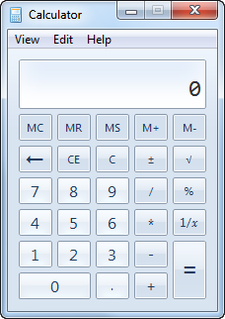

Your calculator should provide these same basic buttons, with the same functionality. Operations on your calculator will be entered in infix form. Your calculator should allow the user to press keys on the keyboard as well as pressing buttons with the mouse (as the Windows calculator does).

To help with positioning of elements, WPF provides many layout manager classes called ‘Panels’. The WPF book in the class covers these in Chapter 5 (WPF 4.5 Unleashed, by Nathan).

Note that because you are implementing the basic calculator, order of operations are not followed; for example, on the basic calculator

1 + 2 * 3 = 3 * 3 = 9

Whereas, if the order of operations were observed, we would have

1 + 2 * 3 = 1 + 6 = 7

For the menu items, you should implement **Edit -> Copy, Edit -> Paste, View -> Standard. View -> Digit Grouping, & and Help -> About**.

Beyond the basic functionality required here, you are free to make the calculator look any way you like.

**You may use the designer in Visual Studio to make this calculator; it is not necessary for you to write all the design code yourself. If you set up the Panels well, it’s really just a copy & paste job.**

Zip up your project using ZIP format only. (I will not accept anything other than a standard ZIP file.) Delete unnecessary large database/debug files to minimize upload/download size. (Make sure that you don’t delete anything important, though.) Submit to the dropbox no later than the due date/time.

Note that while commenting this program does not entail that you follow the OIT guidelines document (which is a document for C++), I expect significant inline commenting of your code; that means, ***something informative every few lines***.

**Extra Credit**

**Rewrite your calculator so that it observes the algebraic order of operations. To do this, you may need to add some buttons (like parentheses, for example).**

Please note that if you do the extra credit item, mention this in the submission box in Blackboard. If you do not, it is possible that I simply won’t see it.