Mr. StataCookie

Annexe

Découpage des modules

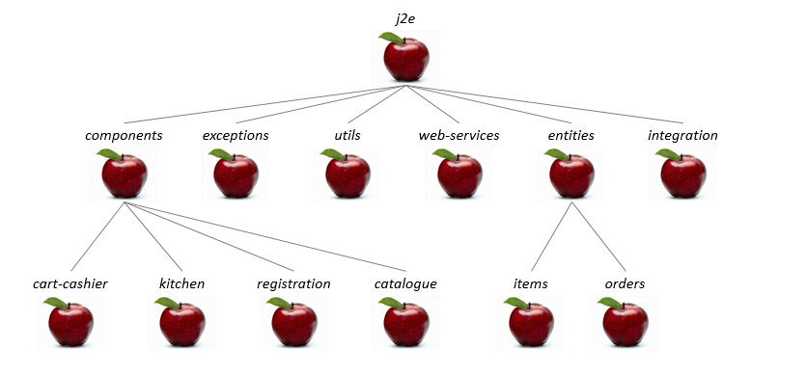

Découpage des modules

Contenance des modules

|  |  |
| --- | --- |
| Nom du module | Contenu |
| Cart-Cashier | CartBean  CashierBean  CartStatefulBean  CartStatelessBean  CartCounter  CartModifier  Payment  CartTest  CashierTest |
| Kitchen | KitchenBean  OrderProcessing  Tracker  KitchenTest |
| Registration | CustomerRegistryBean  CustomerFinder  CustomerRegistration  CustomerRegistryTest |
| Catalogue | CatalogueBean  CatalogueExploration  CatalogueTest |
| Exceptions | AlreadyExistingCustomerException  ExternalPartnerException  PaymentException  UnknownCustomerException  UnknownOrderId |
| Utils | Logger  BankAPI  Database |
| Web-Services | CartWebService  CartWebServiceImpl  CustomerCareService  CustomerCareServiceImpl |
| Items | Cookies  Item  ItemVerifier |
| Orders | Customer  Order  OrderStatus |
| Integration | DatabaseIntegrationTest  PaymentIntegrationTest |

Contenance des modules