Null Coalescing Assignment Operator:

[Null Coalescing operator in PHP 7](https://riptutorial.com/php/example/7164/null-coalescing-operator-----) made a huge difference in PHP development because we could write the following code.

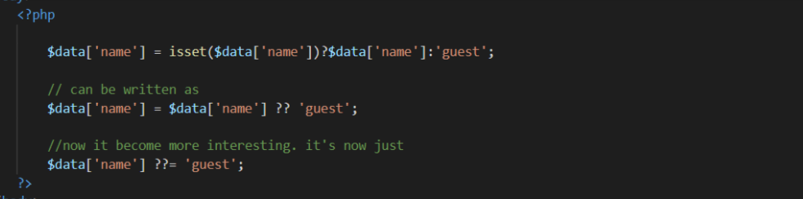

All of the above codes do the same thing. Check if the $data['name'] is set. If yes, get it. If not, get “Guest” and assigns to $data['name']. As I mentioned, PHP 7.4 update makes the syntax less verbose.