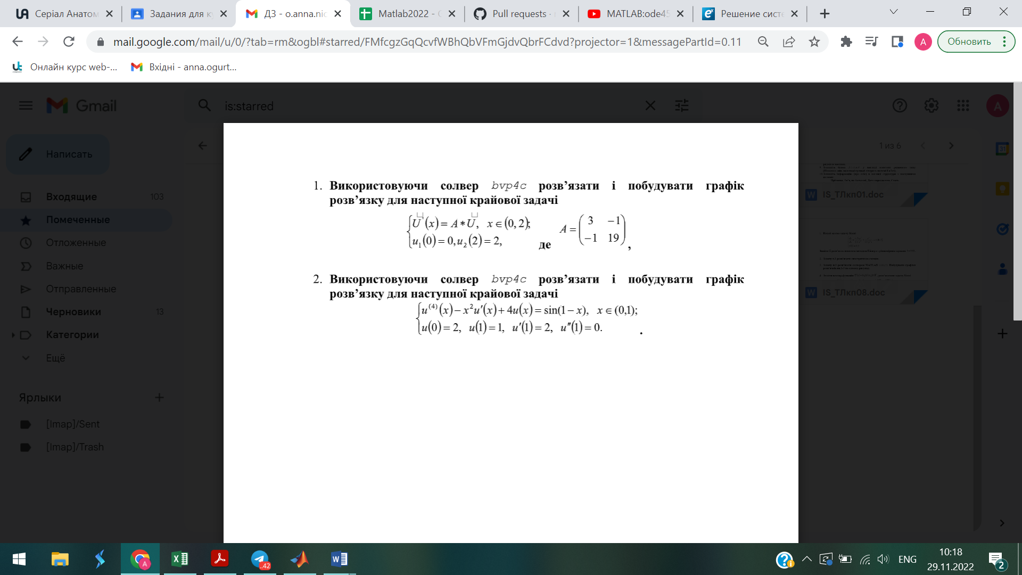

clear, clc

T=1;

x=0:0.1:T;

io=bvpinit(x,[0,0,0,0]);

u=bvp4c(@myfun,@myfun2,io);

U=deval(u,x);

plot(x,U,'gD-','MarkerSize',7)

function du=myfun(x,u)

du=[u(2)

u(3)

u(4)

sin(1-x)+x^2*u(2)+4*u(1)];

end

function bc=myfun2(ua,ub)

bc=[ua(1)-2,ub(1)-1,ub(2)-2,ub(3)];

end



function lect9

clear; clc

a = 0; b = 2;

g(1)=0; g(2)=2;

f = @(x) A.*U`

x = [a b];

u_init = [3 -1, -1 19];

solinit = bvpinit(x,u_init);

sol = bvp4c(F,G,solinit);

x = linspace(a,b,21);

u = deval(sol,x);

plot(x,u(1,:),'b-','ro ','LineWidth',1.5,'MarkerFaceColor','y')