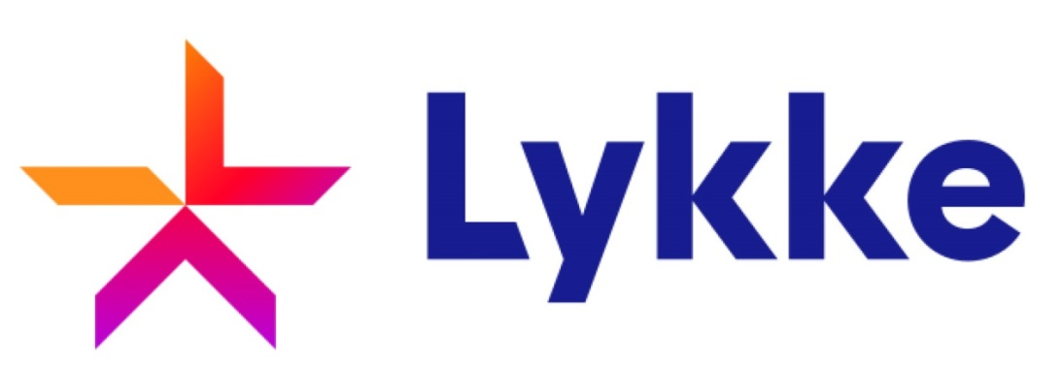

**Lykke Cyprus Ltd**

**Privacy Policy**

**January 2017**

Contents

1. Introduction 3

2. Usage of Personal Information 3

3. Cookies 4

4. Security Technology 4

5. Links to Third Party Websites 4

6. Links to Third Parties 4

7. Sharing Information with Our Affiliates 5

8. Sharing Information with Third Parties 5

9. Choice/Opt-out 5

10. Access to Personally Identifiable Information 5

11. Changes to this Privacy Statement 5

# Introduction

Lykke Cyprus Ltd does its utmost to ensure the privacy, confidentiality and security of its clients are preserved both throughout their interaction with the company and afterwards, to the fullest extent achievable by the firm. This privacy policy describes how all information that is collected by Lykke Cyprus Ltd will be used. We value the relationship that we have built with you and we place a very high priority protecting the data that you have provided to us.

By opening an account with Lykke Cyprus Ltd and its subsidiary website or by using any of the Lykke Cyprus Ltd website, you give your consent to the use of your personal information and also collection of the information by Lykke Cyprus Ltd as per explained in this policy privacy statement.

# Usage of Personal Information

Upon an account opening with Lykke Cyprus Ltd, we will collect information from you to verify your identity and to create your trading account. This information helps us to provide you with a better service as we strive to provide the top quality services to you.

Some of the information we collect includes your name, contact details, mailing address, email address, telephone number, personal identification data, passport number, tax or identification number and other information that may be needed. Other information that is collected will be stated in our registration forms and this may change from time to time. Our clients undertake to supply us with true, updated and accurate information about their identity. Furthermore, they are required to state categorically that they are registering and trading on their own behalf and are not seeking at any time to act any manner which could be considered fraudulent nor are they seeking to impersonate any other individuals for any purposes whatsoever.

Lykke Cyprus Ltd will collect information from your Internet Protocol (IP) address, browser type, operating system, time stamps, transaction history and also your Internet Service Provider (ISP).

Should you decide to close your accounts and part ways with Lykke Cyprus Ltd, we will retain your information and use it to comply with regulatory requirements. We may also contact with you time to time to share information on our new offers.

# Cookies

A cookie is a small text file that will be stored on the visitor's computer for record and tracking purposes — which is also part of our authentication system. The Company do link the information it stores in cookies to any personally identifiable information the client submits while on its site. The Company uses both session ID cookies and persistent cookies. A session ID cookie does expire when the client closes its browser. A persistent cookie remains on the clients’ hard drive for an extended period of time. To remove persistent cookies, follow the directions provided in the Internet browser's "help" file. Lykke Cyprus Ltd may also use independent external service providers to track the traffic usage on the website.

# Security Technology

Our servers are safeguard behind a firewall to protect your information better.

# Links to Third Party Websites

Lykke Cyprus Ltd has included links on this site for your use and reference. We are not responsible for the privacy policies on these websites. You should be aware that the privacy policies of these sites may differ from our own. The existence of any such links does not constitute an endorsement of such websites, the contents of the websites or the operators of the websites.

# Links to Third Parties

Lykke Cyprus Ltd will never disclose any private or otherwise confidential information in regards to our clients and former clients to third parties without the express, written consent of our clients, except in such specific cases in which disclosure is a requirement under law, or is otherwise necessary in order to perform verification analysis on the clients’ identity for the purposes of safeguarding their account and securing their personal information. Lykke Cyprus Ltd also reserves the right to disclose the clients’ personal information when it believes that disclosure is necessary to protect the clients’ rights and/or to comply with a judicial proceeding, court order, or legal process served on the Firm’s site. Lykke Cyprus Ltd will not be liable for any unlawful or unauthorised use of the clients’ personal information resulting from cookies on the Firm’s website that Lykke Cyprus Ltd does not have access to or control over.

# Sharing Information with Our Affiliates

Lykke Cyprus Ltd may share certain personal information with our affiliates for business purposes. The information that is shared will be used for informing customers on new services and products, providing better service to the customers, or to aid in the trading activity, its affiliates of the company as permitted an applicable by law. Our affiliates includes companies that are owned by us, companies that we have stakes in and also companies that has ownership shares in our company.

# Sharing Information with Third Parties

Lykke Cyprus Ltd will not disclose your personal information to third parties, except as described in this policy. The disclosure to third parties may include the sharing of your personal information with non-affiliated companies to help provide you with better services. Companies that are non-affiliated with Lykke Cyprus Ltd will maintain the confidentiality of the information that is shared with them. The usage of the information will be dictated by Lykke Cyprus Ltd. Lykke Cyprus Ltd will only keep your information and will not sell it to any other parties.

# Choice/Opt-out

If you no longer wish to receive any communication from the company, you may opt-out of by following the relevant instructions included in each communication sent by Lykke Cyprus Ltd. Lykke Cyprus Ltd reserves the right to contact you, albeit the fact that you have opted out, in cases where Lykke Cyprus Ltd deems such contact as necessary.

You shall be notified accordingly if your personal information is collected by any third party that is not our agent/ service provider, so you can make an informed decision as to whether or not you want to share your information with that party.

# Access to Personally Identifiable Information

If your personally identifiable information changes, you must inform us accordingly; please e-mail us support@lykke.com.cy or call us +XXX.

# Changes to this Privacy Statement

The contents of this statement may be altered at any time, at our discretion. If you have any questions regarding the privacy policy of Lykke Cyprus Ltd then you may contact us through email or support ticket.