**Sales & Returns Performance Analysis Report  
Project #1 – Sales & Returns Performance Trends Dashboard**

**Prepared by:**Lyle Cory Miller

**Role Targeted:  
Business Analyst | Operations Analyst | CRM Specialist**

**Tools Used:  
Excel • Tableau**

**Date Completed:**April 2024

**Portfolio Repository:**

**•** [**GitHub – lylecorymiller**](https://github.com/lylecorymiller) **•** [**LinkedIn – lylecorymiller**](https://www.linkedin.com/in/lylecorymiller)

**Project #1: Sales & Returns Performance Analysis Report**

**Project Overview**

This project analyzes **sales performance** and **product return trends** using the **Sample - Superstore Sales Dataset**. The goal is to uncover key patterns in returns, assess their **financial impact**, and deliver **strategic recommendations** to improve **profitability**, **customer satisfaction**, and **operational efficiency**.**Objectives**

* Analyze **annual sales** and **profit growth** from **2018–2021**
* Measure the **return rate (%)** and **profit loss ($)** due to product returns
* Identify **high-return product subcategories** affecting profitability
* Highlight **geographic regions** with the most return activity
* Propose **data-driven strategies** to minimize return losses and improve decision-making

**Tools Used**

* **Excel** **-** Data Cleaning & preparation
* **Tableau -** Data Visualization & Dashboard Development

**Dataset Source**

This project uses the [**Sample - Superstore Sales Dataset**](https://www.tableau.com/sites/default/files/2021-05/Sample%20-%20Superstore.xls), a widely used dataset in analytics for simulating real-world **retail transactions**. It includes details on **orders, products, categories, profits, returns, customers**, and **regions**, making it ideal for **sales operations** and **profitability analysis**.  
**Data Cleaning & Preparation**

Performed in **Excel**, the dataset was cleaned and prepared through:

* **Removed irrelevant columns** (e.g., *Customer Name*, *Customer Email*, *Postal Code*)
* **Standardized column names** andensured proper formatting
* **Converted data types** for date, numeric, and currency fields
* Created a **Data Dictionary tab** to define variables and support documentation
* Creating **calculated fields** in **Tableau** for:
  + **Returns Rate** (**%**)
  + **Profit Loss** (**$**) due to returns
* **Exported cleaned dataset** as .xlsx, .csv for use in **Tableau** visualizations

**Key Insights & Findings**

1. **Annual Sales & Profit Performance (2018-2021)**
   * **Sales** rose from **$483,966 (2018)** to **$733,215 in (2021).**
     + Temporary decline in **2019 (↓ 2.78%)**, followed by strong recovery.
   * **Profit** grew steadily from **$49,556** to **$93,439.**

**Summary of Impact:** Consistent **profit growth** and a strong **sales rebound** post-2019 signal healthy operations.

1. **Return Rate & Profit Impact**

* **Return Rate:** **8.0%** of all orders were returned.
* **Profit Loss:** Returns caused a total loss of **$23,232**.

**Summary of Impact:** Return volume was moderate, but the **financial impact** was substantial.

1. **Top Returned Subcategories (by Volume)**

* Most returns came from **Phones (24,853)**, **Chairs (23,948)**, and **Tables (18,100)**

**Summary of Impact:** These subcategories may benefit from **product improvements** or **clearer customer communication.**

1. **Geographic Return Insights**

* Most return activity occurred in ***California****,* ***Texas****,* ***and New York***.

**Summary of Impact:** These high-revenue regions also pose **high return risks**, making them ideal for **localized return strategies**.

1. **Subcategories with Highest Profit Loss**

* Highest return-related losses: **Copiers** (**$8,611)**, **Paper ($3,237)**, **and Accessories ($2,868)**.

**Summary of Impact:** These categories require attention to **pricing**, **returns policy**, or **product quality.**

**Tableau Dashboard Overview**

The Tableau dashboardincludes clear, **interactive insights** that display:

* **KPIs:** Return Rate (%), Total Return Loss ($)
* **Year-over-year Sales** and **Profit** (line chart)
* **Top Returned Subcategories** (bar chart)
* **Profit Loss by Subcategory** (bar chart in $)
* **Geographic Map** of product returns (interactive)
* **Dynamic Filters** by Year, Subcategory, and State
* **Dashboard Name**: *Sales & Returns Performance Dashboard* *(****Tableau Public****)*
* **Upload Details:** *Published to* ***Tableau Public*** *and saved as* ***.twbx*** *file*
* **Dashboard Preview:** *See Figure 1 below*

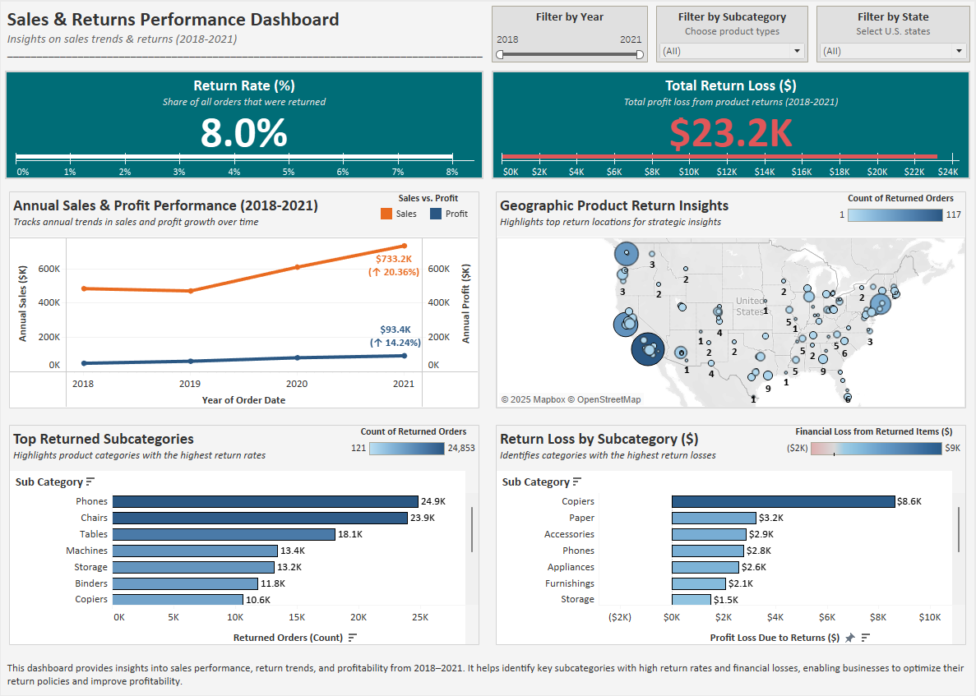

Figure 1: Sales & Returns Performance Dashboard – Tableau Visualization

**Business Impact & Recommendations**

This analysis helps reduce **return losses** and improve **sales performance** by:

1. **Minimize Return Losses in Key Product Lines**

* Analyze top returned products to identify **quality issues** or **mismatched expectations.**
* Improve **customer education** and product descriptions to reduce preventable returns.

1. **implement Region-Specific Return Strategies**

* Develop **localized return policies** for high-return regions *(e.g., California, Texas, New York).*
* Adjust **logistics and supply chain operations** to reduce regional return impact.

1. **Optimize Profitability Through Policy & Pricing Adjustments**

* Reassess **pricing strategies** for high-loss subcategories (Copiers, Chairs, Appliances).
* Introduce **targeted incentives** or stricter **return policies.**
* Leverage **predictive analytics** to improve **inventory planning** and reduce return risk.

**Calculated Fields & Tableau Analysis**

All analysis was completed in **Tableau** using calculated fields to derive **dynamic**, **filterable metrics** including **Return Rate (%)** and **Profit Loss ($)**. These were built directly from the **cleaned dataset** to uncover return trends, sales performance, and regional insights across subcategories.  
**File Export & Submission**

* **Cleaned dataset** exported as .xlsxand .csvfor use in **Tableau**
* **Tableau Workbook** saved as .twbxfor **portfolio use**
* **Dashboard image** exported as .pngand .pdffor **professional sharing**
* Finalized documentation (**this report**) saved as .docx and .pdf
* **GitHub README** included as both README.md and .pdf
* All **project files** are organized and stored in **GitHub** and **LinkedIn portfolio** for **easy access**

**Final Thoughts**

This project delivers a **data-driven analysis** of **sales trends** and **product return performance** using **Excel** and **Tableau**. It uncovers **profit loss**, highlights **operational risks**, and provides **actionable recommendations** aligned with the goals of roles such as **Business Analyst**, **Operations Analyst**, and **CRM Specialist**.

The interactive dashboard is published on **Tableau Public** and is part of my **professional portfolio** for **hiring managers** to explore: [Sales & Returns Performance Dashboard on Tableau Public.](https://public.tableau.com/app/profile/lyle.cory.miller/viz/SalesReturnsPerformanceDashboard20182021/SalesReturnsPerformanceDashboard?publish=yes)