**IT Help Desk Performance Analysis Report  
Project #2 – Customer Support Ticketing System**

**Prepared by:**Lyle Cory Miller

**Role Targeted:  
Business Analyst | Systems Analyst | IT Operations Analyst**

**Tools Used:  
Excel • Tableau**

**Date Completed:**June 2024

**Portfolio Repository:**

**•** [**GitHub – lylecorymiller**](https://github.com/lylecorymiller) **•** [**LinkedIn – lylecorymiller**](https://www.linkedin.com/in/lylecorymiller)

**Project #2: IT Help Desk & Ticketing System Analysis Report**

**Project Overview**

This project analyzes **IT support ticket data** to evaluate help desk performance and uncover patterns in **resolution rates**, **ticket volume**, and **support channel usage**. The goal is to highlight areas for improvement and drive better customer service through **data-driven decision-making**.**Objectives**

* Analyze overall **ticket volume** and **resolution status**
* **Measure the ticket resolution rate (%) and detect operational delays**
* Review the distribution of **priority levels** (Critical, High, Medium, Low)
* Evaluate trends across **support channels** (Email, Phone, Chat, Social Media)
* Deliver **recommendations** to streamline IT help desk performance

**Tools Used**

* **Excel -** Data Cleaning & Preparation
* **Tableau -** Data Visualization, Calculated Fields & Dashboard Design

**Dataset Source**

This project uses the ***Customer Support Ticket Dataset*** from [Kaggle](https://www.kaggle.com/datasets/suraj520/customer-support-ticket-dataset). Though simulated, it closely mirrors real-world IT help desk environments. It includes essential fields such as **ticket priority**, **resolution times**, **support methods**, and **customer satisfaction**, making it ideal for analyzing operational performance.  
**Data Cleaning & Preparation**

Performed in **Excel**, the dataset was cleaned and structured for analysis through:

* **Removed irrelevant columns** (e.g., *Customer Name*, *Customer Email*, *Ticket Description*)
* **Deduplicated rows** and **standardized field names** (e.g., *Ticket_ID*, *Customer_Age*, *Ticket_Status*)
* **Formatted date fields** (e.g., *Ticket_Creation*, *First_Response*, *Resolution_Time*)
* Created a **Data Dictionary** tab to document fields and definitions
* Creating **calculated fields** in Tableau for:
  + **Ticket Resolution Rate** (%)
  + **Pending Requests** (**Open Tickets**)
* **Exported cleaned dataset** as .xlsx, .csv for use in **Tableau** visualizations

**Key Insights & Findings**

1. **Total Ticket Volume & Resolution Status**

* A total of **8,469 support tickets** were processed
* **49.6%** of tickets were **closed**, while **50.4%** remained **open**.
* **2,881 tickets** were still pending customer or agent follow-up.

**Summary of Impact:** High volume of unresolved tickets suggests a need for **improved follow-up protocols** and better **tracking systems** to reduce bottlenecks.

1. **Ticket Priority Distribution**

* **Medium-priority** tickets were the most frequent (**2,192 tickets**)
* **Critical tickets** were also high (**2,129 tickets**), indicating many urgent issues
* **High and Low-priority** tickets were nearly equal in count (~2,000 each)

**Summary of Impact:** The help desk is facing a **disproportionate number of urgent requests**, which calls for enhanced **priority management** and **escalation workflows**.

1. **Support Channel Usage**

* **Email** (2,143) and **Phone** (**2,132**) were the most used methods
* **Social Media** (**2,121**) and **Chat** (**2,073**) also saw high engagement

**Summary of Impact:** Balanced channel usage shows that support is being accessed through **multiple touchpoints**. This highlights the importance of **staffing appropriately across all channels** and investing in **real-time support tools**.

**Tableau Dashboard Overview**

The Tableau dashboard includes clear, **interactive visuals** that display:

* **Total support tickets** processed and their **resolution status**
* Breakdown of **ticket volume by priority level** (Critical, High, Medium, Low)
* **Ticket volume by communication channel** (Email, Phone, Chat, Social Media)
* **Dynamic Filters** by Ticket Count, Priority, and Channel
* **Dashboard Name**: *IT Help Desk Performance Dashboard* ***(Tableau Public)***
* **Upload Details:** *Published to* ***Tableau Public*** *and saved as .twbx* *file*
* **Dashboard Preview:** *See Figure 1 below*

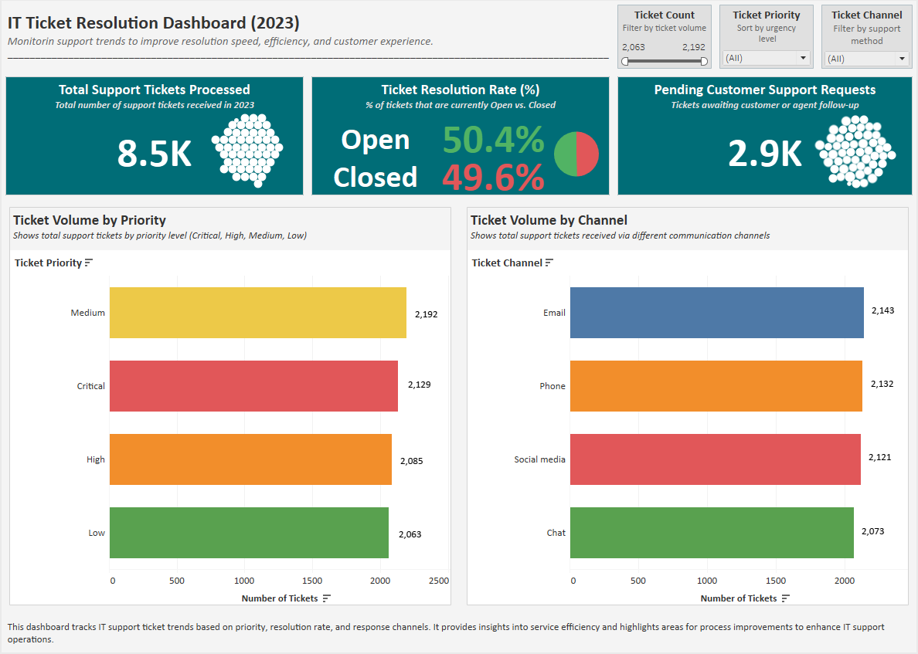

Figure 1: IT Help Desk Performance Dashboard – Tableau Visualization.

**Business Impact & Recommendations**This analysis supports actionable strategies for IT teams:

1. **Reduce Customer Response Delays**

* Implement **automated follow-ups** for unresolved tickets
* Define **Service Level Agreements (SLAs)** to improve resolution time targets

1. **Prioritize Critical & High-Priority Tickets**

* Assign **dedicated agents** for urgent tickets
* Create **automated escalation rules** to fast-track resolution

1. **Optimize Support Staffing**

* Allocate resources across **Email, Phone, and Chat**
* Scale **chat-based support** for faster interactions

**Calculated Fields & Tableau Analysis**

All analysis was completed in Tableau using **calculated fields** to derive dynamic, filterable metrics including **Ticket Resolution Rate (%)** and **Pending Support Requests (Open Tickets)**. These were built directly from the cleaned dataset to uncover trends in **ticket volume, urgency, and support channel usage**. The calculations enhanced the dashboard’s interactivity and allowed for real-time filtering by **ticket priority**, **channel**, and **volume**, supporting actionable insights for IT operations.

**File Export & Submission**

* **Cleaned dataset** exported as .xlsxand .csvfor use in **Tableau**
* **Tableau Workbook** saved as .twbxfor **portfolio use**
* **Dashboard image** exported as .pngand .pdffor **professional sharing**
* Finalized documentation (**this report**) saved as .docx and .pdf
* **GitHub README** included as both README.md and .pdf
* All **project files** are organized and stored in **GitHub** and **LinkedIn portfolio** for **easy access**

**Final Thoughts**

This project delivers a **data-driven assessment** of **IT help desk performance** using **Excel** and **Tableau**. It identifies **operational inefficiencies**, **highlights trends** in **ticket resolution** and **support channel usage**, and provides **actionable strategies** to improve service quality—core priorities for roles such as **Business Analyst**, **Systems Analyst**, and **IT Operations Analyst**.

The interactive dashboard is published on **Tableau Public** and is part of **my professional portfolio** for **hiring managers** to explore: [IT Help Desk Dashboard on Tableau Public](https://public.tableau.com/app/profile/lyle.cory.miller/viz/ITHelpDeskTicketingSystemDashboard/ITHelpDeskTicketingSystemDashboard).