**Global Logistics Performance Analysis Report  
Project #3 – International Supply Chain & LPI Score Assessment**

**Prepared by:**Lyle Cory Miller

**Role Targeted:  
Business Analyst | Operations Analyst | Systems Analyst**

**Tools Used:  
Excel • SQL • Power BI**

**Date Completed:**November 2024

**Portfolio Repository:**

**•** [**GitHub – lylecorymiller**](https://github.com/lylecorymiller) **•** [**LinkedIn – lylecorymiller**](https://www.linkedin.com/in/lylecorymiller)

**Project #3: Global Logistics Performance Analysis Report**

**Project Overview**

This project evaluates international logistics performance using the **Logistics Performance Index (LPI)**. The goal is to identify country-level strengths and weaknesses in **supply chain efficiency**, highlight **infrastructure quality gaps**, and provide strategic recommendations to improve global logistics operations.**Objectives**

* Identify **top & bottom 3 countries** by LPI Score (2023)
* Analyze **global LPI score trends** (2010–2023)
* Visualize **LPI performance distribution** across countries
* Compare **global infrastructure quality** by country
* Support policy and business decisions through **data-driven logistics insights**

**Tools Used**

* **Excel -** Data Cleaning & Preparation
* **SQL (Microsoft SQL Server) -** Data Extraction & Analysis
* **Power BI –** Data Visualization, Calculated Fields & Interactive dashboard

**Dataset Source**

This project uses the dataset **“Logistics Performance Index (LPI)”** from the [**World Bank’s Logistics Performance Index (LPI)**](https://lpi.worldbank.org/international), which measures the logistics efficiency of **100+ countries** based on factors like **customs**, **infrastructure**, **international shipments**, and **delivery timelines**.  
**Data Cleaning & Preparation**

Performed in **Excel** and **SQL**, the dataset was cleaned and structured for analysis through:

* **Removed grouped ranks, duplicate scores, and metadata columns** from the raw LPI dataset
* **Merged LPI data across years (2010–2023)** into a standardized long-format structure
* **Handled missing values** and cleaned data inconsistencies
* **Enforced consistent column names** and ensured consistent **data types**
* **Manually mapped regions to countries** for global segmentation
* Created a **Data Dictionary** tab to document all fields and descriptions
* **Exported cleaned dataset** as .xlsx, .csv for use in **SQL** analysis and **Power BI** visualizations

**Key Insights & Findings**

1. **Top & Bottom 3 Countries by LPI Scores (2023)**

* **Top Performers:** *Singapore (4.30), Finland (4.20), Denmark, Germany, Netherlands, Switzerland (4.10).*
* **Lowest Countries**: *Libya & Afghanistan (1.90), Somalia (2.00).*

**Summary of Impact**: Countries with **conflict** or **underdeveloped infrastructure** rank lowest, while **Northern Europe** and **East Asia** lead in global logistics.

1. **Global Average LPI Trend (2010–2023)**

* Global average improved from **2.87 (2010)** to **3.00 (2023).**
* Sharp increase in **2023**, showing renewed global investment.

**Summary of Impact:** Reflects steady **supply chain progress** and increasing investment in **logistics modernization.**

1. **Global LPI Score Distribution by Country (2023)**

* Countries across **Europe** and **East Asia** dominate high LPI scores**.**
* Lower scores are concentrated in **Sub-Saharan Africa** and **fragile economies.**

**Summary of Impact**: Signals urgent need for **logistics support** and **infrastructure funding** in low-performing regions.

1. **Infrastructure Quality Leaders & Laggards (2023)**

* **Top Performers**: *Singapore (4.6), Switzerland (4.4), Canada (4.3), Germany (4.3).*
* **Lowest Performers:** *Libya (1.7), Afghanistan (1.7), Madagascar/Haiti (1.8).*

**Summary of Impact**: **Infrastructure quality** strongly correlates with **LPI success**. Improving logistics infrastructure in low-performing regions is critical for **economic development**.

**Power BI Dashboard Preview**

The Power BI dashboard delivers **interactive insights** on:

* **Global logistics performance** by country
* **Top** and **bottom LPI scores** (2023)
* **Infrastructure performance segmentation**
* **Global LPI score averages** across time (2010–2023)
* **Region-level comparisons** and **global heat map**
* **Dashboard Name**: *Global Logistics Performance Dashboard (Power BI Visualization).*
* **Upload Details:** *Published to Power BI and saved as .pbix file*
* **Dashboard Preview:** *See Figure 1 below*

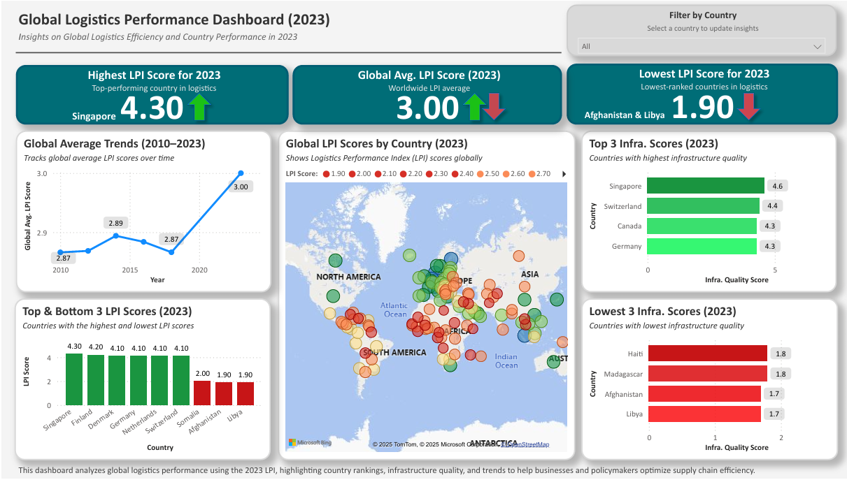

Figure 1: Global Logistics Performance Dashboard (2023) – Power BI Visualization.

**Business Impact & Recommendations**

This analysis helps **policymakers** and **business leaders** strengthen logistics systems by:

1. **Investing in Infrastructure**

* Prioritize improvements in **low-performing countries** to support **trade growth**.

1. **Benchmarking High Performers**

* Apply successful strategies from top countries like ***Singapore*** and ***Germany*** to improve logistics policy and technology.

1. **Tracking Progress Over Time**

* Use **LPI data** as an ongoing benchmark to guide reforms and monitor logistics development

**SQL Queries & Data Extraction**

To analyze logistics performance trends, key insights were extracted using **SQL** in **Microsoft SQL Server**. Below are the primary queries:

1. **Retrieve Available Years in the Dataset**

**SELECT DISTINCT** Current_Year

**FROM** LPI_International_Logistics_Analysis;

**Purpose:** Lists all unique years in the dataset to support trend analysis.

1. **Top 3 LPI Scores (2023)**

**SELECT** TOP 3 Economy, LPI_Score

**FROM** LPI_International_Logistics_Analysis

**WHERE** Current_Year = 2023

**ORDER BY** LPI_Score **DESC**;

**Purpose:** Identifies the 3 countries with the highest LPI scores in 2023.

1. **Bottom 3 LPI Scores (2023)**

**SELECT** TOP 3 Economy, LPI_Score

**FROM** LPI_International_Logistics_Analysis

**WHERE** Current_Year = 2023

**ORDER BY** LPI_Score **ASC**;

**Purpose:** Returns the 3 lowest-ranked countries by logistics performance in 2023.

1. **Global Average LPI Scores Over Time**

**SELECT** Current_Year, **AVG**(LPI_Scores) **AS** Avg_LPI_Score

**FROM** LPI_International_Logistics_Analysis

**GROUP BY** Current_Year

**ORDER BY** Current_Year **ASC**;

**Purpose:** Calculates average LPI score per year to visualize global trends.

1. **Infrastructure Scores by Country (2023)**

**SELECT** Economy, Infrastructure_Score

**FROM** LPI_International_Logistics_Analysis

**WHERE** Current_Year = 2023

**ORDER BY** Infrastructure_Score **DESC**;

**Purpose:** Ranks 2023 infrastructure scores to compare top and bottom countries.

**SQL Summary**

**SQL** was used to **extract**, **filter**, and **analyze logistics performance data** directly from the **cleaned dataset**. Key queries retrieved **top and bottom LPI scores**, **tracked global trends** from **2010 to 2023**, and **calculated global averages** for deeper insight into **performance changes over time**. This **structured querying approach** ensured **data accuracy**, **transparency**, and **reproducibility** throughout the analysis process.

**Key SQL Queries Used:**

* **Retrieve Unique Years** for Time-Series Analysis
* **Top 3** & **Bottom 3** **Countrie**s by LPI Score (2023)
* **Global Average LPI Score by Year** (2010–2023)
* **Global LPI Score Distribution by Country** (2023)
* **Top** & **Bottom Countries by Infrastructure Score** (2023)

**File Export & Submission**

* **Cleaned dataset** exported as .xlsxand .csvfor use in **SQL** and **Power BI**
* **Power BI Dashboard** .pbix saved for **portfolio use**
* **SQL Query File** .sql saved for **portfolio use**
* **Dashboard image** exported as .pngand .pdffor **professional sharing**
* Finalized documentation (**this report**) saved as .docx and .pdf
* **GitHub README** included as both README.md and .pdf
* All **project files** are organized and stored in **GitHub** and **LinkedIn portfolio** for **easy access**

**Final Thoughts**

This project delivers a **data-driven assessment** of **global logistics performance** using **Excel, SQL, and Power BI**. It identifies **performance gaps** across countries, highlights **infrastructure disparities**, and provides **actionable recommendations** to support **trade readiness** and **supply chain strategy**—key focus areas for roles such as **Business Analyst**, **Operations Analyst**, and **Systems Analyst**.

The **interactive dashboard** and all supporting files are included in my professional portfolio on GitHub, including the Power BI file: **Logistics_Performance_Dashboard.pbix** and the SQL queries used in this analysis: **logistics_analysis_queries.sql.**