# Earth

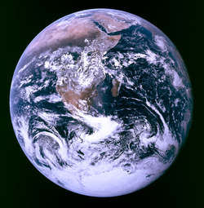

Figure The earth seen through space

## How big is the Earch

The Earth is nearly 13,000 km wide. It's the largest *terrestrial planet* in the Solar System.

The Earth weighs 5,973,700,000,000,000,000,000,000 kg. That's a lot. But it is little compared with Jupiter (319 Earths) and tiny compared with the Sun (335,789 Earths) or other stars!

## How long is a day on this planet

A day on Earth is 24 hours long. That's daytime *and* nighttime. A 24 hour day is how long it takes the Earth to spin around once. On the half of the Earth that is facing the sun it is daytime and on the half of the Earth that is facing away from the sun it is nighttime.

The spin of the earth is also the reason why the sun appears to rise in the east and to set in the west. Although it looks like the sun is moving from the surface of the earth, it is really the surface of the earth that is moving. The reason we do not feel like we are spinning is because the earth is so big compared to the size of people.

## What is Earth made of

When a planet is made of rock, we call its surface the *crust*. Below the Earth's crust is hot molten rock. It is in a layer called the *mantle*. The hot molten rock is what comes out of volcanoes. It's then called *lava*.

Under the mantle is the *core* of the Earth. We think it is made from solid iron and nickel, surrounded by hot molten iron. The temperature there is very very hot!

The Earth's crust is very thin compared to the mantle and the core. But it is very thick to us. Nobody has drilled all the way through it yet. Even the deepest underground mines are far away from reaching its deepest base.

## Earth Facts



* The Earth is the only planet we know to have life on it.
* The Earth is the third planet from the Sun.
* The Earth is the only planet we know that has liquid water on the surface, but scientists are trying to find others.
* The Earth's axis is tilted which is why we have four different seasons.
* The Earth is 4.6 billion years old