# Neptune

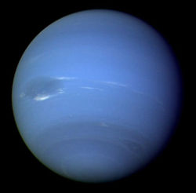

Figure Neptune seen from Voyager 2

## How big is the planet

Neptune is very similar to Uranus in size. Its diameter is only slightly smaller, at 49,528 km wide[1]. It is almost as big as four Earths in length.

## How long is a day on Neptune

A day on Neptune lasts 16 hours and 7 minutes[2].

## How long is a year on Neptune

One year on Neptune is about ***165*** Earth years, or 60,265 days.

## Neptune Facts



* Wind speeds on Neptune can reach 450 meters per second.
* Neptune was discovered because its gravitational field was affecting the orbit of Uranus.
* Neptune is sometimes farther from the Sun than Pluto.

1. http://www.nasa.gov/worldbook/neptune_worldbook.html
2. http://solarsystem.nasa.gov/planets/profile.cfm?Object=Neptune&Display=Facts