# Sun

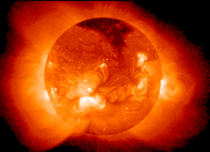

Figure The sun as seen through an X-ray telescope.

## What is the Sun?

The Sun is a star—the closest one to Earth. It is a large ball of very hot gas. The air we breathe and the Helium in a balloon are both gases. It is over 5,500 °C at the surface, and much hotter at the center, about 15 million °C. The Sun is made of mostly hydrogen (70%) and helium (28%). It turns much hydrogen into helium every second, thus creating heat and light.

The Sun makes light and heat that warms the surface of the Earth and allows plants to grow. We can get food from plants, and we can burn wood and other parts of plants to cook, warm our houses, and make cars go. Without the Sun there would be no life on Earth.

## How big is the Sun

The Sun is very big - much, MUCH bigger than the Earth! It is more than a million km (109 Earths) across and contains more than 99.9% of the Solar System's mass. If you could stand on the surface of the Sun, you would weigh 28 times as much as you do on Earth because the Sun has more mass and therefore more gravitational pull than earth.

More than a million Earths could fit beneath the surface of the Sun. It doesn't look that big from Earth, though. That's because the Sun is so far away. Compared to other stars, the Sun is about average-sized. There are much bigger stars, and much smaller stars.

A very thin *solar wind* of gases blows from the Sun all the way to the edge of the Solar System. When it gets there, the gases mix with those coming from other stars.

## Sun Facts



* If you looked at the Sun in a telescope, you could blind yourself......
* The Sun is 150,000,000 km (93 million miles) away from Earth.
* The Sun's light takes 8 minutes to reach us on Earth.
* The temperature of the Sun's light decreases proportionately as it travels further.
* Every second, the Sun turns over 4 million metric tons of gas into energy.
* The Sun is as wide as 109 Earths.
* The Sun is so hot that a piece of it the size of a pinhead could kill someone 160 kilometres (100 miles) away.