*The Solar System*

by The Author

Copyright Nature Publications

Revised:

*The Solar System*

by The Author

***Contents***

No table of contents entries found.

# General Outline

The book is about the solar system. The contents are from wikibooks. Please refer <http://en.wikibooks.org/wiki/Wikijunior_Solar_System> for more information.

The book contains basic information about sun and the 9 planets in the solar system: Mercury, Venus, Earth, Mars, Jupiter, Saturn, Uranus, Neptune and Pluto.

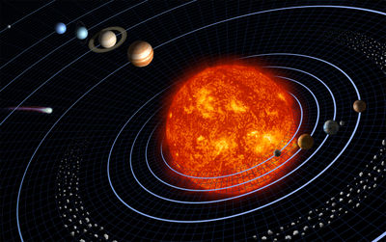

Click here to enter text.

Click here to enter text.

Click here to enter text.

Click here to enter text.

Click here to enter text.

Click here to enter text.

Click here to enter text.

Click here to enter text.

Click here to enter text.

Click here to enter text.

Click here to enter text.