OpsFortress v0.3 Database Review & Validation Report
DA/BA Review after Laravel Migration Refactor
Prepared for Kevin, Yiming, and the WHS App / OpsFortress team

Review Area | Summary
Environment | Local PostgreSQL database connected to Laravel refactor project
Migration status | Laravel migrations ran successfully
Database scope | 48 public tables created
P0/P1 coverage | P0 tables covered; P1 post-task/training tables present
Core relationships | Master-data and WHS content relationships validated
Main limitation | Full worker runtime journey not yet validated because runtime tables have no seed data
Recommended workflow | Gold benchmark prompt -> structured JSON -> JSON Schema -> Python -> Excel -> Laravel importer -> PostgreSQL

Executive Summary
The v0.3 database migration provides a strong foundation for the OpsFortress / WHS App workflow. The local PostgreSQL database was successfully created, Laravel migrations ran successfully, and 48 tables are now available for review. The main P0 table coverage and core master-data relationships have been validated.
The key limitation is that the current seed data only validates setup and content records. It does not yet include a full worker runtime journey. Runtime and evidence tables exist, but they currently contain no rows, so they will need to be validated later using demo runtime data or real worker app activity.
Core principle
AI generates the WHS/SWMS content. Python controls the Excel structure. Laravel importer validates before writing to PostgreSQL.

Area | Result | Note
Local migration | Pass | Laravel migrations successfully ran
Table coverage | Pass | 48 tables created
P0 coverage | Pass | Core P0 tables are present
P1 coverage | Present | Post-task and training tables already exist
Core relationships | Pass | Master/content relationships are connected
Runtime data | Not yet validated | Runtime/evidence tables currently have no rows
Importer tracking | Ready structurally | Tracking tables exist, but importer has not processed a workbook yet
Python / JSON workflow | Recommended | Best path for stable workbook generation and validation

Part 1 - Current Status
The local PostgreSQL and Laravel environment has been successfully prepared for database review and validation. A clean PostgreSQL database named opsfortress_demo was created locally, and the latest Laravel refactor migration was executed successfully through Laravel. The migration created 48 tables in the public schema, and the database seeder inserted minimal demo data into the key core tables.
Evidence | Result
Laravel migration status | All migrations show status = Ran
PostgreSQL table count | 48 public tables created
Seed data | customer_accounts contains demo data for Acme Construction
Core row counts | Main customer, business, workplace, user, task, SWMS, activity step, and pre-start question tables have minimal seed data

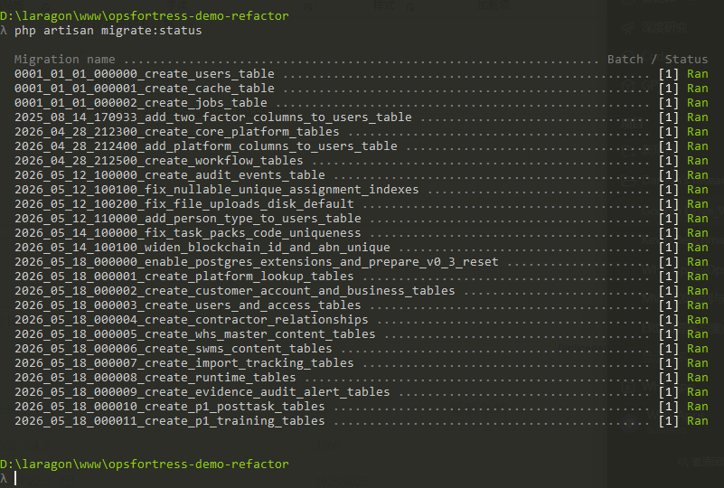
Figure 1 - Laravel migration status shows all migrations have run successfully.
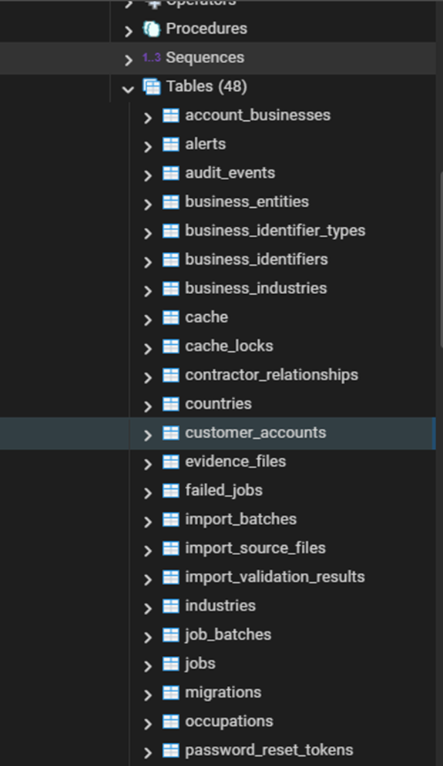
Figure 2 - pgAdmin shows 48 tables in the opsfortress_demo database.
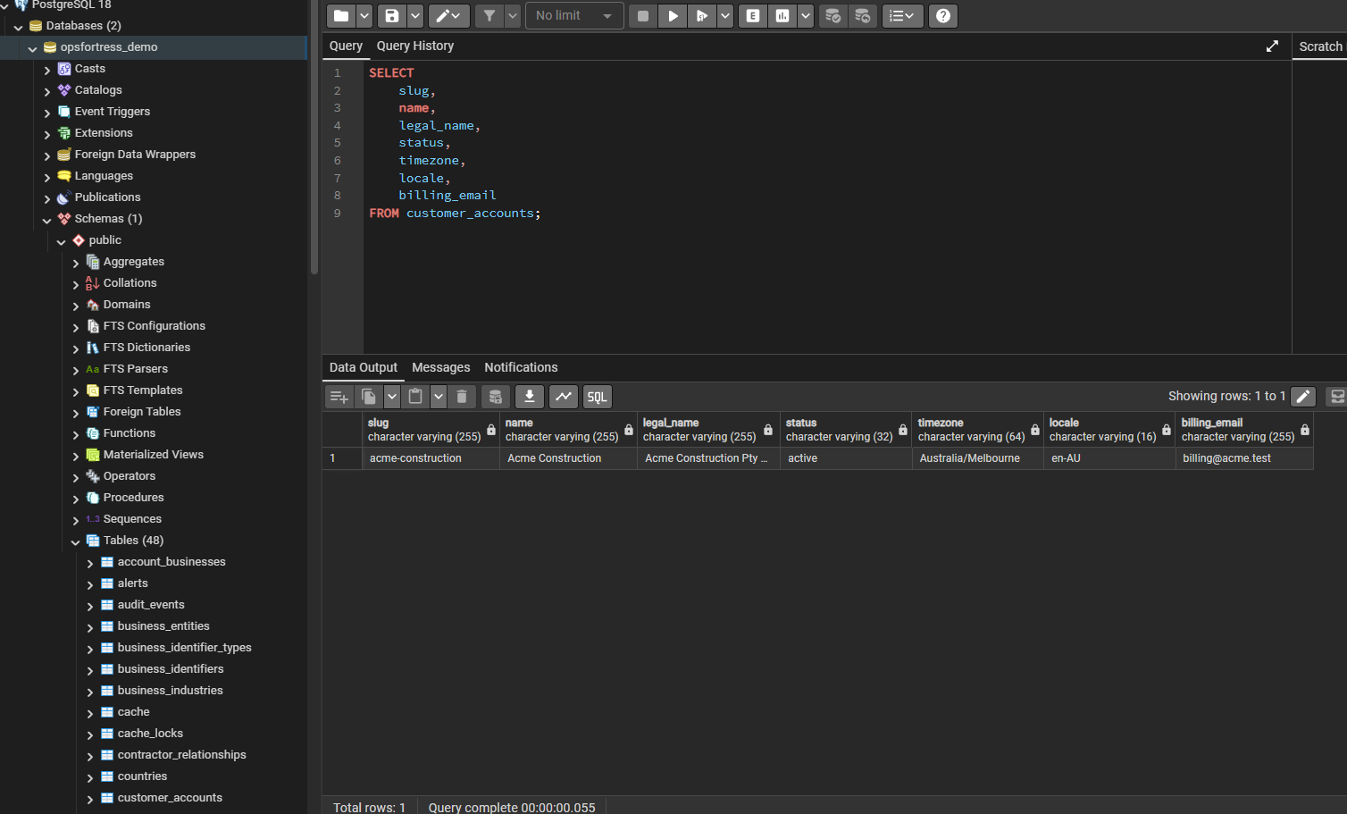
Figure 3 - customer_accounts contains demo seed data for Acme Construction.
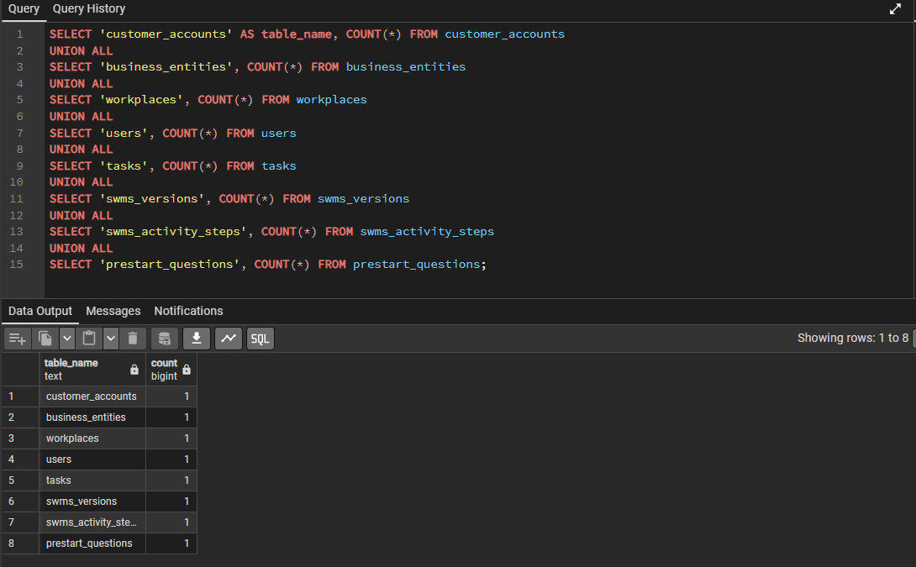
Figure 4 - Core table row count query confirms minimal seed data across key setup/content tables.
Initial observation
The current seed data is minimal. It confirms that the database structure and seeding process work, but it should not be treated as production-level SWMS content volume.

Part 2 - Database Scope Overview
The migrated PostgreSQL database contains 48 public base tables. These tables are not a random flat list. They can be grouped into clear functional layers that reflect the OpsFortress / WHS App architecture.
Layer | Purpose | Example Tables | Review Note
Laravel System | Framework operations | cache, jobs, sessions, migrations | Not business data
Core Platform / Onboarding | Account, business, workplace, users and access | customer_accounts, business_entities, workplaces, users | P0 core
WHS Content / Imported Master Data | Static task/SWMS content and access rules | tasks, swms_versions, swms_activity_steps, prestart_questions | Main importer target
Runtime / Worker Actions | Worker-created task activity | worker_task_sessions, swms_step_events, prestart_responses | App-generated
Evidence / Audit / Alerts | Compliance proof and traceability | signatures, evidence_files, audit_events, alerts | Compliance layer
Importer Tracking | Import batches, source files and validation logs | import_batches, import_source_files, import_validation_results | Importer-ready foundation
P1 Extensions | Post-task and training workflows | posttask_questions, training_questions, training_attempts | Present but secondary

Architecture view
Source workbook / Python-generated Excel -> importer tracking -> WHS content tables -> worker app runtime tables -> evidence and audit trail.

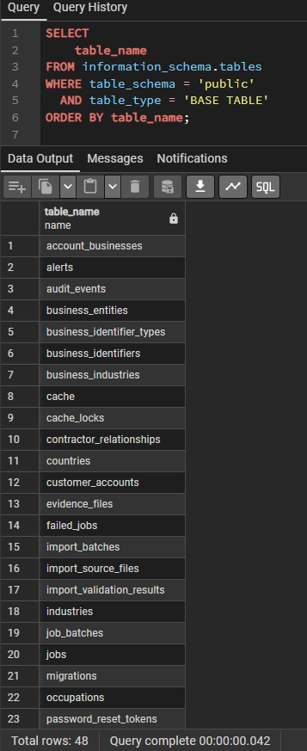
Figure 5 - SQL query confirms that 48 public base tables exist in PostgreSQL.

Part 3 - P0 / P1 Table Coverage Review
The P0/P1 coverage check confirms that all expected tables are present in the current v0.3 migrated database. P0 tables are covered across core onboarding, user/access, WHS content, runtime, evidence/audit and importer tracking. P1 post-task and training tables are also present, but their first-stage usage should be confirmed before they are included in the first importer or demo scope.
Area | Coverage Status | Review Comment
P0 Core / Onboarding | Covered | Account, business, workplace and identifier structure exists
P0 User / Access | Covered | User, business access, workplace access and contractor relationship tables exist
P0 WHS Content / Imported Master Data | Covered | Main importer target tables exist
P0 Runtime / Worker Actions | Covered | Worker-generated session, step event and pre-start response tables exist
P0 Evidence / Audit / Import Tracking | Covered | Evidence, audit, alerts and importer tracking tables exist
P1 Post-task / Training | Present | Tables exist, but first-stage usage needs confirmation

Review note
Coverage is good, but coverage does not prove relationship correctness. The next step is to validate the foreign key relationships and confirm that the schema logic matches the expected business workflow.

Part 4 - Core Relationship Validation
This section validates whether the main tables connect to each other in a way that supports the expected OpsFortress / WHS App workflow. The foreign key export contains 131 relationships, confirming that the v0.3 migration has created a strongly connected schema rather than a set of isolated tables.
Relationship Area | Validation Result | Comment
Customer -> Business -> Workplace | Pass | Seed data connects Acme Construction to business entity and Melbourne CBD Site
User -> Business / Workplace Access | Pass | Alex Admin has active admin access at both business and workplace level
Task -> SWMS Version -> Activity Step | Pass | Demo task links to SWMS v1 and a worker-facing activity step
Task -> Pre-start Question | Pass | Demo task links to a pre-start question with question type and critical-failure flag
Runtime / Worker Journey | Schema pass; data not yet validated | Runtime/evidence tables have no rows in current seed data
Audit Events | Needs confirmation | Confirm whether audit_events uses generic reference model or needs direct worker_task_session linkage

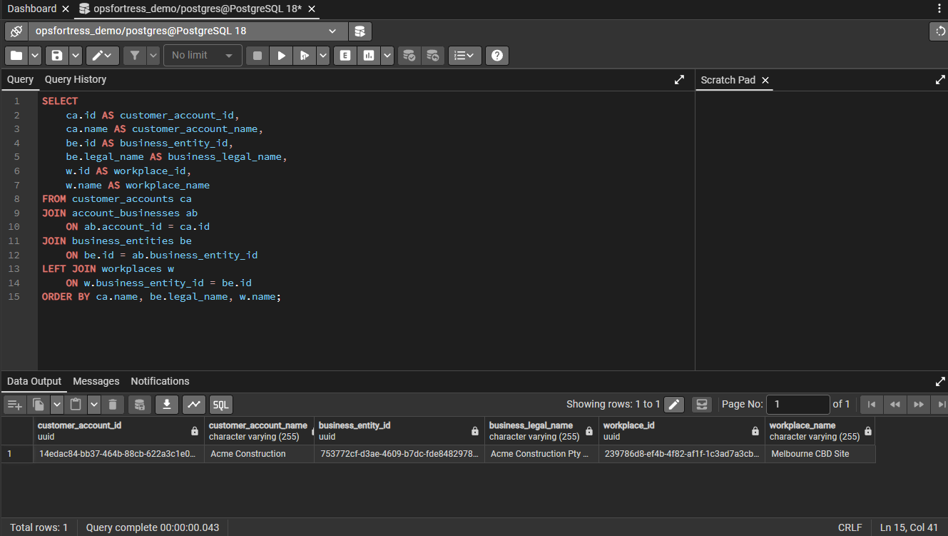
Figure 6 - Seed data validates the customer -> business -> workplace relationship.
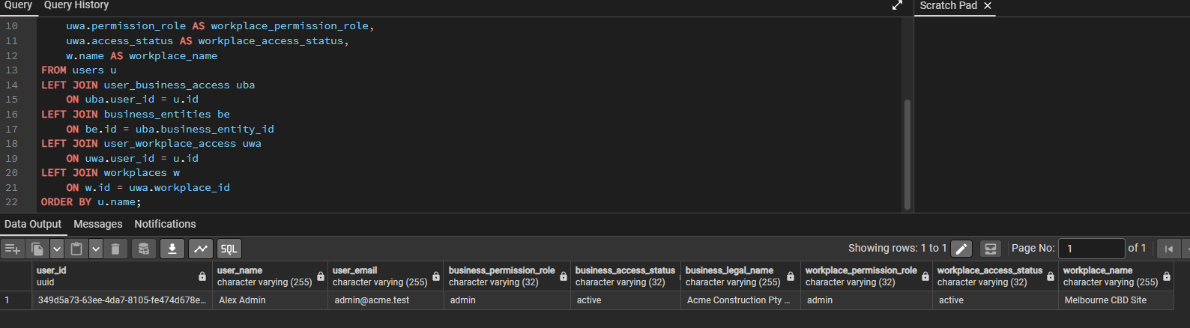
Figure 7 - Seed data validates business-level and workplace-level user access.
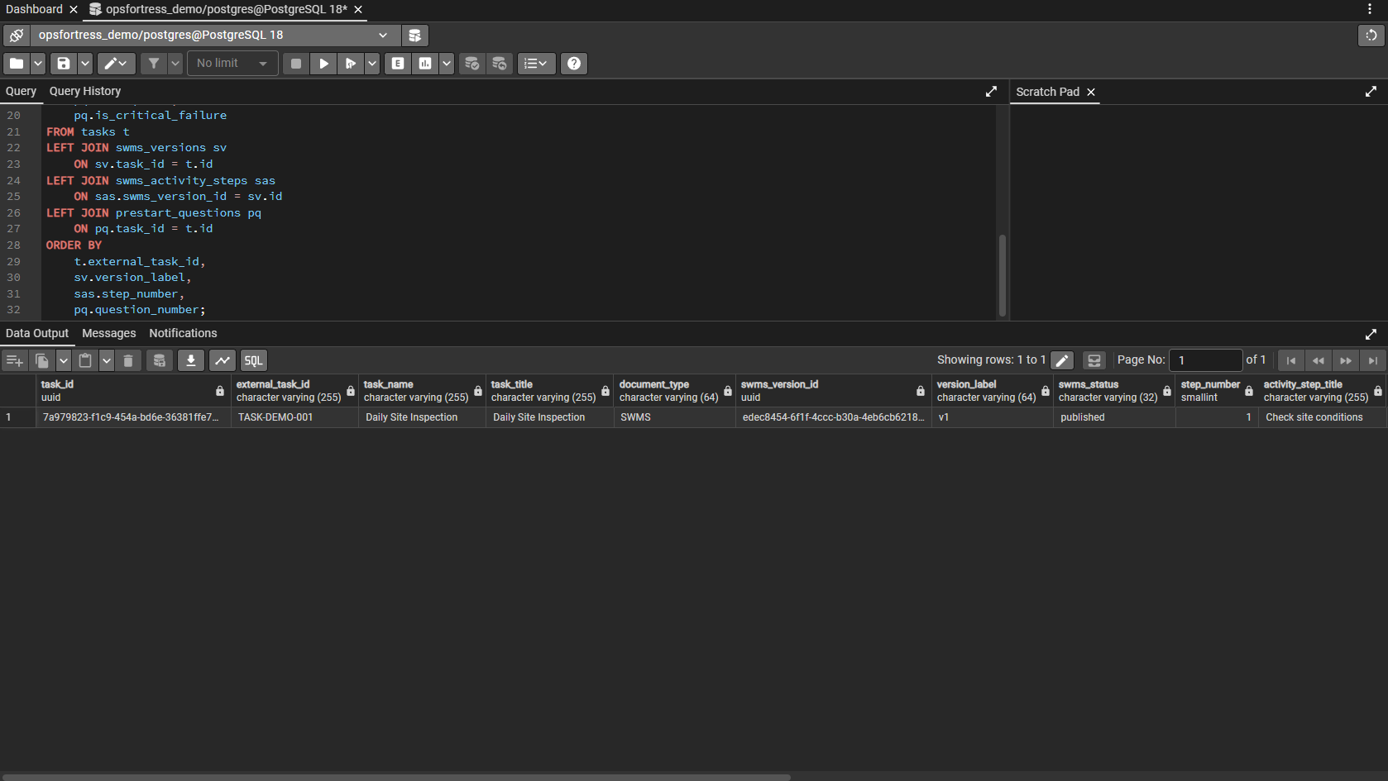
Figure 8 - Demo task connects to SWMS version and activity step.
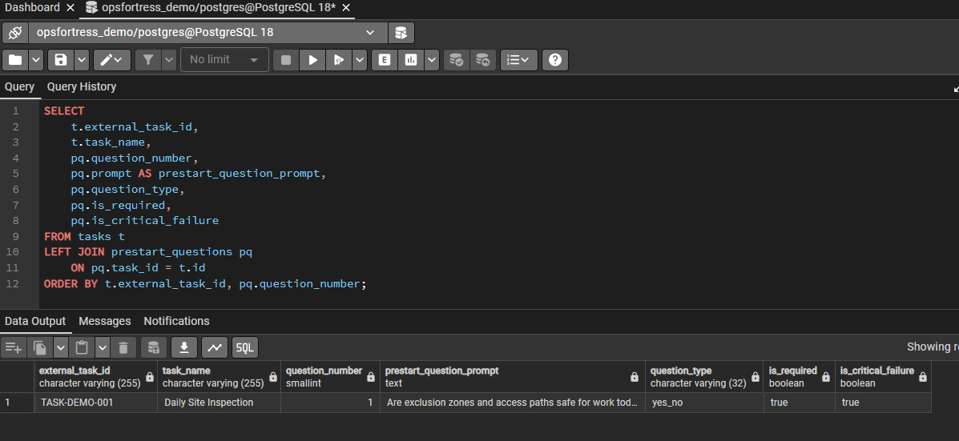
Figure 9 - Demo task connects to pre-start question and validation fields.
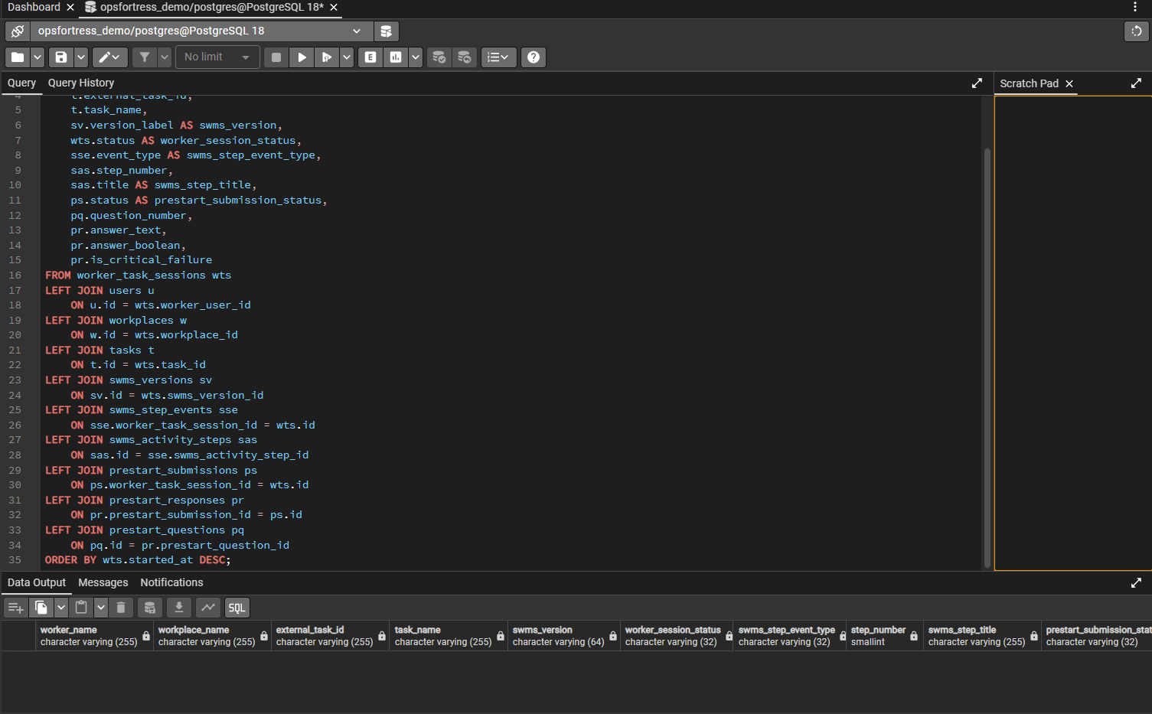
Figure 10 - Runtime chain query runs, but no runtime rows are present in seed data.
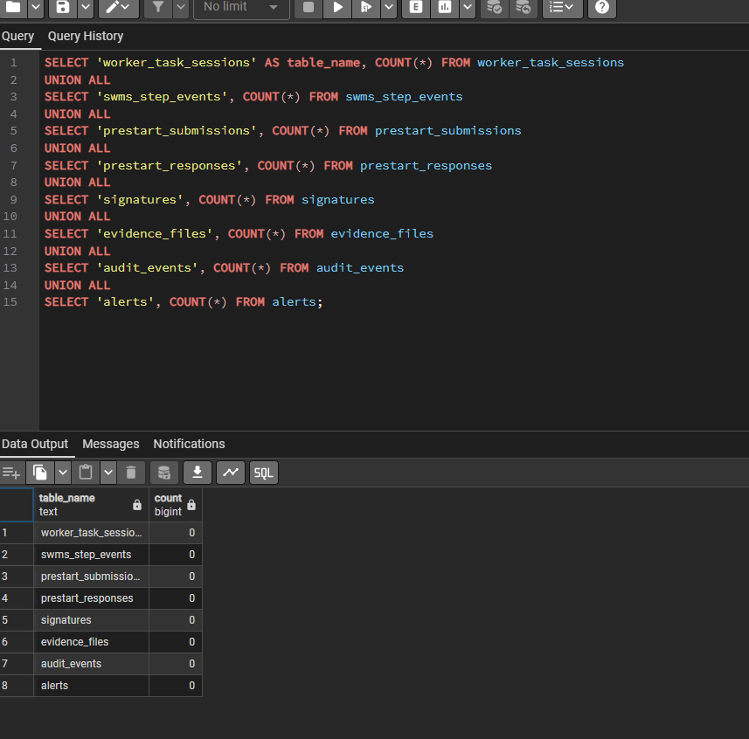
Figure 11 - Runtime/evidence/audit row counts are currently zero.
Part 4 conclusion
The P0 master-data and content relationships pass initial validation. The full worker action -> event record -> response/evidence/audit chain still needs to be validated later with demo runtime data or real worker app activity.

Part 5 - Imported Data vs App-Generated Data
This section confirms that the database separates data into three clear groups: imported content, real worker activity, and importer tracking records.
Data Group | Created By | Examples | Current Result
Imported WHS/SWMS content | Python-generated Excel and Laravel importer | tasks, SWMS versions, activity steps, pre-start questions, industries, occupations, access rules | Minimal seed data exists
Worker activity data | WHS App runtime | worker sessions, SWMS step events, pre-start submissions/responses, signatures, evidence, audit events, alerts | Currently empty
Importer tracking data | Laravel importer | import batches, source files, validation results | Currently empty

Key rule
The importer should bring in fixed WHS/SWMS content only. Worker activity data should be created by the app when workers actually use it. The importer should also create its own tracking records.

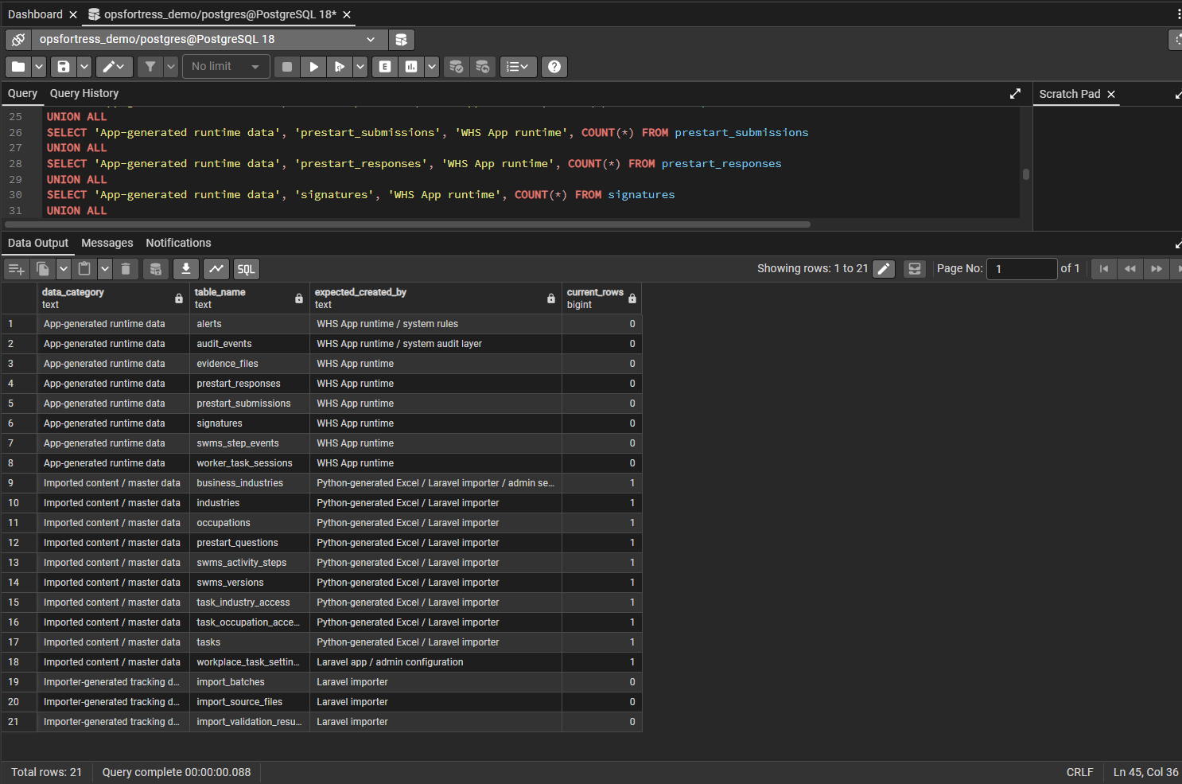
Figure 12 - Row count query confirms the separation between imported content, app-generated runtime data and importer tracking records.

Part 6 - JSON Schema / Python / Importer Validation Requirements
The database review confirms that the future content workflow needs clear validation gates before data reaches PostgreSQL. The AI prompt should generate structured content, but JSON Schema, Python and the Laravel importer should control structure, consistency and database readiness.
Layer | Main Responsibility | Should Validate
Gold benchmark prompt | Generate WHS/SWMS content | Content quality, task wording, hazards, controls
Structured JSON | Hold AI output in machine-readable format | Task, activity, question, industry and occupation structure
JSON Schema | Check AI output before Python | Required fields, correct data types, valid structure
Python layer | Validate data and generate final Excel | Sheet names, columns, IDs, relationship rules
Importer-ready Excel | Final file submitted to importer | Fixed workbook framework
Laravel importer | Final check before database write | Required sheets, FK matching, duplicates, validation results
PostgreSQL | Store validated data | Final source of truth

Validation Area | Rules
JSON Schema | Check that AI output is structured, complete and machine-readable. Validate task ID, title, document type, activities, hazards, controls, pre-start questions, industry path, occupation/role path, required fields and data types.
Python | Generate the final framework-compliant Excel workbook. Enforce fixed sheet names, column names, column order, required fields, ID format, unique task IDs, relationship rules, allowed values and data types.
Laravel importer | Act as the final database gatekeeper. Check required sheets/columns, duplicates, foreign key resolution, industry/occupation mapping, validation results, and block failed imports.

Database-side Requirement | Reason
Task must have a unique external ID | Needed to import into tasks
SWMS version must link to a task | Required for swms_versions.task_id
Activity steps must link to SWMS version | Required for swms_activity_steps.swms_version_id
Pre-start questions must link to task | Required for prestart_questions.task_id
Industry and occupation mapping must be valid | Required for access control
Runtime tables must not be imported from Excel | They should be generated by app use
Import batches must be recorded | Needed for traceability
Failed validation must stop import | Prevents bad data entering PostgreSQL

Main rule
AI generates content. Python controls the Excel structure. The Laravel importer protects the database.

Overall Conclusion & Next Steps
The v0.3 database migration is a strong foundation for the OpsFortress / WHS App workflow. The local database has been created successfully, the Laravel migrations ran successfully, and the main P0 areas are covered. The core master-data and content relationships are working, and the database now shows a clear boundary between imported content, app-generated runtime data and importer-generated tracking records.
The main limitation is runtime validation. The runtime and evidence tables exist, but they currently contain no seed data. These will need to be tested later using demo runtime data or real worker app activity.
Open Point | Reason
Confirm audit_events design | Need to know whether audit_events uses a generic reference model or needs direct worker_task_session linkage
Add demo runtime data | Needed to test the full worker journey
Confirm first importer scope | Need to know whether first demo is P0 only or includes post-task/training
Review Kevin sample workbooks | Needed to compare sheet names, column order, IDs, required fields and relationship structure
Define first locked Excel framework | Needed for Python generation and importer validation
Convert Part 6 requirements into implementation rules | Needed for JSON Schema, Python checks and Laravel importer logic
Recommended Next Step | Owner / Purpose
Confirm open database design points with Yiming | Database and audit traceability alignment
Use Kevin sample workbooks for comparison | Validate sheet names, columns, IDs and relationships
Define the first importer-ready Excel framework | Create the Python output target
Build Python validation rules | Enforce framework and database requirements
Build or confirm Laravel importer command | Load validated Excel into PostgreSQL
Test one full workbook import | Confirm end-to-end import flow
Add demo runtime data | Validate worker action -> event record -> evidence/audit flow

