1.Summary statistics:
In A vs D, the number of upregulated gene is 365 and down regulated gene is 653. In G vs D upregulated gene number is 833, down regulated gene is 1202. The p value is set at 0.05 and the log2FoldChange value is >1 and <-1. The summary of p-value and logFC shows in the picture below.
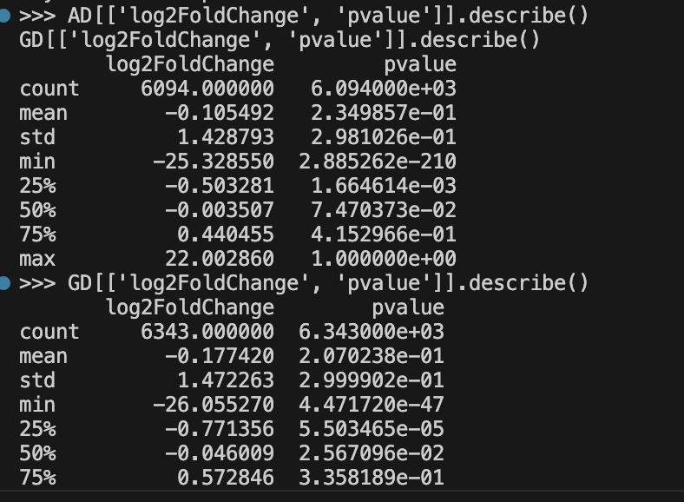
Figure1: The summary of p-value and logFC

Plots:
Volcano plots:
The plots display the relationship between statistical significance (−log10 adjusted p-value) and the magnitude of expression change (log2 fold change). Significantly upregulated genes appear on the right, while downregulated genes are located on the left.
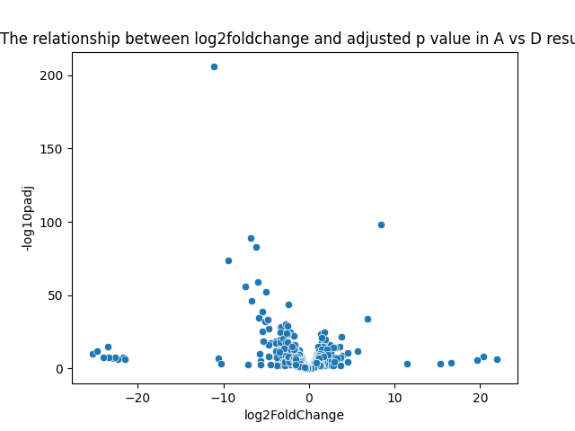
Figure2: Volcano plot for A vs D
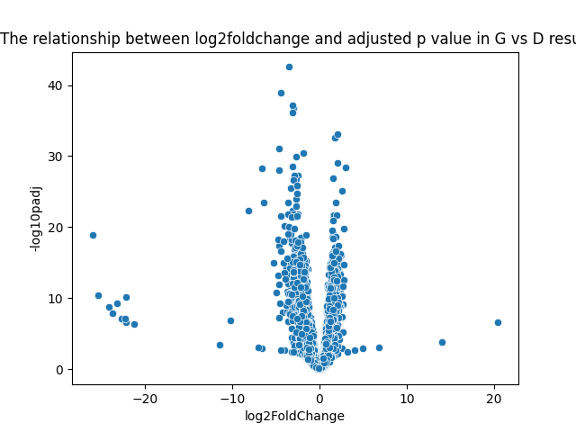
Figure3: Volcano plot for G vs D

MA plots:
The pictures below show the MA plot in both A vs D and G vs D. Green dots mean the gene is upregulated, red dots mean the gene is downregulated.
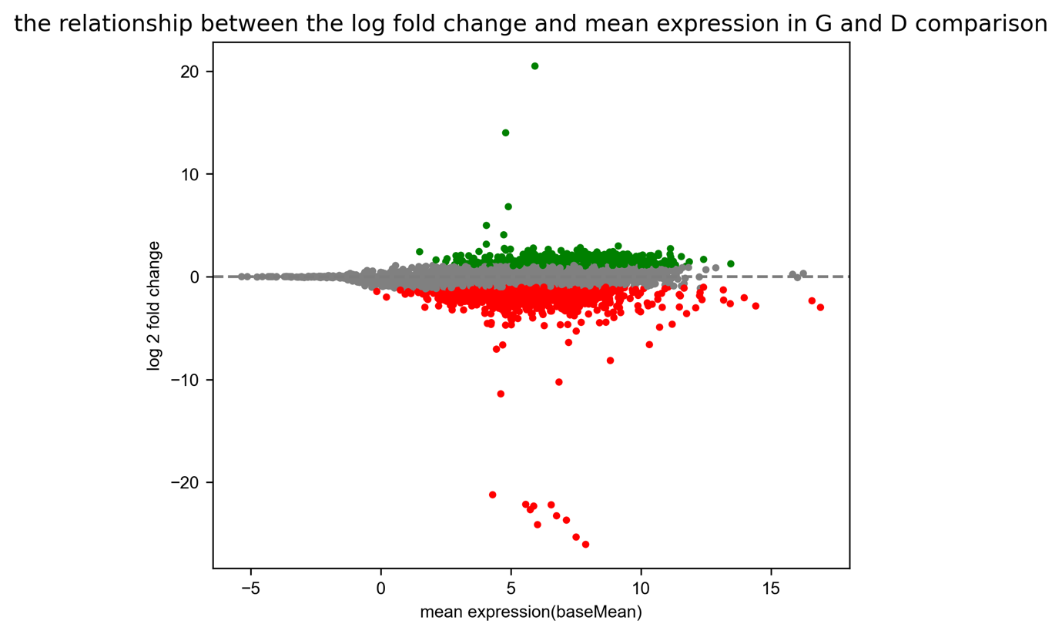
Figure4: MA plot for A vs D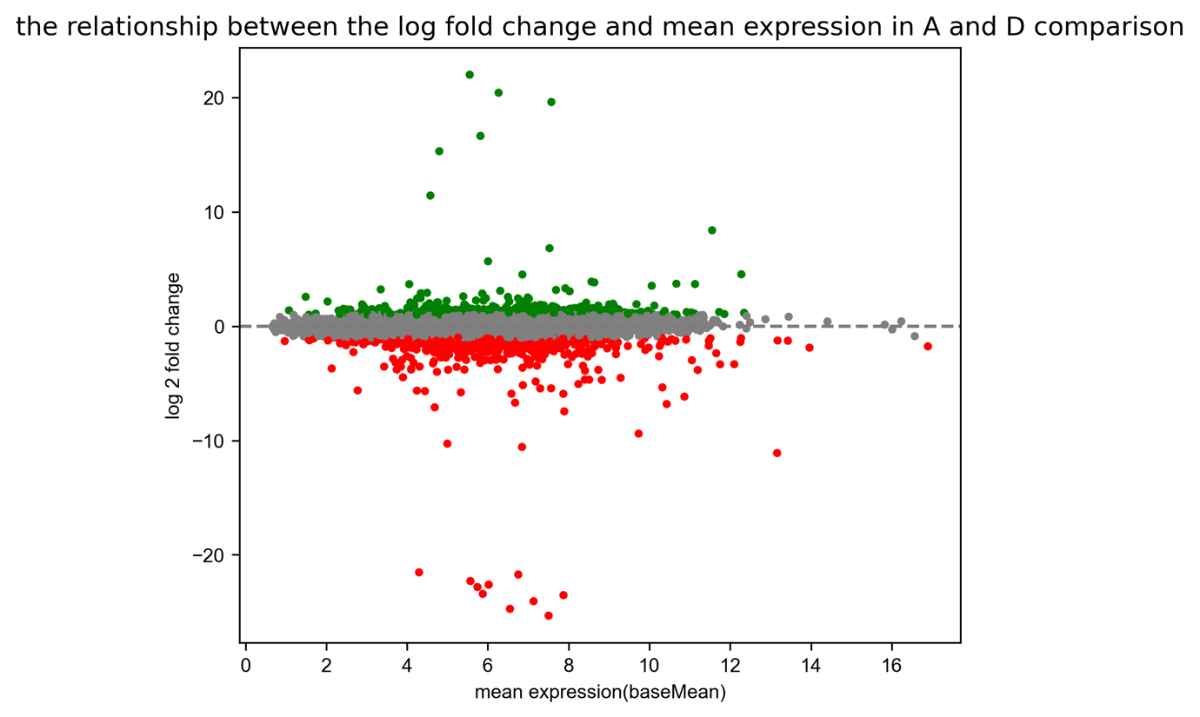

Figure5: MA plot for G vs D
Histogram:
The pictures below show the histograms for A vs D and G vs D. They can show the distribution of statistical significance.
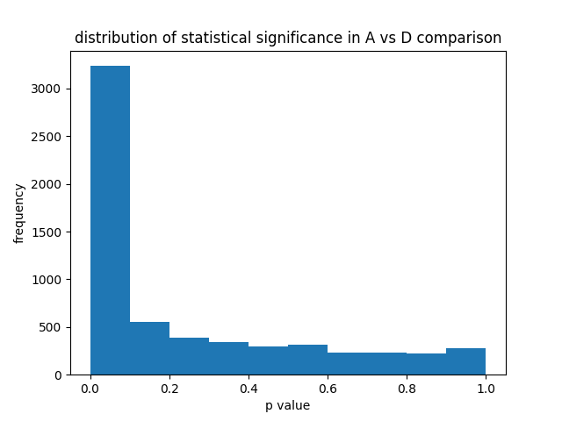
Figure6: Histogram of p-value for A vs D
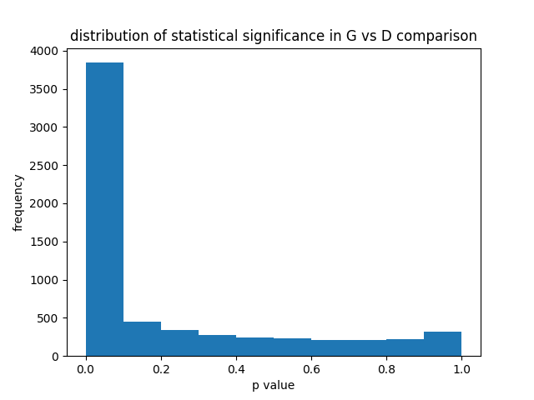
Figure7: Histogram of p-value for G vs D

Heatmaps:
The heatmaps present the expression patterns of the top 30 expressed genes based on log2 fold change.
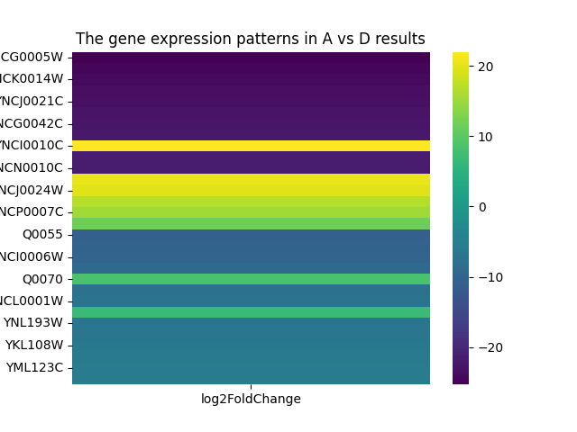
Figure8: Heatmap for A vs D.
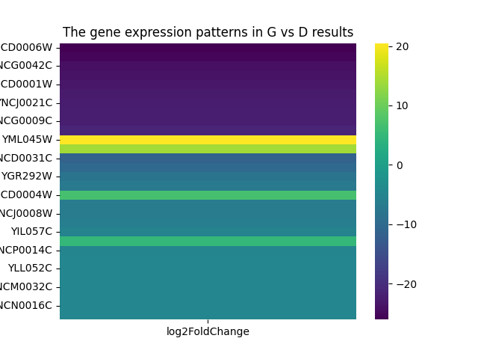
Figure9: Heatmap for G vs D.

Tables:
The image below shows a portion of the table (the remaining tables are attached as CSV files in the folder because they are too large). The tables show the significantly upregulated and downregulated genes with their corresponding fold changes, p-values, and adjusted p-values.
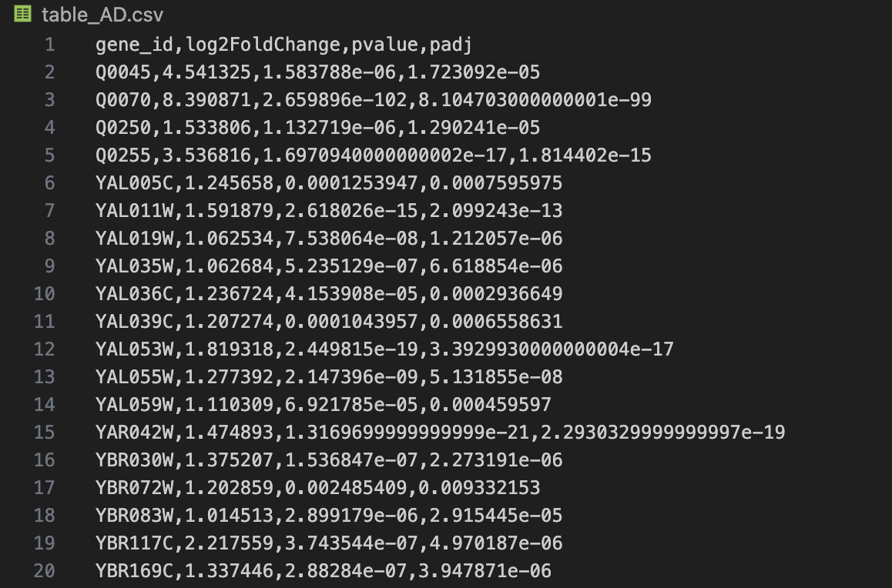
Figure10: Example of significantly upregulated and downregulated genes in A vs D.
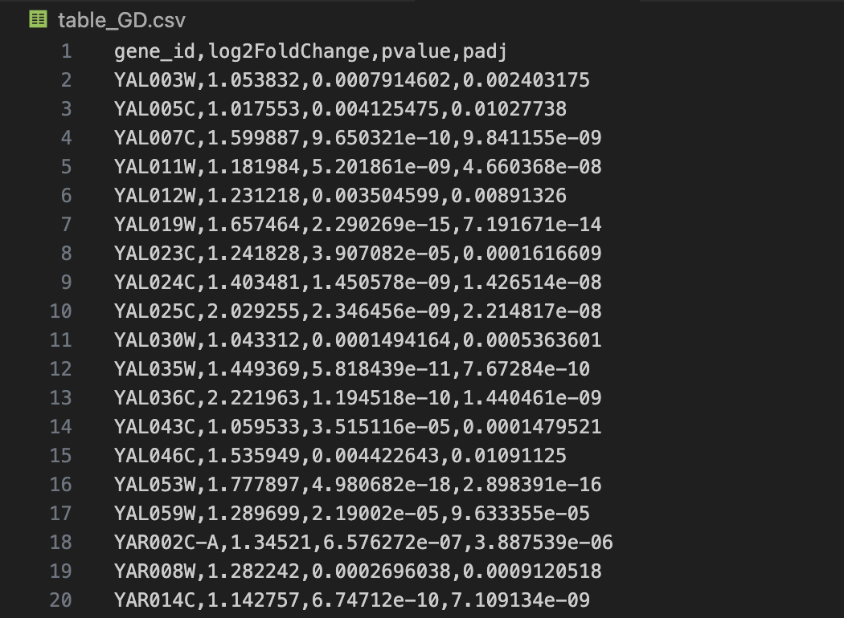
Figure11: Example of significantly upregulated and downregulated genes in G vs D.

Additional analysis:
Clustering:
The picture below shows the clustering map for the top gene expression in both A vs D and G vs D groups, based on the log2foldchange value.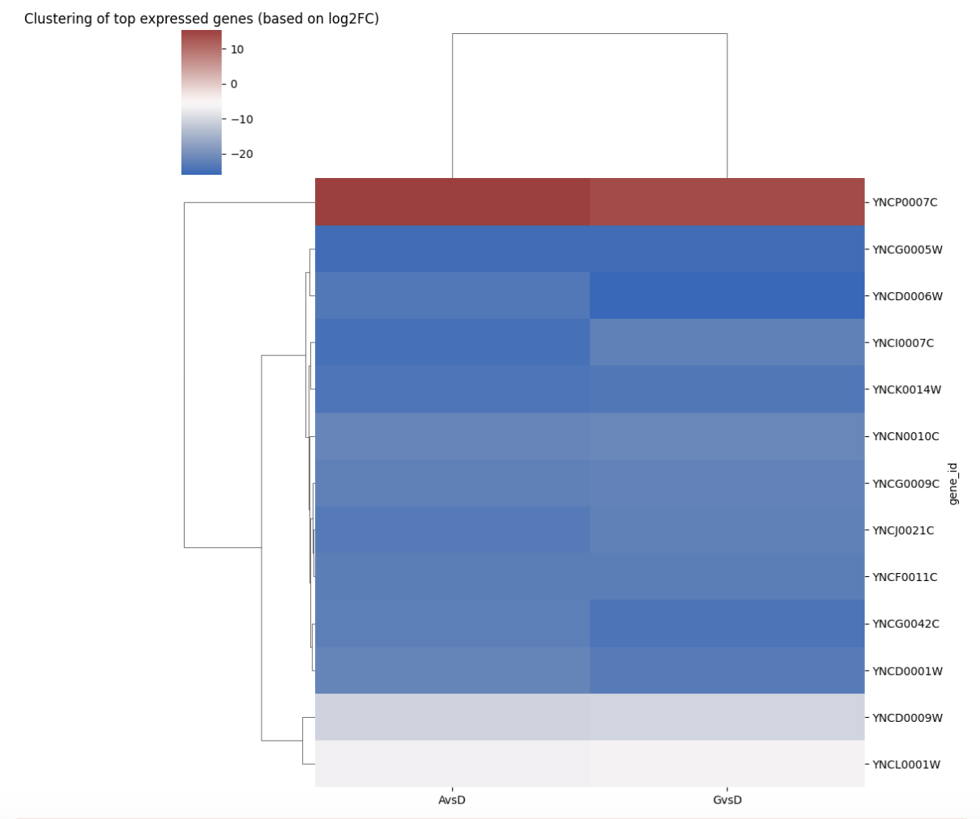
Figure12: Clustering map of top differentially expressed genes.

Pathway:
Using GO_Biological_Process_2023 as the database and yeast as the organism, it shows that no GeneSets are valid, this is likely due to yeast gene ID format mismatches.

