2. The heaviest pumpkin is 2947.032 lbs, Pastorelli, Bruna, growth from Radda in Chianti,Tuscany,Italy in 2021.
5. The relationship between the estimated weight and actual weight of the pumpkins.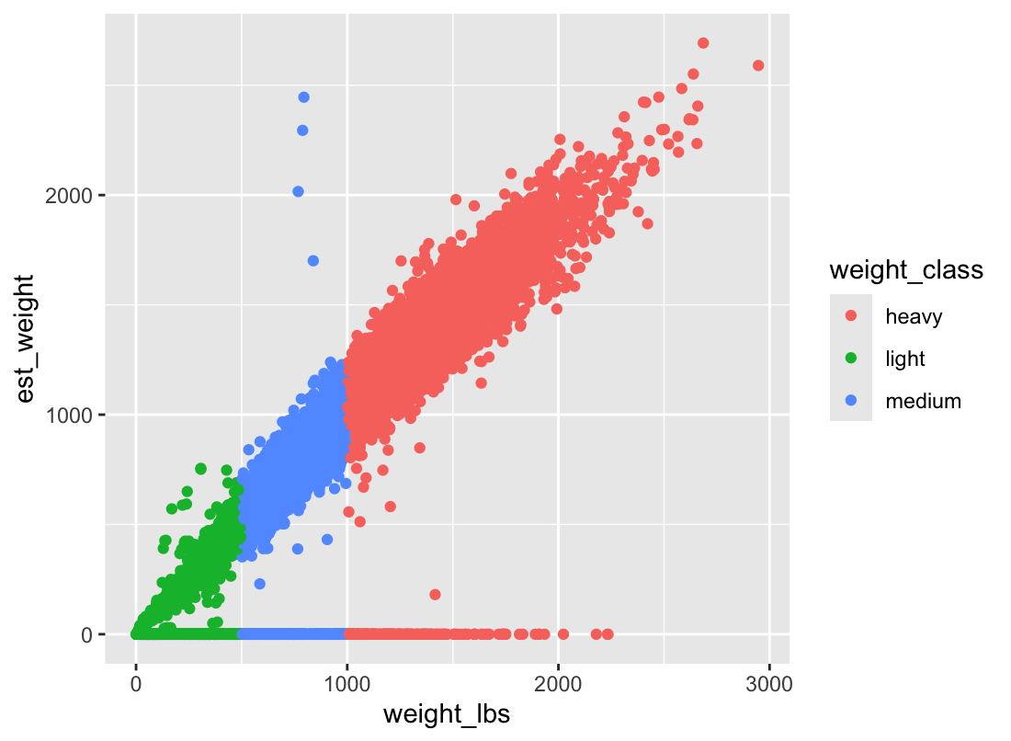
Figure1: The relationship between real weight and estimated weight

7. a. Mean weight: Australia-179lbs, Austria-608lbs, Belgium-1077lbs. Belgium is the highest mean weight. b. Australia Autumn Gold had the lowest mean weight.

8. pumpkin weight distributions (in lbs) for three selected countries as a boxplot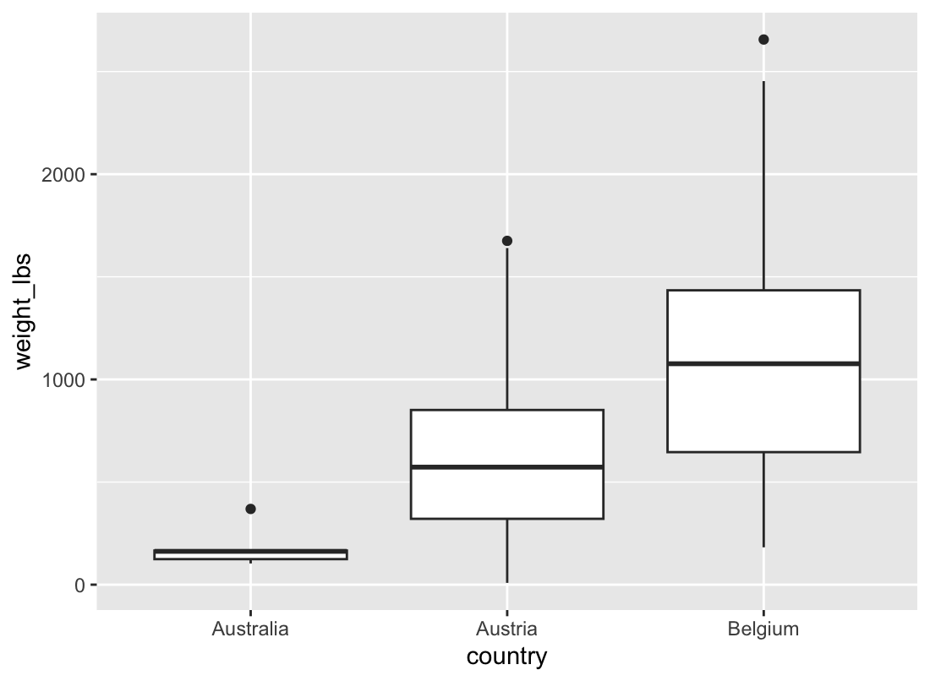
Figure2: Relationship between average pumpkin weight in different countries in boxplot

9. facet plot showing the data from each variety of pumpkin as a separate sub-plot
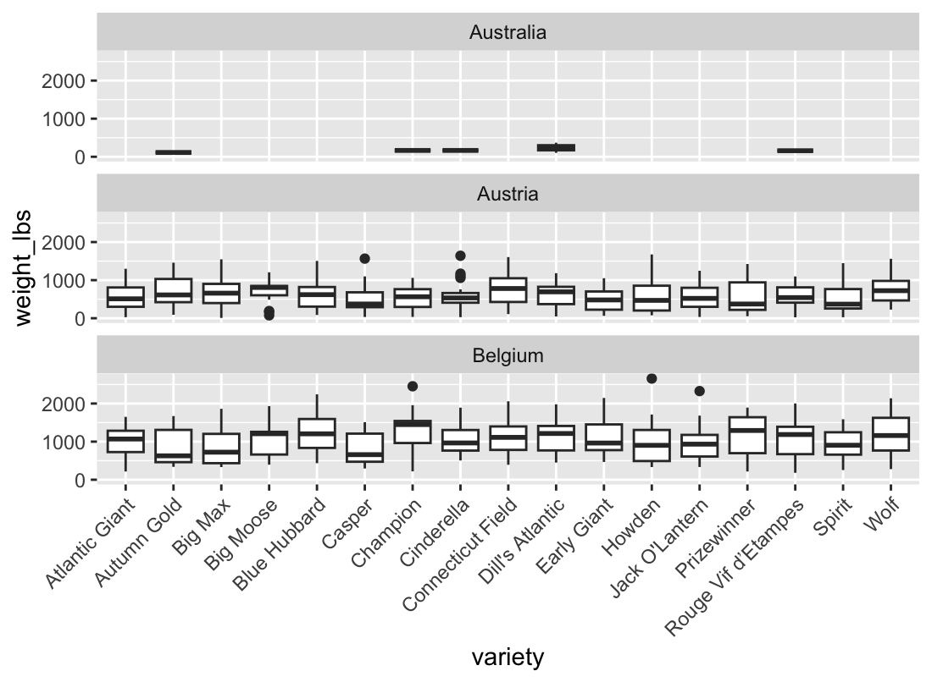
Figure3: The relationship between different varieties and weight varies in different countries.

