Game Design Document

Fill up the following document

1. Write the title of your project.

Ans: Bunny Maze

1. What is the goal of the game?

Ans: The goal of the game is to make the bunny move in the maze to collect the carrot.

1. Write a brief story of your game.

Ans: The story is about a bunny who is hungry and reaches a maze at the end of the maze there will be a carrot for the bunny to eat. The bunny will face an obstacle when the bunny is in the maze.

1. Which are the playing characters of this game?

* Playing characters are the ones who respond to the user based on the input from the user.
* Cars, monkeys, dinos, wizards, etc., are the playing characters in the game.

|  |  |  |
| --- | --- | --- |
| Number | Character Name | What can this character do? |
| 1 | Bunny | Move up, down, left and right |
| 2 | Obstacle | Targets the bunny to attack the bunny |
| 3 |  |  |
| 4 |  |  |
| 5 |  |  |
| 6 |  |  |
| 7 |  |  |
| 8 |  |  |

1. Which are the Non-Playing Characters of this game?

* Non-Playing characters are the ones that don't have an action or behavior when the user interacts with the game.
* Hurdles, stones, bananas, coins, etc., are non-playing characters in the game.

|  |  |  |
| --- | --- | --- |
| Number | Character Name | What can this character do? |
| 1 | Coins | The coins are needed to be collected by the bunny |
| 2 | Carrot | The carrot is needed to be collected by the bunny |
| 3 |  |  |
| 4 |  |  |
| 5 |  |  |
| 6 |  |  |
| 7 |  |  |
| 8 |  |  |

Draw your imagination of this game. What does this game look like?

* Draw the game either on your computer or on paper.
* Add images of the game scenes to show each of the playing and non-playing characters at least once.

Ans:

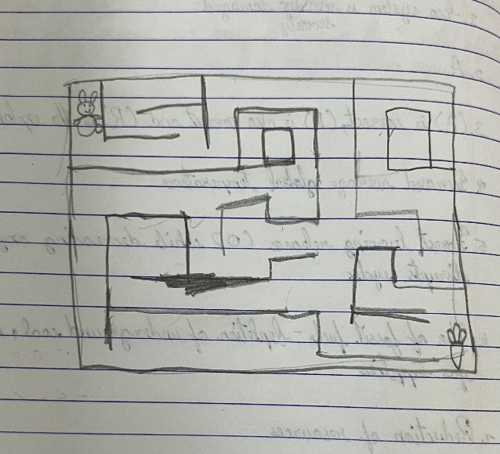

How do you plan to make your game engaging?

Ans: There will be obstacles, the maze is colourful, there will be timer and there will be coins to collect.