# **Apply Filters to SQL Queries**

## **Project Description**

The company I work for is striving to make its system more secure. It is my responsibility to ensure the system's security, investigate any potential security issues, and update employees' computers when necessary. The following steps provide examples of how I have used SQL with filters to perform security-related tasks.

## **Retrieve Failed Login Attempts After Business Hours**

A potential security incident occurred outside of business hours (after 6:00 PM). All failed login attempts outside of business hours must be investigated.

The following code shows how I created an SQL query to filter failed login attempts outside of business hours.

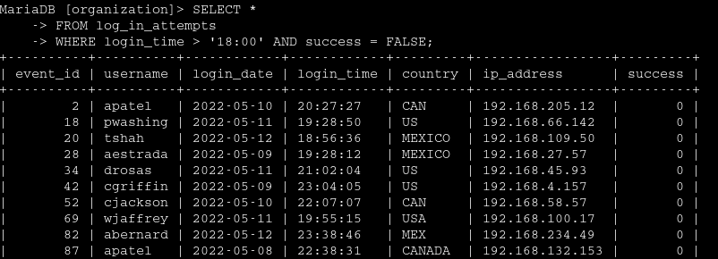

The first section of the screenshot corresponds to my query, and the second section represents a fraction of the output. This query filters the failed login attempts that occurred after 6:00 PM. I started by selecting all data from the log_in_attempts table. Then, I used a WHERE clause combined with the AND operator to filter my results to only include login attempts that occurred after 6:00 PM and that were unsuccessful. The first condition is login_time > '18:00', which filters for login attempts that happened after 6:00 PM. The second condition is success = FALSE, which filters for failed login attempts.

## **Retrieve Login Attempts on Specific Dates**

A suspicious event occurred on 09/05/2022. Any login activity on 09/05/2022 or the day before must be investigated.

The following code shows how I created an SQL query to filter login attempts that occurred on specific dates.

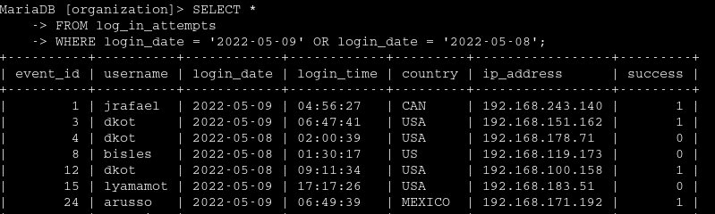  
The first section of the screenshot corresponds to my query, and the second section represents a fraction of the output. This query returns all login attempts that occurred on 09/05/2022 or 08/05/2022. I started by selecting all data from the log_in_attempts table. Then, I used a WHERE clause combined with the OR operator to filter my results to only include login attempts that occurred on 09/05/2022 or 08/05/2022. The first condition is login_date = '2022-05-09', which filters for logins made on 09/05/2022. The second condition is login_date = '2022-05-08', which filters for logins made on 08/05/2022.

## **Retrieve Login Attempts Outside of Mexico**

After reviewing the company's data regarding login attempts, it seems the issue lies with login attempts that occurred outside of Mexico. These login attempts need to be investigated.

The following code shows how I created an SQL query to filter login attempts that occurred outside of Mexico.

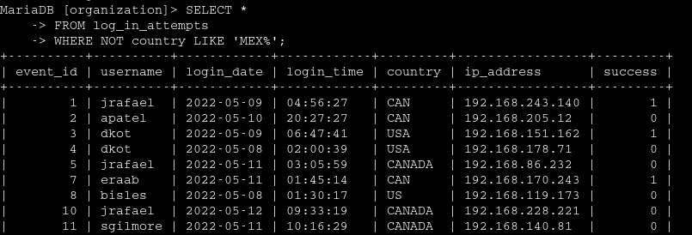

The first section of the screenshot corresponds to my query, and the second section represents a fraction of the output. This query returns all login attempts that occurred in countries other than Mexico. I started by selecting all data from the log_in_attempts table. Then, I used a WHERE clause combined with the NOT operator to filter countries other than Mexico. I used LIKE combined with MEX% as the matching pattern, because the dataset represents Mexico, such as MEX and MEXICO. The percentage symbol (%) matches any number of unspecified characters when used with LIKE.

## **Retrieve Marketing Department Employees**

My team wants to perform updates on the computers of certain employees in the marketing department. To do this, I need to obtain information to determine which computers need to be updated.

The following code shows how I created an SQL query to filter the computers of marketing employees located in the East building.

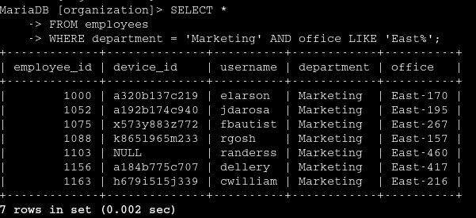

The first section of the screenshot corresponds to my query, and the second section represents a fraction of the output. This query returns all marketing department employees located in the East building. I started by selecting all data from the employees table. Then, I used a WHERE clause combined with the AND operator to filter employees who work in the marketing department and are in the East building. I used LIKE combined with East% as the matching pattern because the data in the office column corresponds to the East building with a specific office number mentioned. The first condition is the segment department = 'Marketing', which filters marketing department employees. The second condition is the segment office LIKE 'East%', which filters employees located in the East building.

## **Retrieve Employees from the Finance or Sales Departments**

The computers of employees in the finance and sales departments also need to be updated. Since a separate security update is required, I need to gather information to determine only employees working in these two departments.

The following code shows how I created an SQL query to filter the computers of employees from the finance or sales departments.

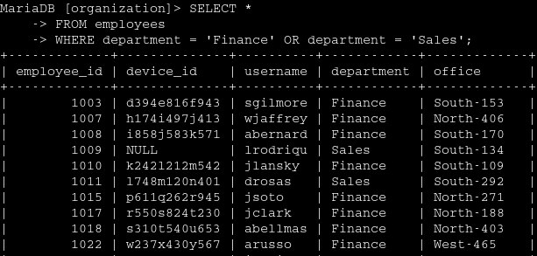The first section of the screenshot corresponds to my query, and the second section represents a fraction of the output. This query returns all employees from the finance and sales departments. I started by selecting all data from the employees table. Then, I used a WHERE clause combined with the OR operator to filter employees from the finance and sales departments. I used the OR operator rather than AND because I want to retrieve all employees working in either of these departments. The first condition is department = 'Finance', which filters employees from the finance department. The second condition is department = 'Sales', which filters employees from the sales department.

## **Retrieve All Employees, Except Those Working in the IT Department**

My team needs to perform an additional security update on the computers of employees who are not in the IT department. To do this, I first need to gather information to determine which employees are affected.

The following example shows how I created an SQL query to filter the computers of employees who are not part of the IT department.

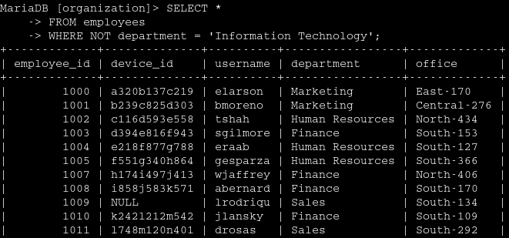The first section of the screenshot corresponds to my query, and the second section represents a fraction of the output. The query returns all employees who are not part of the IT department. I started by selecting all data from the employees table. Then, I used a WHERE clause combined with the NOT operator to filter employees who are not part of this department.

## **Summary**

I applied filters to SQL queries to retrieve specific information about login attempts and employee computers. I used two different tables: log_in_attempts and employees. I used the AND, OR, and NOT operators to filter the specific information needed for each task. I also used LIKE and the percentage symbol (%) to filter patterns.