A general model of genomic coefficients of relatedness.

Matthew Ackerman, Parul Johri, Ken Spitze, Micheal Lynch.

Abstract:

General Introduction : Relatedness, population genetics, ?.

Some phenotypes are the results of simple, single locus genes, however, many phenotypes result from complex genotypic and environmental interactions. The goal of quantitative genetics is frequently to partitioning phenotypic variation into genetic additive, dominance, and epistatic components and environmental components. (Lynch and Walsh 1951). These ? are the lowest order terms that appear in a linear regression of known phenotypes onto individuals with a known relatedness. The two most important components of the regression are the coefficent of coancestory () and the coefficent of cofraternity (). Knowlage of these two coefficient allow genetic variance to be partitioned into additive and dominance variation using the equation where sigma A squard is the additive genetic variation and sigma D squared is the dominance genetic variation.
Estimates of relatedness can be obtained either through path analysis of pedigrees (Wright 1922) or the analysis of molecular markers (Lynch and Ritland 1999, Wang 2002, Fernández and Toro 2006, Kalinowski et al. 2006, Wang 2007, Anderson and Weir 2007, Wang 2011). However, existing methods for estimating relatedness from molecular markers suffer from a number of problems. Either restrictive assumptions about allowed relationships, typically an assumption of no inbreeding (Lynch and Ritland 1999 or Wang 2002) are made, the analysis is computationally intractable for large data sets (Fernández and Toro 2006), or . . .
These pedigree based measures were later reinterpreted as measurements of the probability that alleles shared between individuals were identical by decent (IBD) (Malèécot, 1948, Cockerham 1971). Thinking of relatedness in this fashion made it clear that the probability that two individuals shared some genotype different 'modes' of Figure 1. Defining relatedness as a probability limits estimates of relatedness to the interval of zero to one, and methods of inference that limit estimated probabilities to the interval of zero to one have been developed (Li et al. 2011). If no negative relatedness exist then the expected or average relatedness within a population can never be zero (since some individuals within a population are have positive relatedness). However, relatedness can also be viewed as a property of the correlation of the genotypes of two individuals (Lynch and Ritland 1999). While the genotypes of individuals can be uncorrelated on average, providing an obvious interpretation for unrelatedness, the correlation of the genotypes may arise from factors other than shared ancestor (Rousset 2002), meaning that when relatedness is thought of as a covariance or regression it does not strictly give information about shared ancestry. However the the correlation definition of relatedness has several desirable properties that ...
Additionally genetic variation often has an appreciable component of geographical structure. ...
Traditional treatments of relatedness have emphasize the expectations of statistical distributions, but because each round of reproduction involves a limited number of recombination events, typically on the order of one event per chromosome arm, the actual pattern of inheritance can very substantially from the expectation (Speed and Balding 2015). For instance, a pair of human half siblings have an expected relatedness of 0.125, but the 5% of half siblings will have a relatedness less than 0.092 or greater than 0.158 (Speed and Balding 2015).
With these facts in mind we seek to develop a set of summary statistics describing relatedness that 1) are computationally tractable, unbiased estimation that are robust to population stratification 2) sufficient, meaning that estimates of the joint genotype distribution can be recovered from the statistics, so that any other summary statistic describing relatedness can be calculated from these summary statistics 3) ....

Statistical introduction:

Random variables and co-variance, co-skewness, and co-kurtosis coefficients:
Diploid individuals are created from the fusion of two haploid gametes, so a comparison of two diploid individuals involves the comparison of four haploid gametes. If we treat the genotype of a gamete as a random variable, that is a variable whose value is sampled from some probability distribution rather than a variable representing some unknown but fixed quantity, then we can explore how the genotypes of each of the four gametes with the genotypes of any of the three other gametes are associated. Our first step in this process is choosing a probability distribution to model the genotypes of gametes. The most simple distribution that we can choose is the Bernoulli distribution, a distribution that takes on a value of 1 (often times called a 'success') with probability and a value of 0 (often times called a 'failure') with probability 1-. In the case of the genotype of a gamete a 1 or a success could represent the gamete possessing a common genotype, which we will sometimes call sampling the major allele, and a 0 or failure could represent possessing an infrequent genotype, which we'll call sampling the minor allele. Here the probability of success () can also be called the exception or mean of the distribution, and it represents the frequency of the major allele in the population from which a gamete was sampled.
We can then use this simple model to describe the four possible genotype of two gamete, which we will refer to as and : sample the major allele in both gametes, in but not , in but not , or in neither gamete. The probabilities of these four out-comes can be specified by three parameters : the frequency of the major allele in the population from which was sampled, the frequency of the major allele in the population from which was sampled, and the correlation of and . The correlation of and is a traditional measurement of the relatedness of and . … Because we do not require the major alleles in gamete and gamete to have been sampled from the same population this same formulation can also be used to describe the correlation between genotypes at two different locations within the same gamete. Used in this way the correlation coefficient is described as a measure of the linkage disequilibrium between two locations (loci) in the genome, rather than as a measure of the relatedness between two gametes.
Where the term terms describe the cumulants of the distributions. Cumulants are the coefficients of a Taylor expansion of a cumulant generating function around 0, and a Taylor expansion is simply (). represent the cumulates of the distribution and , and is simply an alternative way of expressing the … which may be …

Continuing in this way we can consider the statistical description of the association between three gametes (or between three different locations within a single gamete or any other combination of three Bernoulli distributed random variables). As before we will have three parameters representing the probability of sampling a major allele in each of the three gametes and again we will have a correlation coefficient describing the relatedness of the gametes. For three gametes we will have a total of three relatedness coefficients and three means. However, these six parameters are insufficient to specify the probabilities of the eight different outcomes. We will need one additional parameter. The co-skewness is a natural choice for this parameter, since it is the lowest moment of the joint distribution which gives us additional information, and in fact (). Skewness is a measure of the asymmetry of a probability distribution, that is whether values in the distribution have a tendency to be either larger (for positive skewness) or smaller (for negative skewness) than the mean. Co-skewness represents a tendency of the jointly distributed variables to simultaneously take over values on the same (for positive) or different (for negative) sides of the means of each individual distributions. However co-skewness differs from a correlation coefficient, in that while the correlation coefficient of a random variable with itself is always 1, the co-skewness of a random variable with itself is simply the skewness of the random variable. Ultimately we would like to use a parameter which exhibits the desirable property of taking on a value of 1 when a varaibale is compared to itself and zero whenever any of the variables are independent of each other. To obtain this we introduce, which is a measure of the coefficient...

Figure 1. The haploid gametes and (represented by arrows) compose the diploid individual (represented by a circle), and the gametes and compose the diploid individual .
0 when any of the three componenents are independent of each other, 1 when the three componenets are identical to each other, -1 when
(Equation 1)

In the
(Equation 2)
Finally we can consider the statistical association of the four gametes that define diploid individuals. Between four Bernoulli distributions there are four means, six covariances, and four co-skewnesses, but an additional fourth order moment, a co-kurtosis () are is needed for a sufficient description of the joint distribution. In terms of a diploid individual two of the correlations coefficients describe inbreeding () (the correlation coefficents of the two gametes which fused to from the diploid individuals). The average of the four remaining correlation coefficients define the traditional measure of relatedness (). The four third order co-skewness coefficients (), are averaged into two statistics we dub inbred-relatednesses coefficients, and the fourth order moment we dub the zygosity correlation coefficient (). These six terms fully describe the joint distribution of genotypes of a pair of diploid individuals when the maternal and paternal origin of alleles are not considered.

When more than two alleles are considered, the full relatedness model can be recovered, however, . . .
Diploid individuals:
When describing gametes we will use the lower case letters , , or , and when describing diploid individuals we will use the uppercase letters or , as depicted in figure 1. So, for instance, we represent the relatedness of the gametes and as , and the relatedness of diploid individuals and as . We will continue to treat genotypes as random variables that take on value of 0 or 1 for gametes, and now we will consider the random variables and which are defined in terms of the haploid gametes we have already considered. The genotype of individual is expressed as the mean of the values of the two gametes and which fused to create individual : , and in the same way we will define the genotype of the second individual as . Additionally, since we are explicitly considering the case where the two gametes that compose each diploid individual cannot be distinguished from each other we will assume and , though it is not necessarily the case that ....

Figure 3. ...
Since is Bernoulli distributed with expectation its variance is . The variance of is where is the covariance between a and b. The inbreeding of individual , , is the product-moment correlation coefficient between a and b:

. (3)

We can obtain from if we assume that :

, (4)
and similarly
. (5)

Where and are the expectation of the squared genotypic value, and are generally not equal to the square of the expectation of the genotypic value (i.e ).

The covariance of the genotypes between individuals is the average of the covariances for each haploid genome: . If we again assume that the gametes which produced individual both originated from the same population, so that , and make the same assumption for individual , so that , then we can obtain the relatedness for the to diploid individuals, remembering that the denominator depends on the variance of genotypes in the gametes and not the variance of genotypes in the diploid genomes:

. (6)

The inbred-relatedness coefficient is defined as:
(7)

.
Where is the skewness of a Bernoulli distributed random variable and is . The expression is the standardized co-skewness of , , and . It has a very similar form to the product-moment correlation coefficient used to describe relatedness.
We define the measurement inbred-relatedness in diploid individuals as the average inbred-relatedness of each of their haploid genomes, so . If we again assume that and we can obtain:

(8)
and
(9).

Similarly for zygosity coefficient we can define co-kurtosis of the haploid genomes as :

and by assuming that and and dividing by the maximum co-kurtosis we obtain:
(10)

where is the kurtosis of the Bernoulli distribution, and is .
These measures can be related to the nine condensed modes of IBD (?) in the following way:

The final term, , cannot be expressed in terms independent of the allele frequencies and since the S₂ and S₇ are dependent on different powers of allele the frequency. While this may seem unfortunate, it allows us to obtain separate estimates of and , so long as loci with different allele frequencies are included in our data. The terms , and can be recovered, but , no other terms can be fully isolated.
Genetic thing:

The genetic covariance is defined as

Figure 2. A diagrammatic representation of additive dominance effects.
The dominance deviation of an individuals phenotype, unfortunately represented as equal to the IBD mode of in an outbred population, is given by the zygosity corelation coefficient: , thus inbreeding dramatically increases the shared dominance deviation of individuals over the . Interestingly we do not recover a parameter that is independent of allele frequency ...

The behavior and biological significants of the statistics :

Correlation between gametes produced by the same individual:

The correlation coefficient between two gametes, a and b, produced by individuals A and B is :

(Equation 11)

The co-skew coefficient of the gametes a, b and c, produced by individuals A, B and C is :

And the co-kurtosis coefficients of the gametes a, b, c and d produced by individuals A, B, C and D are :
(Equation 12)

(Equation 13)

Finally all the coefficients relating an individual to itself can all be expressed in terms of the inbreeding coefficient of that individual :

The iterative method of calculating this coefficients:

These coefficients can be calculated from known pedigrees using the provided “pedigree_calc.py” python script.

Calculating the probability of genotypes:
An important step in obtaining unbiased estimates of the relatedness of individuals is the correct calculation of the probability of genotypes. This takes ...

Numerical estimation of parameters:
The seven components of relatedness were estimated by maximizing a likelihood equations on the observed data.

Maximized by a multivariate secant method.
This method was implemented in the program mapgd, which was also used to estimate allele frequencies and sequencing error rates.

Simulations:
A python script was used to simulate genomic sequences at coverages of 3 and 10x coverage with error rates of 0.001. Two separate kinds of simualtion where then performed: a set of simulation when the true value of allele frequencies was known and a set of simulation where allele frequenceis were estimated form samples of 10 or 100 individuals. The relatedness of individuals in the sample was varied to study the effects of … . The program mapgd was used to obtain estimates of both allele frequencies and relatedness. Allele frequency estimates are obtained by a maximum likelihood method similar to that outlined in [CITATION]; however, the parameters are initialized from a heuristic assessment of the genotypes in the sample, rather than the method of initilization outlined in [CITATION]. Additionally a goodness of fit test was used to exclude sites demonstrating a poor fit to the estimated parameters. A more detailed explanation of the allele frequency estimation algorithm and goodness of fit test are provided in the documentation for mapgd.
The joint probability distribution of genotypes can be undefined at low allele frequencies when relatedness parameters are negative, so the minimum allele frequency used in simulations was either 0.001 or the minimum allele frequency for which genotype frequencies were defined, which ever was larger. The true values for allele frequencies where used in estimating relatedness. A random number of relatedness components (between 0 and 6, inclusive) where chosen to be non zero, and then these components were assigned a random number between -1 and 1.

Simulation Results:
Including related individuals in the data set used to estimate allele frequencies produces a downwardly bias estimates of relatedness, however, if the number of closely related individuals in the data set small...

Daphnia :
Daphnia pulex is a microcrustacean commonly found in ephemeral ponds. They overwinter in dessication resistant ephippia that are produced strictly by sexual reproduction in the case of cyclically parthenogenic Daphnia (cyclicals) or strictly by parthenogenesis in the case of obligate parthenogenic Daphnia (obligates). Cyclicals are expected to display annual, discrete sexual generations, because ephippial production typically happens late in the season, and ephippia are thought to require at least a breif dormancy period before hatching, and hatching is enhanced by a period of cold treatment.
Three samples of 96 Daphnia pulex were isolated from four ephemeral ponds : Kickapond, Portland Arch, Sps, and Busey. Each of these samples were screened using 6 alozyme loci for evidence of a multilocus genotype that would indicate the presence of obligate clones in the sample. Since no multilocus genotype was evident, these populations were sequenced to ~15x average coverage on an Illumina MySeq sequencer. The reads were then aligned to the reference genome (Genome paper) and the program mapgd was used to analyze the data (supplemental methods : analysis of Daphnia data).

Daphnia Results:
Several individuals within each population show significant relatedness to each other. In all populations we recovered several half-siblings (Kickapond:6, Portland Arch:?, Busey:?) , the offspring of irregular first cousins (Kikapond:?, Portland Arch:?, Buse?) and … Overall roughly 13% of all Daphnia within ponds had relationship of second cousin our closer. Over all the three populations of Daphnia show mild, but not significant, inbreeding, , consistent with the ... and consistent with the site estimates of . … Additional, a number of clonally identical individuals were found (Portland Arch:?, Buser:?). By analyzing these populations for markers for asexuality that we had previously uncovered (Tucker et al. 2013, Xu et al. ?), we found that the clonally identical individuals were all asexual . . .
(Vanoverbeke and De Meester, 2010)
Inbreed relatedness coefficients show a strong negative correlation with each other (supplemental figure S2). That is, if individual A is related to individual C at sites where A is inbred, then individual C is typically not related to individual A at sites where C is inbred. This negative relationship is not apparent in the simulated data (supplemental figure S1, blue box). However, these terms each have strong and opposite correlation with the error term (, supplemental figure S1, green box). The error term is present in our equations to account for differences in allele frequencies between the populations from which the two individuals arise, but we cannot correct for difference in allele frequencies between this populations without additional information. If we restricting the analysis to the portion of individuals that show no evidence of population structure, the association is reduces, but does eliminated. It is not clear whether the association arises as an artifact of population structure or whether some biologically significant process may account for the association.
Zygosity coefficients also show a strong negative correlation with each other. That is, if an individual A is related to individual C at sites where A is inbred, then individual C is typically not related to individual A at sites where C is inbred. This association almost certainly arises from the strong correlation of errors in the estimate of zygosity coefficients (supplemental figure S1, red box). While errors are correlated, few of the estimated zygosity coefficients are significant.

What do the numbers mean?
Discussion:
Although we have not derived a method for inferring structure within

The secent method:
The partial derivatives of a …

The goodness of fit test:

Comparison of allele frequency estimates in mapgd to allele frequency estimates obtained from VCF:
The standard tool used to obtain allele frequency estimates is VCF
Comparision of relatedness estimates from mapgd to relatedness estiamtes using IBD methods:

Supplementals Materials:

Python scripts used in simulations:
The python scripts used for this simulation can be obtain from the Lynch lab website from the url: https://github.com/LynchLab/MAPGD/scripts/.

An Example workflow for producing relatedness estimates:

First reads need to be aligned to a reference. We recommend that you trim any adapter sequence that may be present in your reads (for example using Trimmomatic, available from http://www.usadellab.org/cms/?page=trimmomatic) prior to alignment. Once you have done this type:

bwa aln Reference.fna ind1.fastq > ind1.sai
bwa sam Reference.fna ind1.sai ind1.fastq > ind1.sam

bwa aln Reference.fna ind2.fastq > ind2.sai
bwa sam Reference.fna ind2.sai ind2.fastq > ind2.sam
.
.
.
bwa aln Reference.fna ind96.fastq > ind96.sai
bwa sam Reference.fna ind96.sai ind96.fastq > ind96.sam

The aligned reads then need to be put into an 'mpileup' file format. We recommend removing pcr duplicates with the samtools rdup prior to producing an mpileup file. Once duplicates are removed type:

samtools view -bS ind1.sam > ind1.bam
samtools sort ind1.bam ind1.sort
samtools index ind1.sort.bam
.
.
.
samtools view -bS ind96.sam > ind96.bam
samtools sort ind96.bam ind2.sort
samtools index ind96.sort.bam

samtools mpileup -q 25 -Q 25 ind1.sort.bam ... ind96.sort.bam > ind1-96.mpileup

This produces an tab delimited 'mpileup' which must be converted into the 'pro' file format. The 'ei' command (estimate-individual) in mapgd uses 'pro' file to produce estimates of error rates, allele frequencies, and genotype probabilities. To obtain genotype probability estimates type:

cat ind1-96.mpileup | mapgd proview -n | mapgd ei -s -m 0.001 -g 3 -N 3 --gcf -M 4 > population.gcf

The gcf file format (a temporary file format that will likely be deprecated in favor of the vcf format) can be used to estimate the components of relatedness. Finally type:

mapgd er -t pedigree.csv population.gcf > relatednesses.csv
This will produce a file with 23 columns, listing the identity of clones (ID1 and ID2), the coverages used in the analysis for each clone (min-max) the total number of loci used in the analysis (sites) the best fit values estimated (e, f1,f2, theta, s12, s21, d'12, z'12) for each pair of individuals, and the log likelihood ratio statistic (dll) for each estimated parameter. The dll is the best ratio between the best fit and the best fit when the parameter is set to zero, and can be tested for significance by taking the dll statistic into a chi-squared distribution with one degree of freedom. Additionally the total likelihoods for the best fit, the fit of unrelated individuals are show and can be compared by using a chi-squared distribution with one degree of freedom with eight degrees of freedom.
The file pedigree.csv is an optional file that contains a verbal descriptor of a pedigree relationship (e.g. 'twins') followed by the seven parameters (e.g. 0, 0, 0.5, 0, 0, 1, 0). If this file is provided an additional two columns will appear on every line displaying the verbal description with the highest likelihood score and the log likelihood ratio statistic comparing the best fit and the parameters of the verbal description. A default file with a large number of relationships and verbal descriptors is provided with mapgd.
For a more detailed explanation of the options and commands available in mapgd, please see the Readme file available at https://github.com/LynchLab/MAPGD/.

References:

Cockerham, C. 1971. Higher order probability functions of identity of alleles by descent. Genetics 69:235-246.

Speed, D. and Balding, D. J. 2015. Relatedness in the post-genomic era: is it still useful? Nature Reviews Genetics 16, 33-44.
Dai, B., S. Ding and G. Wahba. 2012 Multivariate Bernoulli distribution. Bernoulli 19:1465-1483.

Wright, S. 1922. Coefficients of inbreeding and relationship. American Naturalist 56: 330–338.

Li, M-H., I. Strandén, T. Tiirikka, M-L Sevón-Aimonen and J. Kantanen. 2011. A Comparison of Approaches to Estimate Inbreeding Coefficient and Pairwise Relatedness Using Genomic and Pedigree Data in Sheep Population. PloS ONE 6: 1-9.

Tucker, A. E., M. S. Ackerman, B. D. Eads, S. Xu, and M. Lynch. 2013. Population-genomic insights into the evolutionary origin and fate of obligately asexual Daphnia pulex. Proc Nat Acad Sci. 110: 15740-15745.

Vanoverbeke, J., and L. De Meester. 2010. Clonal erosion and genetic drift in cyclical parthenogens-the interplay between neutral and selective processes. J. Evol. Biol. 23:997-1012.

Lynch, M., and B. Walsh. 1998. Genetics and analysis of quantitative traits. Sinauer Associates, Sunderland, MA.

Wang, J. 2011. Coancestry: a program for simulating, estimating and analysing relatedness and inbreeding coefficients. Molecular Ecology Resources 11:141-145.

Milligan (2003),

Xu et al. Genetics …
Xu et al.

[x]

[x]

[x]

Assuming A=C

[x]

[x]

[x]

[x]

[x]
Full:

[ ]

[ ]

[ ]

However, these are not the only meaningful conceptualization of relatedness. This

thought of as a measure of the correlation between the genotypes of individuals. , not all of which describe relatedness as a and Alleles which are identical by descent are a subset of the more general set of alleles that are identical by state (IBS). Any two alleles that have identical sequence are said to be identical by state. Two alleles that are initially identical by decent lose this identity whenever a new mutation or recombination event occurs. Subsequence mutation or recombination events can restore identity by state, but can never restore identity by decent. Since mutation and recombination rates are dependent on sequence length, the probability that two alleles are identical by decent will depend on the length of the segment of DNA which is treated as an allele.

As a limiting case we can treat a single genomic base pair as an allele, and in this case mutation rates are sufficiently low (and recombination rates non-existent) that a pair of individuals are nearly guaranteed to share alleles that are IBD at most loci, and thus using this definition of allele we would say that all real populations are highly inbreed. However, this treatment of relatedness differs dramatically from traditional views of relatedness that do not consider shared ancestry in the distant past as contributing to inbreeding.

Figure 1:The nine different modes of identity by descent (IBD) relating two diploid individuals. The top two alleles (a, b) belong to individual A, and the bottom two alleles (c, d) belong to individual C. Alleles which are IBD are connected by a solid lines. Theses 9 modes can be used to obtain the coefficients of co-ancestry (), inbreeding ( f ), and co-fraternity ().

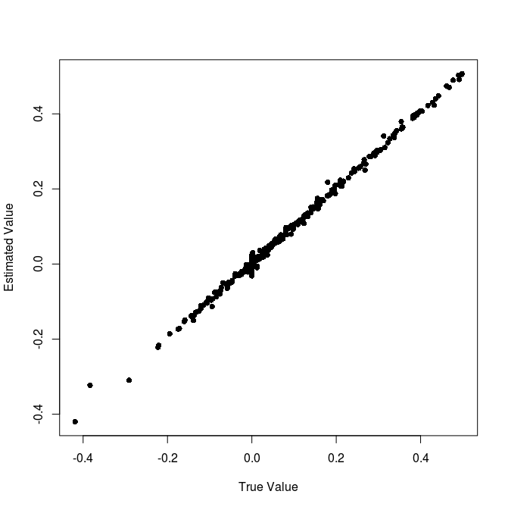  a | 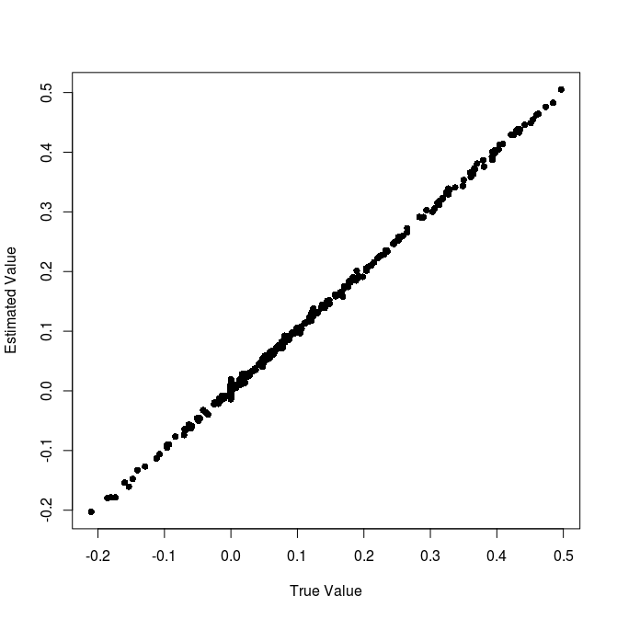  b
c | d

Figure ?:Simulation using 3x (a) and 10x (b) coverage at 100,000 loci and 3x (c) 10x (d) coverage at 5,000 loci, as described in the text. Here all parameters are graphed jointly. A summary of biases and MSE can be found in table ?.

Figure S1: The errors of parameters on simulated data plotted against each other. The majority of the errors are uncorrelated, but the errors in estimates of z₁ and z₂ have a strong negative correlations (red box), and errors in the estimate of are positively correlated with errors in the estimate of s_{CA} and negatively correlated with errors in the estimate of s_{AC} (green box). Despite showing a strong negative relation in the Daphnia pulex populations, s_{AC}
ε
fA
fC
ΘAC
sAC
sCA
Δ'AC
z'AC
Table ?:The Biases, MSEs, and r² of errors for estimates on a 3x coverage at 100,000 loci.

Figure 1. The haploid gametes and (represented by arrows) compose the diploid individual (represented by a circle), and the gametes and compose the diploid individual .

