(1)

**Changes of Understanding about some Concepts in Logic**

Although I had been convinced that there would be abundant unknown knowledge in a completely new subject, it actually astonished me that there are varieties of concepts in logic, which contain almost every corner condition that I either realize or am unaware. But in the course, I have learnt a lot about the concepts in logic. Talking about them together at a time is arduous, so I decide to divide them into collocations to discuss them.

**Object logic, Meta-logic, Object language, Meta-language**

“Object” means “target”, that is, the goal we need to attain. Hence, object logic is the logic we are studying. When studying some objects, we need some tools to conduct it. The tool that we utilize to study object logic is named as meta-logic. We use meta-logic to investigate object logic.

In the meanwhile, the concepts need a language to express its content. The language we are using the study the object logic is named as meta-language. As the opposite of meta-language, in mathematical logic, when we are in the study and discussion of a formal system, we are dealing with signs and formal language. At this time, we have to use another language, that is, object language.

For instance, we can take Java, a programming language, in analogy to the object language. When we are studying the logic in the program written in Java, we use Chinese as the meta-language and follow the grammar of Chinese as meta-logic to learn the content of Java and then study the Java program. These are the functions and contents of meta-language and meta-logic.

**Conditional,** **Antecedent, Consequent**

The first time I came into contact with the conditional was in solving the questions in mathematics in primary school. I thought it was easy to understand.

* we have if A then we can get B, if B then we can get C. Then, by A, what can we get?

It is the simplest example in primary school. At that time, I thought the conditional was the thing which the known condition told us what could we get from what, and we may need to utilize it to solve the relative given question.

However, my cognitive of the conditional in the past was so limited in solving the questions that I was always holding a thought that no matter how the conditional generates, there must follow at least a question. Whether the conditional can be independent with the questions or they have to come in union? I have been holding the wrong answer.

After the course, I have learnt something about the conditional. The conditional statement is in either the following forms:

* *If “Antecedent” then “Consequent”*
* *“Consequent” if “Antecedent”*

Among the sentences above, there are two new concepts.

* *Antecedent* means precondition, the assumption that can entail the consequence.
* *Consequent* means consequence, the result that corresponds the antecedent.

These two concepts and the conjunction between them make up a conditional.

The form “*if … then …*” is usually called a conditional proposition (假言命题). By the same token, the form “*…* *if …*” can also be used in the conditional proposition. The difference between them is that the position of the antecedent and the consequent is reversed. However, they similarly express there is a sufficient condition (充分条件) between the antecedent and the consequent, that is, the antecedent can deduct the consequent, but the converse is not always true.

Conditional is an essential concept in logic, and also plays a vital role in other disciplines. From natural science to human science, nearly most subjects invoke the argument. Nevertheless, the argument cannot get rid of the conditional since the combinations of the antecedent are as the premises, and the combination of the consequent is as the conclusion, making the conditional interwoven with the argument, so every argument-depended subject also relies on the conditional.

In analogy with the notion of the truth of proposition, there is also a notion of the truth of a conditional. However, the truth of a conditional has more restrictions than the truth of proposition. The truth of a conditional depends on three terms:

1. The truth of its antecedent;
2. The truth of its consequent;
3. Necessarily relevant and conditional relation between its antecedent and consequent. (important!)

Only when all the three above are satisfied then the conditional is true, otherwise, is false. We should notice the third term (3.). it is an important term that we can use it to distinguish the conditional and the material implication. Simultaneously, without (3.), we cannot conclude the truth of a conditional when merely knowing the truth of its antecedent and consequent.

* A => (A∧B)

Is the statement above true or not? This draws forth two new concepts: empirical conditionals and logical conditionals.

Empirical conditionals, from literally, rely on our living experience. We need some specific details to judge whether the empirical conditionals are true or not, that is, the concrete contents of the antecedent and the consequent is required. These conditionals are more like our daily used conditional.

Logical conditionals, other than empirical conditionals, are independent with the experience. We can judge them only by their abstract form without the concrete contents. Hence, when a form of logical conditional was once confirmed to be true, then in any situation, the result would not change the truth of the form.

In analogy with the notion of the validity of argument, there is also a notion of the validity of a conditional. But they are quite different since whether a conditional is valid or not depends on the logic system in which the conditional is defined. For a certain logic system, if a logical conditional is universally true, then it is called a valid conditional, or also entailment. If it is universally false, then it is called an invalid conditional. What calls for special attention is that we need to confirm a logic system first and then we can judge the validity of a logical conditional.

**Sufficient condition, Necessary condition,**

**Sufficient and necessary condition**

From the collocation above, I have expounded the meaning of sufficient condition. Actually, there exists a corresponding notion that is necessary condition. These conditions has been learnt and used in junior high school, so I am easily understand the concept of these conditions.

* A => B

Sufficient condition (充分条件) tells that the antecedent A can deduct the consequent B, but the converse is not always true.

* A <= B

Necessary condition (必要条件) tells that the consequent B can deduct the antecedent A, but the converse is not always true.

* A => B & A <= B

Sufficient and necessary condition (充要条件) tells that the antecedent A can deduct the consequent B, and vice versa.

**Material implication**

Before learning this concept, I think we should acquaint ourselves with the concept of the extension (connotation) and the intension (denotation) in advance.

When we say extension or intension, we need a notion to discuss. The extension of a notion is all the objects that have the intrinsic properties reflected by the notion. And the intension of a notion is the sum of all the intrinsic properties that the notion indicates.

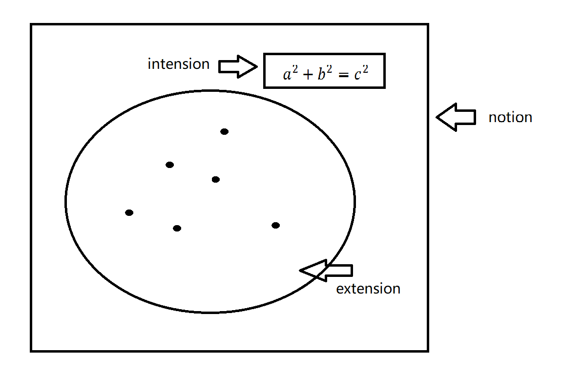

It looks like hard to understand, so we can utilize the graph for instance. In this graph, the notion is the set; the extension of the notion is all the elements in this set; the intension of the notion is the properties that all the elements share, which in this graph, is a2 + b2 = c2.

At the first time I thought the material implication sounded like the notion of conditional, but in fact, the notion of conditional is represented by the extensional notion of material implication. As a result, the criterion of the truth of the conditional and the material implication is different. There are three terms that the truth of a conditional depends on, but there just two terms that the truth of a material implication depends on:

1. The truth of its antecedent;
2. The truth of its consequent;

In material implication, the relevance between the antecedent and the consequent is not guaranteed. It is the greatest distinction between the conditional and the material implication.

I guess many people would confound these notions of conditional and material implication. What would happen if we confused them as one thing? Actually, it would lead to implicational paradoxes, which is a huge crash of classical mathematical logic.

* If the sea is blue, then the cock will crow.

From the perspective of everyday language, it does not make sense in any way, and almost no one would talk like so in daily life. After all, Could the color of the sea and the cock crowing have anything to do with? However, in the sense of material implication, this sentence is true since its antecedent and consequent are true. therefore, we cannot confound the conditional with the material implication.

(2)

**Changes of Understanding about Logic**

Logic is a marvelous and wonderful discipline for me. Ever since childhood, I have been told that logic is vital for a person. However, what is logic and how the logic works were still ambiguous for me even though I had some comprehension of logic. Perhaps my comprehension of logic was narrow, earlier than I learnt some concepts of logic in this course, I had been unable to tell the differences between the mathematical logics and the philosophical logics, because I did not know the real notion of the mathematical logics and the legible notion of the philosophical logics before.

Therefore, when I faced some contents about them and their embranchments, I always regarded them as branches of logic and put them all in a basket named philosophy, so I held a thought for a long time, that is, either the mathematical logics or the philosophical logics is a part of the human science.

By the time that I had learnt the course of introduction of mathematical logics, I have gained some comprehension of the mathematical logics. The mathematical logics is a kind of formal logic that uses symbols and mathematical methods to conduct a study. Although deduction and proofs are the central objects both in mathematical logics and traditional logics, during the study process, unlike the traditional logics, mathematical logics reduces the actual contents of the antecedent and consequent, and merely leaves the abstract form of the argument. Perhaps it would sometimes lead to some empirically ridiculous form of arguments, it immensely simplifies the arguments and makes it precise for us to study. Based on the methods and the embranchments in the mathematical logics, many subjects such as mathematics and computer science are able to develop and solve the problems and paradoxes.

As soon as the notion of the mathematical logics came up in the course, I realized why I could not analogize it to the philosophical logics and learn it in the way as the philosophical logics, because the mathematical logics is not a simple part of logic even though there is a “logic” in the phrase. It is more than a logic but more like a mathematics.

As a matter of fact, the contents of logic that I encountered the first time was about the ancient modal logics, which is a part of philosophical logics. Therefore, I thought it may be the reason why I was more familiar with the philosophical logics, and treated the logic and all its embranchments as a part of human science.

However, it astonished me that my thoughts from the above is still wrong. Strictly speaking, the philosophical logics is the study of the more philosophical aspects of logic. It never means that philosophical logics does not refer to the abstract field. What the philosophical logics concerned is to characterize some concepts such as syllogism, rational thinking, truth, and thinking content in the most fundamental way as possible as it can, and to attempt to model them by using modern formal logic.

As a principle of reasoning, logic has been explored by many civilizations in history. Ever since the earliest logical expressions appeared, logic has played an important role in the development of philosophy and science and has been undeniably related to the development of knowledge, science and technology. logic has always been a veritable catalyst for change as a wellspring of innovation.